

West Australian Test Papers

PHYSICS

Year 11

2005

SOLUTION BOOKLET

&

MARKING GUIDE

Markers should note that the solutions presented here are skeletal answers and
should be used as a guide only.

Alternate answers used by students may be perfectly acceptable and discretion
should be used.

Section A

1a) Newton’s third law. Equal and opposite forces cause the skaters to move off in opposite directions. Because the skaters are on ice they will accelerate due to Newton’s second law.

b) Newton’s law of inertia (Newton’s first law). Objects continue to do what they are doing unless acted upon by an outside force. Therefore when a car accelerates the occupants are pushed back in their seats because they tend to remain what “they were doing”.

- Change in momentum = p _{final} - p _{initial}

85 .0 x (1000 / 3600) x 0.145 = 105.0 x (1000 / 3600) x 0.145

1000 x 0.145 / 3600 (85.0 north - 105.0 south)

1000 x 0.145 / 3600 (85.0 north + 105.0 north)

1000 x 0.145 / 3600 x 190 north = 7.65 kg m s⁻¹ north

Change in momentum is 7.65 kg m s⁻¹ north

- The mass of plutonium is kept below its critical mass before the bomb is detonated. For a chain reaction to be sustained there needs to be enough neutrons absorbed by the plutonium.

- Q = 2 x 4 200 x (100 – 20)

Q = 6.72 x 10⁵ J

But the jug is only 60% efficient. Therefore the energy required is:
6.72 x 10⁵ x 100/60 = 1.1 x 10⁶ J

- Let T ºC be the equilibrium temperature.

Heat lost = Heat gained

mass of potato x specific heat of potato x (100-T) = mass of water x specific heat of water x (T-0)
2 100 x (100 – T) = 4 200 x (T-0) (masses cancel out)

(100 – T) = 2 (T-0)
100 = 3T
T = 33.3ºC

- Reduction in mass from 2.00 g to 0.125 g represents 4 half lives
4 half lives = 4 x 3.8 = 15.2 days

- This is a property of real gases. There is a force holding the particles together. When the gas expands, work is done on this force and the energy needed can only come from the internal energy of the gas and it cools.

8a) As the sheet becomes thicker the number of beta particles reaching the detector will decrease.

b) Alpha particles will not penetrate any thickness of the sheet so are not suitable to be used.
Gamma radiation will penetrate all thicknesses so cannot be used.

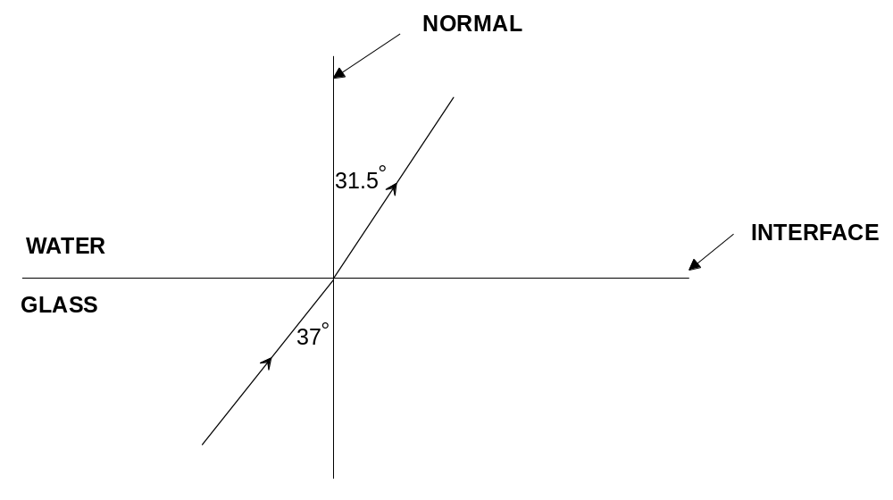9)

n₁ x sin θ₁ = n₂ x sin θ₂

1.33 x sin 37 = 1.53 x θ₂

angle of refraction is 31.5º

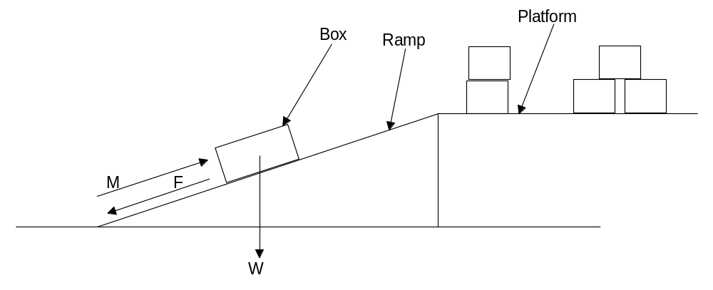10a),b),c)

- The average is 41.27º

Sin critical angle = 1 / n

Sin 41.27 = 1 / n
n = 1.52

The most likely sample is sheet glass

12 a) A
b) B
c) D
d) C

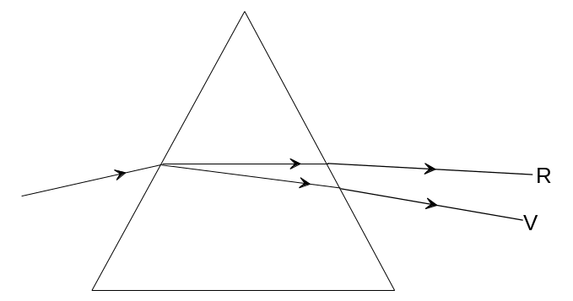13a)

b) This is dispersion. The different frequencies of the light that comprises the visible spectrum are refracted by different amounts giving rise to the spectrum.

14a) Q = m x c x ΔT

= 2 x 4 180 x (25 - 4)

= 1.76 x 10⁵ J

b) Power = energy / time
= 1.76 x 10⁵ / (90 x 60)
= 32.5 W

15a) V = I x R
V= I x 18
I = 0.33 A

b) q = I x t
q = 0.33 x (30 x 60) = 600 C

Section B

1a) 43 ⁺ 2ºC

b) Solid and liquid

c) 11.8 - 4.2 = 7.6 min

d) Q = 255 x 7.6 x 60 = 1.16 x 10⁵ J

e) Q = m x l
1.16 x 10 ⁵ = 11.3 x l
l = 1.02 x 10⁴ J kg⁻¹

- Specific heat of solid is greater than liquid because the gradient of the graph is steeper for the liquid which means for a given value of Q the resulting change in temperature is larger.

- Q = m x c ΔT

  - x 60 x 255 = 11.3 x c x (44 – 20)

c = 237 J kg⁻¹ K⁻¹

2a) ¹⁴N₇ + ¹n_{o} → ¹⁴C₆ + ¹H₁

b) 5 500 ⁺ 500 years

c) 117 counts per hour is 0.0325 Bq
0.26 → 0.13 → 0.065 → 0.325
This represents 3 half lives or 16 500 years (± 500 years)

d) The spoon is the same age as the tomb. Gold or rock carvings could be much older from a different dynasty.

e) Absorbed dose = energy / mass measured in grays (Gy)
Dose equivalent = absorbed dose x quality factor measured in sieverts (Sv)
Estimate the mass to be 80 kg

Mass of C-14 = 10⁻³/100 x 100
= 0.1 /100 g of C-14
= 10⁻³ g of C-14

Number of C-14 atoms
= (10⁻⁶ / mass of C-14) = (10⁻⁶ / 2.3247 x 10⁻²⁶)
Dose equivalent = 1 x (10⁻⁶ / 2.3247 x 10⁻²⁶) x (5 x 10⁻²⁰ x 1/80)
= 2.7 x 10⁻² S_{V}

3a)
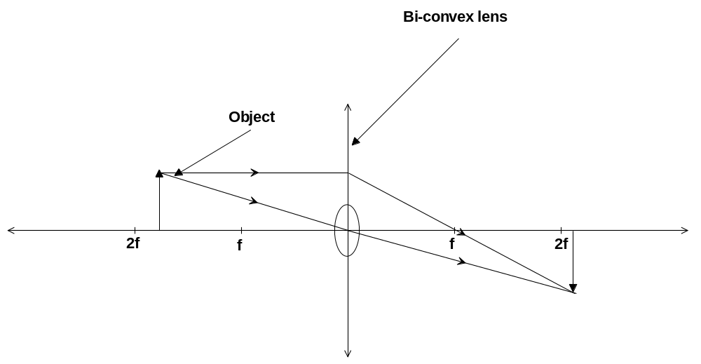

b) 1/f = 1/u + 1/v

1/5 = 1/8 + 1/v

1/v = 3/40

v = 13.33 cm

c) The image is real, inverted and enlarged.

d) Myopia (short sightednessis) an eye defect, it occurs when the eye cannot focus on distant objects. The eyeball is too long or the cornea is too rounded.

e)
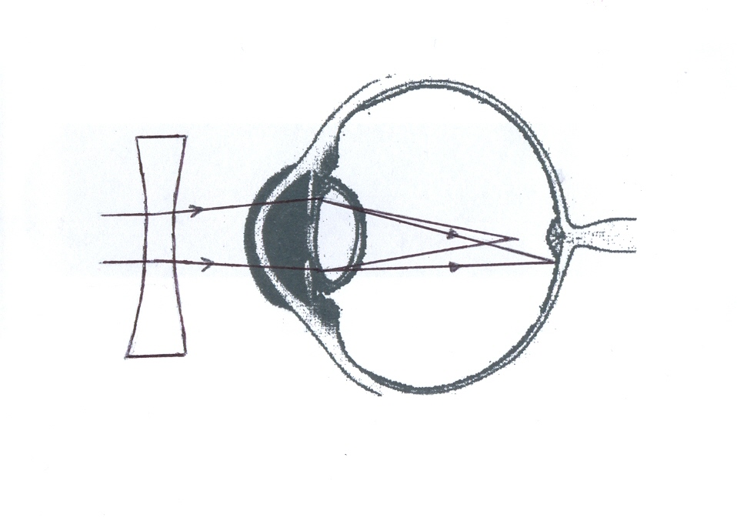

4a) Acceleration = 40 / 0.05 = 800 m s⁻² in the direction of the return.

b) Change in velocity is 17.5 - (-22.5) = 40 ms⁻¹

Impulse is equal to change in momentum = 0.057 x 40 = 2.28 kg m s⁻¹ in the direction of the return

c) vertical displacement allowed is (0.950 – 0.914) = 3.6 cm = 0.036 m
s = u t + 0.5 a t²
0.036 = (0 x t) + (0.5 x 9.8 x t²)
t = 8.57 x 10⁻² s

speed = distance / time

12 / 0.0857 = 140 m s⁻¹ which is 504 km h⁻¹

This is much faster than is reasonable as professional tennis players can only hit the ball between 100 and 200 km h⁻¹

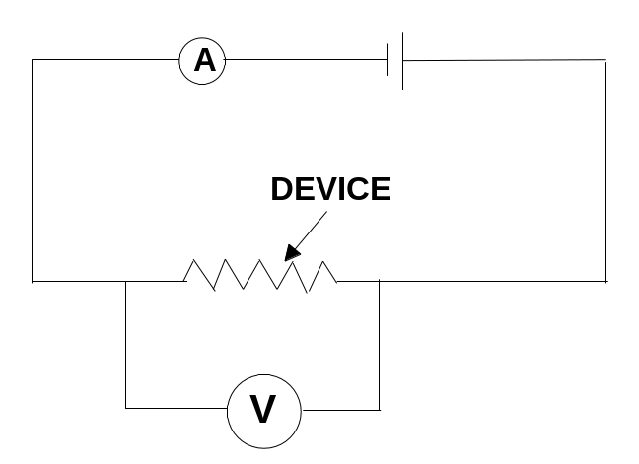
5a)

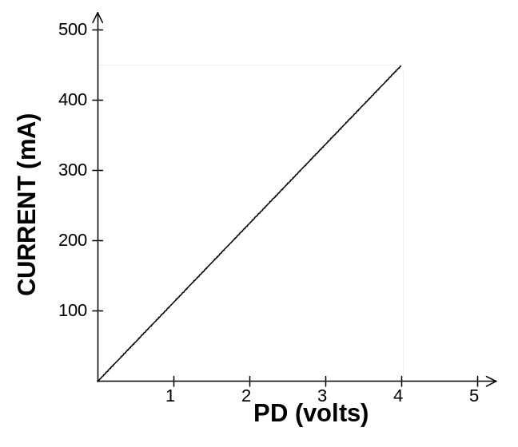b)

c) R = V / I
4.2 / 0.49 = 8.6 Ω

d) No. There is a low value for the resistance so if the voltage is increased then the current would increase and the circuit would become hot. Increased temperature would increase resistance.
OR
Yes, given the linear nature of this data. If 5V was used and the circuit was switched on for a short period of time.
e) V = 4.0 and the current is 0.45 A

Q = I x t

- = 0.45 x t
t = 222 s which is 3.7 min

6a) Velocity is changing uniformly

b) Yes. Gradient is constant.

c) Velocity is 72 km h⁻¹ which is equal to 20 m s⁻¹

Acceleration = 20 / 60 = 0.33 m s⁻²

d) Constant speed

e) Constant deceleration.

f ) 72 x (1000 / 3600) = 20 ⁺ 1 m s⁻¹

g) Displacement can be measured by calculating to area under the graph.
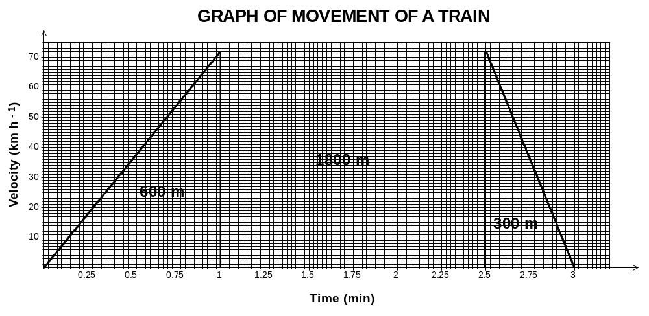

600 m + 1 800 m + 300 m = 2 700 m = 2.7 km

7 a)
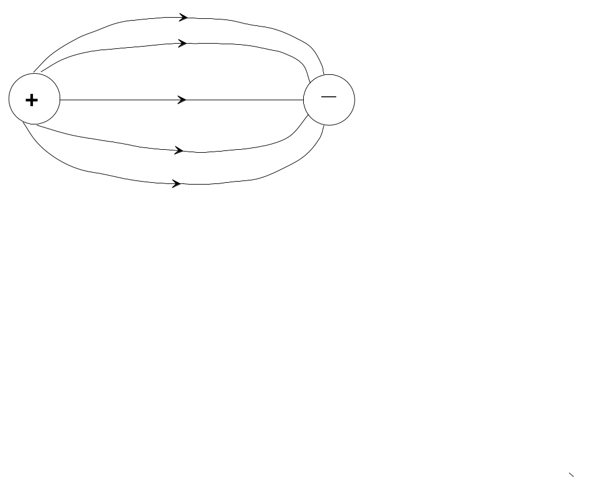

b) Attraction Force = 9 x 10⁹ x (5 x 10⁻⁹) x (15 x 10⁻⁹)
(30 x 10⁻³) ²

Force is 7.5 x 10⁻⁴ N

c) A charge of negative 10 nC is distributed equally amongst A and B.

d) Repulsion Force = 9 x 10⁹ x (5 x 10⁻⁹) x (5 x 10⁻⁹)
(30 x 10⁻³) ²

Force is 2.5 x 10⁻⁴ N

Both lose charge to the surroundings being a poor conductor. Loss of charge is increased if there is high humidity.

8a) I = V / R
I = 9.0 / 10 = 0.9 A

b) I_{T} = I₁ + I₂

I₁ = I_{T} - I₂
I₁ = 1.35 - 0.9
I₁ = 0.45 A

c) R = V / I
R = 9.0 / 0.45
R= 20 Ω

d) 1/R_{T} = 1/R₁ + 1/R₂

1/R_{T} = 1/10 + 1/20

1/R_{T} = 3/20

R_{T} = 20 / 3 = 6.7 Ω

Section C

Question 1

- 40/600 = 1/15

So 1/15 x 4 000 = 266.6 tonnes is saved.

- 40 MW = 40 x 10⁶ J s⁻¹
= 40 x 10⁶ x (60 x 60 x 24) = m x 4 200 x (13 – 5)
m = 1.03 x 10⁸ kg per day

- On a hot day the cooling system would be required more because more heat would be needed to be removed from the campus buildings.

- The heat exchanger would be used to transfer heat from the closed loop, that is now warmer, to the outlet pipe.

- Cooler water is more dense than warm water so it sinks to the bottom. Conduction and convection will also inhibit warm water from getting to the bottom.

- The heat from the buildings will end up in the lake and will heat water at the surface of the lake.

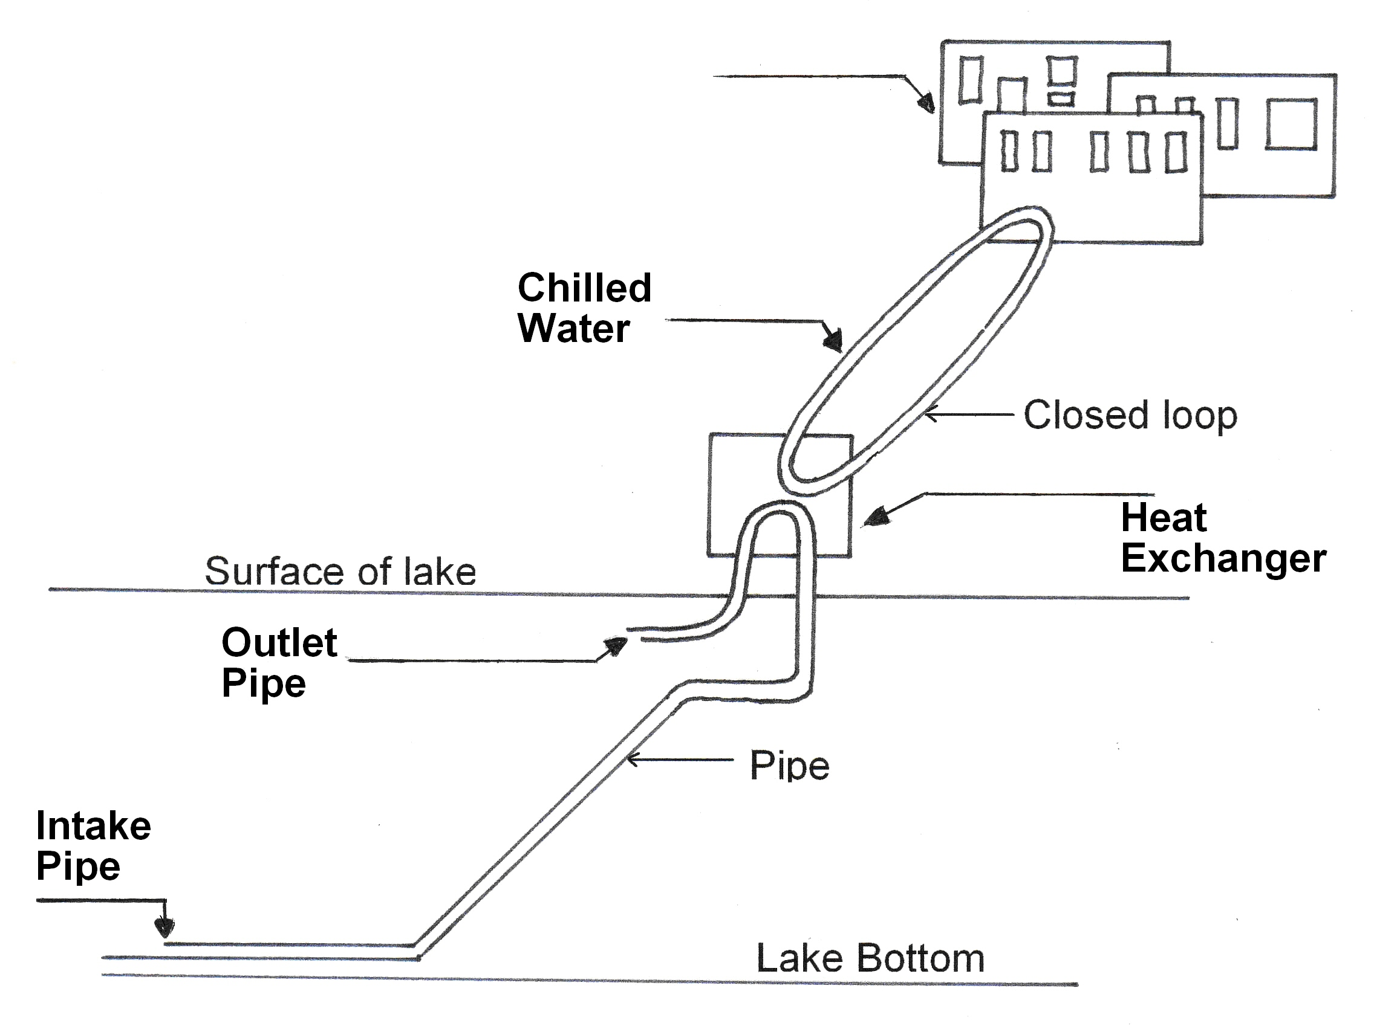
Question 2

- The radiation necessary for treating food is high energy gamma rays, X Rays and accelerated electrons. These radiations can penetrate the food.

- X Rays are very dangerous and the energy must be restricted.

- 10 MeV = 10 x 10⁶ x (1.6 x 10⁻¹⁹) J

= 1.6 x 10⁻¹² J

4(i) ⁵⁹Co₂₇ + ¹n_{o} → ⁶⁰Co₂₇

(ii) ⁶⁰Co₂₇ → ⁶⁰Co₂₇ + γ

Co-60 is relatively easy to produce and γ are highly penetrating.

- Electrons are particles. They will interact with other particles and hence their penetrability is reduced.

- It is referred to as cold pasteurization.

- The production of X Rays by bombarding a target with high speed electrons is very inefficient.

9 A risk analysis is a procedure that needs to be considered when there is some doubt about how safe a procedure is. The pros and cons are weighed up and a decision is made about how viable the process is. Strict guidelines need to be adhered to when food is irradiated,

