These test papers are copyright and must not be reproduced in any way.
©
This paper should be withdrawn after use in the examination or classroom and retained by the teacher until Tuesday 5th December.
Test papers may not be used for private tutoring in the year of publication.



PHYSICS

YEAR 11

2006

INSTRUCTIONS TO CANDIDATES

TIME: 2½ Hour Paper: MARKS: 170

Attempt questions 1 to 15 Section A
Attempt questions 1 to 7 Section B
Attempt question 1 Section C

TIME: 3 Hour Paper: MARKS: 200

Attempt ALL questions

STRUCTURE OF THE PAPER

Section | No. of  Questions | No. of questions  to be attempted | No. of marks  out of 200 | Proportion of  exam total
A: Short Answers | 15 | ALL | 60 | 30%
B: Problem Solving | 8 | ALL | 100 | 50%
C: Comprehension and  Interpretation | 2 | ALL | 40 | 20%

Note: Above refers to 3 hour paper. For less than 3 hours refer to front cover.

INSTRUCTIONS TO CANDIDATES

Write your answers in the spaces provided beneath each question. The value of each question (out of 200) is shown following each question.

The enclosed Physics: Formulae and Constants Sheet may be removed from the booklet and used as required.

Calculators satisfying conditions set by the Curriculum Council may be used to evaluate numerical answers.

Answers to questions involving calculations should be evaluated and given in decimal form. Quote the final answer to not more than four significant figures. Despite an incorrect final result, credit may be obtained for method and working, providing these are clearly and legibly set out.

Questions containing specific instructions to show working should be answered with a complete, logical, clear sequence of reasoning showing how the final answer was arrived at; correct answers which do not show working will not be awarded full marks.

Questions containing the instruction "Estimate" may give insufficient numerical data for their solution. Students should provide appropriate figures to enable an approximate solution to be obtained.

Section A: Short Answers

Marks allocated: 60 marks out of a total of 200 (30%)

Attempt ALL 15 questions in this section. Each question is worth 4 marks.
Answers are to be written in the space below or next to each question.

1 a) Which is not one of Newton’s laws of motion?

A The total momentum of a system of interacting bodies remains constant, providing no external force acts.

B The rate of change of momentum of a body is directly proportional to the external force acting on the body and takes place in the direction of the force.

C If body A exerts a force on body B, then body B exerts an equal and oppositely-directed force on body A.

D A body continues in a state of rest or of uniform motion in a straight line unless acted upon by some external force.

Answer:

2 In a football match, a player kicks a stationary football of mass 0.44 kg and gives it a speed of
32 m s^{–1}.
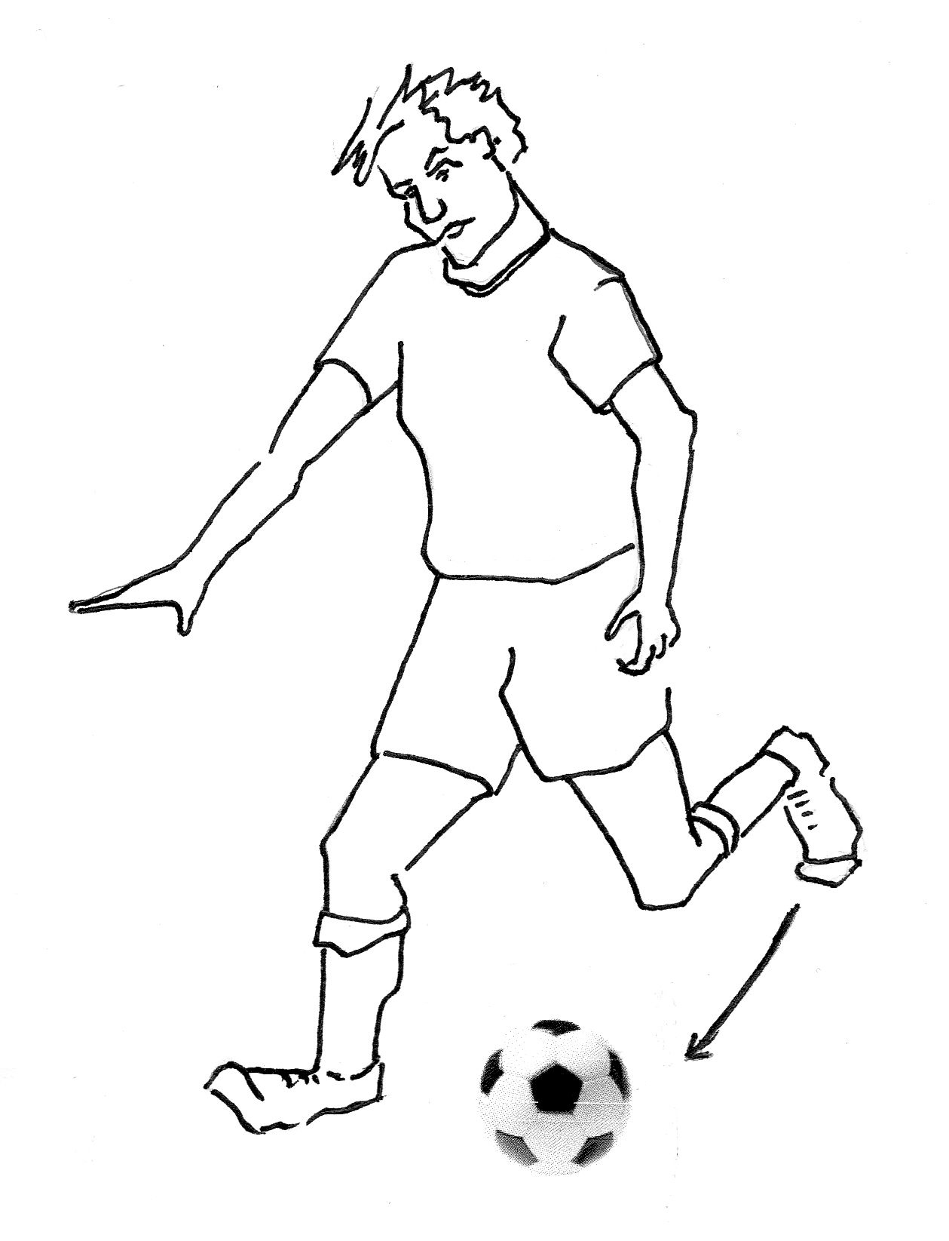

a) The contact time between the football and the footballer’s boot was 9.2 ms. Calculate the average force of impact on the football. (2 marks)

b) A video recording showed that the toe of the boot was moving along the straight line of the impact force when it struck the football. The force of the impact slowed the 1.60 kg boot down from a speed of 24 m s^{–1} to a speed of 15 m s^{–1}. Calculate the change of momentum of the boot. (2 marks)

3 (a) In an experiment to find the range of α-particles in air, the apparatus shown below was used.

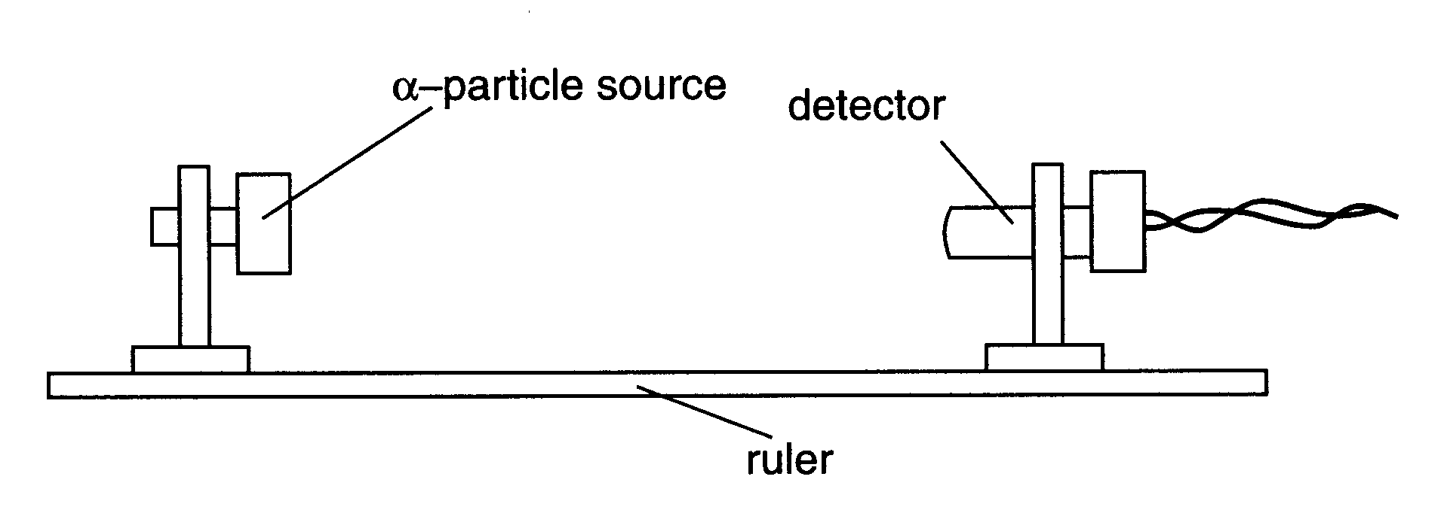

The results of this experiment are shown below.
(i) State what causes the count rate 9 cm from the source. (1 mark)

(ii) Estimate the count rate that is due to the source at a distance of 2 cm.
(1 mark)

(iii) Suggest a value for the maximum distance that α-particles can travel from the source. Justify your answer. (2 marks)

4. How much heat would be absorbed by a person’s skin if they were to come into contact with
10.0 g of steam at 100 °C? (Body temperature is 37 °C)

5. An energy conscious farmer is planning to build a dam near to the family home. It may be placed either on the western side which is near to the ocean, or on the eastern side which is the direction from which hot winds blow. State which side would mean that less energy to cool the house would be needed on a typical summer day, and explain the physics behind this.

6 You are given two samples of radioactive waste. The characteristics of the samples are summarised in the table below.

 | SAMPLE A | SAMPLE B
Radioactive constituent | Strontium – 90 | Hydrogen - 3
Amount of material | 6.0 x1 0 ²⁰ atoms | 6.0 x 10²⁰ atoms
Half-life | 29 years | 12 years
Emission type | High energy beta particles | Low energy beta particles
Does the material accumulate in the body? | Yes. Deposits in bone, close to marrow | Yes. Fairly even distribution over the body

a) Which of the two samples would have the higher activity? Explain. (2 marks)

b) Which of the two samples would pose the greater health risk due to radiation if accidentally swallowed? Explain. (2 marks)

7 An engineer is designing an ice making machine. Water will enter the device at 18 ºC and the ice cubes are to be cooled to -5 .00 ºC before release. Show that about 0.6 MJ of energy must be removed from 1.50 kg of water at 18 ºC to change it into ice at -5.00 ºC.

8 Calculate the binding energy per nucleon of a Be-9 atom having a mass of 9.012182 u.

9 The Figure below shows an optical fibre in air. XY is a ray of light passing along the fibre.

a) On the diagram, carefully continue the ray XY until it passes Z. (1 mark)

b) Explain why the ray does not leave the fibre at Y. (1 mark)

c) The light in the optical fibre has a wavelength of 3.20 x 10⁻⁷ m and is travelling at a speed of 1.90 x 10⁸ m s⁻¹. Calculate the refractive index of the material from which the fibre is made . (2 marks)

10 A hoist electric motor in a factory is used to raise a mass of 200.0 kg through a vertical height of 11.0 m in 14.0 s. What is the average power exerted by the motor?
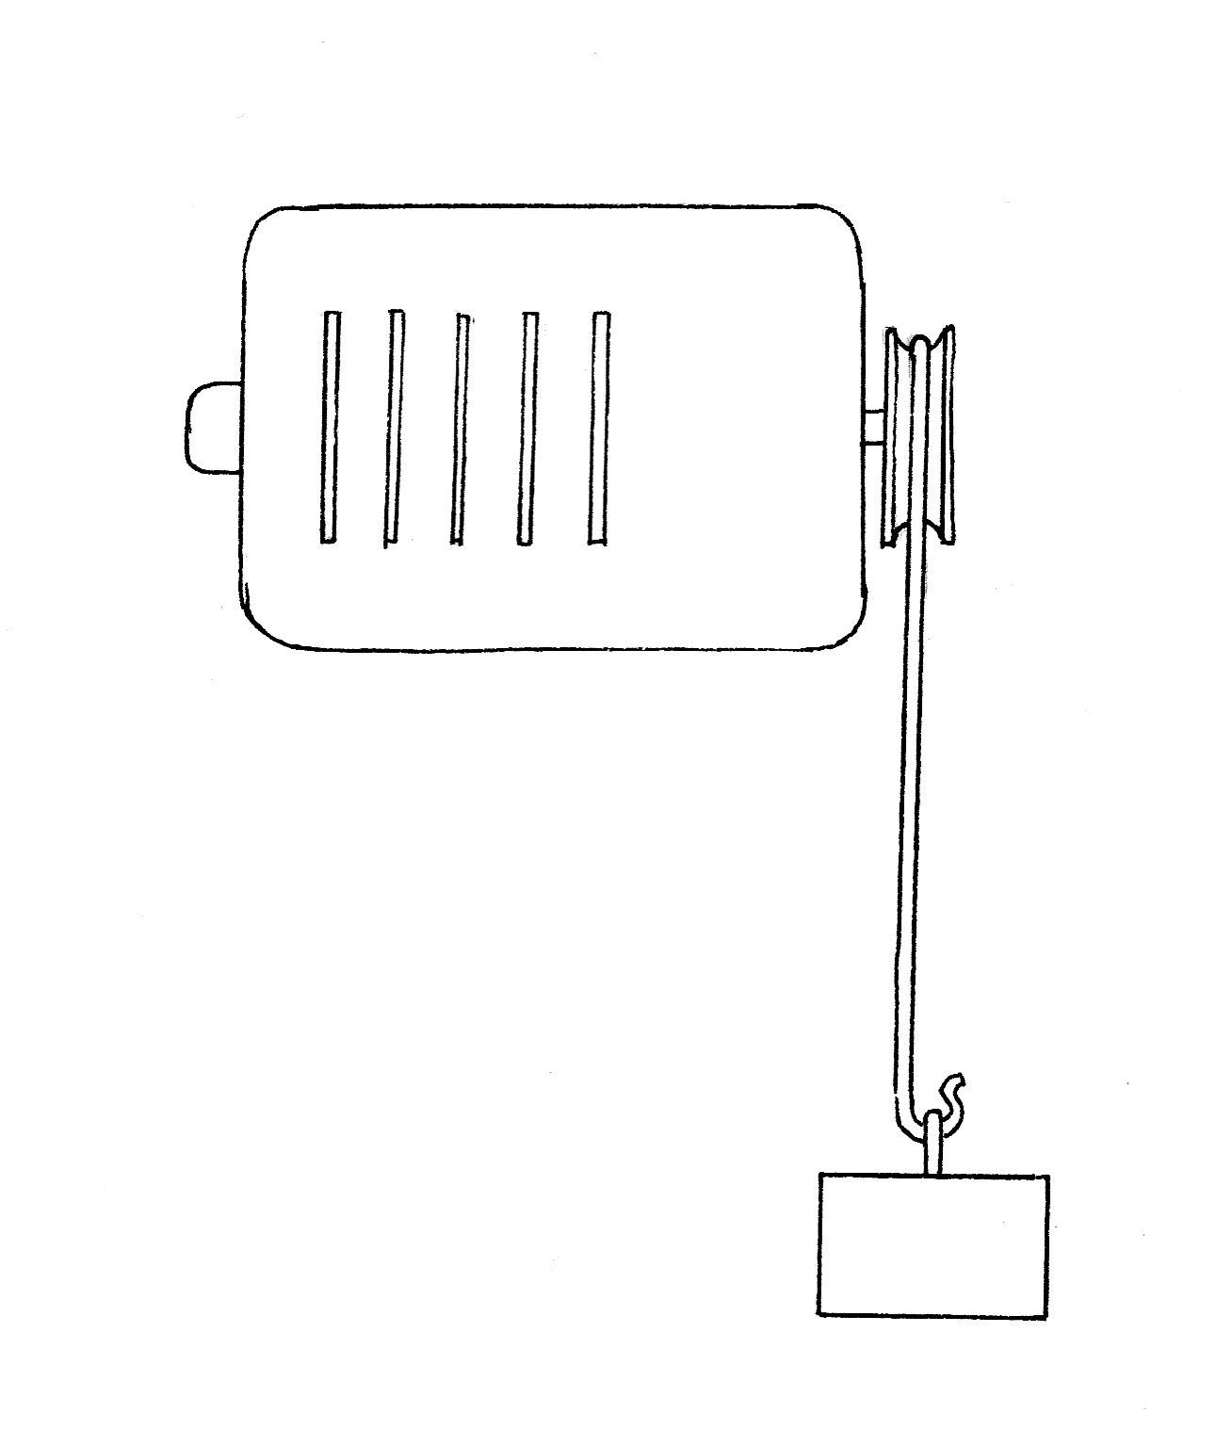

11 The diagram below shows a lens used as a magnifying glass. The position of the eye is shown and the size and position of an object standing at point O.

a) Measure the focal length of the lens. ________________ (1 mark)

b) On the diagram, use a ruler to construct accurately the position of the image. You should show how you construct your ray diagram and how light appears to come from this image to enter the eye. (2 marks)
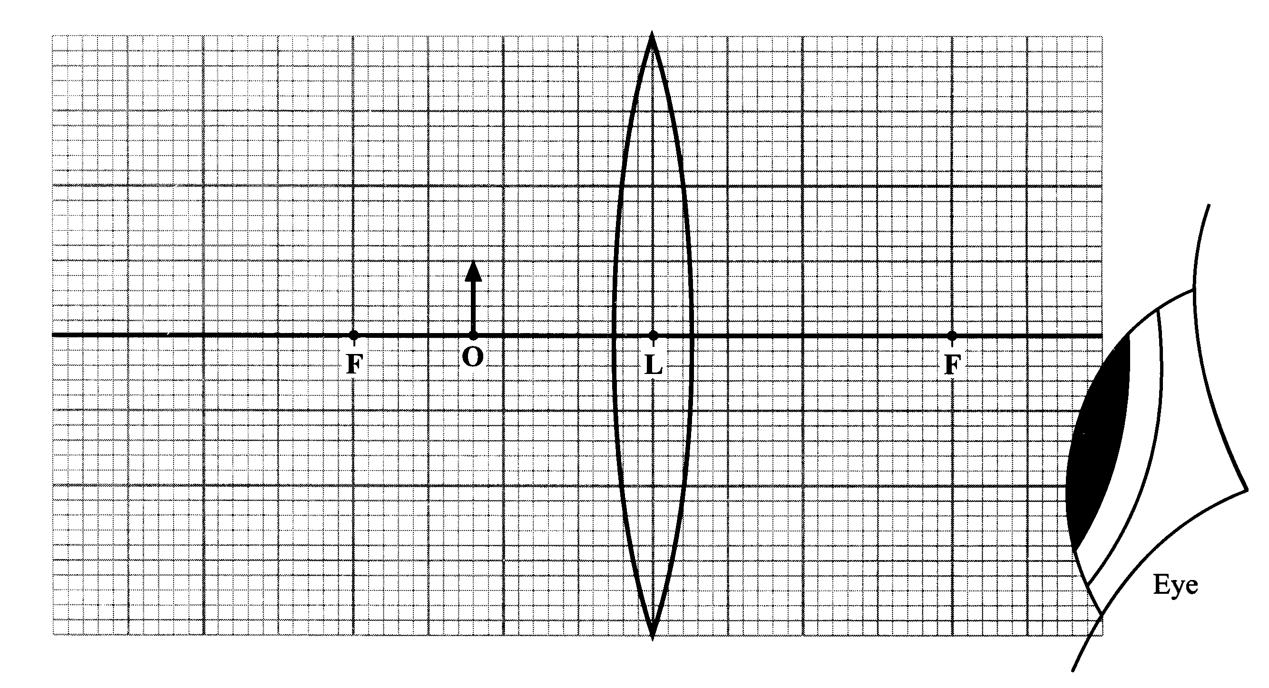
c) Determine the magnification of the lens. (1 mark)

12 a) Which speed/time graph applies to an object having a constant non-zero acceleration? (1 mark)

Answer:

b) A car accelerates uniformly from 20.0 km h^{–1} to a speed of 100 km h^{–1} in
5.80 s. Calculate the magnitude of the acceleration of the car in m s^{–2}.
(3 marks)

13 Both red and violet light form part of the visible portion of the electromagnetic spectrum.
(a) State two ways in which red light differs from violet light. (2 marks)

(b) A narrow beam of white light (W) hits the side of a prism. Which diagram best shows the paths of the red light (R) and violet light (V) as they pass through the prism and emerge on the other side? (2 marks)
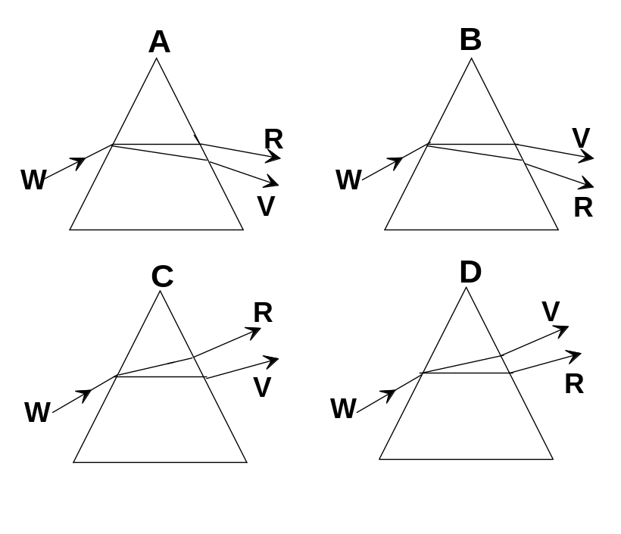

Answer:

14 An adult wants to cool a hot cup of soup which is at 85 °C before giving it to a child. 0.30 kg of soup is in an insulated cup and the adult adds a 0.1 kg ice block at 0 ^{º}C to the soup. If the thermal properties of the soup are the same as for water, calculate the final temperature of the soup when the ice has just melted.

15 A particular sensor system is used to sample data at regular intervals. The data are then transmitted along metal cables before storage by a computer for future analysis. The average current carried by the sensor system is 35 mA and the effective sensor resistance is 22 kΩ.

a) Calculate the heat energy dissipated in the system in a 24 hour period. (2 marks)

b) In an attempt to increase the versatility of the sensor system, the diameter of the cables is reduced. Suggest a disadvantage of reducing the diameter of the cables. (2 marks)

Section B: Problem Solving

Marks allotted: 100 marks out of a total of 200 (50%)

This section contains 8 questions.

You should answer: ALL of the questions 1, 2, 3, 4, 5, 6, 7 and 8

Answer the questions in the spaces provided.

- 1 (14 Marks)
A factory that uses water to cool its machinery pumps water through a pipe at the rate of 20 kL s^{-1.} The pump can supply kinetic energy to the water at the rate of 50. kJ s⁻¹.
20% of the energy supplied to the water is wasted due to friction between the water and the pipe. This ‘waste’ energy is all transformed to heat energy.

- What mass of water is pumped per second? (2 marks)

(b) What quantity of ‘waste’ energy is transferred to the water due to friction between the water and the pipe? (2 marks)

(c) What is the increase in temperature of the water as it flows through the pipe? (4 marks)

(d) Apart from the fact that water is plentiful and relatively cheap, why is it preferred as a coolant for machinery? (2 marks)

(e) If the water is recycled through the machinery in a continuous stream, would the water still be effective in cooling the machinery? Explain your answer. (2 marks)

(f) Explain in terms of the kinetic theory how the temperature of the water increases due to friction. (2 marks)

2. (13 Marks)
A laboratory technician takes a series of sensitive geiger counter readings every half hour at a fixed distance from a sample that contains radioactive element (X). The readings are recorded in the table below. The reading when the source was removed was 180 counts min⁻¹

Time (h) | 0.5 | 1.0 | 1.5 | 2.0 | 2.5 | 3.0 | 3.5 | 4.0 | 4.5 | 5.0
Experimental count counts/min | 2477 | 2031 | 1633 | 1315 | 1184 | 916 | 760 | 635 | 548 | 470
True count counts/min

(a) Complete the table above and using either the graph paper below, or your graphics
calculator, plot data that will enable you to determine the half life of the radioactive
element (X). (If you use your graphics calculator sketch the shape of the labelled graph
on the grid. (4 marks)



(b) From the graph calculate the average half life of the element (X). (4 marks)

(c) If the original mass of the sample containing radioactive element (X) is 0.205 kg, what will be the mass of radioactive element (X) after 4.8 hours? (2 marks)

(d) During the experiment radioactive element (X) is decaying into element (Y) and emitting a certain type of radiation. What proportion of the original sample consists of radioactive element (X) after 3.2 hours, if at the beginning of the experiment, the original sample consisted of 50% radioactive element (X)? (2 marks)

(e) The technician found that a sheet of paper placed between the original source and the counter reduced the count rate. What type of radiation was radioactive element (X) emitting? (1 mark)

3 (15 marks)
A scientist puts an object 5.00 cm from a 0.100 m focal length concave lens.

(a) Draw a labelled ray diagram to show where the image would be formed. (3 marks)

(b) Calculate mathematically the position of the image. (4 marks)

(c) Describe the nature of the image. (2 marks)

(d) What is the magnification of the image? (2 marks)

(e) List two devices that utilise concave lenses? (2 marks)

(f) If a convex lens was used in by the scientist instead of a concave lens, describe the nature of the image. (2 marks)

- 4. (13 Marks)

An Australian Rules player mis-kicks a football and it goes vertically into the air with an initial velocity of 11.0 m s^{–1}.
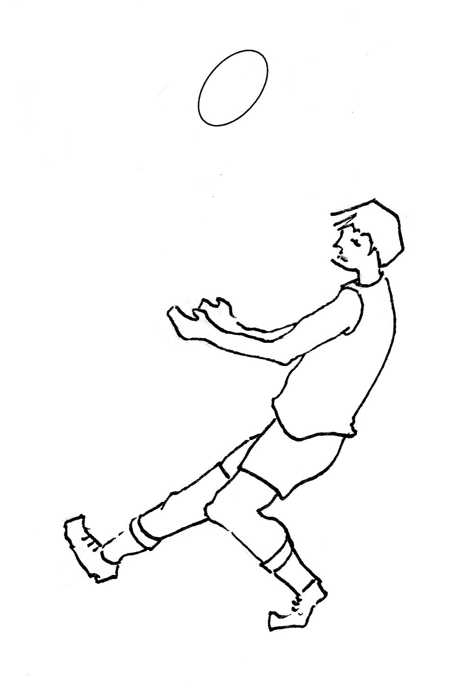

(a) How long does he have to get out of the way if he wants to avoid being hit by the ball on the way down? The football left his boot at a height of 1.20 m, and he is 1.80 m tall? (ignore air resistance in this question) (4 marks)

(b) Calculate the greatest distance above the ground reached by the football. (3 marks)

(c) State the speed and acceleration of the football at its highest point. (2 marks)

speed is __________________

acceleration is ___________________

(d) Calculate the speed of the football at the moment of impact with the ground. (2 marks)

(e) What is the value of the acceleration due to gravity at the following positions of the ball’s flight? (2 marks)

- On the way up ________

- On the way down ________

5 (14 marks)
(a)The Figure below shows the electron gun that accelerates electrons in an electron microscope.
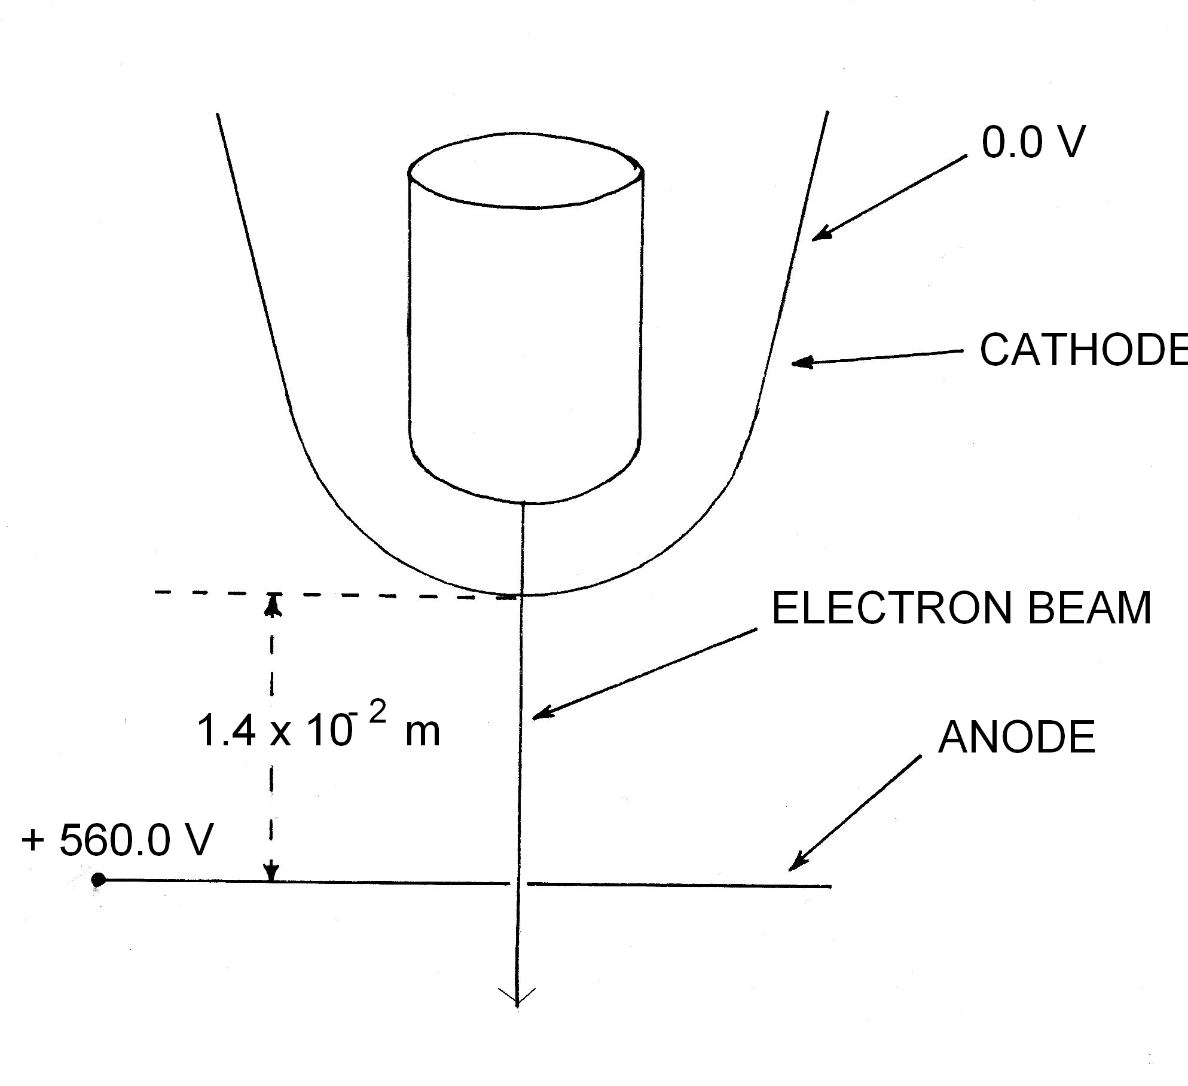

(i) Draw, on the diagram, electric field lines in the region between the anode and cathode. Assume that there are no edge effects and that the holes in the plates do not affect the field.
(2 marks)

(ii) Calculate the work done on an electron by the electric field in the region between the anode and cathode. (3 marks)

- (b) Two small, insulated spheres are attached to nylon threads 0.30 m long and hung from a common point. (see diagram below). Each has a mass of 3.0 x 10⁻⁶ kg. When the spheres are given equal quantities of charge they separate and hang so the angle between them is 28º.
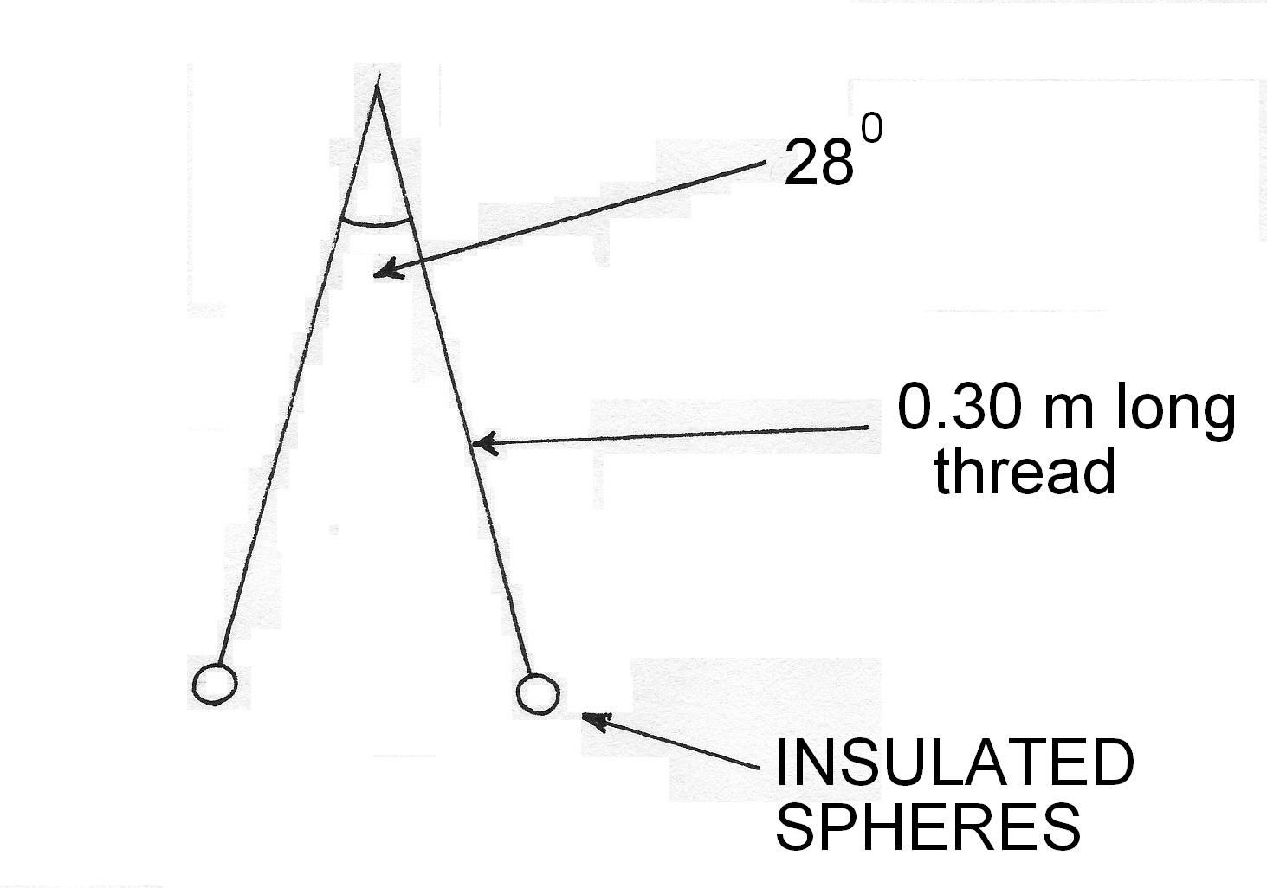

(i) Calculate the force that is causing the spheres to separate. (3 marks)

(ii) Calculate the charge on each sphere (4 marks)

(iii) If the spheres are left in the separated position for several hours, what would you observe? Explain your observation. (2 marks)

- 6. (11 Marks)

An electric coffee maker has a resistance of 75.0 Ω and operates on a 240 V supply. 85% of the electrical energy is converted into heating 0.50 kg of water which is initially at 23º C.

- Calculate the heat energy required to just bring the water to its boiling point.
(3 marks)

- Calculate the quantity of electrical energy required to boil the water. (3 marks)

(c) Calculate the time taken to boil the water. (3 marks)

(d) If the cost of a kW h of electricity is 15.2 cents, what is the cost of boiling the 0.5 kg of water? (2 marks)

7 (10 marks)
The Figure below shows a skier being pulled by rope up a slope of incline 15° at a constant speed. The total mass of the skier is 90.0 kg. Two of the forces acting on the skier are already shown.
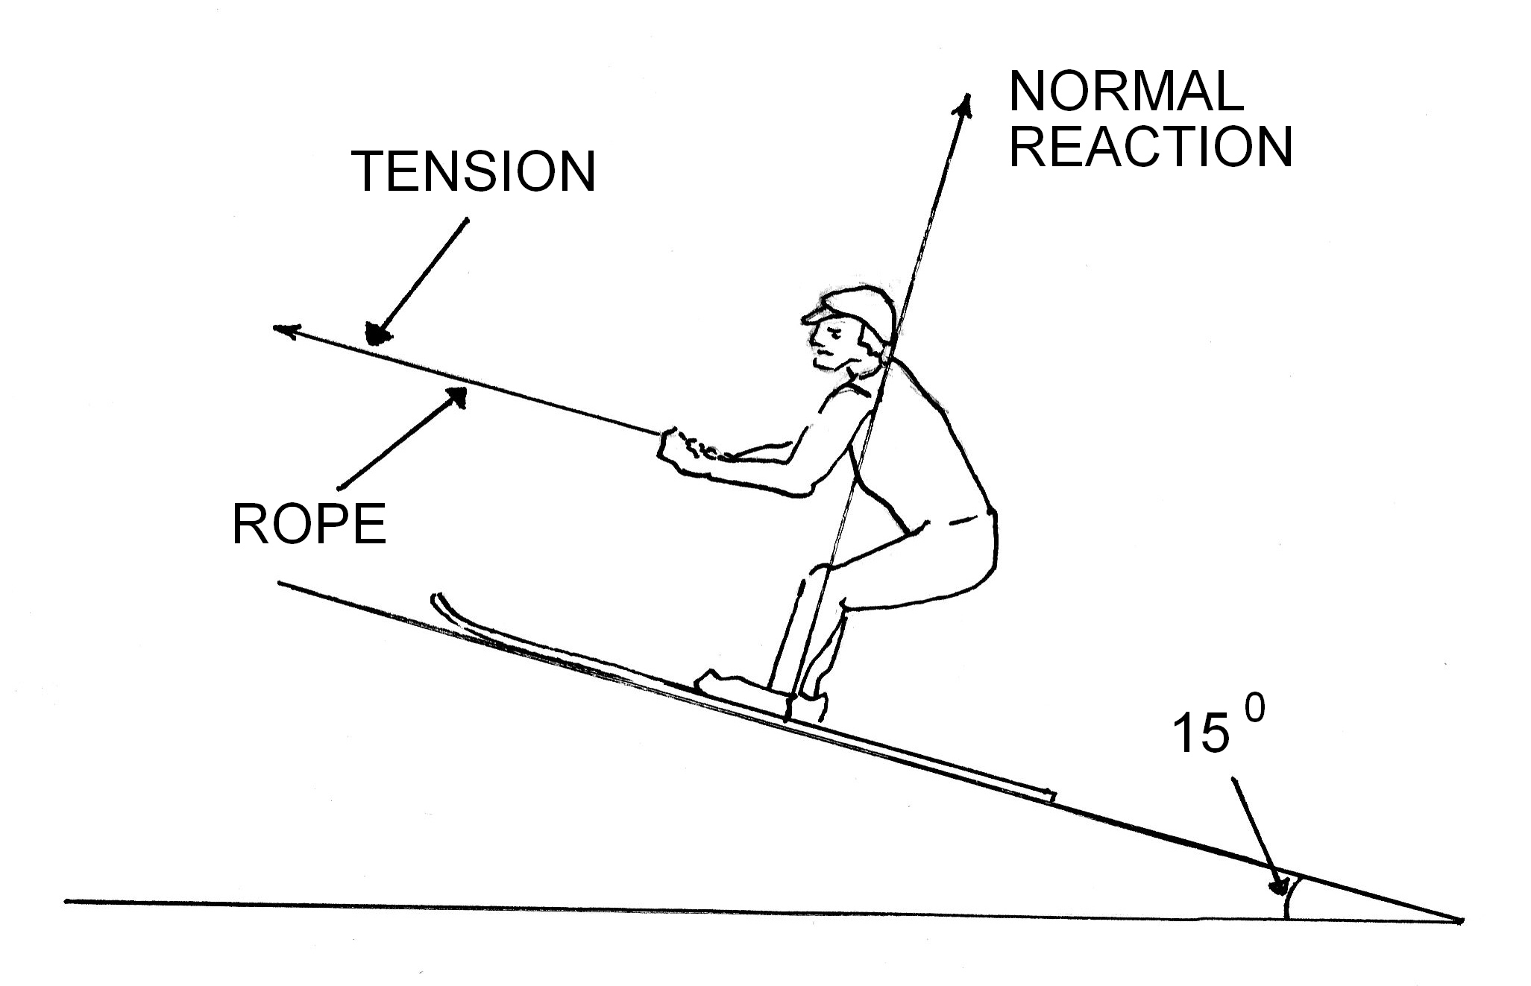

a) Mark with arrows and label on the Figure above, a further two forces that are acting on the skier. (2 marks)

b) Calculate the minimum tension in the rope pulling on the skier. (4 marks)

c) A constant force of 300.0 N, parallel to the hill, moves the skier through a distance of
140 m up the hill at a constant speed.

(i) If this takes 5.0 minutes, what is the average speed of the ski-tow? (2 marks)

(ii) How much of the work done by the rope is dissipated as heat? (2 marks)

8 (10 marks)
The circuit diagram below shows a battery connected to a number of resistors.

10 Ω
12 V

(a) Calculate the total circuit resistance. (4 marks)

(b) If the current in the ammeter shown is 0.60 A. Calculate the power dissipated in one of the 4 Ω resistors. (2 marks)

(c) Calculate the voltage across one of the 5 Ω resistors. (2 marks)

(d) If the 4 Ω resistors were connected in series rather than in parallel, would the reading on the ammeter still register 0.6 A? Explain your answer. (2 marks)

Section C: Comprehension and Interpretation

Marks allotted: 40 marks out of 200 (20%)

BOTH questions should be attempted. Each question is worth 20 marks.

Read each passage carefully and answer all of the questions at the end of each passage.
You are reminded of the need for clear and concise presentation of answers. Diagrams (sketches), equations and /or numerical results should be included as appropriate.

Question 1

Sudden Stop
(Paragraph 1)
Vehicles are not intrinsically dangerous: let's face it, you are most unlikely to have an accident if your car never leaves your driveway. Which tends to prove that it is the movement that causes all the problems. You see, as soon as your vehicle moves it comes under the influence of a variety of physical forces, some good for you, some bad. Things like momentum, kinetic energy, centripetal force, gravity, drag, directional force, etc.

(Paragraph 2)
The worst of that lot is kinetic energy, a function of the speed and loaded mass of the vehicle. This kinetic energy increases proportionally with the square of your speed. In other words, when you triple your speed (for example when you go from 30 km h⁻¹ to 90 km h⁻¹) your kinetic energy increases
9 times (3x3). This is not good because your braking distance will increase 9 times when you increase your speed 3 times. (Please note that I am not talking about the total stopping distance, as this would include the driver's thinking distance).

(Paragraph 3)
You probably realise what this means in practical terms: if you hit at 90 km/h the crash is going to be 9 times worse than it would be at 30 km/h. However if you take this a bit further, you will see that something good comes out of it. If faced with any crisis, wipe as much speed off the car as you can. So, you see that firstly (before taking evasive action with the steering wheel), you have to decrease your speed as much as you can - without locking the wheels - and then you must try to avoid a hard landing. Given a choice, a clump of bushes is preferable to a parked car, and hitting the back of a parked car at 60 km h⁻¹ will be pretty much the same as hitting a brick wall at half that speed.

(Paragraph 4)
Above all, never hit a tree!! Trees are the most unforgiving things that you may come up against in anger. There is no "give" in them and you concentrate the whole force on a narrow profile. And of course, make sure that your loads are secure, the baby is in the baby capsule on the back seat, and you and your passengers are all correctly buckled in.

Questions
1. Explain why the sudden stop in the collision is a killer. (3 marks)

2. Verify the claim that the "stopping distance increases 9 times when the speed increases 3 times". (Assume that the braking force is constant.) (4 marks)

3. What does "driver thinking time" have to do with the total stopping distance in a collision? (2 marks)

4. Why is hitting the back of a parked car at 60 km h ⁻¹similar to hitting a brick wall at half the speed? (3 marks)

5. Explain the Physics behind the claim that loads should be secured in a moving vehicle? Is this the same reasoning behind the wearing seat belts for people? (4 marks)

6. Explain how design features such as “crumple zones” use the concept of impulse to reduce the severity of injury to drivers in the event of a collision. (4 marks)

Question 2

Camouflage for Soldiers

(Paragraph 1)
Camouflage make up that can protect troops from the heat of explosions is being developed by British defence researchers. Wearing the cream could mean the difference between a severe burn that needs a skin graft and a far less serious injury. The Ministry of Defence says burns from explosions account for up to 30 per cent of British military casualties, and even superficial injuries can be painful enough to severely hinder a soldier. The figure is so high because the radiant heat and hot gases from blasts can injure over much greater range than shrapnel. Exposed skin such as the face and hands are most at risk. Gloves and cotton hoods can protect these areas to some extent, but soldiers often avoid them because they are bulky and restrictive. Cotton is used instead of synthetic materials because it does not melt when heated.

(Paragraph 2)
Scientists at Porton Down near Salisbury have developed a skin cream that blocks up to 80 per cent of the heat from explosions. To a standard skin cream base of glycerol and zinc oxide, they added fine particles of titanium dioxide which, at a specific size, can reflect infrared radiation. Conventional explosives produce intense pulses of near infrared light that can burn the skin in less than 10 milliseconds.

(Paragraph 3)
Making the cream reflective to IR was not enough, however. Explosions also produce dangerously hot gas, so they included a solid "melt additive" called cetyl alcohol. This melts at 47 °C, the temperature at which skin would normally burn. So when hot gas hits the cream, the heat is absorbed in melting the cetyl alcohol. The developers say that when the blast wave has passed, the melted additive re-radiates the absorbed heat slowly and safely as it solidifies. "Because the heat comes back more slowly, the bloodstream can transport the heat away," they say.

(Paragraph 4)
The Porton Down team tested its mixture by setting off explosions near cream-coated ceramic plates designed to have the same thermal properties as skin. Thermocouples embedded in the plates recorded how much heat got through the cream. The team also blasted cream-covered sheets of donated human skin with flashes from infrared lamps. The cream blocked up to 80 per cent of the heat blast in ideal lab conditions, but the team expects only about 50 per cent protection in the field. A dark brown version of the cream has already been produced for the Ministry of Defence to assess.

(Paragraph 5)
Other experts on heat transfer in skin, say soldiers in the field could definitely benefit from the protective cream. "It's becoming more important for the military, because the number of burns they get is going up. Soldiers are now more exposed,” they say.

QUESTIONS:
1. Give 2 reasons why the British Ministry of Defence is very interested in the research of this burn cream. (2 marks)

2. The article indicates that cotton gloves and hoods may be worn, but for soldiers they are not particularly desirable as they restrict movement. What property of cotton would make it a suitable choice of material as opposed to material such as lycra and synthetic plastic based material, which would not restrict movement? (2 marks)

3. Ideally what colour should the cream be made to provide the best protection from radiant energy? (1 mark)

4. Will this burn cream preferentially have a low or high Latent Heat of Fusion? Give two reasons for your choice. (3 marks)

5. Explain the following quote from the article:
(Paragraph 3)"Because the heat comes back more slowly, the bloodstream can transport the heat away," he says. (3marks)

6. If on average 10.0 g of the burn cream is applied to the face (at a temperature of 37 °C) in a standard application, how much heat could be absorbed before the temperature of the skin exceeded 47 °C?
The heat characteristics of the developed cream are given as:
c_{solid} = 8.50 x 10² J kg⁻¹ K⁻¹ and L_{f} = 1.70 x 10⁵ J kg⁻¹. (3 marks)

7. State one advantage and one disadvantage of a dark brown version of the cream, and explain your reasoning. (4 marks)

8. Suggest why the cream “blocked up to 80% of the heat blast in ideal lab conditions, but the team expects only about 50% protection in the field”. (2 marks)

END OF EXAMINATION

