

West Australian Test Papers

PHYSICS

Year 11

2006

SOLUTION BOOKLET

&

MARKING GUIDE

Markers should note that the solutions presented here are skeletal answers and
should be used as a guide only.

Alternate answers used by students may be perfectly acceptable and discretion
should be used.
Section A

- A

2 (a) change in momentum = m x v = 0.44 x 32 = 14.08 kg m s⁻¹
Impulse = change in momentum = F x t = 14.08 = F x (9 x 10⁻³)
Average force = 1.53 x 10³ N

- Change in momentum = 1.6 (24 – 15) = 14.4 kg m s⁻¹

3 (a) (i) Background radiation only.

  - If background count is about 20counts per min, then the count due to the source is (562 – 20) = 542 counts per min

  - Between 5 and 6 cm

4 Heat lost by the steam as it condenses on the skin and reduces to body temperature.
(100 – 37) = 63^{ο}
= m x L + m c ΔT
= 0.01 x (2.25 x 10⁶) + (0.01 x 4 180 x 63)
= 2.51 x 10⁴ J

5 If the farmer wants to make use of the dam water to cool the house then it would be best placed on the eastern side of the house. In that position the wind would evaporate water from the dam which would cool the air. Air blowing from the ocean would already be cooled. So the farmer could expect to have cool air blowing into the house when either a westerly or easterly wind was blowing.

6 (a) Sample B. Its activity would be decreasing at a more rapid rate due to its shorter half life. Over say a period of 12 years the rate of sample B would have reduced from
6 x 10²⁰ atoms to 3 x 10²⁰ atoms whereas sample A would have reduced to only about 4 x 10²⁰ atoms.

(b) Sample A. The high energy beta particles have a greater penetrative ability and deposits in greater concentration and will be able to cause damage in the bone marrow which is crucial to the blood supply.

- Energy removed from the ice = m c ΔT + m L + m c ΔT

(1.5 x 4 180 x 18) + (1.5 x 3.34 x 10⁵) + (1.5 x 2.10 x 10³ x 5)
= (112 860) + (5.01 x 10⁵) + (15 .75 x 10³)
= 0.6296 MJ which is close to the 0.6 MJ quoted in the question.

- mass of proton = 1.00782 u

mass of proton = 1.007 276 u
mass of neutron = 1.008665 u
For Be-9 which has 4 protons and 5 neutrons
Mass of protons and neutrons = 4(1.007 276) + 5(1.008665) = 9.072429 u
Mass defect = 9.012 182 – 9.072 429 = 0.060 247 u
Energy in MeV = 0.060 247 x 931 = 56.089 957 MeV
Binding Energy per nucleon = 56.089 957 / 9 = 6.23 MeV per nucleon
9 (a)
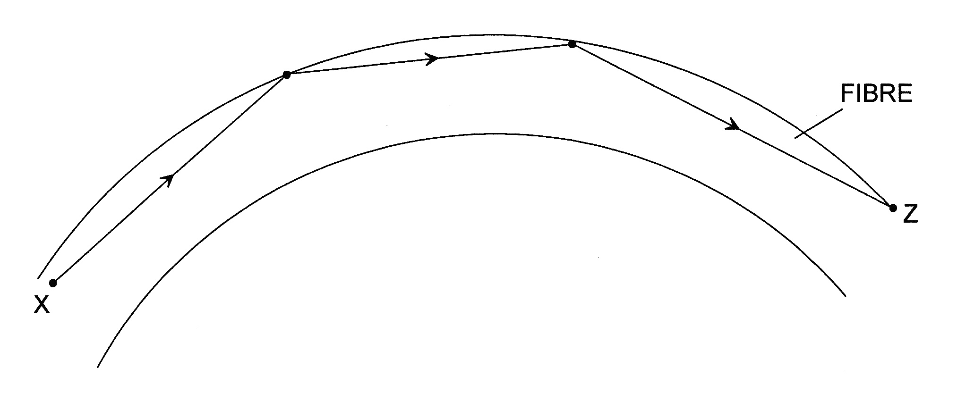

(b) The ray is incident on the sheath of the fibre at an angle that exceeds to critical angle of the sheath so the ray is totally internally reflected.

(c) n = c_{v} / c_{m} = 3 x 10⁸ / 1.9 x 10⁸ = 1.58

10 Power = Energy / time = m g h / t = (200 x 9.8 x 11) / 14 = 1.54 kW

11 (a) focal length is 3.8 cm

(b)
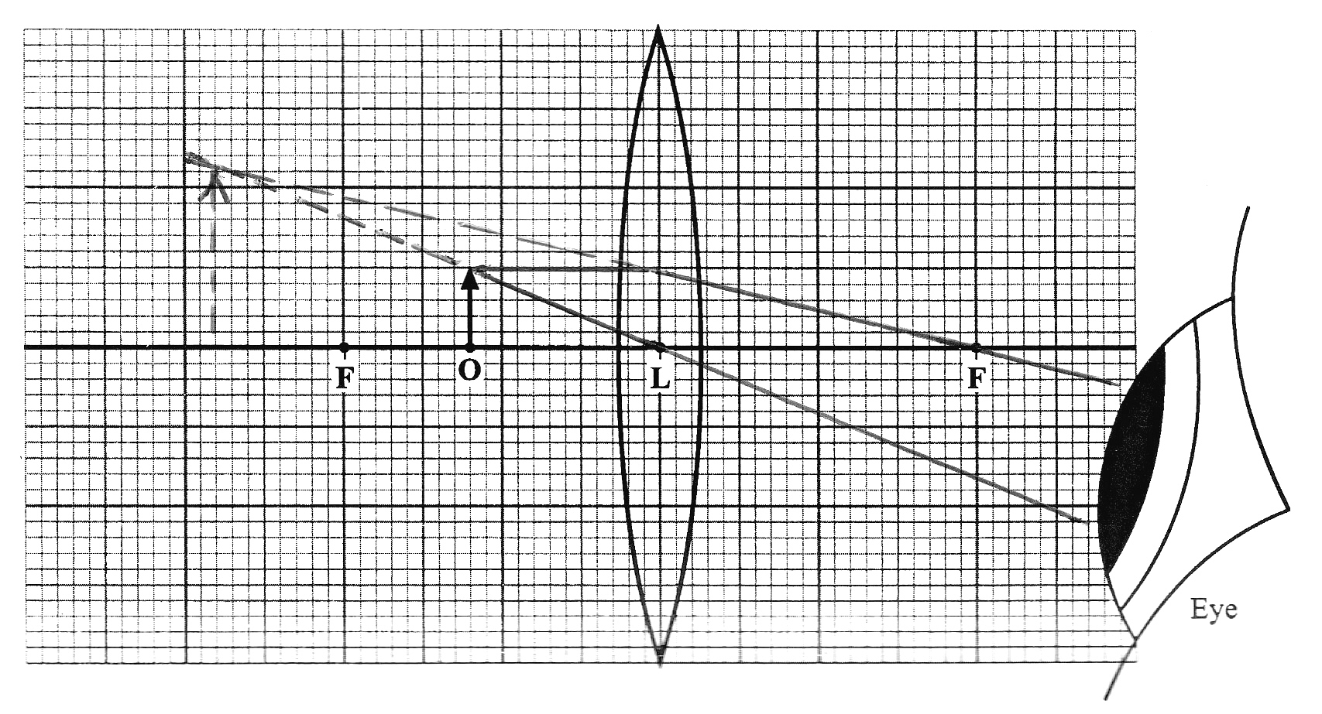

(c) M = image height / object height = 2.5 / 1.0 = 2.5

12 (a) B

- 20 km h⁻¹ = 5.555 m s⁻¹
100 km h⁻¹ = 27.777 m s⁻¹
Change in velocity = 27.777 – 5.555 = 22.22 m s⁻¹
Acceleration = 22.22 / 5.8 = 3.83 m s⁻²

13 (a) Red light has a longer wavelength than violet light
Red light has lower frequency than violet light.

- Prism number 1

- Heat gained by the iceblock = Heat lost by the soup
(m x L) + (m c ΔT) = (m c ΔT)
(0.10 x 3.34 x 10⁵) + [0.10 x 4 180 (T – 0)] = [0.30 x 4180 x (85 – T)]
33 400 + 418 T = 106 590 - 1 254 T
1 254 T + 418 T = 106 590 - 33 400
1 672 T = 73 190
T = 44ºC

15 (a) P = I² x R
P = (35 x 10⁻³) ² x (22 x 10³) = 26.9 W
In 24 h represents (24 x 60 x 60) s = 86 400 s
So energy dissipated in 24 h = 26.9 x 86 400 = 2.32 x 10 ⁶ J

(b) By reducing the diameter of the cable the resistance will be increased. This will result in even more heat energy being dissipated in the cable.

Section B

1 (a) 20 000 L is equivalent to 20 000 kg.

(b) 50 000 x 20/100 = 1.0 x 10 ⁴ J

(c) Q = m x c ΔT = (1.0 x 10⁵) = (20 000 x 4 180 x ΔT)
ΔT = (1.0 x 10⁵) / (20 000 x 4 180)
= 1.2 x 10 ^{-4 o}C

(d) Water has a relatively high specific heat capacity. It can absorb large quantities of heat without an appreciable rise in temperature, making it an excellent coolant.

(e) Yes. The rise in temperature of the water is very small so the recycled water could be reused as a coolant.

- The molecules of water are in contact with the pipe and they rub against the pipe. This produces friction which raises the average kinetic energy of the molecules which gives rise to a higher temperature.

2

Time (h) | 0.5 | 1.0 | 1.5 | 2.0 | 2.5 | 3.0 | 3.5 | 4.0 | 4.5 | 5.0
Experimental count counts/min | 2477 | 2031 | 1633 | 1315 | 1184 | 916 | 760 | 635 | 548 | 470
True count counts/min | 2297 | 1851 | 1453 | 1135 | 1004 | 736 | 580 | 455 | 368 | 290

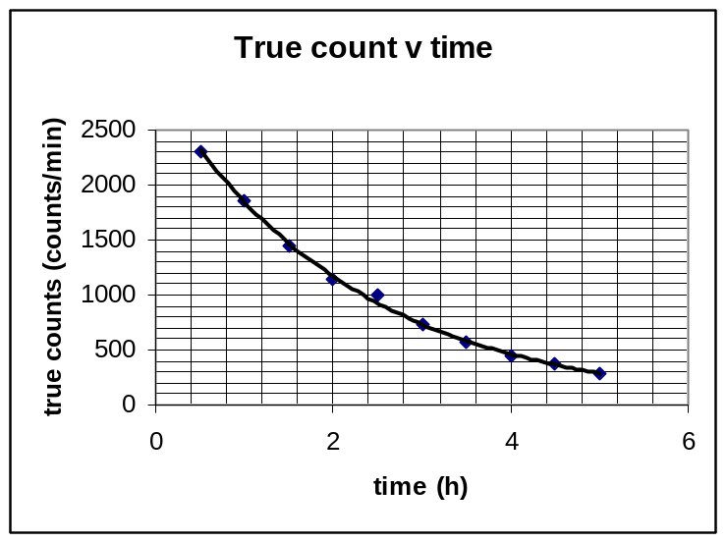

- The half life is 1.6 h

(c) 4.8 h represents 3 x half lives. If the original mass was 0.205 kg then after 3 half lives the mass would be 0.0256 kg

(d) 3.2 hours represents 2 x half lives. If the original sample was pure “X” then the proportion remaining would be 0.5. However the original sample was only 50% “X”. Therefore the proportion of “X” remaining of the original sample is 0.25.

- alpha radiation

3 (a)
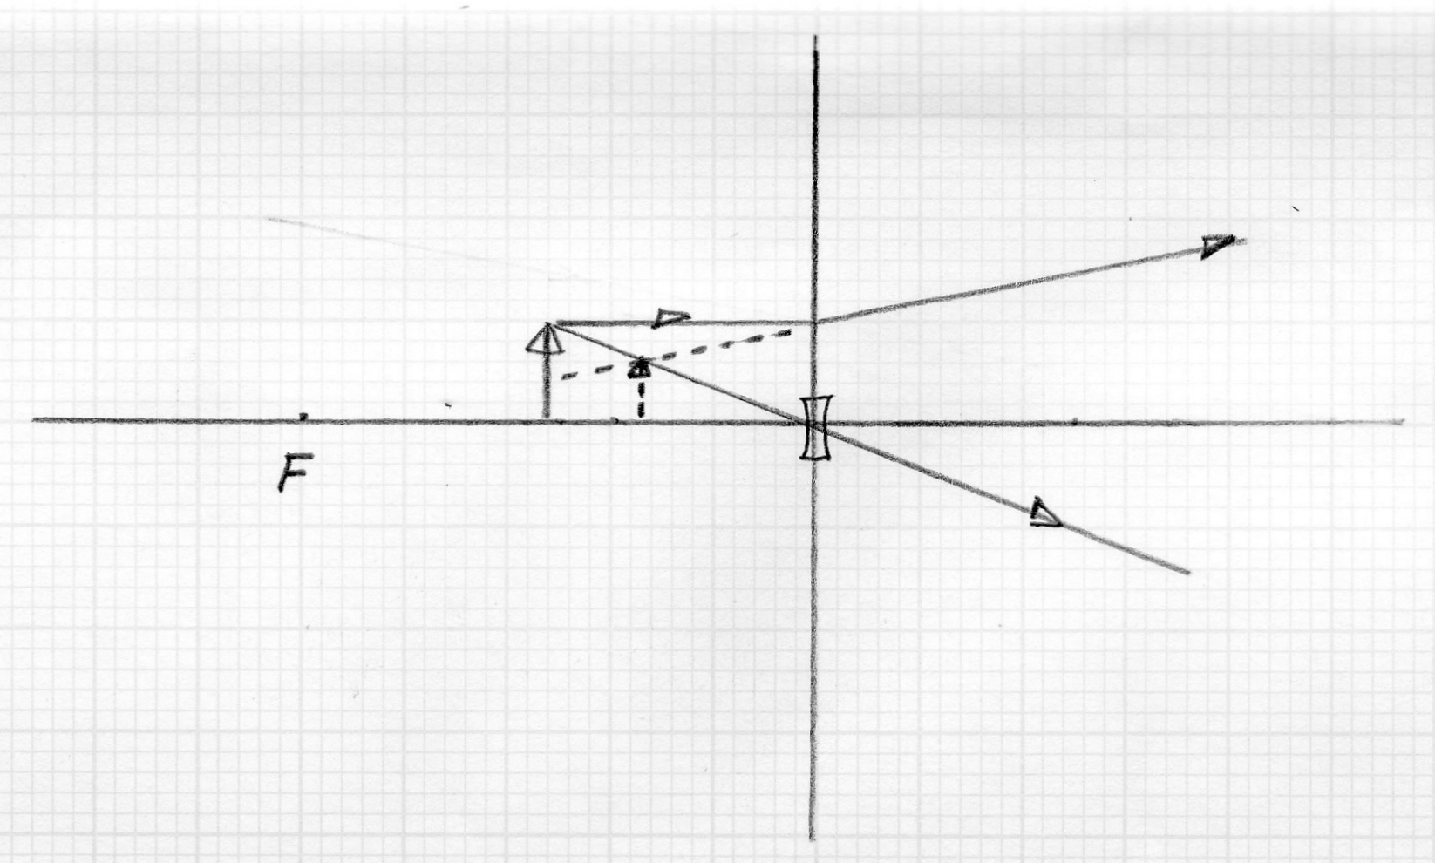

(b) 1/f = 1/u + 1/v (Because the lens is concave the focal length will be negative)

1/-10 = 1/5 + 1/v

- 1/v = 1/10 + 1/5

-1/v = 3/10

So v = -3.3 cm

(c) The image is virtual, erect and diminished in size.

(d) M = image distance / object distance = 3.3 / 5 = 0.67

(e) spectacles and telescopes.

(f) The image would have been enlarged, virtual and upright.

4 (a) let up be positive
s = -0.6 m
a = 9.8 m s⁻²
u = -11 m s⁻¹
t = ?

s = u t + 0.5 a t²

-0.6 = -11 t + 0.5 x 9.8 x t²

t = 2.19 s

(b) v² = u² + 2 a s

0²= -11² + 2 x 9.8 x s

121/ 19.6 = s = 6.173 m
Therefore the greatest distance above the ground is (6.173 + 1.2) = 7.37 m

(c) (i) At its highest point the speed is 0 m s⁻¹
(ii) At highest point the acceleration is 9.8 m s⁻² downwards.

(d) Let up be positive.

u = 11 m s⁻¹
a = -9.8 m s⁻²
s = -1.2 m
v = ?

v² = u² + 2 a s

v² = 11² + 2 x (-9.8 x -1.2)

v² = 121 + 23.52
v² = 144.52
v = 12.0 m s⁻¹

(e) (i) On the way up the acceleration is 9.8 m s⁻²
(ii) On the way down the acceleration is 9.8 m s⁻²

5 (a) (i)
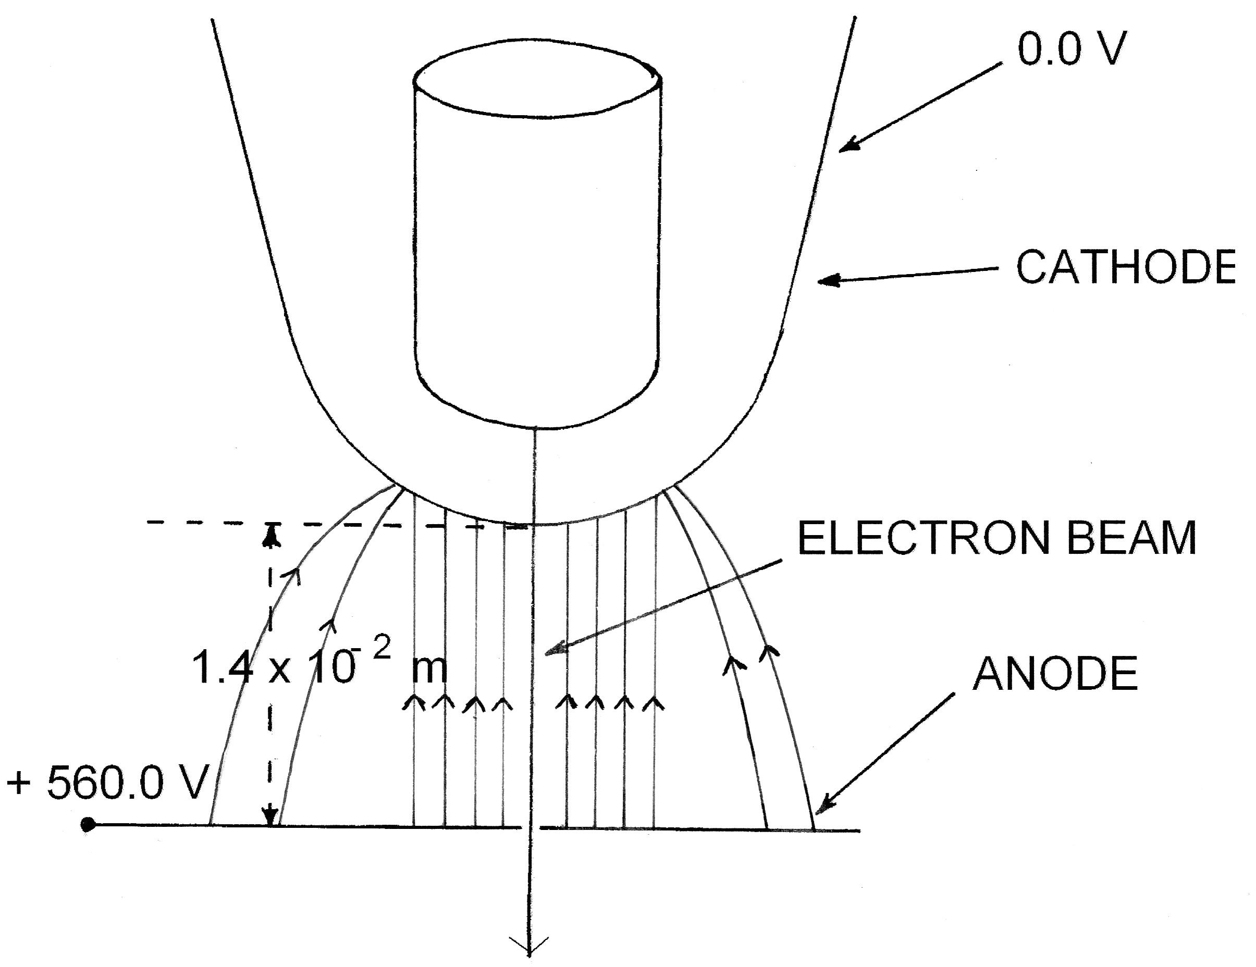

(ii) W = q x V
W = (1.60 x 10⁻¹⁹) x 560 = 8.96 x 10 ⁻¹⁷ J

- (i) Tan 14º = F / (3 x 10⁻⁶ x 9.8)

F = 0.2493 x (3 x 10⁻⁶ x 9.8)
F = 7.3 x 10⁻⁶ N

    - Sin 14º = d / 30 so d = Sin 14º x 30 = 7.258 cm
So the spheres are separated by 2 x 7.258 = 14.5 cm
This is = 0.145 m

F = k q q
d²

7.3 x 10⁻⁶ = 9.00 x 10⁹ x q²
(0.145)²

q² = 7.3 x 10⁻⁶ x (0.145)² / (9.00 x 10⁹) = 1.716 x 10⁻¹⁷

So the charge on each sphere is 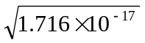 = 4.14 x 10 ⁻⁹ C

    - The spheres would gradually come closer together. As the charge gradually
“leaks” to the surrounding air the force between the spheres becomes less so
the distance between them becomes less.

6 (a) Q = m c ΔT
Q = (0.5 x 4 180 x 77) = 1.61 x 10⁵ J of heat energy

(b) As only 85% of the electrical energy is converted into heat energy, the electrical energy required is (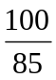 x 1.61 x 10⁵) = 1.89 x 10⁵ J

(c) V = I x R
I = V / R = 240 / 75 = 3.2 A
P = E / t = V x I
(1.89 x 10⁵) / t = (240 x 3.2)
So time is (1.89 x 10⁵) / (240 x 3.2) = 246 s

(d) P = V x I
P = 240 x 3.2 = 768 W = 768 / 1000 kW = 0.768 kW

Number of kW h = 0.768 x (246 / 3 600)
Cost = 0.768 x (246 / 3 600) x 15.2 = 0.8 cents

7 (a)
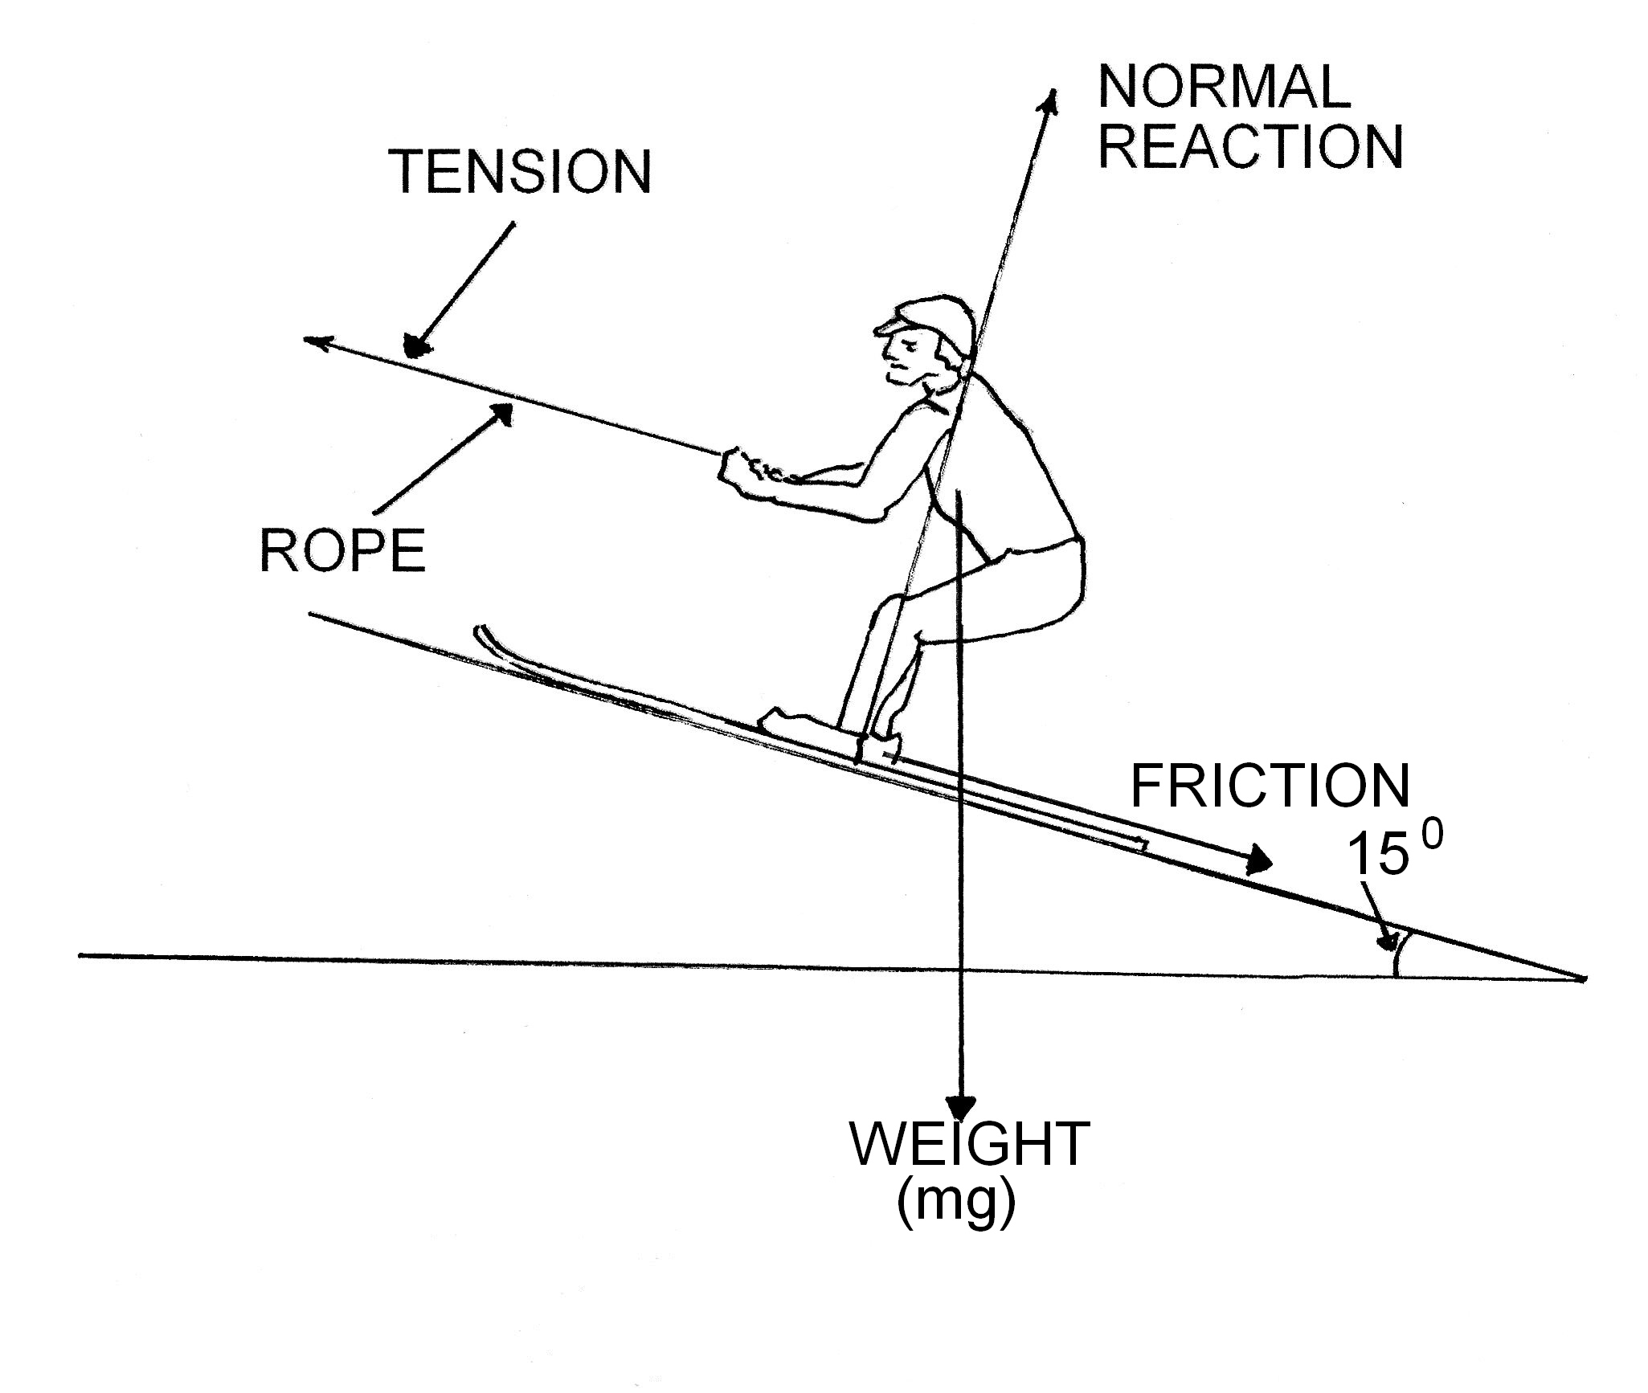

  - Let the tension in the rope be T
sin 15º = T / (90 x 9.8)

T = sin 15º x (90 x 9.8) = 228.3 N

(c) (i) speed = d / t = 140 / (5 x 60) = 0.47 m s⁻¹

(ii) Difference between the minimum tension required and the actual force required is (300 – 228.3) = 71.7 N
Work (energy) dissipated as heat = F x d = 71.7 x 140 = 1.00 x 10⁴ J

    - (a) For the 2 x 4 Ω resistors in parallel
1/R_{T} = 1/R₁ + 1/R₂ …….

1/R_{T} = 1/4 + 1/4
R_{T} = 2 Ω

For the (2 x 4 Ω), (single 8 Ω) and (pair of 5 Ω), resistors all in parallel
1/R_{T} = 1/R₁ + 1/R₂ +1/R₃
1/R_{T} = 1/2 + 1/8 + 1/10

1/R_{T} = 29/40
R_{T} = 1.38 Ω

So the total circuit resistance is 1.38 Ω + 10 Ω = 11.38 Ω

(b) Current in one of the 4 Ω resistors is 0.3 A
V = I R
V = 0.3 x 4 = 1.2 V

P = V x I
P = 1.2 x 0.3 = 0.36 W

(c) The current in the 5 Ω resistor is 0.12 A

V = I x R
V = 0.12 x 5 = 0.6 V

(d) No. the ammeter would register a different value. This is because the resistance in that branch of the circuit would now be 8 Ω not 2 Ω. As the current is proportional to the
resistance, the current would be a different value. The resistance is increased so the
current is less.

Section C
Question 1
- In stopping in a very short time, the change in momentum occurs over a short time so the impulse and hence the impulsive force that the person is subjected to will be very large. The force may be large enough to kill the person. While travelling at any constant speed the occupants and the vehicle are travelling at the same speed so there is no net forward or back force on the occupant. It is the sudden stop that produces a net force.

- v² = u² + 2 x a x s (where s is the stopping distance)

For initial speed of 30 km h⁻¹
0² = 30² + 2 x constant x s
900 = 2 x constant x s

For initial speed of 90 km h⁻¹
0²= 90² + 2 x constant x s
8100 = 2 x constant x s

So ratio of 90 : 30 :: 8100 : 900 which represents a ratio of 9 to 1

- While the driver is thinking (reaction time) the vehicle is still travelling at close to its velocity before the driver is aware of the hazard. During this time there is no braking. The faster the vehicle is travelling the further it will travel and hence increase the stopping distance.

- The parked car will tend to move forward on impact and so increase the time of impact. The change in momentum is spread over a longer time. This will decrease the impulsive force on the occupant of the car so causing less injury. The parked car may also have a crumple zone which will increase the time of the collision and hence reduce the impulsive force. A brick wall will not “give” as much.

- If a load is secured it increases the net mass of the vehicle. The increased mass will reduce the value of the deceleration if the vehicle is involved in a crash. Also - Newtons first law states that bodies in motion remain in motion unless acted upon by an outside force so if the vehicle is stopped suddenly an unsecured load the will continue to travel in the direction the vehicle was travelling. If the load is behind the occupant then it may travel forward and impact on the occupant. Wearing a seat belt is like securing the load. If the vehicle stops suddenly, the occupant is prevented from moving forward and impacting on the steering wheel or dash board.

- I = F x t (where F is the impulsive force and t is the time taken for an impact)

If the time of impact in a collision can be increased then the impulsive force can be reduced. Crumple zones, padding, seat belts etc all increase the time that two bodies are in contact during a collision. If the impulse remains constant for a given collision and one collision involves a crumple zone and the other does not then the crumple zone will increase the time of collision and hence reduce the impulsive force. Injury to the occupants will be reduced.

Question 2

  - It will help reduce the severity of burns. Less soldiers will be either hindered or incapacitated as the result of burns.

  - Cotton does not burn as severely as lycra. Plastic based fabrics tend to burn leaving a sticky residue. Natural fibres tend to have a fire resistant quality.

  - White.

  - A high latent heat of fusion so that a lot of heat can be absorbed before it starts to melt.
If the latent heat of fusion is too low the product will melt too soon and will need to be reapplied.

  - Burns from explosions are very rapid so the cream will tend to melt. In doing so it will absorb latent heat of fusion. When the cream re-solidifies, the latent heat of fusion will be given out. If this were to happen quickly it would burn the skin. As the transfer occurs fairly slowly, the blood flow can remove the heat as it is released, without too great an increase in temperature.

  - Q = (m c ΔT) + (m L)

Q = (0.01 x 850 x 10) + [0.01 x (1.70 x 10⁵)]

Q = 85 + 17 000

Q = 17 085 J

  - A dark cream has the advantage that it will help camouflage in areas where there is vegetation.

A disadvantage is that being brown it will absorb radiation at a greater rate and so be less effective in preventing burns.

8 In the laboratory the cream is being tested under very controlled and ideal conditions.
In the field the cream is subjected to a variety of conditions not replicated in the laboratory. The cream may be affected by sweating, removed when soldiers brush against vegetation or its effectiveness may be dependent on a variety of skin types.
Also the laboratory may not be able to replicate the severity of explosions experienced in the field.

