These test papers are copyright and must not be reproduced in any way.
©
This paper should be withdrawn after use in the examination or classroom and retained by the teacher until Friday 30th November.
Test papers may not be used for private tutoring in the year of publication.



PHYSICS

YEAR 11

2007

INSTRUCTIONS TO CANDIDATES

TIME: 2½ Hour Paper: MARKS: 172

Attempt questions 1 to 15 Section A
Attempt questions 1 to 7 Section B
Attempt question 1 Section C

TIME: 3 Hour Paper: MARKS: 200

Attempt ALL questions

STRUCTURE OF THE PAPER

Section | No. of  Questions | No. of questions  to be attempted | No. of marks  out of 200 | Proportion of  exam total
A: Short Answers | 15 | ALL | 60 | 30%
B: Problem Solving | 8 | ALL | 100 | 50%
C: Comprehension and  Interpretation | 2 | ALL | 40 | 20%

Note: Above refers to 3 hour paper. For less than 3 hours refer to front cover.

INSTRUCTIONS TO CANDIDATES

Write your answers in the spaces provided beneath each question. The value of each question (out of 200) is shown following each question.

The enclosed Physics: Formulae and Constants Sheet may be removed from the booklet and used as required.

Calculators satisfying conditions set by the Curriculum Council may be used to evaluate numerical answers.

Answers to questions involving calculations should be evaluated and given in decimal form. Quote the final answer to not more than four significant figures. Despite an incorrect final result, credit may be obtained for method and working, providing these are clearly and legibly set out.

Questions containing specific instructions to show working should be answered with a complete, logical, clear sequence of reasoning showing how the final answer was arrived at; correct answers which do not show working will not be awarded full marks.

Questions containing the instruction “Estimate” may give insufficient numerical data for their solution. Students should provide appropriate figures to enable an approximate solution to be obtained.

Section A: Short Answers

Marks allocated: 60 marks out of a total of 200 (30%)

Attempt ALL 15 questions in this section.
Each question is worth 4 marks.
Answers are to be written in the space below or next to each question.

1. Complete the following equations and name the emitted particle

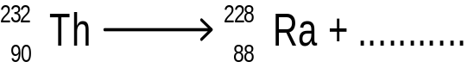

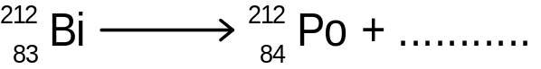

2. A special camera used for photographing very small objects has a convex lens of focal
length 3.0 cm. It is used to photograph a stamp 3.0 cm high placed 9.0 cm from the lens.

(a) At what distance from the lens is the image formed?

(b) What is the height of the image?

3. A pure sample of Nitrogen -18 is found to contain Oxygen -18 after a few days even after it was sealed in a tube. Describe with care the likely reason for the presence of Oxygen.
Give a nuclear equation if appropriate and describe any decay.

4. A Transperth Bus is an inefficient producer of motion energy which results in a large amount
of useless heat being produced. The mass of the Aluminium engine block is 200 kg and also
the mass of water in the cooling system is 20 kg.

By what amount will the temperature of the block and water be increased during the burning
of the fuel if 2.0 MJ of energy is produced in the combustion process?

5. A disc jockey in a night club provides music and a light show for his patrons at the “Lookout”. He has three lights one red, one blue and one green. One of the dancers notices that her blue shirt appears to be different colours depending on which light the disc jockey switches on. Next to each of the coloured lights below, list the likely colour of the shirt when it is illuminated by the coloured light and give a reason for your choice.

(a) Red light, colour of shirt would be__________________________________________

Reason_____________________________________________________________________

___________________________________________________________________________

(b) Blue light, colour of shirt would be__________________________________________

Reason__________________________________________________________________________

________________________________________________________________________________

6. Use an argument based on the Kinetic Theory of Matter to explain why it takes more heat to convert a given amount of water already at 100 ⁰C into steam than to change its temperature
from 0⁰ C to 100 ⁰C.

7. Kate, our laboratory assistant, is worried about her health because of possible exposure to radiation. She knows that she is receiving an absorbed dose of 5.0 mGy from alpha radiation
and 0.75 Gy from gamma radiation over a 20 day time span.

(a) What is her dose equivalent (Sv) over the period?

(b) For health reasons, what safety precautions should she take when handling the radioactive substances? Explain your reasoning.

8. ESTIMATE the maximum acceleration of a talented athlete in the Inter School Division A 100m sprint race at the sports carnival. Detail any assumptions you make.

9. Golf club design has changed greatly since the introduction of jumbo sized metal “woods”. Find the change in momentum of the golf ball and hence the force delivered to the golf ball by the metal wood from the following data:

Speed of metal ‘wood’ at impact | = 70 m s⁻¹
Mass of the club head | = 150 g
Mass of golf ball | = 50 g
Speed of ball on leaving the club head | = 140 m s⁻¹
Time for which contact was made | = 0.02 s

10. (a) The heating coil of an electric jug is an immersion heater with a resistance of 60.0 Ω.
How long will it take to bring to the boil, 1.0 kg of water, originally at 25ºC, when the
electric jug is connected to a 240 V power supply?

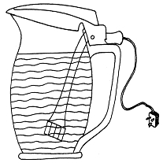

(b) What assumptions did you make?

11. One of the uses of radioisotopes is as tracers to locate leaks in long water pipes without

digging up the pipe along its entire length.

(a) Using the diagram below explain how this is possible.
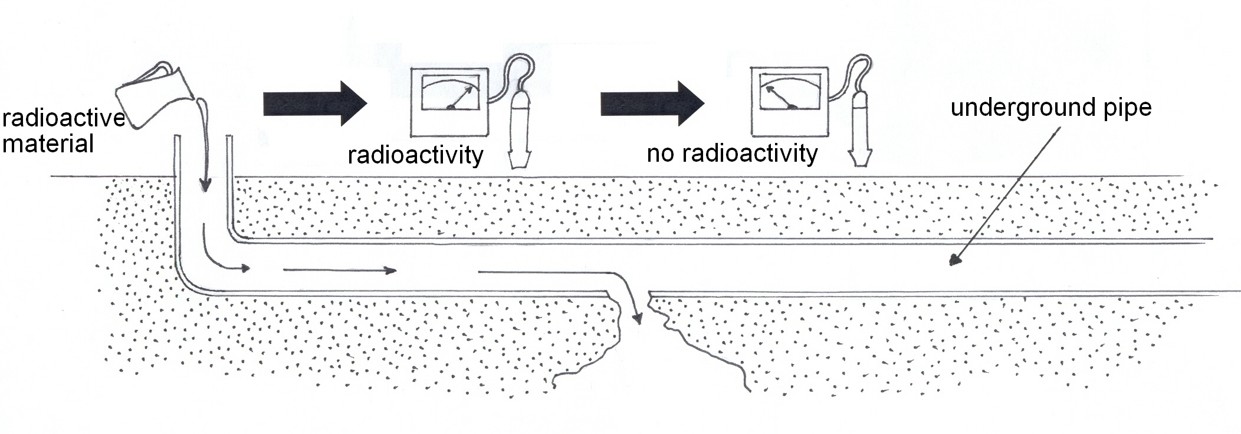

(b) In terms of the type of emitter and half-life, suggest a radioisotope which would be

suitable for such a task. (no need to name the actual element)

Give your reason.

12. A water slide at a children's adventure playground is 6.0 m high and ends in a swimming pool which is 1.0 m deep. The diagram shows the shape of the slide.

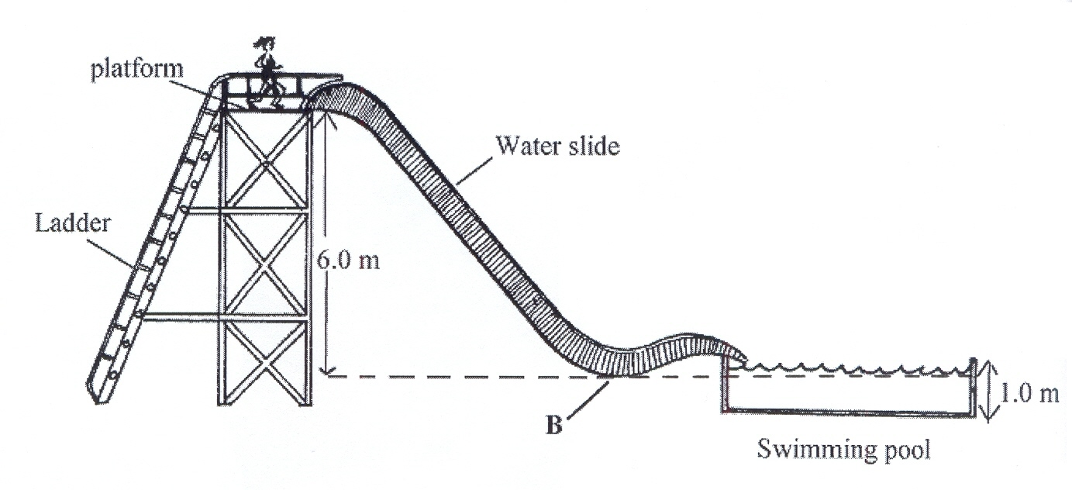
(a) What is the potential energy of Mary whose mass is 60 kg when she is at the top
of the slide? Her centre of mass is 0.5 m from the platform floor.

(b) If half her potential energy was converted into kinetic energy at what speed
would Mary hit the water?

(c) What average power is Mary generating as she climbs to the top of the ladder in 5s?

13. A toaster is marked 240 V, 1 250 W.

(a) What current does it draw from the mains?
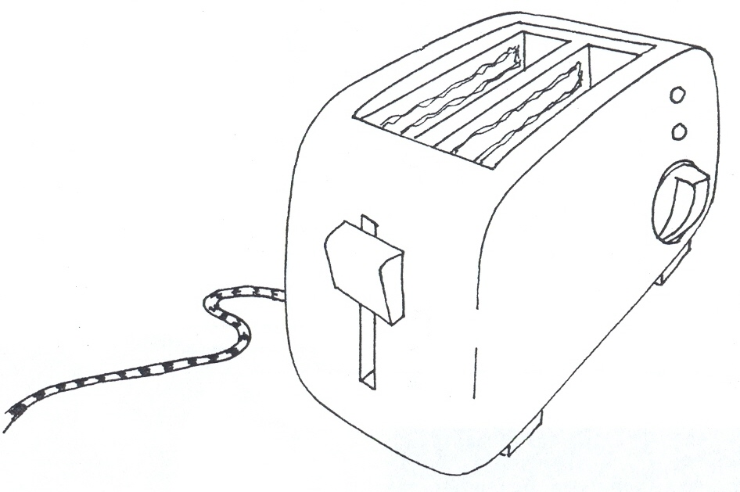

(b) If the owner of the toaster uses it for 2 hours per week, how much would it cost to
operate per week if electricity costs 15cents per unit? (1 unit = 1 kWh)

14. A personal hand held fan had four 1.5 V cells connected in series which drive a small electric motor. The fan had two speed settings as controlled by adjusting the switches in the circuit.
Two resistors whose value is indicated are included in the circuit.
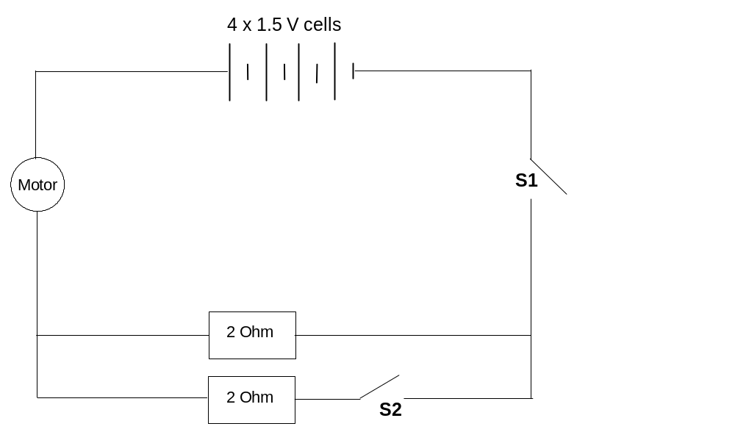

(a) When all the switches are closed what is the total resistance of the circuit?
The motor has a resistance of 3 Ohm.

(b) With respect to the switches S1 and S2 which position should they be in for
maximum motor speed? Give your reason.

15. (a) Determine the current flowing through the 6 Ohm resistor in the diagram below.
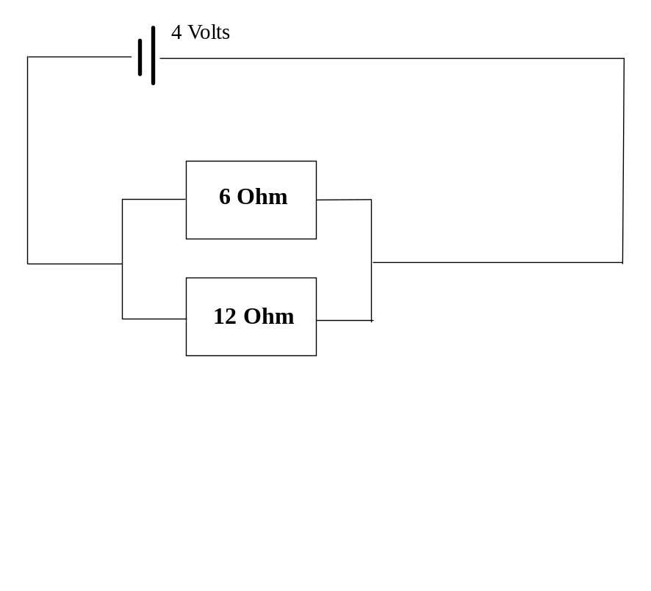

(b) How many electrons pass through the 6 Ohm resistor each second?

END OF SECTION A

Section B: Problem Solving

Marks allotted: 100 marks out of a total of 200 (50%)

This section contains 8 questions.

You should answer: Questions 1, 2, 3, 4, 5, 6, 7 if paper is 2.5 hrs
and all eight (8) questions if your exam is 3 hrs. in duration.

Answer the questions in the spaces provided.

1. (11 Marks)
Data relating to the half life measurements for Pb²¹⁴ are tabulated below

Time | 0 | 1 | 2 | 3 | 4 | 5 | 6 | 7 | 8 | 9
Decays  \min | 100 | 79 | 60 | 44 | 33 | 25 | 19 | 15 | 12 | 10

(a) Plot a suitable graph and from it calculate the half life of Pb²¹⁴. Show your working on
the graph. (4 marks)

The decay equation for Pu 239 is given below

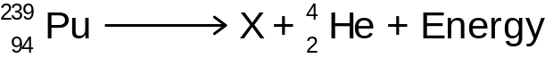

(b) Find the missing particle X and name it. (2 marks)

(c) Calculate the energy in MeV or Joules released due to the decay of one atom of
Pu 239 according to the equation above. (5 marks)

Relevant data is found in the Data section.

2. (16 marks)
The following data was obtained when finding the focal length of a convex lens.
The two right hand columns are left blank intentionally.

Object - lens distance u (cm) | Image - lens distance v (cm)
20 | 63.0
30 | 31.0
40 | 24.6
50 | 21.5
60 | 20.1

(a) Draw a labelled diagram of the apparatus that could be used in this investigation
to obtain the data above. Include in your diagram rays that indicate the position
of the image. (3 marks)

(b) Using a graph or other means calculate the focal length of the lens.
Use the blank columns if you wish. (5 marks)

(c) Where do you think the largest error is in this experiment? Justify your choice.
(3 marks)

(d) Predict the image position for an object distance of 70 cm. Explain your prediction.
(2 marks)

(e) Explain why the image would be clearer if rays of light incident upon the perimeter
of the convex lens were eliminated by using a variable aperture.
(A diagram would help) (3 marks)

3. (14 marks)
A Police Scientist is conducting an investigation involving a car and a pedestrian on a busy
road. The pedestrian was knocked down on a crosswalk but the year 12 student driving the
car insisted that he was not speeding. There were no witnesses.
The skid marks to the pedestrian were 30 m long and the force of friction between the road
and the semi bald tyres was 2.4 x 10³ N when the brakes were on. The car had a mass of
1200 kg including rust and a nice stereo system.
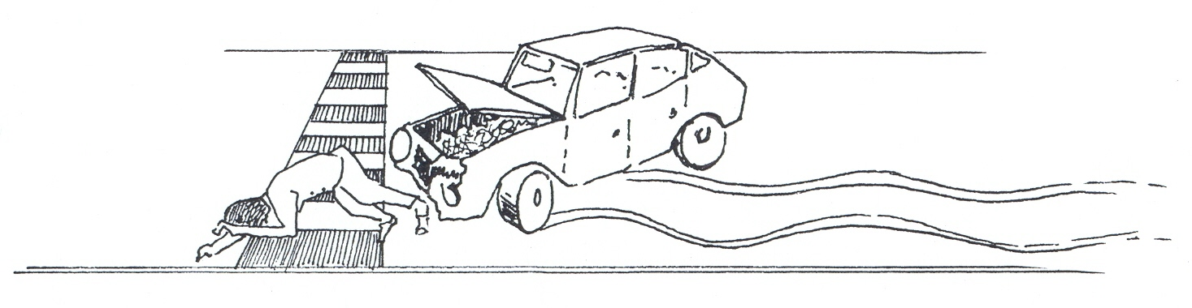
(a) At what rate did the brakes slow the car? (2 marks)

(b) Estimate the initial speed of the car assuming that on impact the car was travelling
at 5 m s⁻¹ (2 marks)

(c) Convert this speed in m s⁻¹ to km hr⁻¹. (2 marks)

(d) The driver’s speed, calculated in (b) was increased by 5 km hr⁻¹ and the driver
started braking at the same 30 m mark. Calculate his new impact speed. (4 marks)

(e) How would your calculations made in (b) have changed if the student had been
drinking and had a reaction time of 0.9 s before he hit the brakes? Explain the
changes this will make to the impact speed in this “new” situation.
Detailed calculations are not required. (4 marks)

4. (14 marks)
You have had a hard football game and you want to soak in a warm bath, but you left the
hot and cold water taps running unattended. When you come back you realise the 50.0 L
of water in the bath at a temperature of 30ºC is too cold for your bath.

(a) How much hot water at 80ºC would you have to add to the bath to adjust the
temperature to 45ºC?
(1 L of water has an equivalent mass of 1 kg) (4 marks)

(b) You accidentally added too much hot water, so the bath now has 75.0 L of water in
it, at a temperature of 60ºC. What mass of ice at 0ºC would you have to add to
adjust the bath back to the desired temperature of 45ºC? (4 marks)

(c) After soaking in the bath you decide to take advantage of a steam room experience.
(A steam room is where steam is generated by pouring water on to hot rocks which
converts water into steam). 0.80 L of water at 25°C is poured onto hot rocks and it
is all converted into steam at 100°C. What quantity of energy is required from the
rocks to do this? Assume the rocks are at a temperature greater than 100°C.
(4 marks)

(d) Explain why a burn caused by the steam would cause more pain than that caused
by an equal mass of water at 100°C. (2 marks)
5. (13 marks)
Resistivity is a property of a material that determines the electrical resistance of that
material. Other variables that determine the resistance are length and cross sectional area.
They are related by the formula:

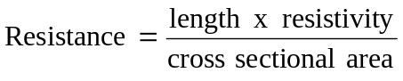

A group of Year 11 students were given the task of finding the resistivity of graphite in a
"lead" pencil. The diameter of the graphite in the pencil was 2.0 mm.
(Cross sectional area = 3.14 x 10 ⁻⁶ m²)

The voltage was determined by connecting a multimeter (on the Volts range) to the
graphite via crocodile clips.

Their results are summarised below

Length of "lead"  x 10⁻² m | Current  (Amps) | Voltage across ends  of pencil (V) | Resistance  (Ohms)
10.0 | 0.29 | 1.74
8.0 | 0.35 | 1.73
6.0 | 0.41 | 1.67
4.0 | 0.53 | 1.49
2.0 | 0.69 | 1.27

(a) Use the results table and complete the column headed "Resistance". (3 marks)

(b) Plot a graph of Resistance (y axis) v Length (x axis) and draw a line of best fit.
(4 marks)

(c) Use the gradient of the “line of best fit” and the cross sectional area of the "lead" to
determine the resistivity of the graphite. (5 marks)

(d) Why does the graph not pass through the origin (0,0)? (1 mark)
6. (10 marks)
In 2001 a very rich American tried to fly a balloon non- stop around the world.
Below is a diagram of his balloon. It was launched at Northam and moved vertically upwards
with a constant velocity of 4.0 m s⁻¹. Unfortunately after only 5.0 mins an essential piece of
equipment became dislodged and fell out of a gap in the basket and fell towards the ground.



(a) How high was the balloon after 5.0 mins? (3 marks)

(b) Neglecting air resistance, how long does it take for the essential piece of equipment
to reach the ground? (3 marks)

(c) With what speed will it impact on the ground? (2 marks)

(d) Describe how would your answers for (b) and (c) change if you included the effect of
air resistance. (No precise answer needed.) (2 marks)

7. (14 marks)
In an experiment to find the specific heat of an unknown liquid a group of students decided
that their group would use an electrical method. A coil was made of Nichrome wire
(resistivity 1.2 x10 ⁻ ⁶ ohm metre) of diameter 1 mm² and therefore cross sectional area
8 x 10⁻⁷ m²

(a) How long should the wire be to have a resistance of 6 ohms? (3 marks)

(b) If the coil was connected to a 12 voltage source, what current would flow? (2 marks)

(c) What would be the heat energy generated each second? State one assumption that you
have made. (3 marks)

Now the coil was completely immersed in the unknown liquid of mass 0.15 kg in a
thermos flask that was a perfect insulator and the temperature rise noted. The liquid was
constantly stirred. The rise was 20°C in a time of 5 mins.

(d) What is the specific heat of the liquid? (4 marks)

(e) The student noticed that, during the 5 mins, the current flowing through the coil
changed. Can you provide a reason for this and would the change be an increase or
decrease in current value? (2 marks)

8. (8 marks)
Much interest has been shown in a recent government announcement that they will grant
a $10 000 subsidy to all households installing a new 2kW panel on their roof.

(a) What energy conversion does a solar panel allow to take place? (2 marks)


(b) Given that the panel has a power rating 2kW, how much electrical energy will be
produced if the sunlight is incident on it for 12 hours? (2 marks)

(c) In which direction would you point the panel in Perth and why? (2 marks)

(d) If solar panels are 15% efficient what area of panels is required to produce 2kW of
electrical power in Perth on a summer’s day?
(The sun’s average intensity in Perth in summer is 800W m ^{– 2} on a panel at right
angles to the sun’s rays.) (2 marks)

END SECTION B

Section C: Comprehension and Interpretation

Marks allotted: 40 marks out of 200 (20%)

BOTH questions should be attempted. Each question is worth 20 marks.

Read each passage carefully and answer all of the questions at the end of each passage.
You are reminded of the need for clear and concise presentation of answers. Diagrams (sketches), equations and /or numerical results should be included as appropriate.

Question 1 Tower of Power (20 marks)

An innovative solution to global warming is about to take place near Mildura in NSW. It involves
the construction of the “tower of power”. An artist’s picture is shown below. It will be huge.
It will be the largest structure on the planet over 1000 m tall. It will have a maximum output
of 200 MW and provide enough power for 180, 000 homes, and save 90 000 tonnes of
greenhouse CO₂ from entering the atmosphere. The project will commence construction in 2010.
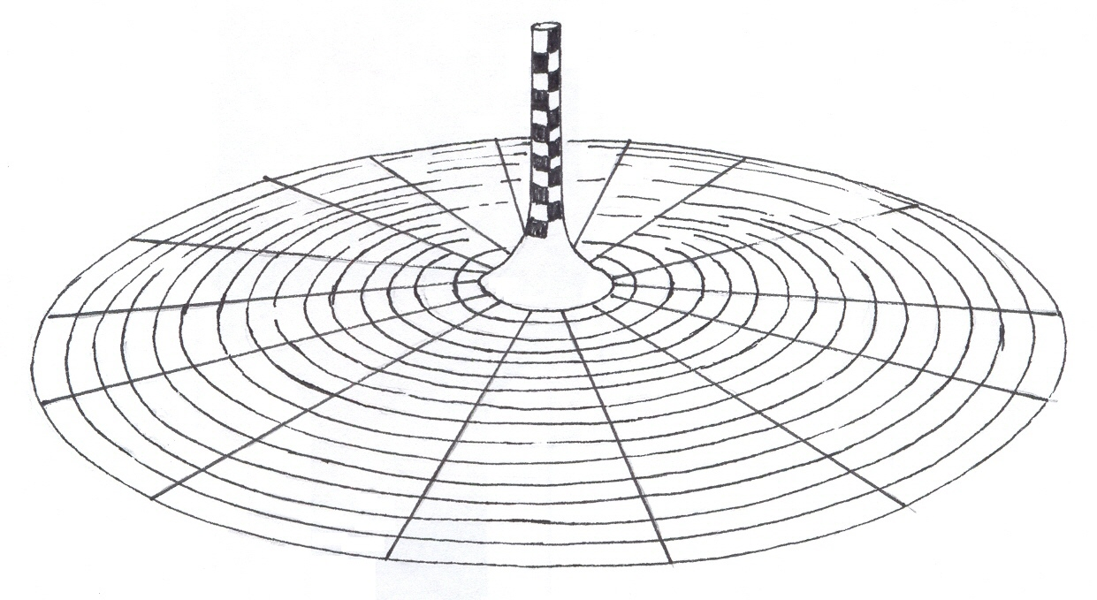

Solar Tower technology is not simply solar energy. Solar Tower technology is created when the
sun’s radiation is used to heat a large body of air under an expansive collector zone; the air is then
forced by the laws of physics to move. Actually the hot air is forced up by the inflow of more
dense cold air and passes through large turbines to generate electricity. A Solar Tower power station will create the conditions to cause hot wind to flow continuously through thirty two 6.25MW pressure staged turbines to generate electricity.

Mildura’s Solar Tower is proposed to generate electricity 24-hours a day. The power station will be at its most efficient on the hottest days when energy is most needed and peak prices are paid for
electricity. Re-radiation of heat present in the ground under the collector zone will provide the energy source during the night. This special feature enhances the commercial viability of the power station and gives the solar tower a consistent competitive advantage over other forms of renewable energy generation. The Solar Tower therefore has a major advantage over wind farms and solar generators: it can operate with no wind, and 24 hours a day.

The solar tower has not been built before but due to enormous shifts in community values and
understanding about the relationship between energy generation and its impact on the environment,
people’s attitude has changed. They are more willing to invest in more costly green sources of energy.

The sun’s radiation will be collected and trapped under the transparent canopy, creating a massive force of air heated to around 35°C greater than the ambient temperature. Air will move at 15 metres per second up the tower that is located in centre of the canopy. The tower has a cross sectional area of about 2000m². The powerful updraft will force the rising air to pass through large turbines positioned at the base of the tower which will generate clean, emission free electricity.

1. Why does the tower have to be so tall (1 000m)? (2 marks)

2. Why does the air rise? (2 marks)

3. How can the Mildura Solar Tower produce power at night and why is this attractive to the investors? (3 marks)

4. Why has the tower not been built before 2010? (2 marks)

5. What is the approximate power requirement of a typical home in Mildura if the Solar Tower
can provide all the power demands? (3 marks)

6. Calculate the theoretical rise in temperature of the moving air originally at 35°C if solar
Radiation incident on the canopy has the value 300 MW.
Data is to be found in the data sheet.
(Air has a density of 1.3 kg m⁻³, specific heat of air is 1 000 J kg ⁻ ¹ °C ⁻ ¹) (3 marks)

7. What will be the energy produced on an average day from all the turbines? (3 marks)

8. Why do you think this project has its critics on the Mildura Council and some within the
Victorian government, which may mean it never gets built? (2 marks)

Question 2 Fusion in Action, the ITER project (20 marks)

A dream of scientists to replicate the reactions in the sun may be about to happen in Cadarache in
southern France. Six governments are joining together to construct an experimental fusion reactor
know as ITER. Researchers have identified the most promising reaction – that of the heavy isotopes of Hydrogen, Deuterium and Tritium joining together to form Helium.

The trick is to heat the molecules to 100 million °C and then contain them long enough for the reaction to occur. The reaction occurs in a magnetic field container known as a Tokamak. This has not proved easy and a concern is that neutrons produced in the fusion reaction could damage the reactors structure.

One of the problems is that at these high temperatures the isotopes lose their electron and form a fourth state of matter known as plasma. The plasma is contained by the magnetic field but turbulence results and high temperatures have never successfully been achieved in the past. It was all thought to be too difficult and fusion research was nearly abandoned in the 1990’s. New research by scientists at the University of Texas has given fusion advocates new hope by calculating that the turbulence can be minimised.

Below is a simplified diagram of how the ITER will provide electrical energy. As you can imagine
this is not a cheap exercise, the six countries have contributed $680 million to complete only the pilot stage. There are no radioactive products and “no long half life products” concerns therefore no radioactive materials that could be used for nuclear bombs. In that sense the ITER is safer than current nuclear reactors. An ingenious design feature is to produce tritium fuel by impacting the Lithium heat blanket with neutrons. The Deuterium is obtained from seawater.
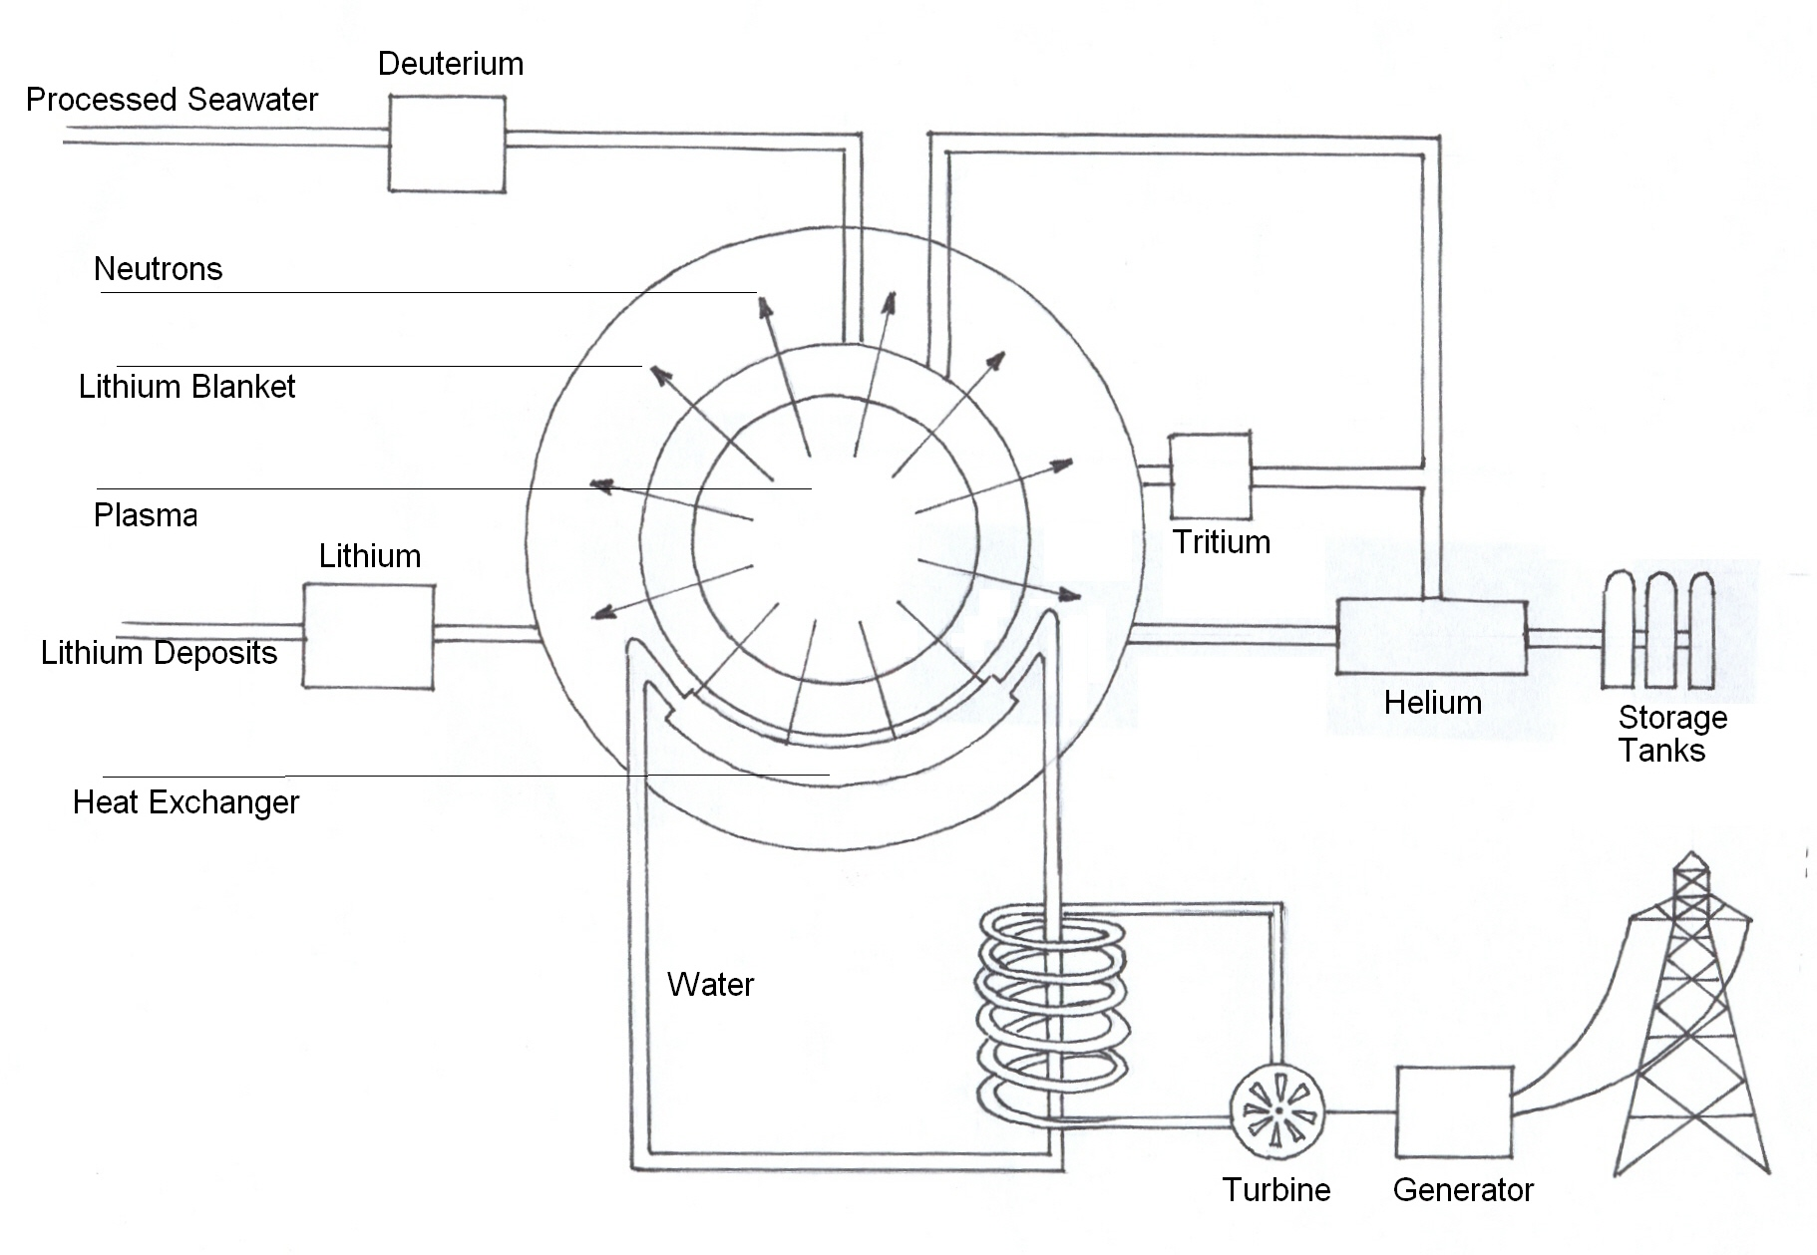

Questions
1. What is the difference between Deuterium 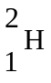 and Tritium 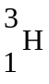nuclei? (2 marks)

2. Give the nuclear equation where these 2 isotopes form Helium 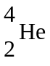.
What else is produced? (3 marks)

3. Calculate the energy released in your reaction in MeV. (4 marks)

4. Why have fusion reactions been very difficult to produce in the past? (2 marks)

5. Draw an energy flow diagram to show how the kinetic energy of the neutrons can produce
electricity. (5 marks)



6. What does the article mean by “no radioactive products and no long half life products” and
Why is this a good feature of the fusion reactor? (2 marks)

7. Give the equation for neutron impacting on the Lithium blanket to produce Tritium.
(2 marks)

END OF EXAMINATION

