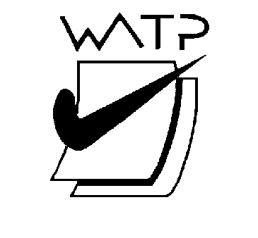

West Australian Test Papers

PHYSICS

Year 11

2007

SOLUTION BOOKLET

&

MARKING GUIDE

Markers should note that the solutions presented here are skeletal answers and
should be used as a guide only.

Alternate answers used by students may be perfectly acceptable and discretion
should be used.
Section A
1. (a) (b)
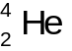Alpha Particle 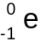 Beta Particle (2, 2)

2. (a) 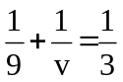 v = 4.5 cm (2)
(b) Mag = 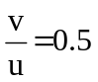
Height of image is 3 x 0.5 = 1.5 cm (2)

3. Nitrogen 18 is radioactive and undergoes Beta Decay.
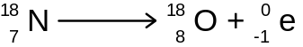 (4)

4.
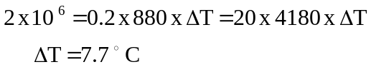 (4)

5. (a) Shirt would look BLACK, no blue light in red to be reflected. (2)
(b) Shirt would look BLUE, blue light incident and is reflected as blue. (2)

6. When heating goes from 0 → 100 the energy goes into increasing the Kinetic Energy
of the particles. They go faster.
When changing state water → steam the separation of the particles increases, the bond
length is increased, the Potential Energy is increased and this requires a large amount
of Energy. (4)

7. (a) Dose equivalent (2)
(b) Need to include:
Not touching the samples
Using tongs
Perhaps suitable apron
Spending as short a time as possible near the sample
(2)

8. Need to appreciate that the acceleration takes place in the first few (3s) seconds and not the
entire 100m. Maximum speed is about 10 m s ^{– 1} and if this happens in 3s then acceleration
is 3.5 m s ^{– 2}. (allow variation of 3 → 5 m s ^{– 2} for full marks but 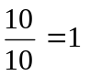 m s ^{– 2} only 2 marks) (4)

9. 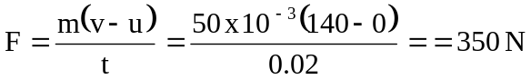 (3)

(1)

10. (a) 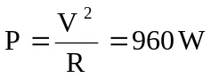
Heat needed 1 x 4180 x (100 – 25) = 3.13 x 10 ⁵ joules
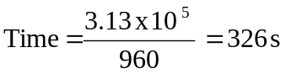 (3)
(b) All the heat is absorbed by the water and none by the jug. (1)

11. (a) Water carries the radioactive tracer and if there is a leak then the detector
will sharply have its count reduced. (2)
(b) Gamma emitter for good penetrating ability. Short half life for safety. (2)

12. (a) (2)
with ref. to bottom of pool.
3822 J
with ref to point B
OR

(b)
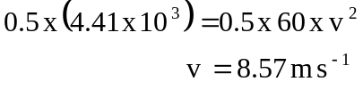 (1)
(c)
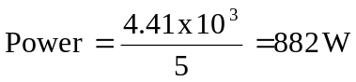 (1)

13. (a) (2)
(b)
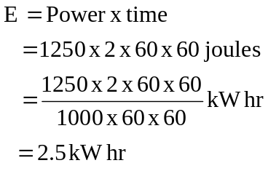
Cost = 0.15 x 2.5 = 37.5 cents (2)

14. (a) 2 x 2 Ohms in parallel is 1 Ohm
R(total) = 1 + 3 = 4 Ohms (2)
(b) Maximum speed when minimum resistance
when S2 open S1 closed R_{T} = 5 Ohms
when S1 and S2 closed R_{T} = 4 Ohms (2)

15. (a)
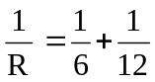 R = 4 Ohms Current 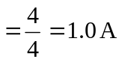 OR 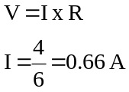

Current through 6 Ohm is ⅔ of 1 amp = 0.66 A (2)
(b) q = I x Time
q = 0.66 x 1
number of electrons = 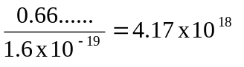 (2)

END OF SECTION A

SECTION B

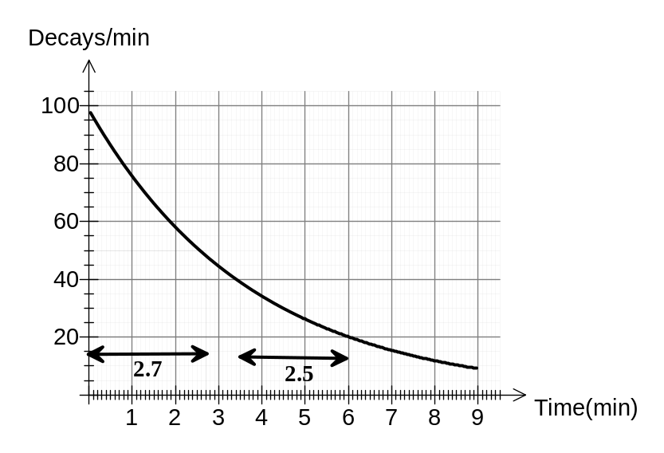1. (a)

(4)
Half life = 2.6 min ± 0.2 min. Need to show two calculations from graph.

(b) Missing particle 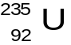 Uranium 235 (1+1)

(c) 239.052157 = 235.04392 + 4.0015
∆m = 0.006737 amu = 6.27 MeV = 10.03 x 10 ^{– 13} J (5)

2.
Object – lens  distance u (cm) | Image – lens  distance v (cm) | 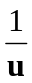 | 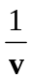 | 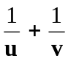
20.0 | 63.0 | 0.05 | 0.016 | 0.066
30.0 | 31.0 | 0.033 | 0.032 | 0.065
40.0 | 24.6 | 0.025 | 0.040 | 0.065
50.0 | 21.5 | 0.020 | 0.046 | 0.066
60.0 | 20.1 | 0.0166 | 0.049 | 0.065
(a)
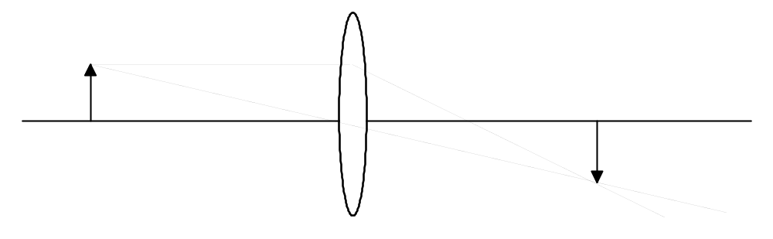 (3)
(b) 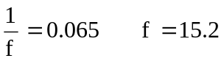 Other methods using graph equally acceptable.
Could plot 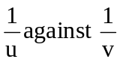 and identify the intercepts or plot uv against (u + v) and
identify the gradient. (5)
(c) Largest error is in measuring image distance v since it is difficult to identify the
image being in focus perfectly. (3)
(d) When object distance is 70 cm then image is at 19.2 cm. (graph or calculation)
(2)
(e) Key idea is that it reduces spherical aberration. The slit would prevent the
outside rays hitting the lens. x

3. (a) F = ma Accel = 2 m s ^{– 2} (2)
(b) 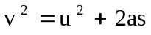 u = 12 m s ^{– 1} OR W = ΔE_{k} (2)
(c) 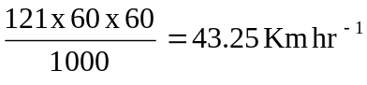 (2)
(d) u = 13.4 m s ^{– 1} (48.2 Km hr ^{– 1})
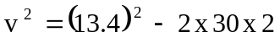 v = 7.7 m s ^{– 1} or 27.8 Km hr ^{– 1} (4)
(e) He would travel 11m before the brakes took effect so that assuming the brakes
caused the same deceleration then the impact speed would increase significantly.
(4)

4. (a) Heat lost = Heat gained
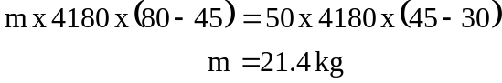 (4)
(b) Heat lost = Heat gained
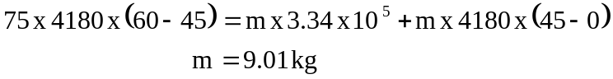 (4)
(c)
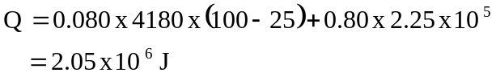 (4)
(d) Key is that heat is given off (lots) when steam at 100°C changes phase to water at 100°C and when this hot water cools as it touches your hand it again gives off a significant amount of heat. In a sense you get burnt twice with steam.
(2)

5. (a)
Length of “lead”  x 10 ^{– 2} m | Current  (Amps) | Voltage across  ends  of pencil | Resistance  (Ohms)
10.0 | 0.29 | 1.74 | 6.00
8.0 | 0.35 | 1.73 | 4.94
6.0 | 0.41 | 1.67 | 4.07
4.0 | 0.53 | 1.49 | 2.81
2.0 | 0.69 | 1.27 | 1.84
(3)
(b)
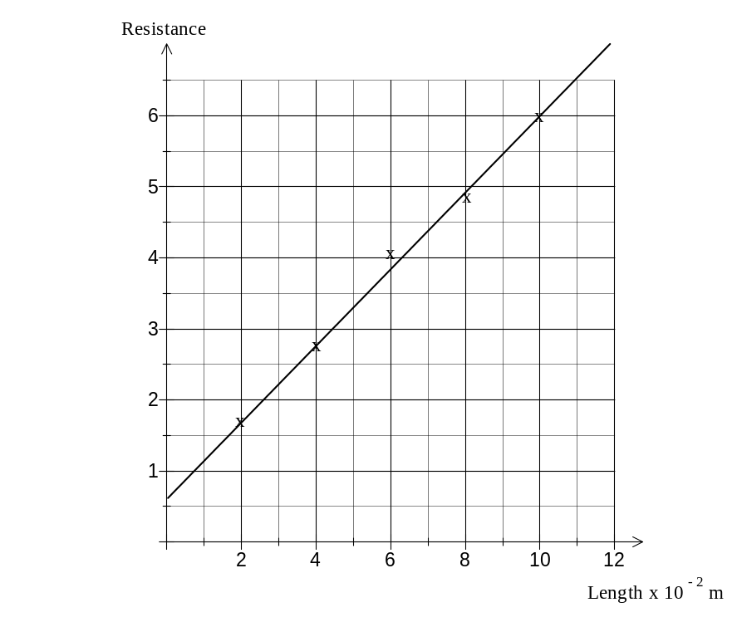 (4)
(c) Gradient = 54 – 58 Ohm m ^{– 1}
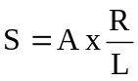
Resistivity = Area x Gradient
= 3.14 x 10 ^{– 6} x 55
= 1.72 x 10 ^{– 4} Ohm m ^{– 1} (5)

(d) Resistance due to wire and connecting clips. (1)

6. (a)
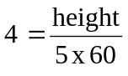
Height = 1 200 m (3)

(b)
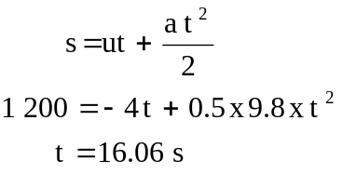 (3)

(c) v = u + at
= - 4 + 9.8 x 16.06
= 153 m s ^{– 1} (2)

(d) Time to fall would increase and the impact speed would decrease. (2)

7. (a)
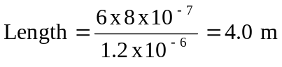 (3)
(b) Current = 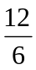 = 2 A (2)

(c) Hear generated = I x V = 2 x 12 = 24 W (2)
Assumption: that all the electrical energy is converted to heat / the coil is an
Ohmic conductor. (1)

(d) Heat = 24 x 5 x 60 = 0.15 x Specific Heat x 20
Specific Heat = 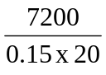
= 2 400 J kg ^{– 1} C ^{– 1} (4)

(e) Resistance of the coil changes with temperature, as the temperature increases
then the resistance also increases. (2)

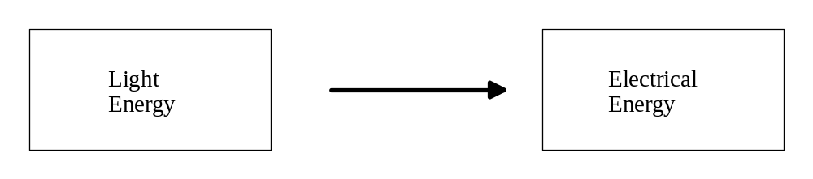8. (a)

(2)

(b) 2 x 1000 x 12 x 60 x 60 = 8.64 x 10 ⁷ J (2)

(c) North to receive maximum sunlight. (2)

(d)
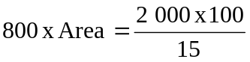
Area = 16.67 m ² (2)

END OF SECTION B

Section C Comprehension

Question 1

1. To ensure the upward force due to rising air is sufficiently powerful to turn the generators. (2)

2. The colder, more dense air moves in and displaces the hot, less dense up the tower causing
convection currents.
As the air is heated it increases in volume and therefore its density decreases causing the
body of air to rise. (2)

3. Underneath the canopy there are solar collectors that store the heat during the day and
re radiate that heat during the night.
The solar tower has the advantage over wind and solar panels in that it is reliable and
works 24/7. (3)

4. Community attitudes to global warming and climate change have driven this renewable
energy project. (2)

5.
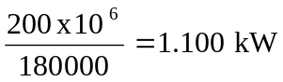 (3)

6.
Change in temp. = 30.6°C (3)

7. 32 x 6.25 x 10 ⁶ x 60 x 60 x 24 = 173 x 10 ³ Joules (3)

8. (a) Enormous cost of construction that will involve huge greenhouse gas emissions.

(b) It is so tall that it could be an aircraft hazard. (2)

Question 2

1. Deuterium has 1 proton, 1 neutron.
Tritium has 1 proton, 2 neutrons. (2)

2.
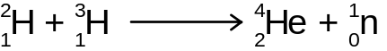

A neutron. (3)

3. 2.013 50 + 3.015 50 = 4.0015 + 1.008 665
Difference = 5.010165 - 5.0290 = 0.018835 amu
= 17.535 MeV (4)

4. Key idea is that turbulence reduces the temperature. (2)

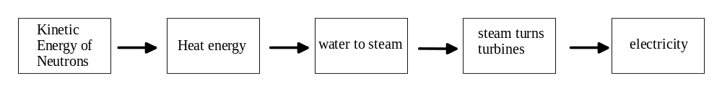5.

(5)

6. Explain what half life means and that some radioactive are dangerous for millions of
years and cannot be stored safely. (2)

7.
(2)

END OF PAPER

