MORLEY SENIOR HIGH SCHOOL

YEAR 11

PHYSICS (UNIT 2B)

SEMESTER 2: EXAMINATION 2009

Student's Name: Tutorial Group:

Teacher's Name: Date:

_____________________________________________________________________________________

TIME ALLOWED FOR THIS EXAMINATION PAPER:

Reading time: 10 minutes

Working time: 3 hours

This question \ answer booklet consists of 15 active pages.

To maximise your marks you must show relevant working, and include correct units in your answers.

If you give a correct numerical answer without showing all the working used to obtain your answer, you will only receive up to two (2) marks for that correct numerical answer.

If you give an incorrect numerical answer but show some correct working, you will receive some marks for your correct working.

Write your answers in the text boxes or table cells (as required) provided beneath each question.

_____________________________________________________________________________________

MARKS SUMMARY TABLE

SECTION | CONTENT DOMAIN | MARKS ALLOCATED | MARKS ACHIEVED
A | Heating and Cooling | 61 Marks
B | Electrical Fundamentals | 59 Marks
TOTAL MARKS |  | 120 Marks
PERCENTAGE MARK

Section A: Heating and Cooling

- What is the meaning of the term: heat?

- What is the meaning of the term: internal energy?

- What is the meaning of the term: temperature?

[6 marks]

In a roof-mounted, evaporative air cooler warm air from outside the house is blown through a pad, inside the air cooler, which is saturated with water at room temperature. The resulting cool moist air then enters the house through ceiling vents.

- What physical process cools the warm air?

[1 mark]

- How does the identified process cool the warm air?

[2 marks]
- If the process occurred at a faster rate, would the amount of cooling be smaller or larger?

[1 mark]

- Why does an evaporative air cooler produce greater cooling on a hot dry day than on a cool dry day?

[3 marks]

- Why does an evaporative air cooler produce less cooling to warm air that already contains moisture?

[3 marks]

- Why would steam at 100 ⁰ C, from the spout of an electric kettle, cause much greater injury to the skin, on your finger, than an equal mass of boiling water, at 100 ⁰ C, splashed onto the same finger? To fully answer this question, you must apply these physics equations: Q = m L_{V} and Q = m c Δ T.

The latent heat of vaporisation L_{V} of water is 2260 kJ kg ^{–1}. The specific of water c is 4186 J kg ^{– 1} C ⁰ ^{– 1}.

[3 marks]
Imagine that your family is travelling in a camper-van fully fitted out with a gas stove, a refrigerator, and a reverse cycle air conditioner. It is a very hot day and unfortunately the air conditioner has broken down.
Your young brother (assuming that you have one) suggests that he should leave the refrigerator door open to help cool the air in the camper-van.

- Would this cool the air in the van, make no difference, or warm the air in the van more? You must fully explain your answer.

[3 marks]

The human body has the ability to regulate its core temperature somewhere between about 37 ⁰ C and about 38 ⁰ C, when the ambient (surrounding) air temperature is between approximately 20 ⁰ C to 55 ⁰ C.

- Can you describe two ways by which the human body responds, physiologically (NOT behaviourally), to cold surroundings by reducing energy loss? [Putting on clothes is not an answer.]

[2 marks]

- Can you describe two ways by which the human body responds, physiologically (NOT behaviourally), to cold surroundings by generating more heat energy? [Eating more is not an answer.]

[2 marks]
A towel placed upon hot dry sand at a beach will eventually reach the same temperature as the sand.

- Why is it much more comfortable to stand on the towel than on the sand, given that they are at the same temperature?

Thermal conductivity k of cotton = 0.03 W m ^{– 1} C ⁰ ^{– 1}; and k of dry sand = 0.15 – 0.25 W m ^{– 1} C ⁰ ^{– 1}.

[3 marks]

Carefully study this “Phase Change Graph for Water” and then answer Question14.

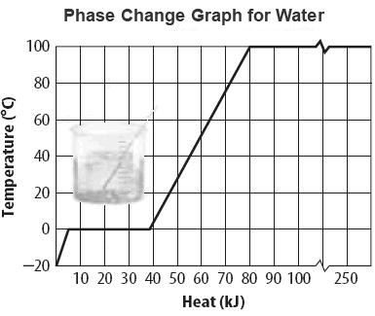

“When you heat a mixture of ice and water, the temperature of the mixture does not rise from 0 ^{O} C until all of the ice has melted”.

- Is the above statement true?

You must use all relevant scientific concepts (ideas), as necessary, to support your YES or NO answer.

[3 marks]
- Why does 25 g of water, at 10 ⁰ C, contain more internal energy than a 20 g ice block at 0 ⁰ C?

[2 marks]

- Why is it scientifically incorrect to say that 25 g of water, at 10 ⁰ C, contains more heat energy than a 20 g ice block at 0 ⁰ C?

[1 mark]

Most people think that the best way to increase your resting metabolic rate is to do cardiovascular exercise like riding an exercise bike. Although this does help a little, (it certainly is best for your heart health), the most efficient way to increase your resting metabolism is to build your muscle mass.

Mr McGarry increases his metabolic rate by 400 Watts (J s ^{–1}) during exercise on his “Repco Bionic” exercise bike. Approximately 75 % of the extra energy released is in the form of excess heat energy.

- At what rate, (in kg s ^{–1}), must sweat be evaporated to remove the excess heat energy produced by riding the exercise bike? Use these two physics formulae: Q = m L _{V sweat} and metabolic rate = Q / t; and assume a time of 1.0 second.

(Latent heat of vaporisation of sweat at a core-temperature of 37 ⁰ C = 2.51 MJ kg ^{–1}). (M = 10 ⁶)

[4 marks]
Law of Conservation of Energy requires: Σ Heat lost from hot objects = Σ Heat gained by cold objects.

- In Ben’s house, water from the hot water tap at 70 ⁰ C is too hot for a bath. He therefore mixes it with water from the cold water tap at 10 ⁰ C. What volume of hot water should Ben add to 100.0 Litres of cold water, to give a bath water temperature of 45 ⁰ C?

Use these physics formulae: Q = m c Δ T; and Σ Heat lost = Σ Heat gained. Note: You can cancel out “c”.

Assume that only 85 % of heat is transferred from the hot to the cold water, as 15 % of heat is lost from the hot water to the surroundings in the bathroom.

Assume that the mass of 1.00 Litre of hot water is the same as for cold water = 1.00 kg.

[4 marks]

Suppose that you are a heating engineer who wants to know the correct capacity of a central heating system to install in a particular house. You can calculate the heat losses from a house using U-values.

If a material transfers heat well it has a high U-value; if a material is a good insulator it has a low U-value.

Table 1, given below, shows the U-value data for selected common home building materials.

TABLE 1: U-VALUES OF SELECTED HOME BUILDING MATERIALS (W m ^{–2} ⁰C ^{–1})

UNINSULATED  HOUSE | Un-insulated Roof/Ceiling | 2.0
UNINSULATED  HOUSE | Cavity Wall | 1.0
UNINSULATED  HOUSE | Windows, single glazed | 5.0
UNINSULATED  HOUSE | Floor without carpets | 1.0
INSULATED  HOUSE | Insulated Roof/Ceiling | 0.3
INSULATED  HOUSE | Cavity filled Wall | 0.5
INSULATED  HOUSE | Windows, double glazed | 2.5
INSULATED  HOUSE | Floor with carpets | 0.3

A heating engineer can calculate the rate of loss of heat using the following mathematical word equation:

Rate of Heat Loss (Watts = J s ^{–1}) = U-value × Area × Temperature Difference (ΔT)

The house being evaluated for a heating system has the following dimensions of area as shown in Table 2.

TABLE 2: AREA DIMENSONS OF RELEVANT PARTS OF THE HOUSE (m ²)

Roof/Ceiling area | 100
Area of brick walls | 200
Area of windows | 40
Floor area | 100

You must calculate, using the physics formula given above, the individual rate of heat loss from the roof, the brick walls, the windows, and the floor; then add them together, firstly for the un-insulated house, and secondly for the insulated house.

Given that the outside temperature is 8 ⁰ C, and that the temperature inside the house is to be maintained at 20 ⁰ C, giving a temperature difference ΔT = 12 ⁰C; what is the calculated rate of heat lost from the:

- Un-insulated house? [5 marks]

- Insulated house? [5 marks]

TABLE 3: TOTAL RATE OF HEAT LOST FROM THE HOUSES (W = J s ^{–1})

BUILDING MATERIAL | UN-INSULATED HOUSE | INSULATED HOUSE
Roof/Ceiling

Brick walls

Windows

Floor

Total Rate of Heat Loss (W)

- Some people think that it is more important to insulate the walls than to double-glaze. This seems sensible as the windows are small. Is it more important to insulate walls or to double-glaze windows? Comment on the idea, given above, referring to relevant tabular data and using relevant calculations.

[3 marks]
- What is the difference in the weekly cost of heating an UNINSULATED home with an INSULATED home, given that the heating system operates for only 6 hours per day? Time must be in seconds since 1 Watt = 1 J s ^{– 1}. You will need to use the physics formula: Energy = Power (J s ^{–1}) × Time (s).

Assume that the cost of electrical energy (electricity), in Perth, is now about 4.45 c per MJ. (M = 10 ⁶)

TABLE 4: DIFFERENCE IN HEATING COSTS

What is the cost of heating an un-insulated home? | What is the cost of heating an insulated home?
What is the weekly difference in heating costs? | Cost Difference ($) =

[5 marks]

Section 2: Electrical Fundamentals

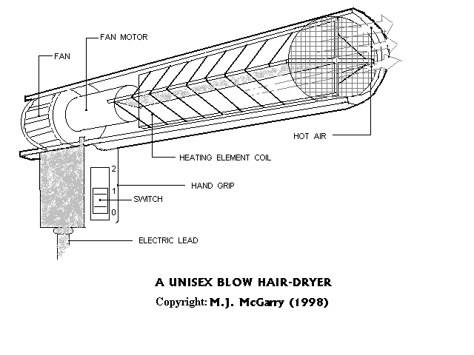Now study the schematic diagram, given below, of a Unisex blow hair-dryer.
- Why is it energy efficient to locate the fan motor after the fan and before the heating coils?

[2 marks]

The electrical circuit for the hair-dryer, shown above, has been drawn in the schematic diagram below.

FAN
MOTOR
HEATING
250 V ELEMENTS

E ₁ E ₂

S ₁

S ₂ S ₃

The heating elements E ₁ and E ₂ each draw 5.50 × 10 ² W, and the fan motor requires 15.0 W to operate.

The voltage supplied to the Unisex blow hair-dryer is 250 V and not the usual voltage of 240 V.

- What advantage is gained by having the heating elements joined in parallel and not in series?

[2 marks]

The switch control on this blow hair-dryer is arranged so that S ₁ must be switched on before S ₂ and then S ₃ can be switched on. Also, if S ₁ is switched off, then S ₂ and S ₃ are also switched off.

- Why are these switching procedures necessary from the viewpoint of safety to the operator?

[3 marks]
- How much power, in kilowatts, is used by the hair dryer when S ₁ is on, and S ₂ and S ₃ are off?

[1 mark]

- How much power, in kilowatts, is used by the hair dryer when S ₁ and S ₂ are switched on; S ₃ off?

[1 mark]

- How much power, in kilowatts, is used by the hair dryer when S ₁, S ₂, and S ₃ are all switched on?

[1 mark]

- How much electrical energy, in kilowatt hours, is consumed by the hair dryer if it operates at its maximum heat setting for 5.00 minutes? Use this equation: Energy (kW h) = Power (kW) × time (h).

[2 marks]

- What is the cost, in cents, of drying your hair if the dryer operates at its maximum heat setting for 5.00 minutes; given that electrical energy, in Perth, now costs about 16.01 cents per kilowatt-hour?

[1 mark]

- How much current flows through the fan motor when the dryer operates at its maximum heat setting? Apply the physics formula: Power P (W) = Voltage V (V) × Current I (A).

[2 marks]
- How much current flows through the heating element E ₁ when the dryer operates at its maximum heat setting? Apply the physics formula: Power P (W) = Voltage V (V) × Current I (A).

[2 marks]

- How much current flows through the heating element E ₂ when the dryer operates at its maximum heat setting? Apply the physics formula: Power P (W) = Voltage V (V) × Current I (A).

[2 marks]

When you turn the key in a car ignition, a number of electrical circuits may be activated. The one system through which most current will flow is, of course, the starter-motor. The circuit drawn below shows, in a very simplified way, how the starter-motor is connected to the car battery. The required switches have been omitted to make the diagram simpler.

The car electrical system is using a negative earth return, i.e., the negative terminal of the car battery is connected to the metal body of the car.

Thick connecting cables

12 V STARTER
Car Battery MOTOR
10 V

Earthed to Car-Body

When you start a cold engine, the current flowing from a 12 V car battery can reach a maximum 100 A; and the voltage across the starter motor must be equal to or greater than 10 V.

- According to Kirchhoff’s second Law, what voltage would exist along the thick connecting cables?

[2 marks]
- What is the maximum resistance of the thick connecting cables? Apply Ohm’s Law: V = I × R.

[2 marks]

- Given that the thick connecting cables are made of copper of resistivity ρ = 1.8 × 10 ^{–8} Ω m; and that their total length ℓ is 1.5 m, what minimum cable cross-sectional area A must be used so as to prevent any over-heating of the cables? Apply this physics formula: R = (ρ × ℓ) / A.

[3 marks]

In Circuit A the two identical globes are in series. In Circuit B the same two globes are in parallel.
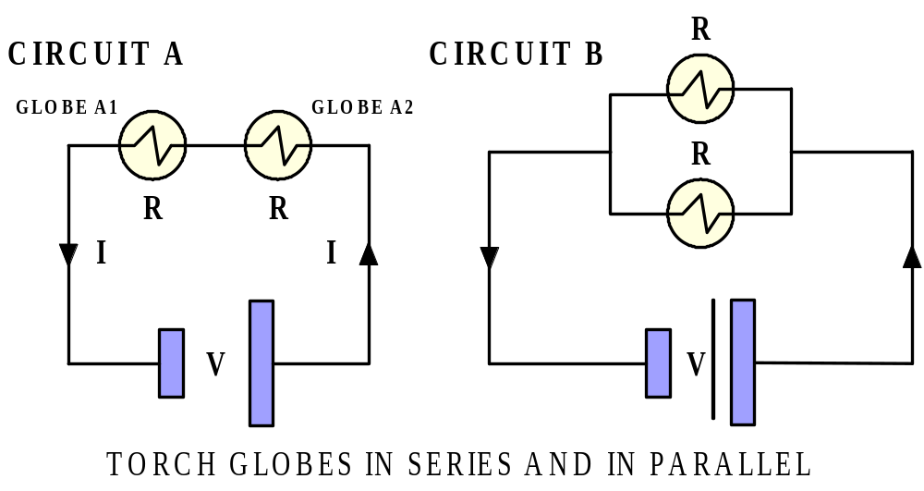
The battery in Circuit A and the battery in Circuit B are identical and they supply the same voltage (V).

- What type of electric current is shown in the above two circuit diagrams? You must refer to the polarity of the battery terminals and to the scientific fact that: Unlike electric charges attract, whereas like electric charges repel, to explain your answer. Is the current conventional or is it electron flow?

[3 marks]
Hypothetical conventional current, in a copper wire connected across a battery, is a flow of positive charges around the electric circuit from the positive (+) terminal to negative (–) terminal of the battery.

- The positive charges, located inside a copper wire, cannot flow as conventional current around an electric circuit via the copper wires. Why can’t the positive charges flow through the copper wire?

[3 marks]

The brightness of an ordinary incandescent electric light globe depends on the temperature of its filament.

The temperature of the globe filament depends on voltage applied across it and current flowing through it.

The brightness of a globe is determined by the voltage applied across it and the current flowing through it.

- Why does the temperature of the filament of a light globe depend on the applied voltage?

[3 marks]

- Why does the temperature of the filament of a light globe depend on the current flowing through it?

[3 marks]

- Are the two globes shown in Circuit A equally bright; if they aren’t, which one is brighter and why?

[2 marks]
- What voltage is applied across each globe in Circuit B?

[1 mark]

- What voltage is applied across each globe in Circuit A?

[1 mark]

- What is the ratio of the voltages applied across each globe in Circuit B to that in Circuit A?

[2 marks]

- What is the total resistance of Circuit A? Use this physics formula: R _{SERIES} = R ₁ + R ₂ +

[1 mark]

- How much current flows through each globe in Circuit A? Apply Ohm’s Law: V = I × R.

[2 marks]

- What is the total resistance of Circuit B? Use this physics formula: R _{PARALLEL} = (1/R ₁ + 1/R ₂ +) ^{–1}.

[1 mark]
- How much current flows through each globe in Circuit B? Apply Ohm’s Law: V = I × R.

[2 marks]

- What is the ratio of the currents flowing through each globe in Circuit B to that in Circuit A?

[2 marks]

- What electrical power is drawn be each globe in Circuit B? Use: Power P = Voltage V × Current I.

[2 marks]

- What electrical power is drawn be each globe in Circuit A? Use: Power P = Voltage V × Current I.

[2 marks]

- What is the ratio of the power drawn by each globe in Circuit B to that in Circuit A?

[2 marks]

- In terms of the electrical power drawn by each globe, how many times brighter are the globes in Circuit B compared to the globes in Circuit A?

[1 mark]

Should you have difficulty in solving Questions 41 through 52, you could use: V = 6 V and R = 2 Ω?

END OF EXAMINATION

