PHYSICS 2003

YEAR 12
These test papers are copyright and may not be reproduced in any way.
 This paper should be withdrawn after use and stored securely in the school until Monday 20th October 2003.
Test papers may not be used for private tutoring before the above date.



Name:________________________________________Teacher:_________________________________

TIME ALLOWED FOR THIS PAPER:
Reading time before commencing work: Ten minutes
Working time for paper: Three hours

MATERIAL REQUIRED/RECOMMENDED FOR THIS PAPER

To Be Provided By The Supervisor
This Question/Answer Booklet comprising 36 pages.
Physics: Formulae and Constants Sheet (inside front cover of this Question/Answer Booklet).

To Be Provided By The Candidate
Standard Items: Pens, pencils, eraser or correction fluid, ruler.
Special Items: MATHOMAT and/or Mathaid, compass, protractor, set square and calculators satisfying the conditions set by the Curriculum Council.

IMPORTANT NOTE TO CANDIDATES
No other items may be taken into the examination room.

It is your responsibility to ensure that you do not have any unauthorised notes or other items of a non-personal nature in the examination room. If you have any unauthorised material with you hand it to the supervisor BEFORE reading any further.

STRUCTURE OF THE PAPER

.
Section | No. of  Questions | No. of questions to  be attempted | No of marks out  of 200 | Proportion of  Examination total
A: Short Answers | 15 | ALL | 60 | 30%
B: Problem Solving | 7 | ALL | 100 | 50%
C: Comprehension and  Interpretation | 2 | ALL | 40 | 20%

INSTRUCTIONS TO CANDIDATES

Write your answers in the spaces provided beneath each question. The value of each question (out of 200)
is shown following each question. You should note that the space made available for an answer is not
necessarily an indication of the length of the answer.

The enclosed Physics: Formulae and Constants Sheet may be removed from the booklet and used as required.

Answers to questions involving calculations should be evaluated and given in decimal form. It is suggested
that you quote all answers to three significant figures with the exception of questions for which estimates
are required. Despite an incorrect final result, you may obtain marks for method and working, provided
these are clearly and legibly set out.

Questions containing specific instructions to show working should be answered with a complete, logical,
clear sequence of reasoning showing how the final answer was arrived at. Correct answers which do not
show working will not be awarded full marks

Questions containing the instruction "Estimate" may give insufficient numerical data for their solution.
Students should provide appropriate figures to enable an approximate solution to be obtained.

When descriptive answers are required, you should display your understanding of the context of a question.
An answer which does not display an understanding of Physics principles will not attract marks.

This page has been intentionally left blank

Section A: Short Answers

Marks allocated: 60 marks out of a total of 200 (30%)

Attempt ALL 15 questions in this section. Each question is worth 4 marks.
Answers are to be written in the space below or next to each question.

1 In an investigation to find the speed of a transverse wave in a string, students set up a signal
generator and connected it to a 2.00 m length of the string. With the signal generator set at
165 Hz, eleven (11) loops fit the vibrating length of string exactly.
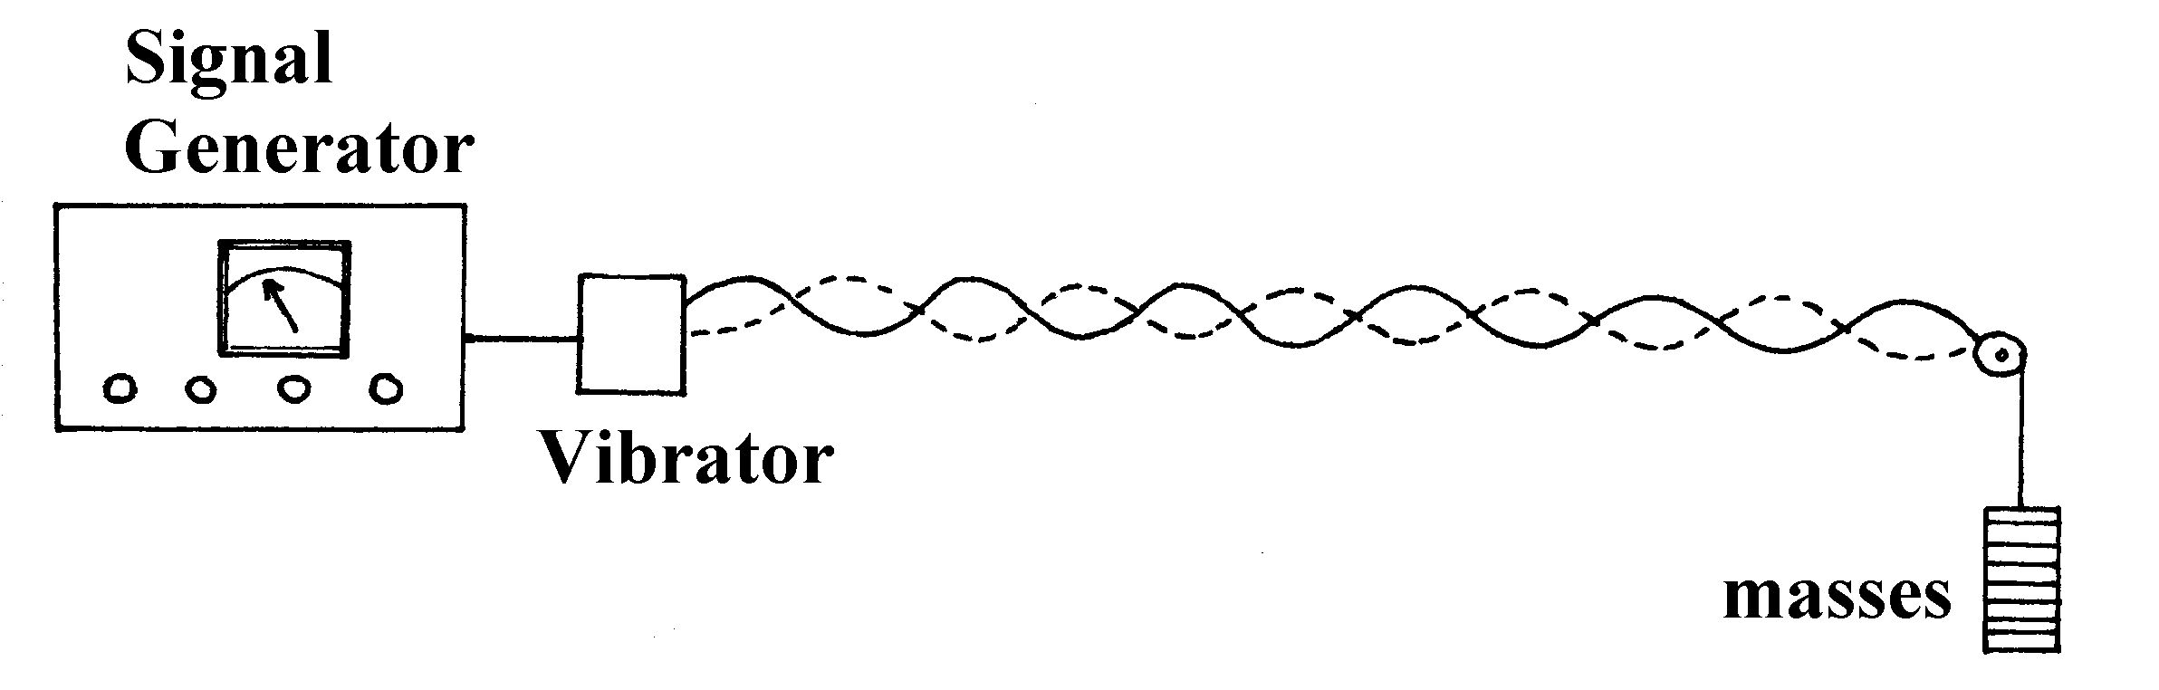
a Calculate the speed of a transverse wave along the stretched string.

b With the apparatus shown and without altering the frequency of the signal generator,
state one way the frequency of the sound produced by the string could be increased.
Explain your answer.

- A piano tuner tightens a mild steel wire of diameter 1.70 mm so that its original length
of 1.64 m is extended by 1.40 mm. Calculate the force exerted on the frame of the piano
by the wire.

- Ricky Ponting, the Australian One Day Cricket captain, takes
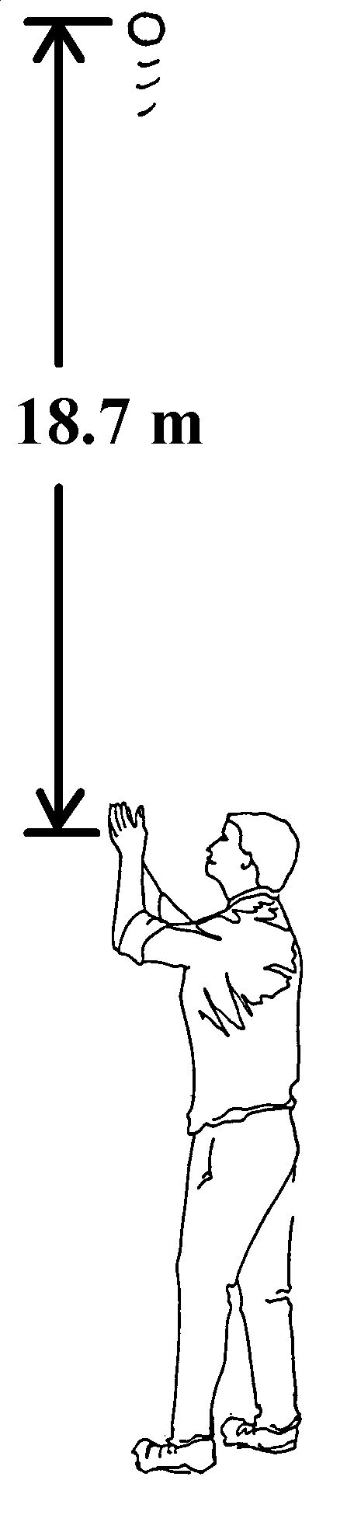
a catch in the outfield and immediately throws the 160.0 g cricket
ball vertically into the air.
See the diagram opposite.

a With what speed does the ball leave his hand if the ball
reaches a maximum height of 18.7 m? (ignore air resistance)

b If there was air resistance and it acted with an average force of 0.06 N, with what speed
would Ricky need to throw the ball so it achieved the same vertical height of 18.7 m?

4 Explain, using a mathematical proof, that all geostationary satellites are at the same altitude above
the Earth.

5 A ship building company uses a powerful laser to cut steel plate. The laser has a power of
900.0 W and produces infra red radiation with a wavelength of 1.00 x 10⁻⁶ m.

a What is the energy per photon produced?

b How many photons are produced per second?

6 A carriage plus riders has a combined mass of 1040.0 kg. The carriage travels upside down on

rails at the top of the circular track of a “loop the loop” funfair ride. The combined mass
(carriage plus riders) has its centre of mass 6.75 m from the centre of the circle when it is
travelling at a constant speed of 13.2 ms ^{– 1}.
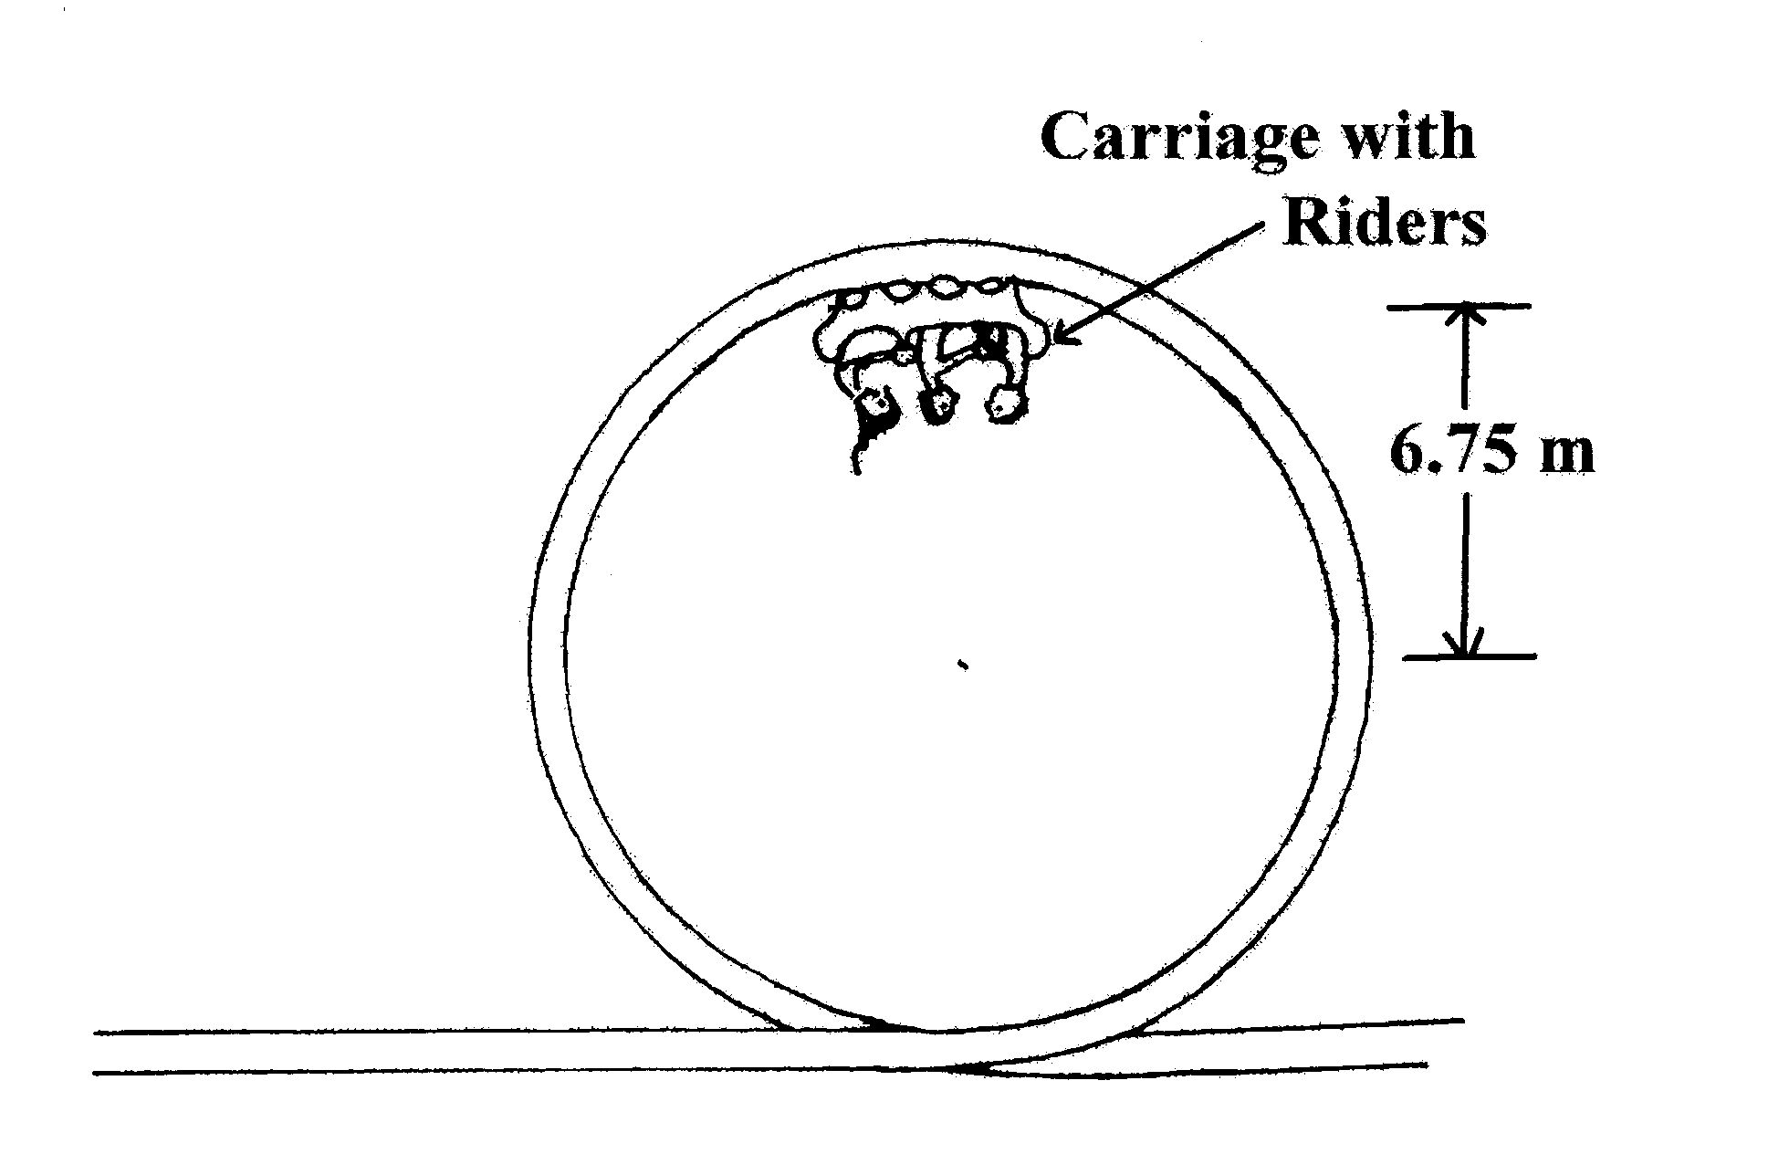
a Calculate the size of the force that the carriage exerts on the rails at the top of the circle.

b On the diagram draw vectors to indicate the forces acting on the carriage.

7 Ultra violet radiation is produced when an electron moves form one energy level in an atom to a
different energy level.

a Would the energy be emitted as the electron moves from a higher level to a lower level or
from a lower level to a higher level?

b Explain why you have chosen your answer to Q7a above.

c Estimate the difference in energy levels (in electron volts) that would be required to produce
ultra violet radiation.

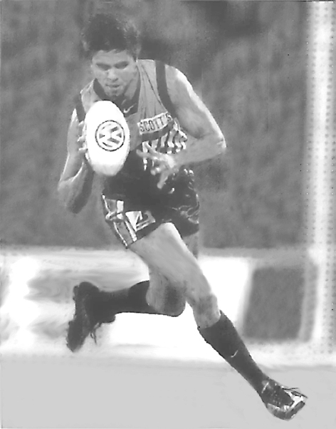
8 Using estimates of the footballer’s
velocity, calculate his angle of lean
to the vertical if he is moving in a circle
of 20 m radius.

9 Observe the diagram of the dentist’s surgery. Two patients are waiting at positions A and B.
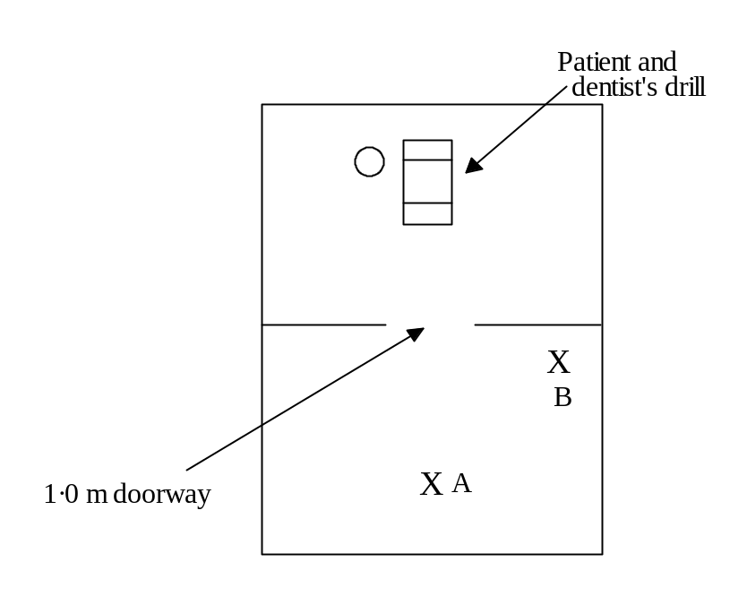
a Why do you think the patient sitting at position B can hear a groan coming from the surgery quite clearly but can hardly hear the high pitched sound of the drill?

b The dentist decides he wants his surgery to be a little more sound proof. What could be done to achieve this?

- Refer to the diagram opposite. The force on
the wire carrying a current of 40.0 A out of
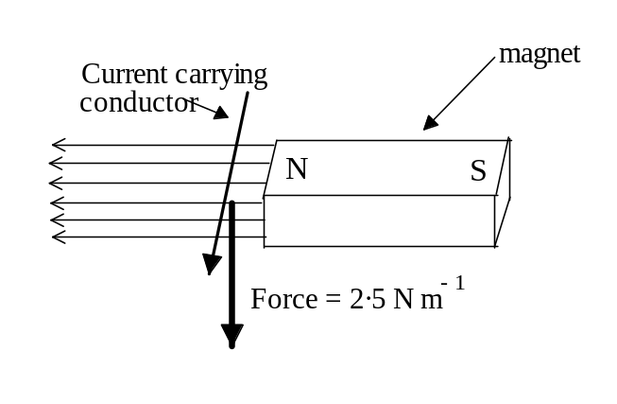
the page is 2.50 N m⁻¹ vertically downwards.
What is the flux density near the pole of the
magnet?

11 Below is a diagram showing a magnet and next to it a current carrying conductor which is carrying
a current into the page. The magnetic fields around the wire and magnet interact.
Draw the field lines which exist around the magnet and the wire.

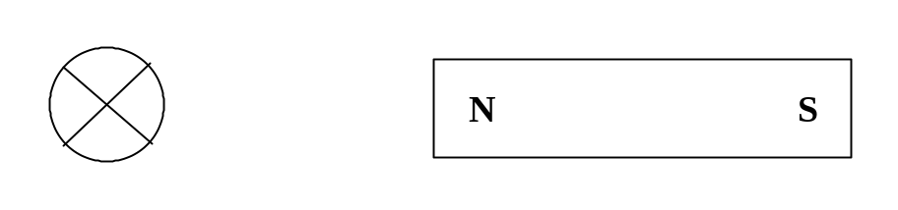

12 A train is traveling due south at 110.0 km h⁻¹ on the Perth to Fremantle line. If the length of
the axles on the train are 2.10 m long and the vertical component of the Earth’s magnetic field
is 5.00 x 10⁻⁵ T, calculate the magnitude and the direction of the e.m.f. induced in one of the axles.

13 A group of trumpet players is putting on a performance in an auditorium. The lead player plays
a note and the loudness of the note is noted. When all the trumpets are played together, each with the same intensity as the lead player, the loudness increases by 12 dB.
How many trumpet players are in the group?

- A transmitter mast is held in the vertical position by four guy wires. Two of the wires each
make an angle of 30.0º to the mast and the other two each make an angle of 35.0º. The tension
in each of the wires is 1 560.0 N. The diagram below shows how the wires are attached to
the mast.
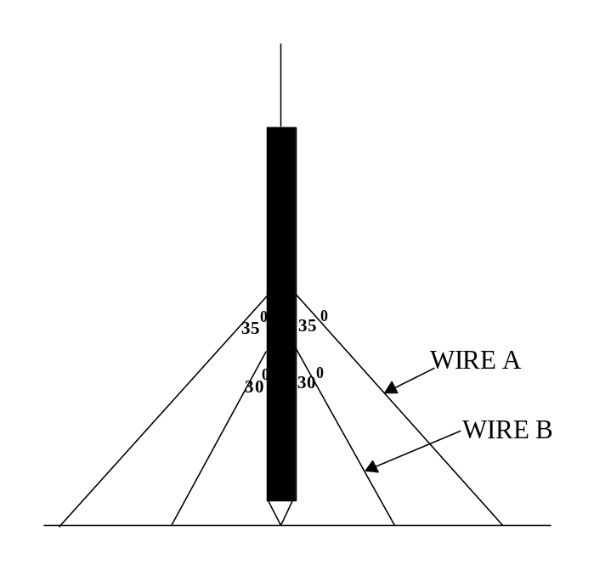
a Which of the wires (A or B) is providing the greater downwards vertical force?

b Explain your answer to (a) above.

c Calculate the vertical component of the wire which makes an angle of 35.0º to the mast.

- The diagram below shows the construction of a simple generator.
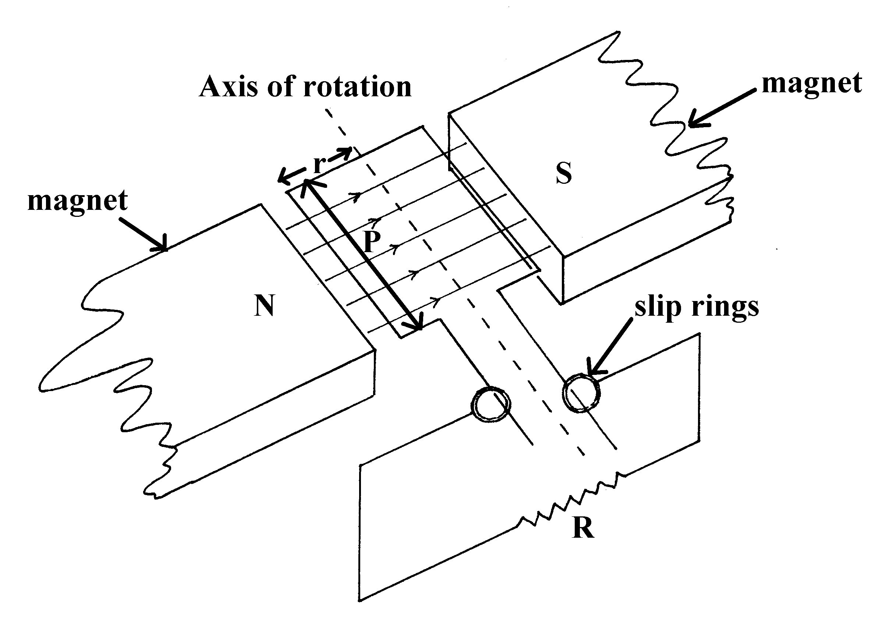
The dimensions of the generator are as follows;
radius of rotation (r) = 12.0 cm
side of coil (P) = 35.0 cm
number of turns in the coil = 75 (negligible resistance)
frequency of rotation of the coil = 50.0 Hz
uniform magnetic field (B) = 1.0 x 10⁻³ T
current flowing in the resistor (R) = 4.50 A

a What is the speed of side P of the coil?

b What is the EMF induced in side (P) of the coil when it is in the position shown?

Section B: Problem Solving

Marks allotted: 100 marks out of a total of 200 (50%).

This section contains 7 questions.

You should answer: ALL of the questions.

Answer the questions in the spaces provided

1 (14 marks)

An iron chimney 6.00 m long and open at both ends has carbon dioxide streaming through it.

If it is securely clamped at both ends the chimney vibrates like a stretched string.

a Calculate the lowest frequency of standing wave that can form on the tube. (3 marks)

b Calculate the lowest frequency
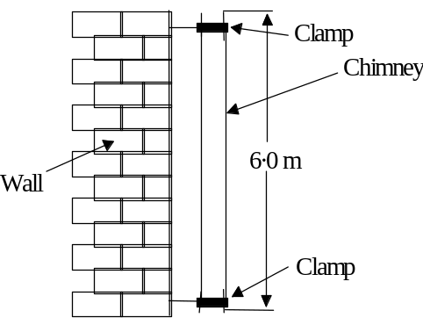
of standing wave that can
form in the chimney. (3 marks)

c Calculate the NEXT frequency of standing wave that can form in the chimney.
(2 marks)

d There is a possibility that the vibration of the gas inside the chimney could cause the
chimney to resonate. What is resonance? (3 marks)

e At approximately which harmonic would the gas inside the chimney vibrate at the same
frequency as the chimney and what would the observer hear in this situation?
(3 marks)

2 (14 marks)
The planet Neptune has eight moons, one of which is called Triton. Inside a space craft at rest on Triton’s surface is a 10.0 kg mass hanging from a spring balance. The spring balance measures force in newtons.

Mass of Triton = 2.14 x 10²³ kg.
Radius of Triton = 1.35 x 10⁶ m.
Mass of Space craft = 2.00 x 10³ kg.
Radius of Tritons orbit around Neptune = 3.53 x 10 ⁸ m.
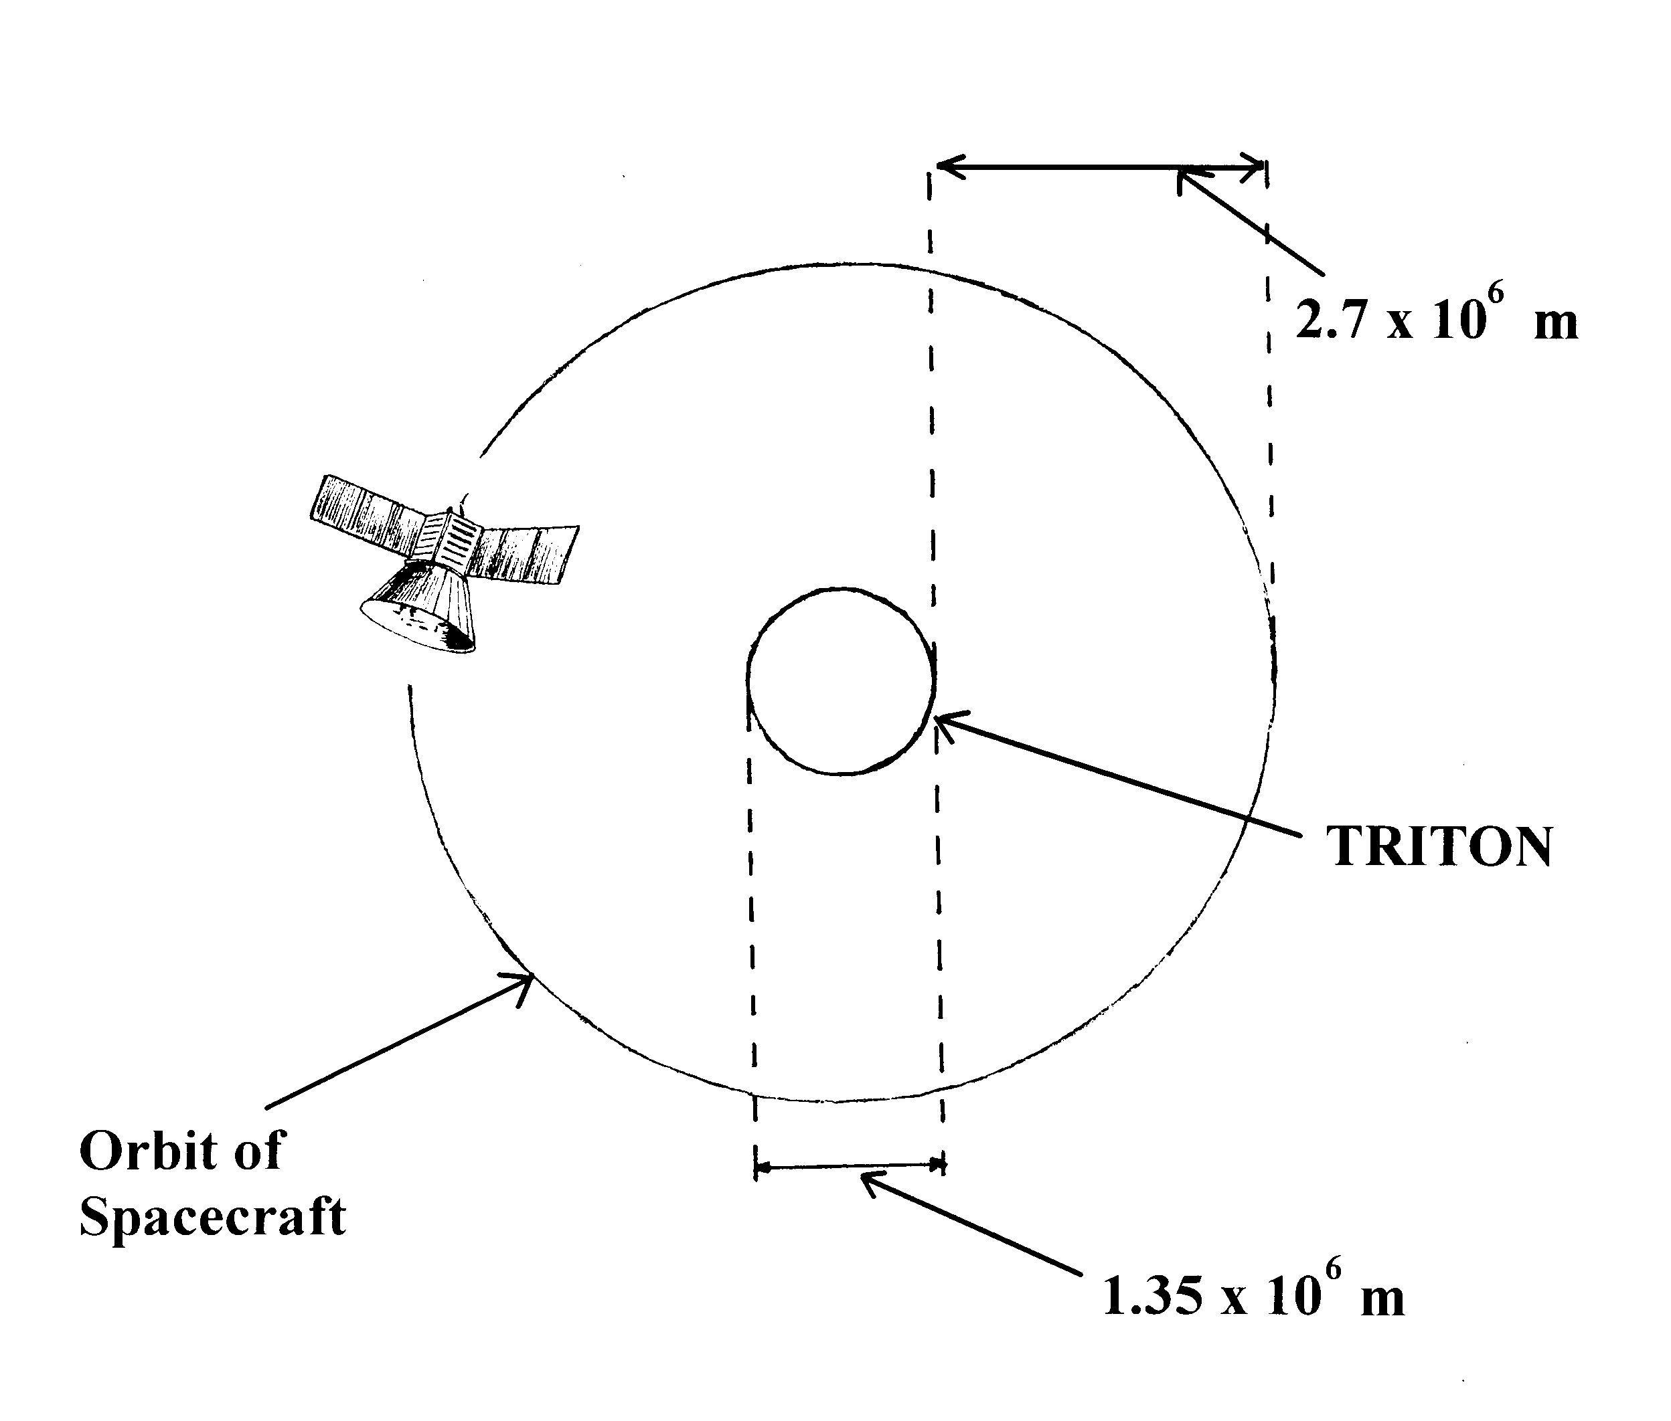
Z
a What is the reading on the spring balance in newtons? (3 marks)

The space craft takes off and is now in circular motion around Triton, at an altitude of
2.70 x 10⁶ m.

b What is the gravitational field strength at this altitude due to Triton? (3 marks)

c Another moon of Neptune is Nereid, which orbits at a distance of 5.50 x 10⁹ m from
Neptune’s centre. Nereid takes 360 days to orbit Neptune.
Determine the mass of Neptune. (4 marks)

d When Neptune is a position Z (not to scale) what is the total gravitational force that the
space craft experiences? (4 marks)

3 (13 marks)
A metal structure, ABCD, is used as part of a crane to lift a heavy load. It is hinged at the wall
at A and supported by a steel cable attached to a point X, 6.45 m above the hinge. The angle
between the cable and the wall is 37º. The weight of ABCD is 950.0 N. A load of 154.0 kg is
being lifted at C. Other dimensions are: AD = 2.50 m, DC = 2.50 m, BD = 1.50 m
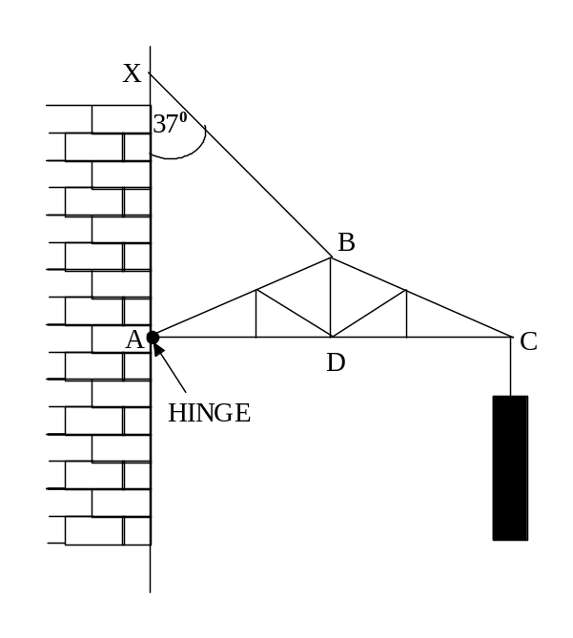
a Calculate the tension in the cable. (4 marks)

b Calculate the magnitude of the reaction force of the wall on the structure at A.
(6 marks)

c Determine the direction of the reaction force of the wall on the structure at A.
(3 marks)

4 (15 marks)
Energy levels for the hydrogen atom are shown below. The diagram is not to scale.
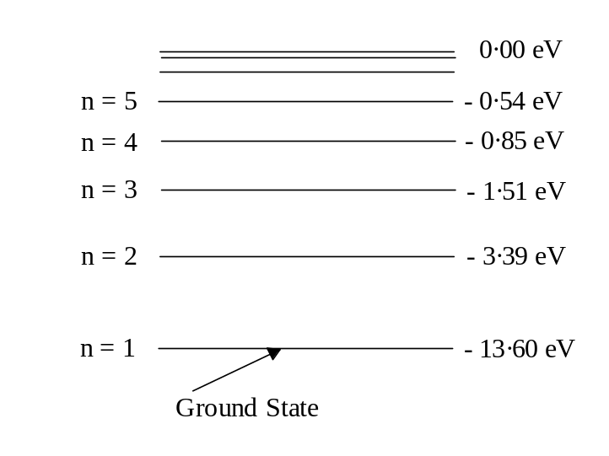
n = ∞

Below is a simplified diagram representing part of the electromagnetic spectrum of the hydrogen atom.
It shows three regions of the spectrum: infra red, visible and ultra violet.

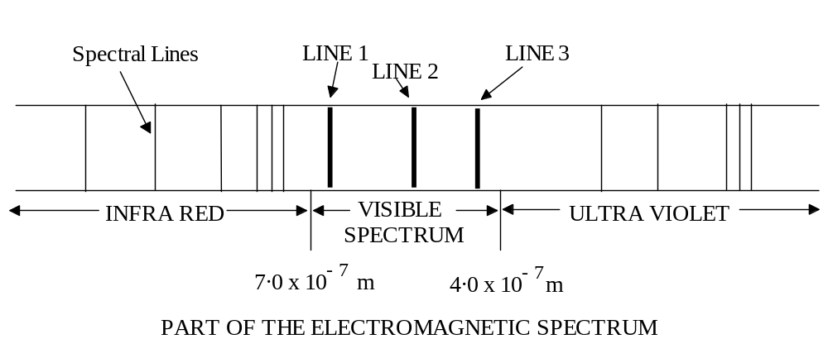

a Using the two diagrams explain how transitions between the energy levels of hydrogen
result in the series of lines in the visible part of the spectrum. (no calculations required).
(4 marks)

b What type of spectrum does this spectrum represent? (1 mark)

c Suggest a reason why there are three (3) lines (not 2 or 4) in the visible part of the
spectrum. Support your answer by completing the necessary supporting calculations.
(5 marks)

d If you were to look at this spectrum through a good quality spectroscope, describe what
you would see. (2 marks)

e Calculate the frequency of the spectral line in the visible part of the spectrum, which is
labelled (2), and state its probable colour. (3 marks)

5 (17 marks)

A simple transformer is constructed by a group of students to investigate electromagnetic induction.
A diagram of the transformer with its attached circuitry is shown below.
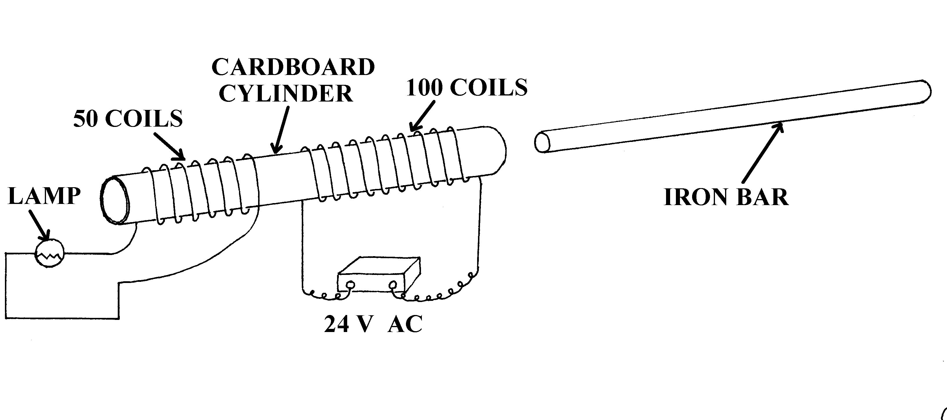
a In a sentence or two explain the meaning of electromagnetic induction using the simple
transformer to help with the explanation. (3 marks)

b When the 24.0 AC power supply is switched on the lamp is seen to glow dimly.
What causes the lamp to glow? (No calculation required.) (3 marks)

c When the iron bar is inserted into cardboard tube through both coils the lamp glow brighter.
Explain why the lamp now glows brighter than before. (3 marks)

d Does the diagram above represent a ‘step up’ or ‘step down’ transformer? Explain your answer.
(3 marks)

e Why does the 24.0 V power supply need to be an alternating current source rather than a direct
current source? (3 marks)

f Calculate the theoretical output voltage of the 50 turn coil. (2 marks)

6 (15 marks)
The following experiment is proposed to demonstrate the elasticity of metals. A diagram of the
apparatus set up is shown below.
Details of the equipment are:
- A uniform heavy metal bar of mass 250.0 kg
- Mild steel wire 4.00 m long when attached between the concrete and the heavy metal bar
- Wrought iron wire 4.00 m long when attached between the concrete and the heavy metal bar
- Diameter of mild steel wire is 1.50 mm
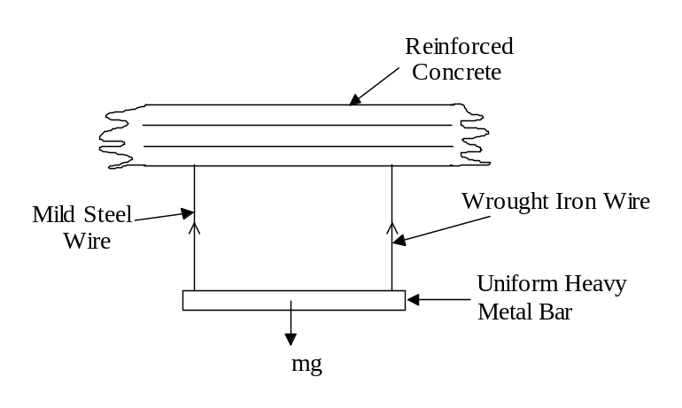

a Rearrange the Young’s Modulus formula so that the extension is the single variable
on the left hand side of the equation. (2 marks)

b Calculate the extension for mild steel using the above formula. (3 marks)

c Calculate the extension for the wrought iron which has a cross sectional area of ‘A’ m ².
Express your answer in terms of ‘A’. (3 marks)

d If the extensions in both the wrought iron and the mild steel are to be the same what is
is the value of ‘A’ in part (c) above? (3 marks)

7 (12 marks)
A soccer player kicks a ball from ground level at an angle of 40.0^{O} to the horizontal
in an attempt to score a goal. The goals are 33.0 m away. The ball lands on the goal line
and bounces into the goals. See the diagram below.
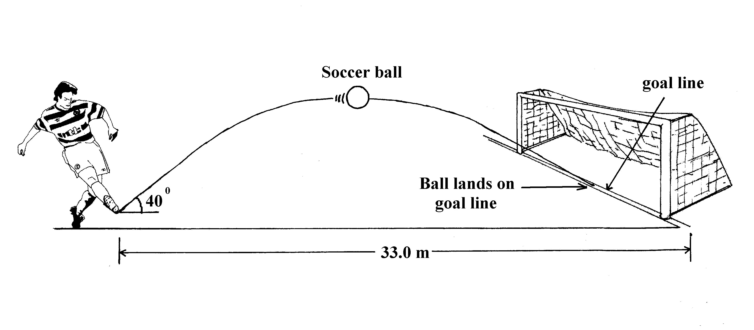
a With what velocity does the ball leave the player’s boot? (ignore air resistance) (6 marks)

b What is the time of flight of the ball? (2 marks)

c What is the highest point above the ground that the ball reaches? (2 marks)

d At what horizontal distance from the kick off point does the ball reach its maximum height?
(2 marks)

Section C: Comprehension and Interpretation

Marks allotted: 40 marks out of 200 (20%)
Question 1 (25 marks)
Probing the Body with Ultrasound

Paragraph 1
Doppler ultra sound is now a well established medical tool and is used particularly for measuring the
velocity of blood flow. Apart from this application it initially found application in astronomy when it was observed that distant galaxies exhibited a shift of spectral lines towards the red moving away from us at
high velocities. More recently this fundamental physical principle has been applied to the measurement
of the velocities of tissues hidden in the body using diagnostic ultrasound. Frequency shift occurs when
a sound wave having a particular velocity is detected by an observer.

Paragraph 2
In diagnostic Doppler ultrasound studies we are generally measuring the returning signal following a reflection from a boundary between different tissues in the body. In this case the reflecting boundary initially acts like a moving observer that is traveling away from the source therefore decreasing the frequency of the ultrasound. In diagnostic measurements on the body the velocities of blood cells
detected average about 0.06 m s⁻¹ and the velocity of sound in the tissue is approximately 1 540 m s⁻¹. Ultrasonic sound in the range of 5 to10 MHz are used to produce the Doppler shifts. A continuous flow Doppler transducer is used to take these measurements. (see figure 1). For targets with a speed much less than the speed of sound the following expression can be used.
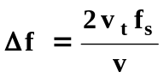

where 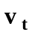 = speed of target
= speed of sound
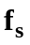 = frequency of the transmitted sound
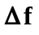 = change in frequency (Doppler shift)

Paragraph 3
The above descriptions as to how the Doppler shifts are produced are made under the assumption that the velocity of motion and the direction of the ultrasound beam are parallel. In many cases this may not be correct and it is frequently impossible to ascertain the angle between the two. If we assume that the angle is θ then for a tissue boundary velocity of v the effective velocity v_{e} would be given by:

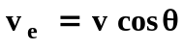

It is generally not possible to measure absolute tissue velocities using Doppler ultrasound.
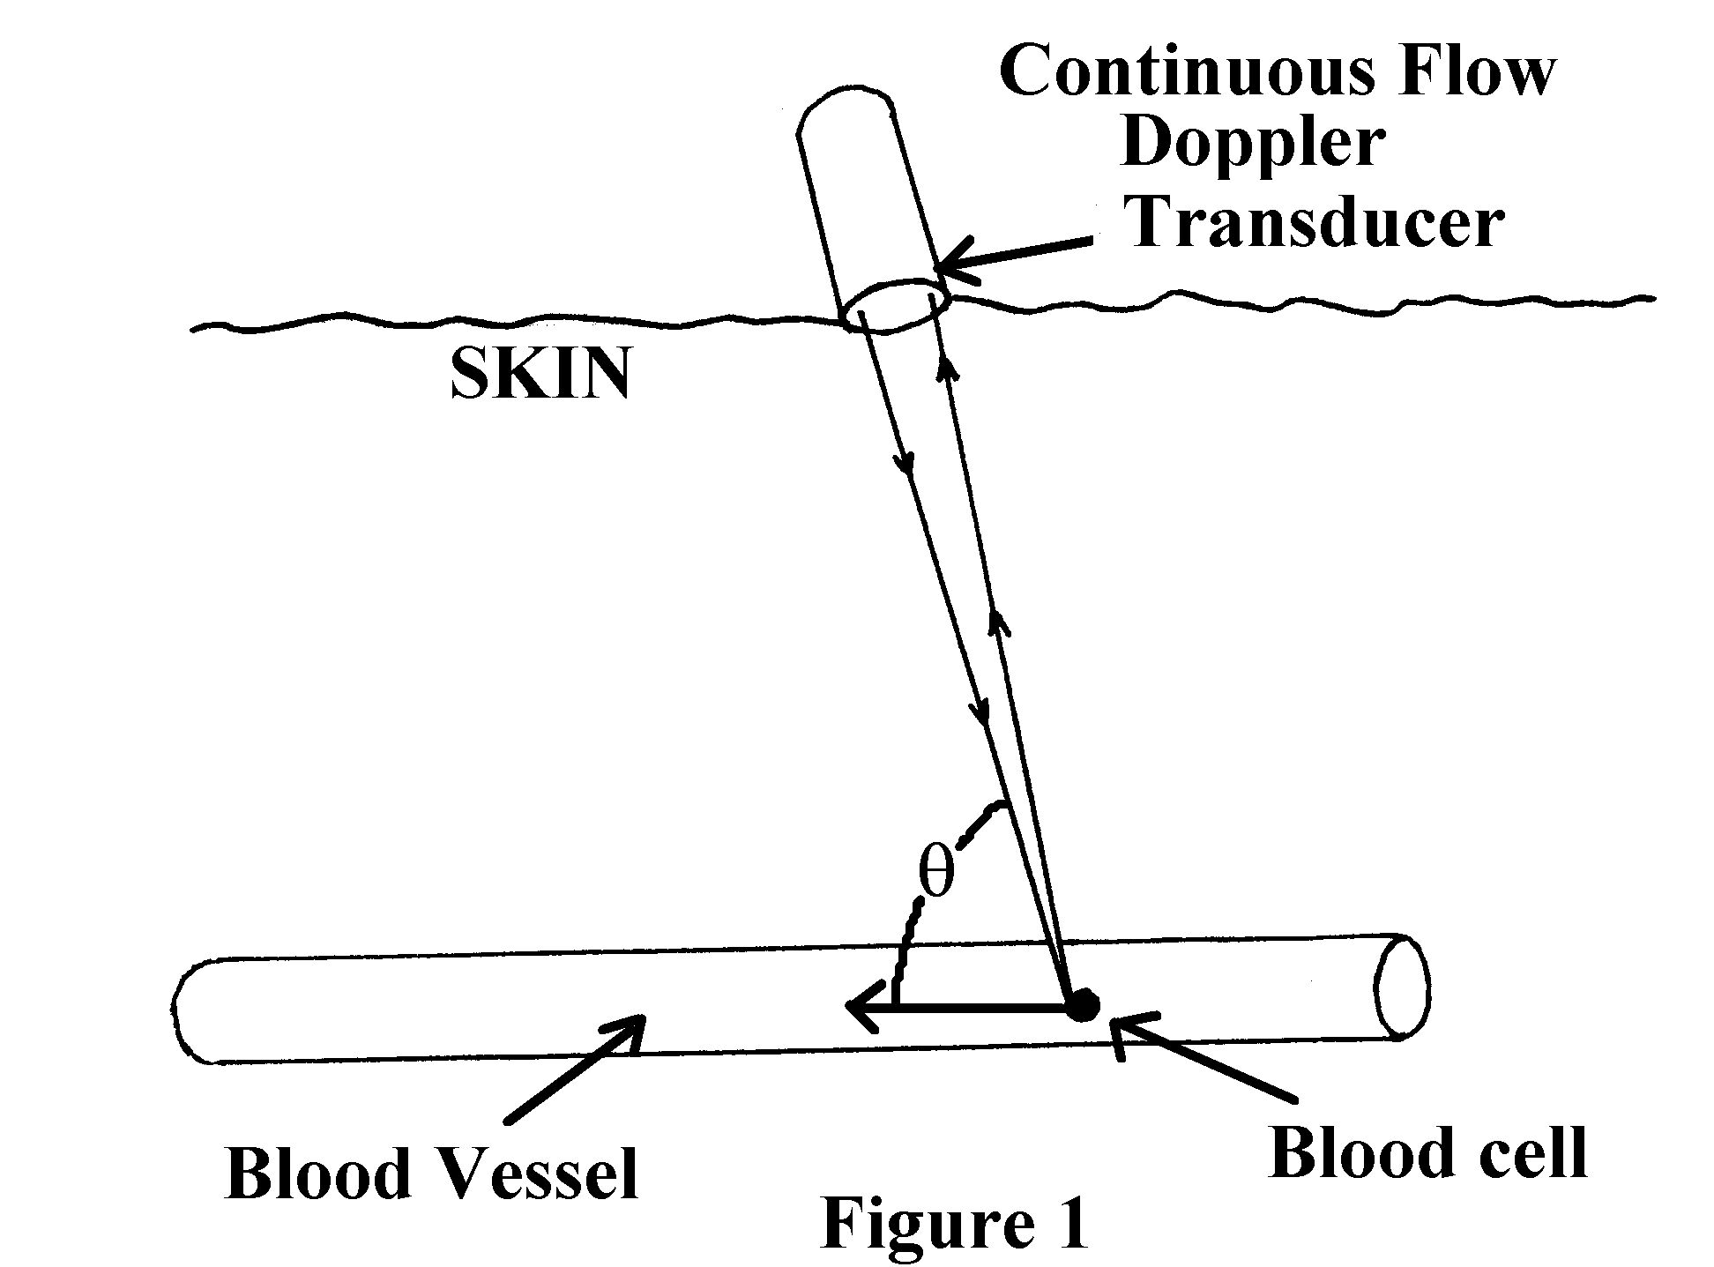
Paragraph 4
Arterial blood velocity pulsates and varies throughout the cardiac cycle from a forward velocity of
0.01 m s⁻¹ through to zero, uniformly, when driven by a heart beat rate of 50 beats per minute.

Questions
- Why is it not possible to measure absolute tissue velocities? (para 3) (3 marks)

- Calculate the Doppler shift which a blood cell would produce if the transducer emitted a
7.0 MHz signal. (para 2) (3 marks)

- Would a spectral shift towards the red produced by a target, indicate the target was moving towards or away from the observer? Explain your answer. (para 1) (3 marks)

- If the velocity of blood cells, as measured by the Doppler transducer when the value of the angle θ is 60º, is 10.0 cm s⁻¹, what is the effective velocity of the cells? (para 3) (4 marks)

- Suggest why ultrasound frequencies rather than audible frequencies are used to measure Doppler shift in human tissue. (3 marks)

- Would ultrasound be used in tracking galaxies to detect “red and blue shifts”? Explain
your answer. (para 1) (3 marks)

- On the axes below draw a graph to show how arterial blood changes its velocity for
1 heart beat. (Assume the person’s heartbeat is 50 beats per minute)
Show scales on the graph axes. (4 marks)
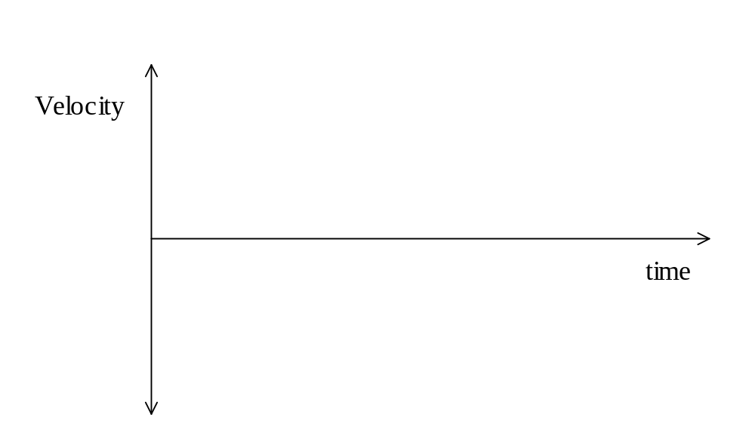

8 If the transducer was placed in contact with a person’s forearm how long would it take
for the transducer signal to reach a tissue boundary 2.0 cm below the surface? (2 marks)

Question 2 (15 marks)
Putting The Shuttle Into Orbit.

Paragraph 1
Space engineers face real complicated questions when putting a space shuttle into orbit. The fully loaded space shuttle has a mass of about 2 x 10⁶ kg. This will take a large amount of thrust just to elevate it from the launch pad. For the first two minutes of flight the two external solid rocket boosters and the main orbiter engines are all firing. The two boosters separate after the 2 minutes and the main engines continue to provide thrust until the external fuel tank empties. This occurs about 9 minutes after take off. The external fuel tank then falls off and the shuttle continues alone.
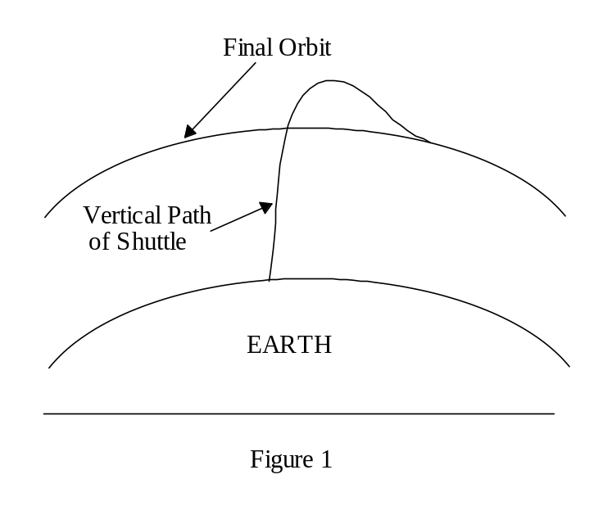
Paragraph 2
The shuttle initially moves in a vertical path through the Earth’s atmosphere. (see Figure 1) Eventually the shuttle overshoots its final orbit radius before moving in a shallow dive to the orbital radius. The final velocity of the shuttle’s orbit is given by:

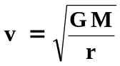

Where: r is the radius of the orbit
G is the universal gravitation constant
M is the mass of the Earth

Questions

- What is the advantage of the shuttle overshooting its orbital path and then doing a shallow dive? (para 2) (3 marks)

- What is the minimum thrust required to just provide lift off for the shuttle? (para 1) (3 marks)

- What effect would the release of the two boosters have on the velocity of the shuttle? (para 1) (2 marks)

- What is the reason that the shuttle navigators make the shuttle ascend vertically after take off? (2 marks)

5 What speed would the shuttle need to maintain if it was to orbit the Earth at an altitude of 200.0 km (3 marks)

6 What change to the shuttle’s motion needs to occur so that it loses altitude? (2 marks)
END OF EXAMINATION
Extra page if needed

