

West Australian Test Papers

PHYSICS

Year 12

2003

SOLUTION BOOKLET

&

MARKING GUIDE

Markers should note that the solutions presented here are skeletal answers and should be used
as a guide only.

Alternate answers used by students may be perfectly acceptable and discretion should be used.

Section A

1a Number of wavelengths in the 2.0 length = 5.5

Wavelength = 2.0 / 5.5 = 0.3636 m

Velocity = frequency x wavelength

Velocity = 165 x 0.3636 = 60.0 m s⁻¹

1b The tension in the string could be increased by adding more masses to the string. As frequency
is directly proportional to the tension an increase in tension caused by additional masses would
result in an increase in frequency.

- Y = (F /A) / (Δl /l)

  - x 10¹¹ = F / [π x (0.85 x 10⁻³)² ] x (1.64 / 1.4 x10⁻³)

F = 2.10 x 10¹¹ x π x (0.85 x 10⁻³)² x 1.40 x 10⁻³ / 1.64

Force is 407 N

3a u = ?
a = -9.8 m s⁻²
s = 18.7 m
v = 0

v ² = u² + 2 as

- = u² + 2 x (-9.8 x 18.7)

u = 19.1 m s⁻¹

3b F = m x a
0.06 = 0.160 x a
a = 0.06/0.160
a = 0.375 m s⁻²

So the ball is going to encounter a downward acceleration of
  - + 0.375) = 10.175 m s⁻²

u = ?
a = - 10.175 m s⁻²
s = 18.7 m
v = 0 m s⁻¹

using v ² = u² + 2 as

v ² = u² + 2 x (-10.175 x 18.7)

u = 19.5 m s⁻¹

u = 19.5 m s⁻¹ is the initial velocity.

4 m v²/r = G M_{e} m/r²

4 π² r³ = G M_{e} T (where T is the time for one orbit)

r ³ = G M_{e} T / 4 π²

r is a constant, independent of the mass of the satellite.

5a c = λ x f
3 x 10⁸ = 1 x 10⁻⁶ x f
f = 3 x 10⁸ / 1 x 10⁻⁶
f = 3 x 10¹⁴ Hz
E = h x f
E = 6.63 x 10⁻³⁴ x 3 x 10¹⁴ J = 1.99 x 10⁻¹⁹ J

5b P = E / t
In 1 second 900.0 / 1.99 x 10⁻¹⁹ photons are produced.
= 4.52 x 10²¹ photons

6a Reaction force at the top of the loop = centripetal force - gravitational force.

R = (m x v ² / r) - mg

R = (1 040 x 13.2² / 6.75) - (1 040 x 9.8)

Reaction between the carriage and the rails is 1.71 x 10⁵ N

6b
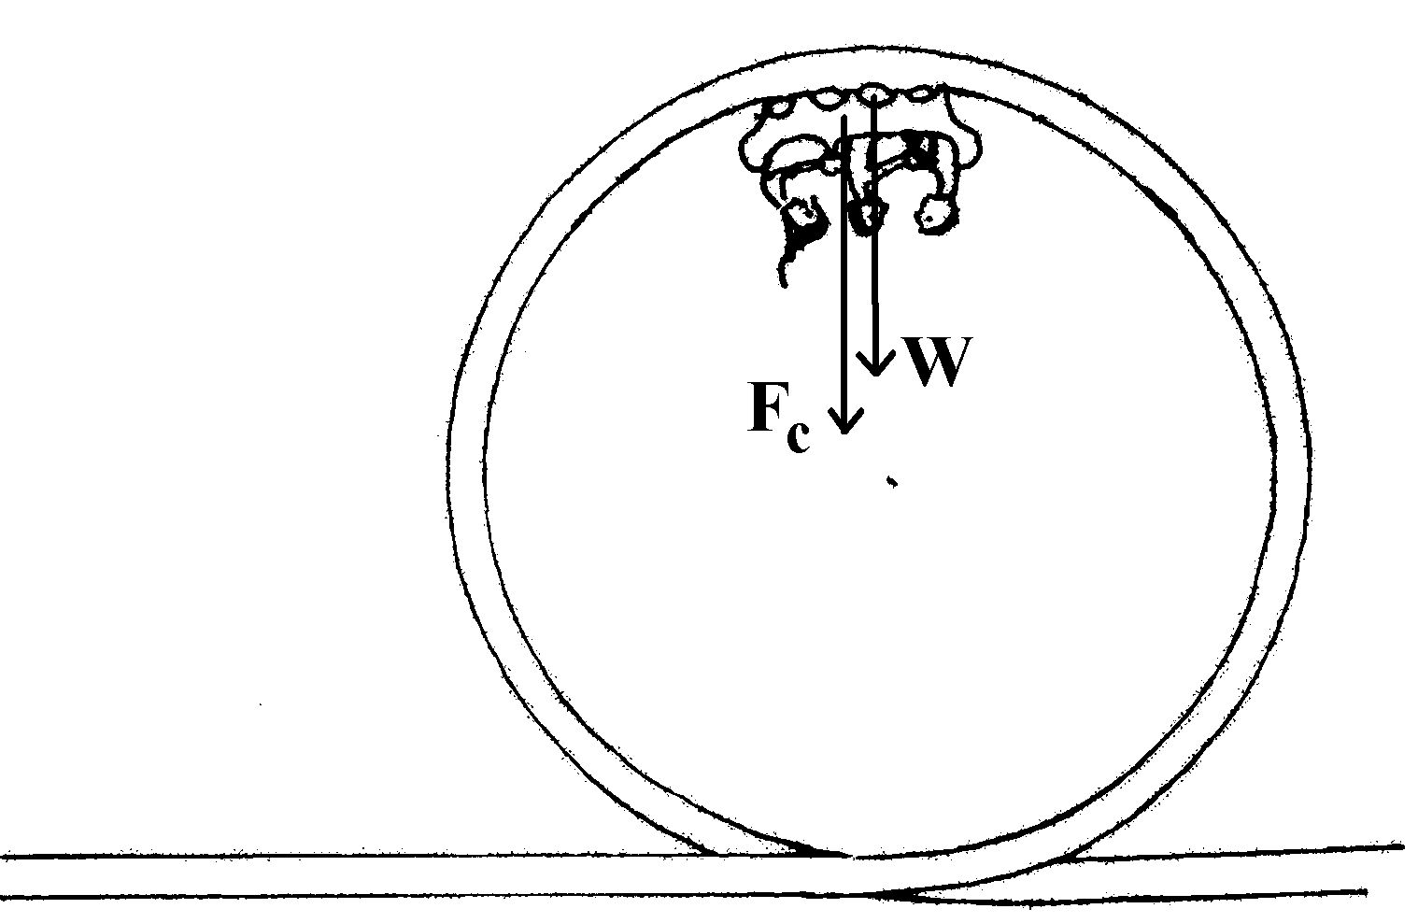
W ≡ weight of carriage plus riders

F _{C} = centripetal force

7a Energy is emitted as the electron moves from a higher level to a lower level.

7b For energy to be emitted the electron must ‘give up’ energy that it has acquired by being in a
higher energy level. For the electron to produce energy with a frequency of ultra violet light the
electron must have been previously promoted to the higher level so it will release energy as it
‘falls’ to the lower energy level.

7c E = h x f

E = 6.63 x 10⁻³⁴ x 10¹⁶ = 6.63 x 10⁻¹⁸ J

E = 6.63 x 10⁻¹⁸ / 1.60 x 10⁻¹⁹ = 41.4 eV

Velocity of footballer = 7 m s⁻¹
Radius = 20 m

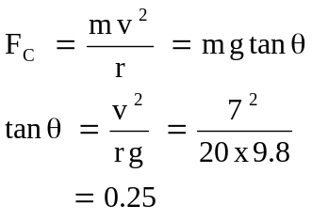
angle of lean to the vertical = 14º

9a The sound is being diffracted. The groan is a lower frequency sound than the sound produced
by the drill so is more likely to be diffracted through the doorway and so reach patient B. The
wavelength of the groan is closer in magnitude to the width of the doorway than the drill
wavelength so greater bending (diffraction) of the sound occurs.

9b A sound absorbing material such as a soft, material with an irregular surface and air trapped
within it, capable of absorbing the sound. Heavy cloth or carpet would be suitable. Special
‘acoustic’ tiles would also be suitable.

- F = I l B

  - = 40 x 1 x B

B = 2.5 / 40 = 6.25 x 10⁻² T

11a
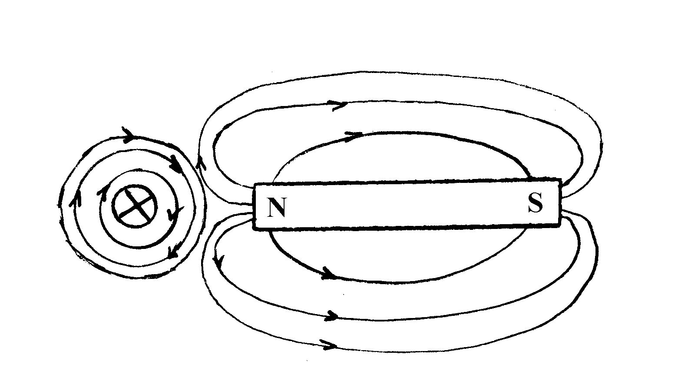

11c The interaction of the magnetic lines of force are such that attraction occurs towards the top of
the diagram and repulsion occurs at the bottom of the diagram. The resultant movement is
therefore in the direction indicated.

12 l = 2.10
B = 5.00 x 10⁻⁶ T
emf = ?
v = 110 km h⁻¹ = 30.56 m s⁻¹

emf = B l v

= 5 x 10⁻⁵ x 30.56 x 2.10 = 3.21 x 10⁻³ V EAST

13 dB = 10 log I / I₁
12 = 10 log I / I₁

  - = log I / I₁

I / I₁ = 10^{1.2} = 15.8

So there are 15 or 16 trumpet players in the group.

14a Wire ‘B’

14b Because of its smaller angle to the vertical, wire B will have a greater vertical component
downwards than wire ‘A’.

14c Cos 35º = vertical component / 1 560
vertical component = Cos 35 x 1 560 = 1.28 x 10³ N

15a v = (2 x P x r) / t

v = 2 x 12 x 10⁻² / .02

= 37.7 m s⁻¹

15b EMF = n x (B v l)

= 75 x (1 x 10⁻³) x 37.69 x (35 x 10⁻²)

= 0.99 V

Section B

1a velocity of sound in iron = 5 200 m s⁻¹
length = 6.0 m = half a wavelength
wavelength = 12.0 m

v = l x f
5 200 = 12 x f
f = 5 200 / 12 = 433 Hz

1b velocity of sound in carbon dioxide = 269 m s⁻¹
wavelength = 12.0 m
f = ?
v = 12 x f
f = 269 / 12 = 22.4 Hz

1c The second harmonic = 2 x 22.4 = 44.8 Hz

1d Resonance occurs when a body vibrates in sympathy with another vibrating source. That is, it
vibrates at its natural frequency in sympathy with the other source.

1e All harmonics will sound for both the gas within the chimney and in the chimney tube itself.
Therefore the harmonic of the vibrating gas which will resonate at the same frequency as the
chimney tube will be a multiple of its fundamental.

433 / 22.4 = approx 19

so it will be the 19th harmonic.
The observer would hear an increase in volume of the sound as more material is vibrating at a particular frequency, thus increasing the loudness of the sound. The observer would hear a sound with a frequency of 433 Hz.

2a g = G x M / r²

= (6.67 x 10⁻¹¹) x ( 2.14 x 10²³) / (1.35 x 10⁶)²

= 7.83 m s⁻²

So the spring balance reading is 10 x 7.83 = 78.3 N

2b Total radius of orbit = (1.35 x 10⁶) + ( 2.7 x 10⁶) = 4.05 x 10⁶ m

g = (6.67 x 10⁻¹¹) x (2.14 x 10 ²³) / (4.05 x 10⁶)²

= 0.87 m s⁻²

2c velocity of Nereid = v = (2 x π x 5.50 x 10⁹) / (360 x 24 x 60 x 60)

= 1.11 x 10³ m s⁻¹

(m v² / r) = (G M m / r²) so M = v² r / G

M = (1.11 x 10³)² x 5.5 x 10⁹) / ( 6.67 x 10⁻¹¹)

Mass of Neptune = 1.02 x 10²⁶ kg

2d The total gravitational force that the space craft experiences is the resultant force it experiences
between being attracted to both Neptune and Triton.

F_{resultant} = (G M_{Nep} m / r²) - (G M_{Tri} m / r²)

= G [ ( M_{Nep} m / r²) - (M_{Tri} m / r²)

= 6.67 x 10⁻¹¹ [ (1.02 x 10²⁶) x (2.00 x 10³) / (3.53 x 10⁸)²] - [2.14 x 10²³) x (2.00 x 10³) /
(3.375 x 10⁶)²]

= 2.30 x 10³ N towards Triton

3a Take moments about the hinge (A)

Σ CM = Σ ACM
(950 x 2.5) + [(154 x 9.8) x 5] = T x sin 37º x 6.45
2 375 + 7 546 = T x 3.882

T = 2.56 x 10³ N

3b To calculate the horizontal tension (T_{h}) in the cable.

Sin 37º = T_{h /} 2 555

T_{h} = Sin 37º x 2 555 = 1.54 x 10³ N

To calculate the vertical component (T_{v}) in the cable

Cos 37º = T_{v} / 2555

T_{v} = Cos 37º x 2 555 = 2.04 x10³ N

At the hinge
Forces down = 950 + 1509.2 = 2 459.2 N
Forces up = 2 040 N

Net force down = 419.2 N
Horizontal force = 1 537.6 N

Resultant is R which is the force of the wall on the structure.

R² = 419.2.² + 1 537.6²

R = (419.2.² + 1 537.6²)^{1/2}

R = 1.59 x 10³ N up.

3c Tan θ = 419.2 / 1 537.6
Therefore the angle is 15.2º above the horizontal.

4a The quantum mechanical model of the atom postulates that electrons can only occupy certain energy levels within the atom. The electrons must be in one level or another, not occupying space between levels. If an electron is supplied a quantum of energy it may be excited to occupy an energy level above. When the electron returns to its original energy level it releases a photon of energy which has a discrete quantity of energy. The photon will have a discrete frequency which places it in a particular place on the electromagnetic spectrum continuum.

4b It is a line emission spectrum.

4c Because the visible spectrum accounts for only a small part of the total electromagnetic spectrum there are limited transitions of electrons that correspond to energy transitions in this region. In the hydrogen atom energy levels shown in the diagram there are a finite number of transitions that correspond to emissions in the visible spectrum. There may be other transitions (emission lines) but these correspond to frequencies outside the range of the visible frequencies.

For a wavelength of 7 x 10⁻⁷ m
frequency = 4.3 x 10¹⁴ Hz which corresponds to an energy of 1.8 eV

For a wavelength of 4 x 10⁻⁷ m
frequency = 7.5 x 10¹⁴ Hz which corresponds to an energy of 3 eV

So for the emission lines to be in the visible region they must have energies between
1.8 eV and 3 eV

The only transitions which fall in between these energy limits are:
1.51 to 3.39 ( n = 3 to n = 2)
0.85 to 3.39 (n = 4 to n = 2)
0.54 to 3.39 (n = 5 to n = 2)

4d It is likely you would see 3 brightly coloured lines on a black background. The colours of the lines would be red and 2 blue/green lines

4e The wavelength of the line number 2 is likely to be about 5 x 10⁻⁷ m

c = λ x f
f = c / λ = 3 x 10⁸ / 5 x10⁻⁷ = 0.6 x 10¹⁵ Hz = 6 x 10 ¹⁴ Hz
The frequency is towards the violet end of the spectrum so the colour is most likely to be blue.

5a The principle of the simple transformer can be used to explain electro magnetic induction. In the case of the transformer in the diagram, the AC current produces an alternating current which produces a magnetic flux about the larger coil. As the flux cuts the smaller coil an induced emf is produced in the latter. As the flux collapses it again cuts the coil and induces an emf in the opposite direction. This process is repeated depending on the frequency of the AC. The emf is only induced as long and the flux is changing with respect to the coil.

5b The induced emf in the smaller coil (caused by the induction from the larger coil) provides enough current for the lamp to glow.

5c The iron bar is a magnetic material so when the flux is produced in the larger coil the effect is enhanced by the presence of the iron bar. The increased flux causes and increased induced emf in the smaller coil and so the lamp glows brighter.

5d The diagram represents a step down transformer. The induced emf is proportional to the number of coils on the secondary coil. The simple ratio of V_{s} / V_{p} = N_{s} / N_{p} illustrates this relationship. So an emf of 24 V in the primary coil would in this case produce an induced emf of 12 V in the secondary coil.

5e The induction only occurs when the flux is threading the coil. If DC was used the threading would only occur as the current initially expanded through the coil and then again when the DC was turned ‘off”. As the AC is threading back and forth many times per second the flux is continuously threading the coil.

5f V_{s} / V_{p} = N_{s} / N_{p}

Vs / 24 = 50 / 100

V_{s} = 12 V

The theoretical emf in the secondary coil is 12 V

6a ΔL = F x L / A x Y

6b Young’s Modulus for mild steel = 2.10 x10¹¹
cross sectional area = π (1.5 x 10⁻³)²
length = 4.00 m
force = (125 x 9.8) N.

ΔL = F x L / A x Y
ΔL = (125 x 9.8) x 4.00 / [π (1.5 x 10⁻³)² ] x 2.10 x10¹¹

= 3.30 x 10⁻³ m

6c ΔL = F x L / A x Y

ΔL = (125 x 9.8) x 4.00 / (A) x 1.93 x10¹¹
ΔL = 2.54 x 10⁻⁸ / A

6d For both the extensions to be equal

2.54 x 10⁻⁸ / A = 3.30 x 10⁻⁵

A = 2.54 x 10⁻⁸ / 3.30 x 10⁻⁵

A = 7.7 x 10⁻⁴

The cross sectional area of the wrought iron wire is 7.7 x 10⁻⁴ m²

7a angle = 40º to the horizontal
horizontal distance is 33.0 m
velocity = V₀

Vertically
s = 0 m
u = sin 40º x V₀
a = -9.8 m s⁻²

s = ut + 0.5 a t²

0 = (sin 40º x V₀ ) t + 0.5 (-9.8 x t²) ………. (1)

Horizontally
s = 33.0
u = cos 40º x V₀

cos 40º x V₀ = 33.0 / t

t = 33.0 / cos40º x V₀ ……………… (2)

Substitute for t in equation (1)

0 = (sin 40º x V₀ ) x (33.0 / cos40º x V₀) + [0.5 (-9.8 x (33.0 / cos40º x V₀ )²]

0 = (tan 40º x 33.0) - 9091 / V₀²

V₀² ⁼ 9091 / 27.69

V₀ = 18.1 m s⁻¹

The ball needs to be kicked with an initial velocity of 18.1 m s⁻¹

7b t = 33.0 / cos40º x V₀
t = 33.0 / 0.7660 x 18.1

t = 2.38 s

7c u = sin 40º x 18.1
a = -9.8 m s⁻²

v ² = u ² + 2 a s
0 = (sin 40º x 18.1) + (2 x -9.8) s

0 = (11.634)² - 19.6 s

s = 135.34 / 19.6 = 6.91 m
7d The ball will reach its maximum height when it is half way along the horizontal distance between the kick point and the goal line. This distance is 16.5 m.

Section C

Question 1

1 It is not possible to measure absolute tissue velocities because it is not possible to assume that the velocity of motion and the direction of the ultrasound beam are parallel.

2 velocity of sound in tissue = 1 540 m s⁻¹

velocity of blood cells = 0.06 m s⁻¹
frequency of transducer = 7.0 x 10⁶ Hz

Δf = 2 v_{t} f_{s} / v

= 2 x 0.06 x (7 x 10⁶) / 1 540
= 5.45 x 10² Hz

3 The target would be moving away from the observer. This movement causes a reduction in frequency as experienced by an observer. Frequencies in the red region of the spectrum are lower than frequencies in the violet region of the spectrum.

4 v_{e} = v cos θ

v_{e} = 10 x cos 60º

v_{e} = 10 x 0.5 = 5 cm s⁻¹

5 Ultrasound frequencies are used rather than audible frequencies because they can penetrate further into tissue than audible waves.

6 No. Sound waves do not travel through space as there is no medium to carry the wave.

7
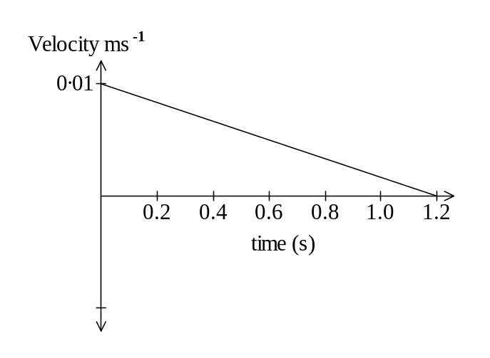

8 velocity of sound in tissue = 1540 m s⁻¹
distance = 0.02 m

v = distance / time

time = 0.02 / 15 40 = 1.30 x 10⁻⁵ s

Question 2

1 The Shuttle overshoots its orbital path and then performs a shallow dive under thrust to increase its speed to the required orbital value.

2 Thrust = force = mg

Thrust = 2 x 10⁶ x 9.8 = 2 x 10⁷ N

3 The release of the two boosters would decrease the mass of the shuttle and so the velocity would increase.

4 By making the shuttle ascend vertically after take off all the thrust is being directed to drive the
shuttle to its highest altitude. If it was to ascend at an angle then a component of the thrust would be used to drive the shuttle sideways and so it would achieve a lesser altitude for the same expenditure of fuel.

5 radius of the orbit = 6.57 x 10⁶
mass of the earth = 5.98 x 10²⁴
G = 6.67 x 10⁻¹¹
v = ( G x M / r)^{1/2}
v = [(6.67 x 10⁻¹¹) x (5.98 x 10²⁴) / (6.57 x 10⁶)]^{1/2}
v = 7.8 x 10³ m s⁻¹

6 The shuttle would need to reduce speed by firing retro rockets for it to descend to a lower altitude. When the new orbit has been achieved the shuttle would then increase speed to maintain the orbit.

