YEAR 12 PHYSICS

SEMESTER TWO EXAMINATION 2003

Name: _________________________

Teacher: _______________________

TIME ALLOWED FOR THIS PAPER

Reading time before commencing work: Ten minutes
Working time for paper: Three hours

MATERIAL REQUIRED/RECOMMENDED FOR THIS PAPER

TO BE PROVIDED BY THE SUPERVISOR

This Question/Answer Booklet
Physics Formulae and Constants Sheet

TO BE PROVIDED BY THE CANDIDATE

Standard Items: Pens, pencil, eraser, correction fluid and ruler

Special Items: Drawing instruments, templates and calculators satisfying the conditions set by the Curriculum Council.

IMPORTANT NOTE TO CANDIDATES

No other items may be taken into the examination room.

It is your responsibility to ensure that you do not have any unauthorised notes or other items of a non-personal nature in the examination room. If you have any unauthorised material with you hand it to the supervisor BEFORE reading any further.

STRUCTURE OF PAPER

Section | No. of questions | No. of questions to be attempted | No. of marks out of 200 | Proportion of examination total
A: Short Answers | 15 | ALL | 60 | 30%
B: Problem Solving | 6 | ALL | 100 | 50%
C: Comprehension and Interpretation | 2 | ALL | 40 | 20%

INSTRUCTIONS TO CANDIDATES

Write your answers in the spaces provided beneath each question. The value of each question (out of 200) is shown following each question.

The Physics Data Sheet must also be submitted with your exam.

Calculators satisfying the conditions set by the Curriculum Council may be used to evaluate numerical answers.

Answers to questions involving calculations should be evaluated and given in decimal form. Quote the final answer to no more than four significant figures. Despite an incorrect final result, credit may be obtained for method and working, provided these are clearly and legibly set out.

Questions containing specific instructions to show working should be answered with a complete, logical, clear sequence of reasoning showing how the final answer was arrived at; correct answers which do not show full working will not be awarded full marks.

Questions containing the instruction estimate may give insufficient numerical data for their solution. Students should provide appropriate figures to enable an approximate solution to be obtained.

SECTION A: Short Answers

Marks Allotted: 60 marks out of total of 200 marks (30%)

Attempt ALL 15 questions in this section. Each question is worth 4 marks. Answers are to be written in the space below or next to each question.

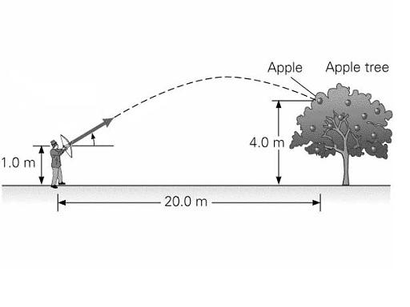
- An archer fires an arrow at a speed of 33.0 ms⁻¹ at an angle of 25° to the horizontal, so that it hits an apple as shown in the diagram below. Using this information and the information provided in the diagram, find the horizontal distance, X covered by the arrow.
X
25 º

- The diagram below shows a novelty bottle holder. It consists of a piece of wood that rests on a flat surface and holds the bottle at a surprising angle. It should be noted that the holder rests on a horizontal surface, but is not attached.
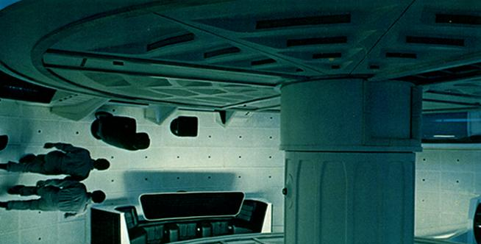
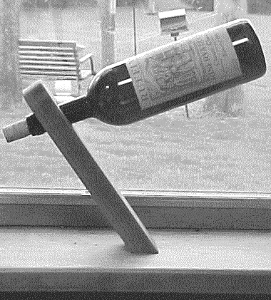
a) Explain the Physics behind this ingenious device.
b) Would the amount of wine in the bottle make a difference? Explain your answer.
NOT ATTACHED!
- The diagram shows two people walking in a futuristic revolving Space Station. If the diameter of the station is 29.5 m, find the rotational period necessary for occupants at the outer circumference, to experience a centripetal acceleration equivalent to “g” on Earth.

- A bus produces a sound level of 84 dB as it passes a cafe. A large truck produces a sound level of 96 dB. What would the sound level be if they both passed the cafe at the same time?
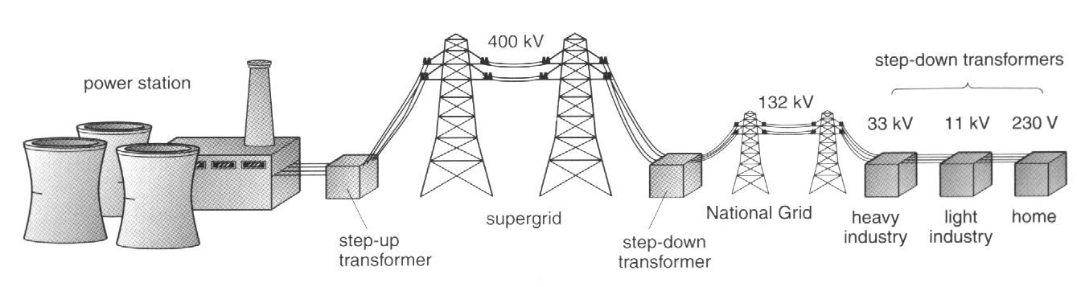
- The diagram below shows how Western Power distributes electrical energy in our state. Explain briefly why the voltage is stepped up to 400 kV and then stepped down for domestic use.

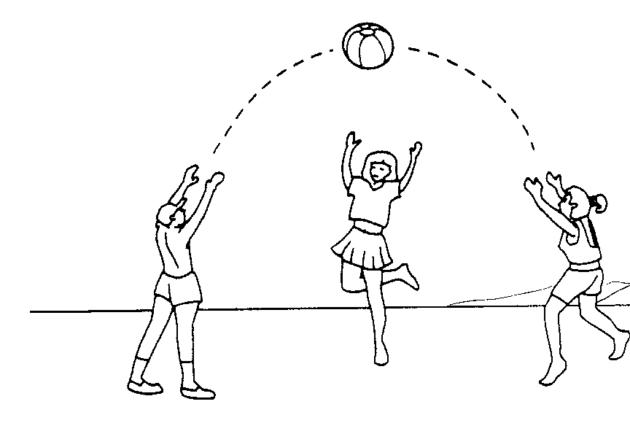
- Consider the diagrams, and indicate with an arrow, the net force in each situation. You may ignore the effects of air resistance.
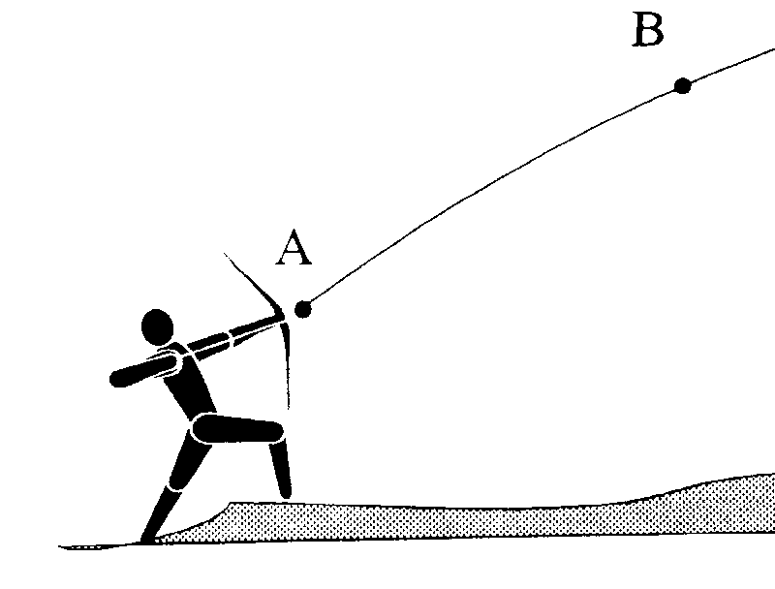
  - What is the direction of the net force on the ball at the instant shown?
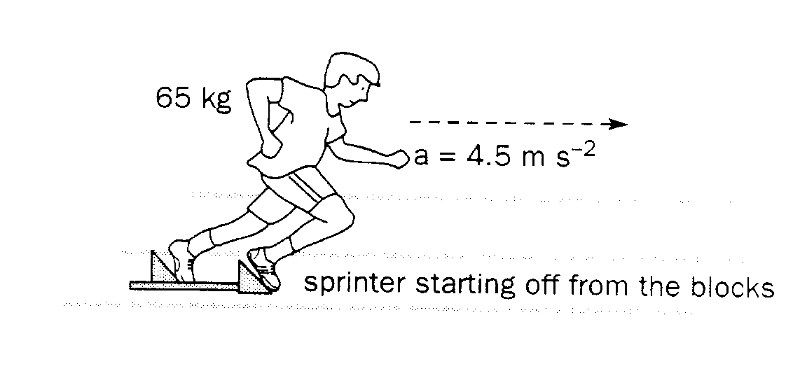
  - What is the direction of the net force on the arrow at position B?
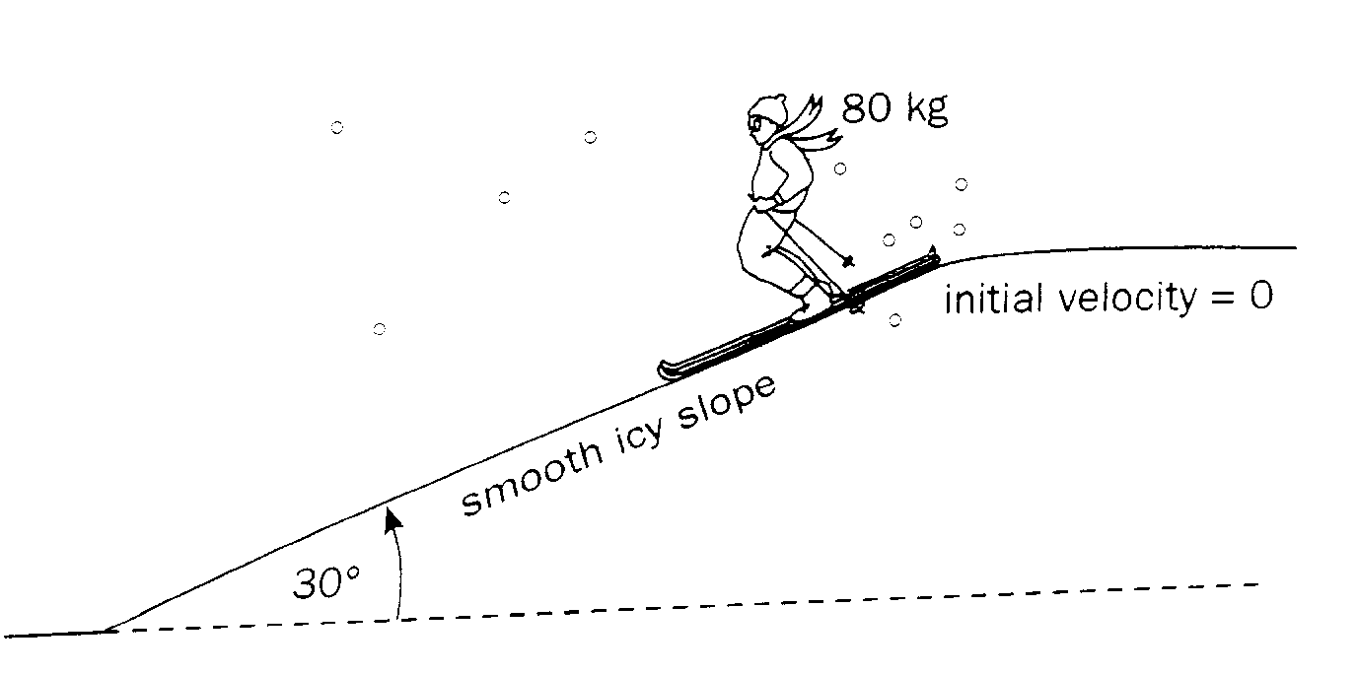
  - What is the direction of the net force on the sprinter?
  - What is the direction of the net force on the skier who is accelerating down the slope?

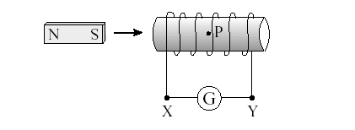
  - The diagram below shows a bar magnet being attracted to a simple solenoid connected to a Direct Current Voltage Supply (DCV). Show with an arrow, the direction of current flow through the coil for the magnet to move in the direction shown?
DCV
  - If you were holding the magnet quite close to the coil and an AC current was applied to the coil, what would you feel?

- Geostationary satellites appear to remain stationary to an observer on the planet about which they are orbiting. Find the altitude above the surface, that a geostationary satellite would have if it were orbiting our Moon. Note: The Moon rotates on its axis once every 28 “Earth days”.
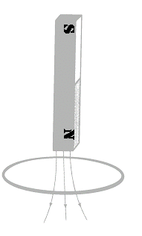
- The diagram shows a bar magnet falling into a single loop of wire.

  - Show with an arrow, the direction of the induced current in the wire.
  - How would the acceleration of the bar magnet vary as it passes through the loop? Explain.
- The graph to the right shows the stress-strain graphs for four different materials.
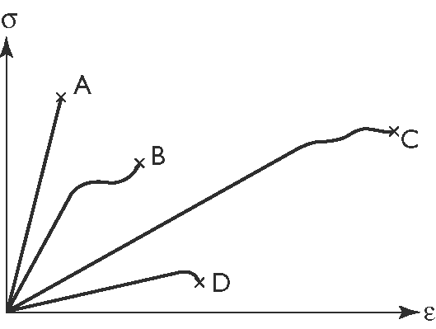
  - Which material has the highest Young’s Modulus value?
___________
  - Which material is most likely to be glass?
___________
  - Which material is the strongest?
___________
  - Which material is the stiffest?
___________
- The diagram below shows a set of equal loudness curves.
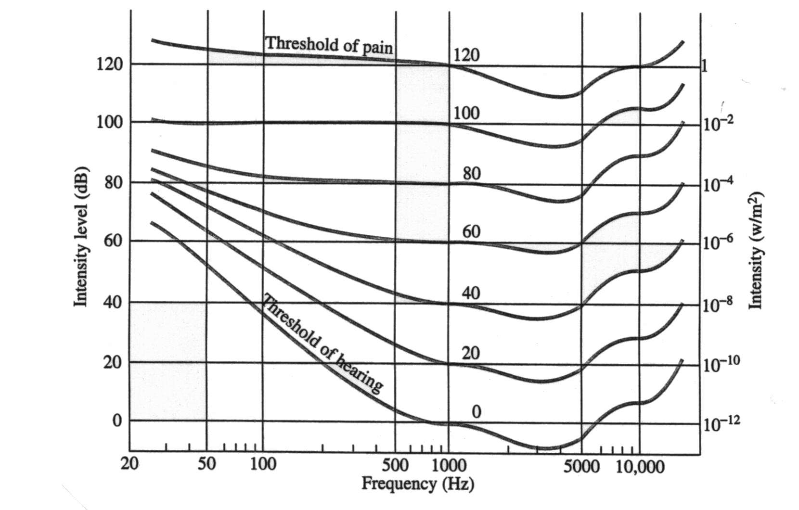
  - Explain why the curves on the graph are not horizontal lines.
  - At what frequency is the human ear the most sensitive? Relate this value to the fact that the human ear canal can be considered to be a closed pipe approximately 2.5 cm in length.

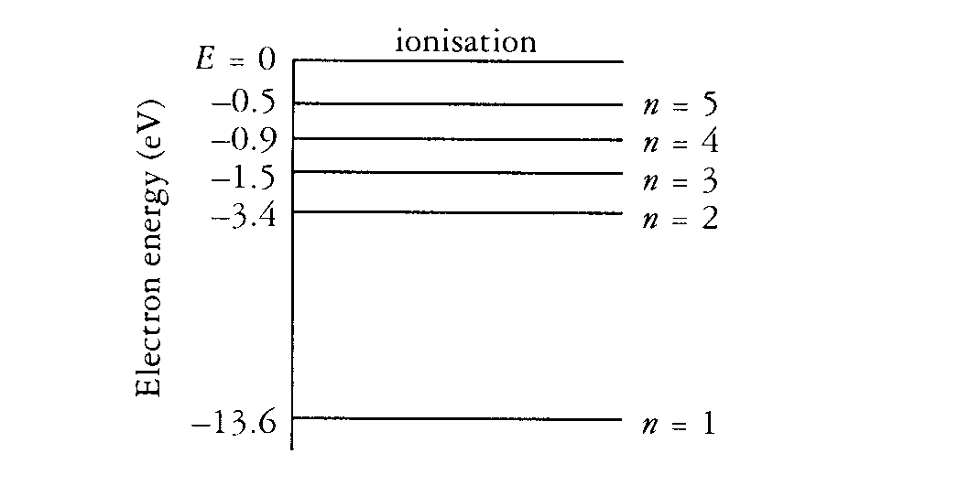
- The diagram below shows the energy levels for hydrogen.
  - If an electron in the n = 3 level returns to the ground state, what are the possible energies of the emitted photon?
  - Do any of the transitions yield photons in the visible part of the electromagnetic spectrum? Explain.



- A child’s mobile hangs in static equilibrium.
The mass of the horse is 200.0 g and the mass of the anchor 50.0 g.
10.0 cm
10.0 cm
10.0 cm
7.50 cm
2.50 cm
  - What is the mass of the teddy bear?
  - What is the mass of the helicopter?
- The diagram shows a simple electric generator.
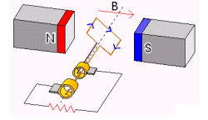
  - Does the diagram represent a dc generator or an ac generator (alternator)? Explain.
  - State two ways that an actual generator would differ from the one shown in the diagram.

Water
Air
- A student holds a 256 Hz tuning fork above a measuring cylinder which is full of water. She then gradually removes water from the cylinder, creating an air column as shown and notices that the sound produced becomes quite loud for the first time when the air column is 32 cm long.
A loud sound is also produced when a second tuning fork of a different frequency is sounded above the 32 cm long air column.

  - Which of the following frequencies could correspond to the frequency of the second tuning fork?
128 Hz 512 Hz 768 Hz
  - On the diagram, sketch the standing wave produced by the second tuning fork.

END OF SECTION A
SECTION B: Problem Solving

Marks Allotted: 100 marks out of total of 200 marks (50%)

This section contains 7 questions. You should answer
ALL of the questions.

Answer all questions in the spaces provided.

- [17 marks]
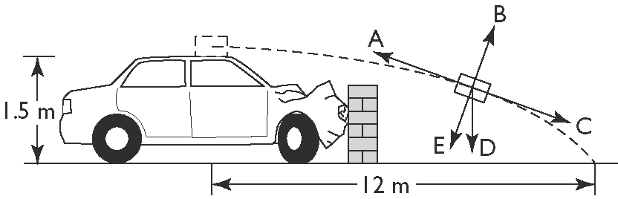
  - Daniel is driving his car on a level road at a constant speed when he accidentally hits a low rock wall. A suitcase which was very poorly secured to the roof of the car slides off the roof and strikes the ground 12 m in front of the point where it was on the car’s roof.
    - Daniel’s friend Tom, whom saw the accident, called out: “Wow – it’s amazing how the suitcase was thrown forward like that!” Do you agree with how Tom worded his exclamation? Explain.

[2 marks]
    - If the effects of air resistance were to be considered, which of the arrows A, B, C, D or E correctly indicates the net force on the suitcase in the position shown.
[2 marks]
    - Imagine that were called to the scene as an investigating police officer. Making any necessary assumptions, estimate the speed of Daniel’s car when it collided with the wall.
[4 marks]
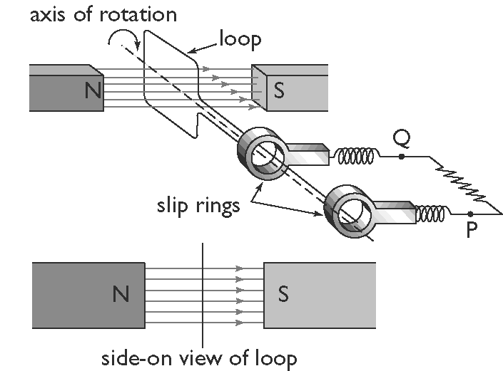
  - Eloise builds a model electric generator, similar to that shown in the diagram below The coil consists of 100 turns of wire and has an area of 6.0 × 10 ⁻³ m². The magnetic field between the poles of the magnets is measured to be 0.25 T.
EXTERNAL CIRCUIT
    - What is the magnitude of the magnetic flux passing through the coils in the position shown?

[2 marks]

    - Eloise then rotates the generator at a steady speed of 2 revolutions per second. What is the average emf induced by the generator?

[3 marks]

    - Assuming the position of the coil is as shown above, in what direction will current flow in the external circuit (P to Q or Q to P) for the next ¼ of a rotation?

[1 mark]
    - If the slip rings were changed to a split-ring commutator arrangement, the generator could be used as a dc electric motor. Find the maximum torue that such a motor would produce when connected to a current of 1.3 A.

[3 marks]
- [21 marks]
  - A simple crane is used in a service station to lift engines (represented as load L) from cars and transfer them to a work bench. Rollers are used so that the mechanic can move the engine from one end of the beam to the other as shown in the diagram. The beam (B) is 2.50 m long, the support wire (S) is attached 0.50 m from the outer end at an angle of 35º to the beam.
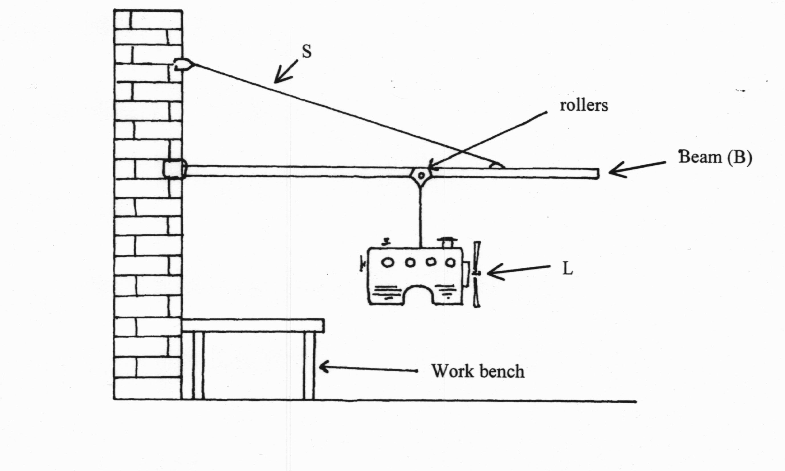
The beam is uniform and has a mass of 38.5 kg. The combined mass of the engine and the rollers is 165 kg. In the current position, the load is 1.50 m from the wall.
    - Draw a “free body diagram” of the beam “B”, showing all forces acting with the load in the position shown. Note: a free body diagram is a simple sketch of an object with all external forces represented as arrows.
[3 marks]
    - Find the tension in the support cable “S”, when the engine is at the position shown.
[3 marks]
    - Find the magnitude and direction of the reaction force that the wall exerts on the beam.
[5 marks]

- Cable S is made from mild steel.
  - At what position, would the engine be located for the stress in the cable S to be at a maximum?
[1 mark]
  - What is the minimum diameter of the cable, so that it doesn’t break when the engine is at the position described in part (i)?

[5 marks]
  - assuming that the cable in fact has a diameter of 1.2 cm, find the maximum amount by which the cable would stretch when lifting the 165 kg load.
[4 marks]
- [16 marks]
This question is about the growth of an electric current in a coil. When a coil is connected to a dc power supply the current in the coil does not change instantaneously but takes a finite time to reach a steady value.
  - Why does the current in the coil take some time to reach a steady value?
[3 marks]
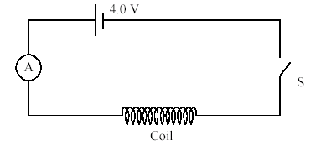
For a given supply, the final steady value of the current is determined by the resistance (R) of the coil. In the diagram below a coil is connected to a dc supply of emf 4.0 V.
When the switch S is closed an electronic timer is started and the current I is recorded at different values of the time t. The results are shown in the table below.
Time (s) | 0 | 0.2 | 0.6 | 1.0 | 1.4 | 1.8 | 2.0
Current (A) | 0 | 0.8 | 1.6 | 1.9 | 2.0 | 2.0 | 2.0

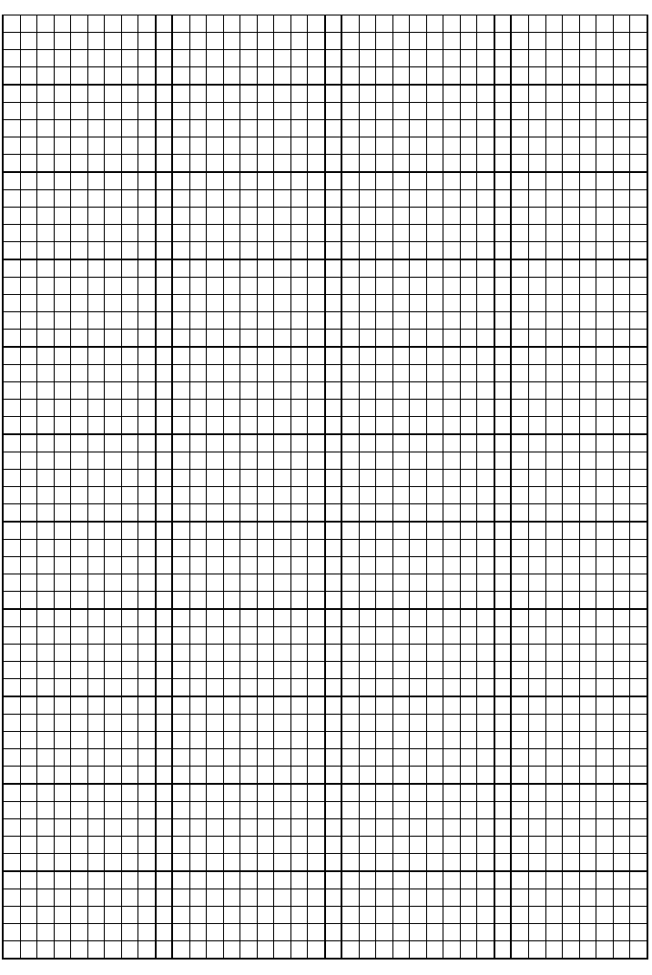
  - On the graph paper provided below, plot a graph of current against time.
[4 marks]
  - What is the steady state value of the current?
[1 mark]

  - Determine the value of the resistance R of the coil.
[2 marks]

  - By drawing a tangent to the curve at the point (0, 0) on your graph, determine the time it would take for the current to reach its steady state value if it were to continue changing at its initial rate. (This time is known as the time constant of the coil).
[2 marks]

  - The initial rate at which the current in the coil changes is given by the expression V/L, where V is the value of the supply potential and L is a property of the coil known as its inductance.
Show that the time constant τ, for the coil is given by the expression:
[3 marks]

  - Determine the value of the inductance L of the coil.
[1 mark]

- [19 marks]
  - Sodium vapour lamps are often used as street lights. They emit a characteristic monochromatic yellow light
    - .Describe the spectrum emitted by such a light.
[2 marks]
    - Could these lamps be used to emit white light? Explain.
[2 marks]
A student uses a sodium vapour lamp which is switched off to conduct the following experiment. Note: You should assume the lamp is full of sodium vapour, but is not emitting any light of its own.
WHITE LIGHT
TRANSMITTED LIGHT
NARROW SLIT
GLASS PRISM
WHITE SCREEN

    - What is the name of the type of spectrum that the student observes?
[1 mark]

    - Describe what the student would observe on the white screen.
[2 marks]

  - Hamish sprinkled some salt (which contains sodium atoms and chlorine atoms) onto a Bunsen flame and noticed that the flame glowed with a yellow colour.
Explain at the atomic level how this type of spectrum is formed.
[3 marks]
  - When white objects are exposed to ultraviolet light, they usually glow very brightly.
    - What is the name of this phenomenon?
[1 mark]
    - By using an “energy level diagram”, explain how ultra violet light can cause a white object to glow in this way.
[3 marks]
  - The diagram below (unlabelled) shows the main parts of an x-ray tube.
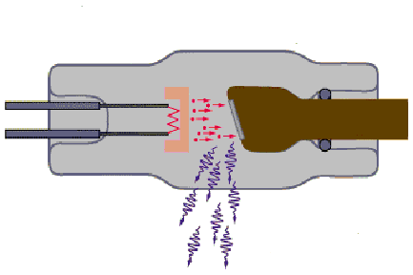
    - Label the important features of the tube.
[2 marks]
    - Briefly describe the generation of x-rays.
[3 marks]
- [16 marks]
  - Two students, Cathy and Ben are discussing an experiment to test the nature of sound waves. They imagine a loudspeaker with a dust particle sitting motionless in front of it, and consider what will happen to the particle when the speaker is turned on.
Cathy says that since there is energy transferred by the wave, the particle will gain energy. A succession of little impulses will push the particle continuously away from the speaker.
Ben agrees that energy is carried by the wave. However, the result of the pressure variations will cause the dust particle to move back and forth about its original position.
DUST PARTICLE
    - Who is correct? Explain.
[2 marks]
    - If the sound from the speaker has a frequency of 200 Hz, sketch on the axis below, a displacement-time for the particle for the first 0.01 seconds after the sound begins interacting with the dust particle.
[3 marks]
  - Two speakers are mounted on a wall in the school gymnasium. One speaker is at head-height and the other is 3 m directly above it. The speakers are connected to the same amplifier, and emit sound waves in phase.
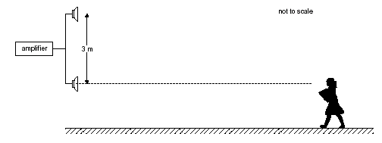
Cathy walks from the far end of the gym towards the lower speaker. Although the sound is quite audible, at a distance of 4.0 m from the speaker it becomes soft.
    - What is this phenomenon called?
[1 mark]
    - What is a possible frequency for the emitted sound that would produce this effect at a distance of 4.0 m from the lower speaker?
[3 marks]
    - Ben thinks he will check this out for himself, and stands on a chair (to hear the sound better) at the same point where Cathy is standing. To his surprise, he finds that the sound is very loud at the point where Cathy is standing. Explain this observation.
[2 marks]
  - Later in the day, Ben is practicing his guitar in the schools recording room. Cathy is standing outside the door as shown.
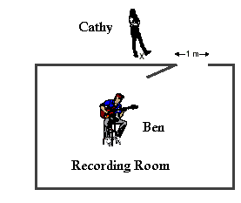
Cathy notices that although she can still hear the sound form Bens guitar, some frequencies seem louder than others.
    - What is the name given to the property of sound that explains this observation?
[1 mark]
    - Estimate the frequency Cathy is likely to hear the best, if the door opening
is 1.00 m.
[2 marks]
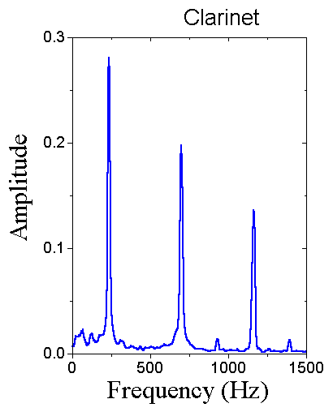
  - The following day, Cathy recorded herself playing the clarinet and produced the following frequency distribution analysis on her computer.
    - What does the graph tell you about the acoustics (sound properties) of a clarinet?
[2 marks]
    - How long is the air column in the clarinet?
[2 marks]
- [11 marks]
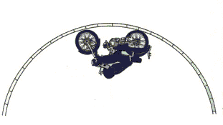
  - The diagram below shows Emma performing an amazing stunt on her motorbike. She is riding around an inverted curved track.
    - Draw labeled vectors on the diagram, showing all forces acting on Emma and her bike.
[2 marks]
    - Given that the radius of curvature of the track is 5.0 m. Find the minimum speed that Emma and her bike would need to have to be able to perform this stunt.
[2 marks]
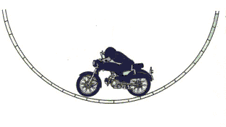
    - The diagram below shows Emma at the bottom of a piece of track also of radius 5.0 m. Estimate the force between Emma and the seat of the bike in the position shown if she is traveling at a steady speed of 30.0 kmh⁻¹. State any assumptions that you make.
[3 marks]
  - An electron and a proton are fired into a uniform magnetic field, each with a velocity of 2.0 x 10⁶ ms⁻¹.
X X X X X X X X X X
X X X X X X X X X X
X X X X X X X X X X
X X X X X X X X X X
X X X X X X X X X X
X X X X X X X X X X
X X X X X X X X X X
X X X X X X X X X X
X X X X X X X X X X
X X X X X X X X X X
X X X X X X X X X X
X X X X X X X X X X
PROTON
ELECTRON

    - Show on the diagram, the path followed by each of the particles.
[2 marks]
    - If the electron had a radius of curvature in the magnetic field of 5.12 cm, find the intensity of the magnetic field in Tesla.
[2 marks]
END OF SECTION B
SECTION C: Comprehension and Interpretation.

This section contains 2 questions and is worth 20% (40 marks out of 200) of the marks for the examination. Answer both questions in this section.

  - Read the passage below and answer the questions that follow. (20 marks)
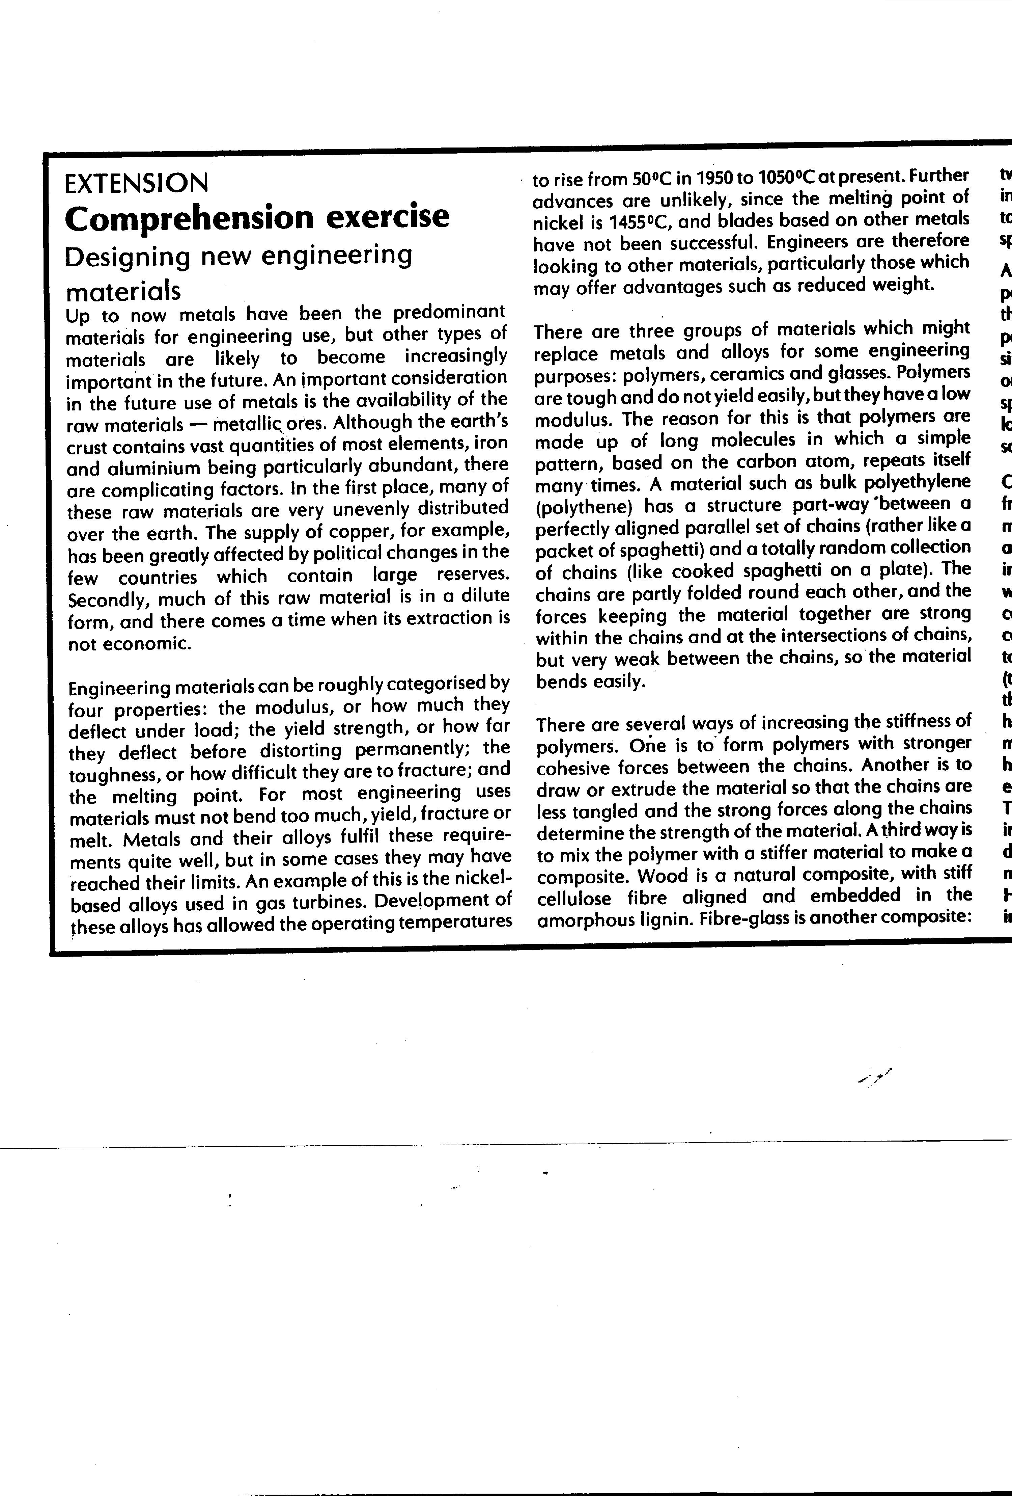
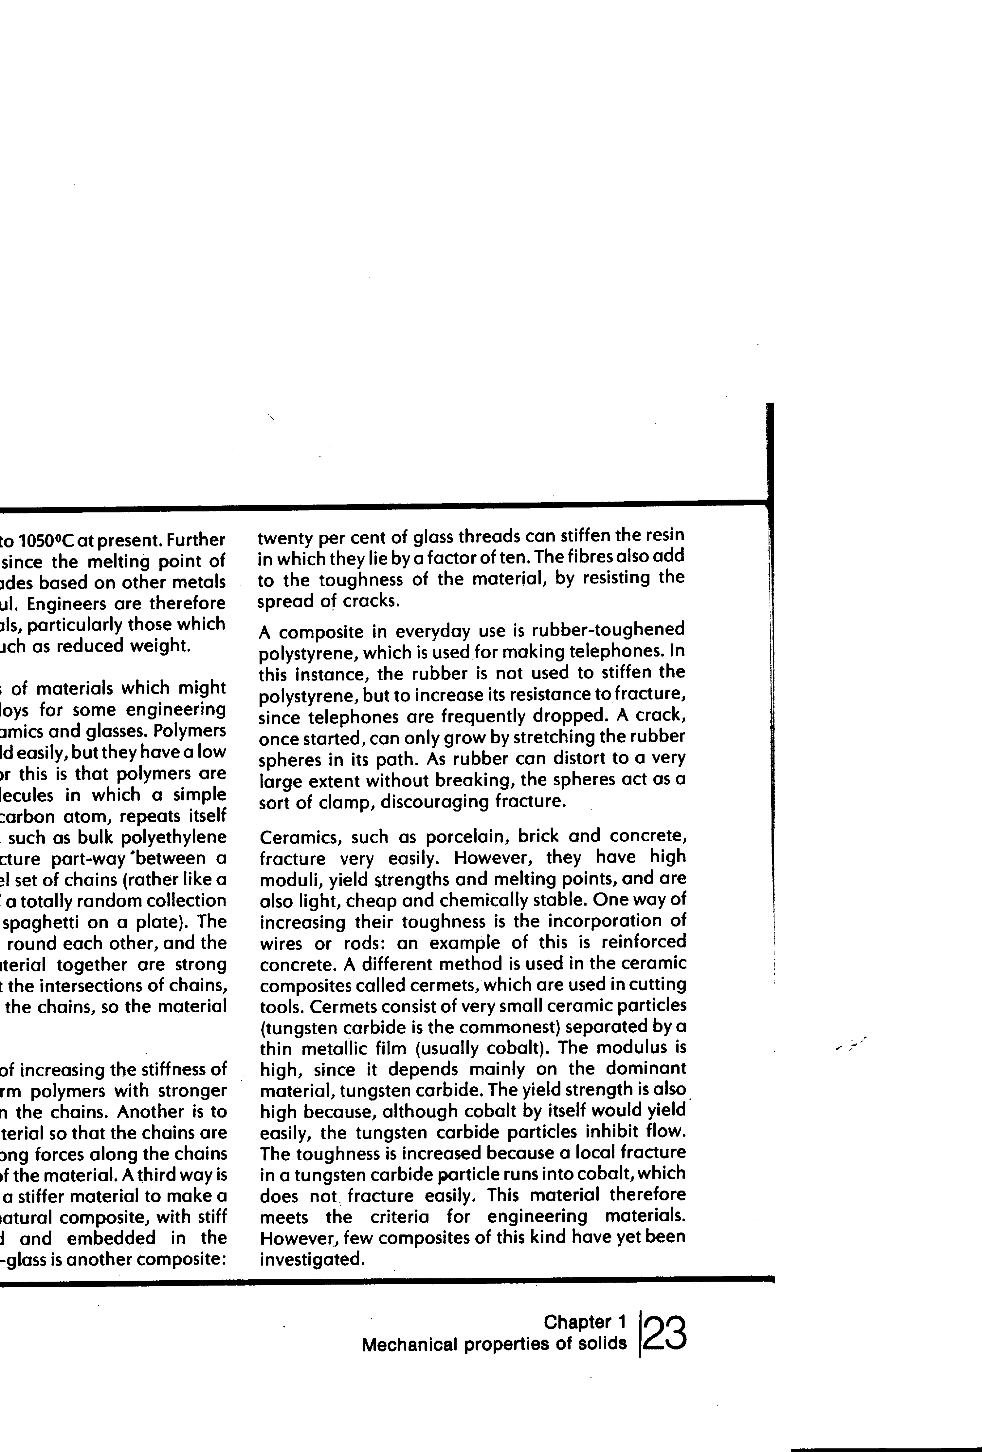
Gordon, J.E. The New Science of Strong Materials.
- Why is it necessary to seek non-metallic substitutes for metals?
[3 marks]
- What are the four important characteristics of engineering materials?
[2 marks]
- The terms modulus and yield strength are not defined in the text. Write a brief description of each term.
[4 marks]
- How has the operating temperatures of gas turbines been increased over the past 50 years and what now limits further advance?
[2 marks]

- Why do polymers bend easily? What are three ways of overcoming the problem?
[4 marks]

- What is a cermet? What properties of ceramic and metallic materials have they been designed to overcome and how does the formation of a composite do this?
[5 marks]
b) Read the passage below and answer the questions that follow. (20 marks)
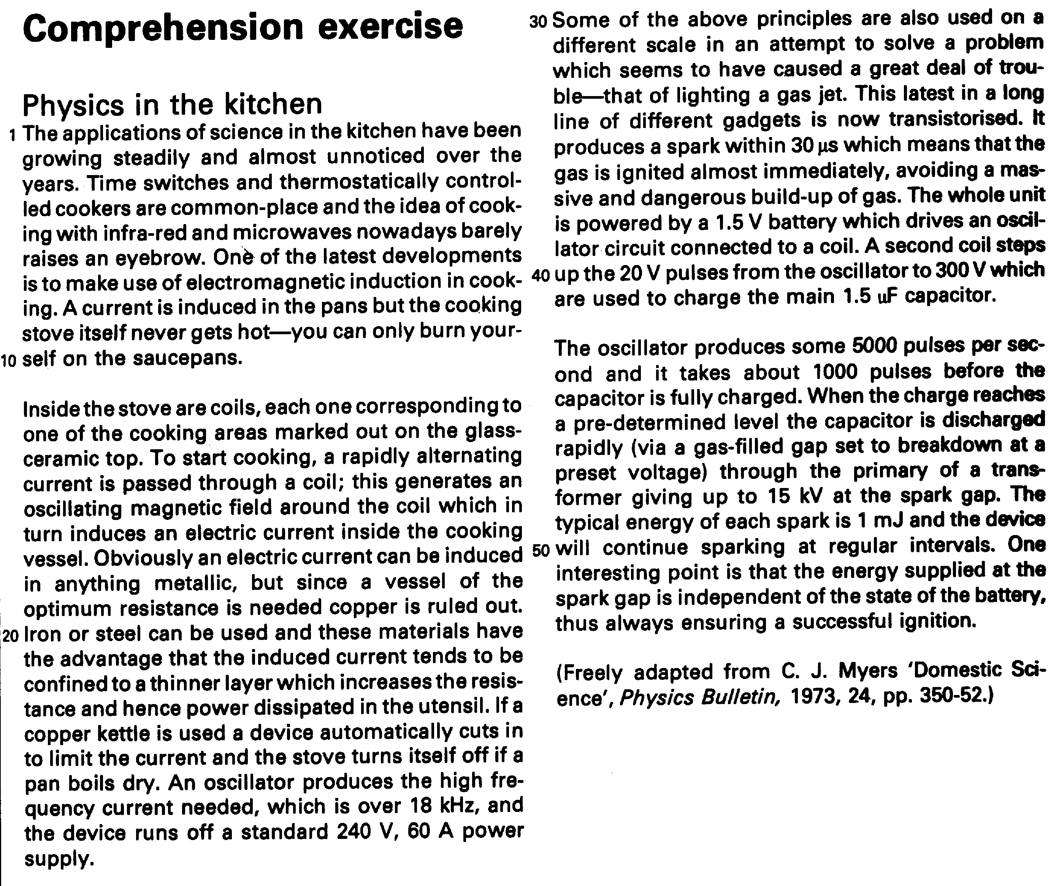

- A cook using an induction stove can turn on the appliance, touch the cooking area and not get burnt. Explain briefly the principle of the stove and why the user would not get burnt in this situation.
[3 marks]
- A friend is concerned that this type of cooking might give her a shock if she touched a pan while it was being used. Explain why this is not possible.
[2 marks]

- Explain why a copper kettle or a glass saucepan can not be used on an induction cook-top.
[3 marks]

- Would a dc current be suitable for an induction cooker? Explain.
[3 marks]
- The high frequency coil and cooking vessel system can be considered to act as a transformer.
i) If electricity is transferred to the cooking vessel at a rate of 2.00 kW and the resistance of the vessel is effectively 2.00 Ω, find the current flowing in the vessel.
[3 marks]

ii) If the supply voltage to the cooker is 240 V, what current does the cooker draw from the mains?
[3 marks]
- Some metals such as nichrome have a particularly high resistance. What would be the consequence of using a cooking utensil made from a metal with very high resistance?
[3 marks]
END OF SECTION C

END OF EXAM
END OF EXAMINATION

