EdWest 2003
Semester Two Physics Examination Solutions
(suggested solutions)

Section A:
- For vertical:
s = ut + ½ at²
3.0 = 33.0 sin 25º t + ½ (-9.81)t²
t = 0.234 (1st time arrow reaches height of apple), 2.62 (the one we want)
For horizontal:
s = 33.0 cos 25⁰ x 2.62
= 78.4 m
- a) C of M is positioned over the base of the holder.
b) Yes. The amount of wine determines position of C of M. ie: if bottle half-full,
C of M would be too far left and bottle may become unstable.
- a_{c} = v²/r
9.81 = (2π14.75/T)²/14.75
∴T = 7.70 s
- I_{bus} = 10^{(84/10)} x 10⁻¹²
= 2.51 x 10⁻⁴
I_{truck} = 10^{(96/10)} x 10⁻¹²
= 3.98 x 10⁻³
∴I_{total =} 4.23 x 10⁻³
∴ dB = 10 log (4.23 x 10⁻³/10⁻¹²)
= 96.3 dB
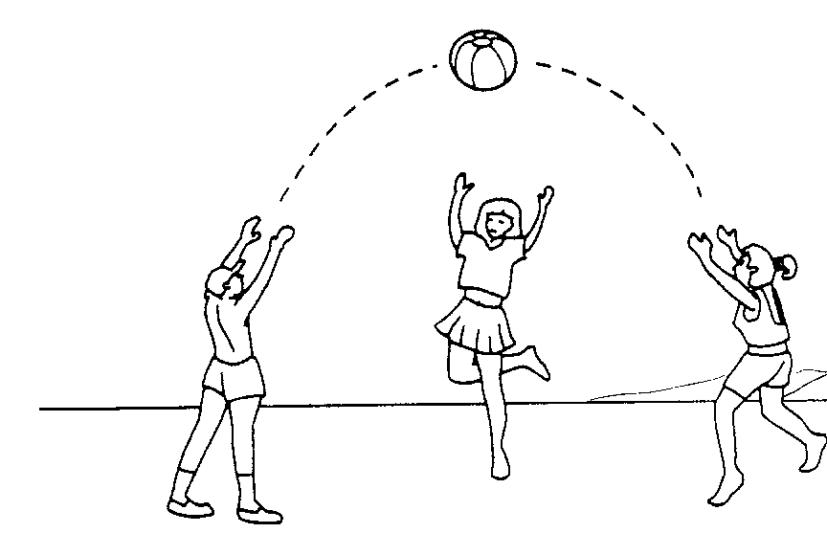
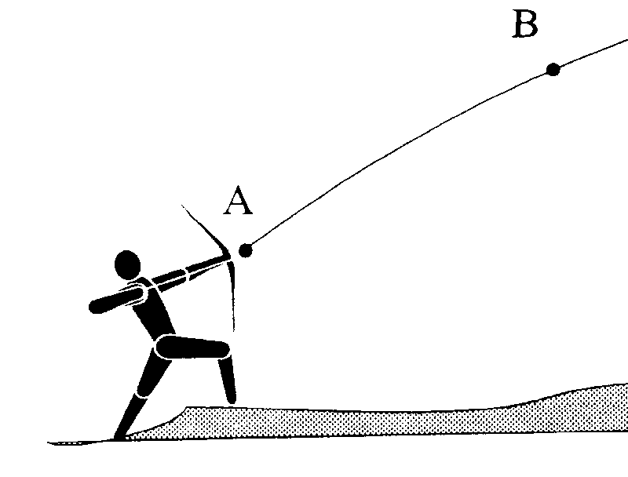
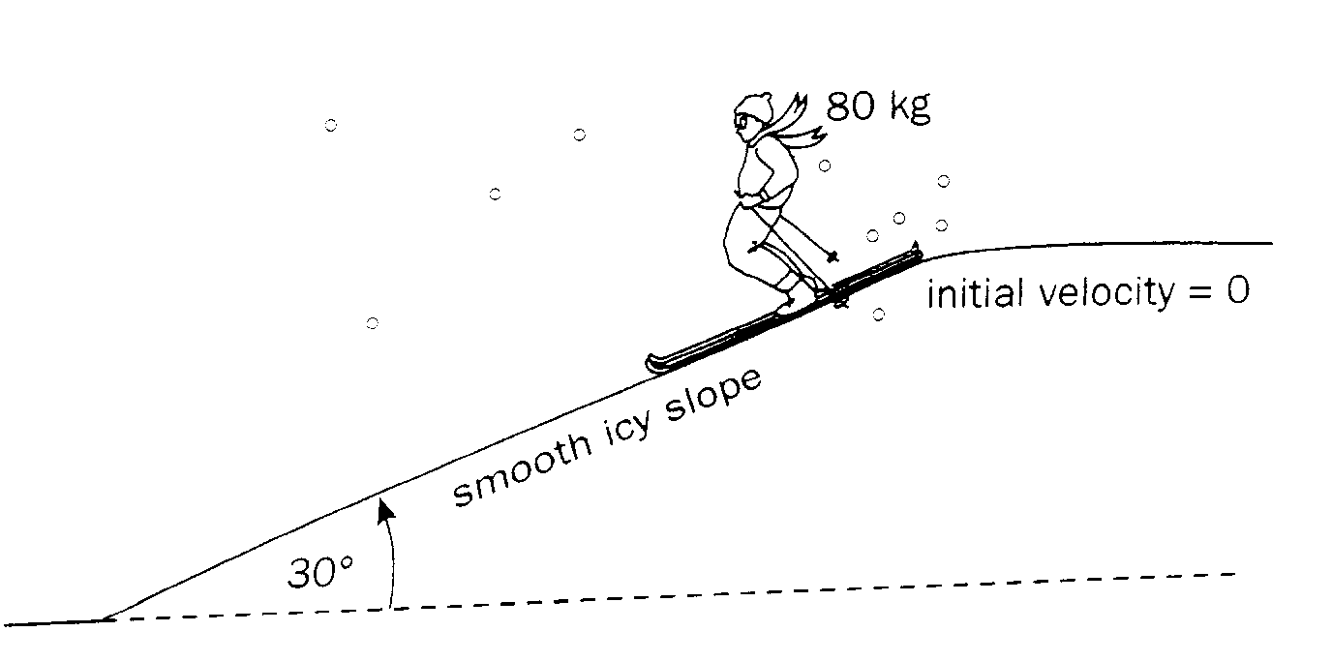
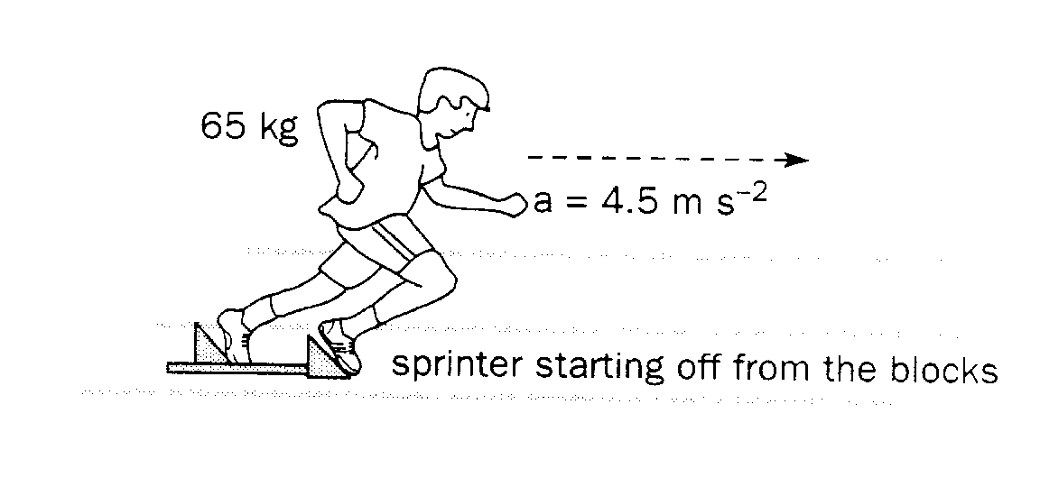
- P_{transmitted} = VI
P_{loss} = I²R, ∴large V and small I will minimise energy lost as heat due to resistance of transmission wires.

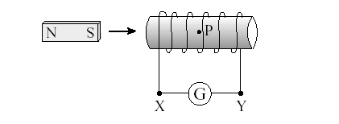
- a)
b) The Magnet would vibrate at the frequency of the applied AC current.
DCV
- GM_{moon}/r² = v²/r
6.67 x 10⁻¹¹ x 7.35 x 10²²/ r²=((2πr)/(28x24x3600))²/r
r³ = 6.67 x 10⁻¹¹ x 7.35 x 10²² x (28x24x3600)² / 4π²
r = 8.99 x 10⁷ m
∴altitude = 8.99 x 10⁷ – 1.74 x 10⁶
= 8.82 x 10⁷ m

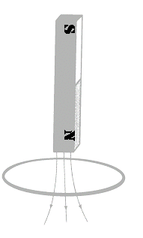
- a)
b) It would begin accelerating at “g” (9.81 ms⁻¹), then as current built up in the coil, there would be a retarding force (Lenz’s Law) and it would accelerate less than 9.81 ms⁻¹ (perhaps even zero acceleration – depending on strength of magnet and resistance of coil). Once it passed through the coil it would again accelerate at 9.81 ms⁻¹.
- a) A, b) A, c) A, d) A
- a) Frequency response of the ear is non-linear.
b) From graph ≈ 3500 Hz.
λ = 4L = 4 x 0.025 = 0.100 m. ∴F = 346/0.1 = 3460 Hz .
ie: The ear canal resonates at approximately 3500 Hz, ∴should be most sensitive for that frequency.
- a) 1.9 eV, 12.1 eV, 10.2 eV
b) Frequencies are: 4.59 x 10¹⁴ Hz, 2.92 x 10¹⁵ Hz and 2.46 x 10¹⁵ Hz
Note: According to Curriculum Council data sheet, the two most energetic photons could be visible (although actually part of the Lyman uv spectrum).
- a) Take M about vertical string.
ΣCM = ΣACM
M_{Teddy} x 9.81 x 2.5 = 0.05 x 9.81 x 7.5
∴M_{Teddy} = 0.15 kg
b) Take M about main vertical string.
ΣCM = ΣACM (note “g” values cancel and are therefore not included)
M_{Helicopter} x 10 = 0.200 x 20 + 0.200 x 10
∴M_{Helicopter} = 0.600 kg
- a) ac generator – slip rings present.
b) Many turns, radial magnetic field, 3 or more sets of coils and slip rings, electromagnets could also be used to supplement the permanent magnets (not replace them as still need initial flux!)


- a) 768 Hz (the third harmonic of the first tuning fork.)
b)
Water
Air

Section B
- a) i) No. The suitcase simply continues on its path (Newton’s 1st Law)
ii) E
iii) Assume: friction between roof of car and suitcase is negligible.
friction between air and suitcase is negligible.
consider vertical:
t = √(2h/g)
= √(2 x 1.5/9.81)
= 0.553 s
consider horizontal:
V_{H} = 12/0.533
= 21.7 ms⁻¹ (78.1 kmh⁻¹)
b) i) Φ = nBA
= 100 x 0.25 x 6.0 x 10⁻³
= 0.150 Wb
ii) emf = ΔΦ/t (t for ¼ of a revolution)
= 0.15/0.125
= 1.20 V
iii) P to Q
iv) Torque = nBAI
= 100 x 0.25 x 6.0 x 10⁻³ x 1.3
= 0.195 Nm
- a) i)
ii) Take M about wall:
ΣCM = ΣACM
165x9.81x1.5 + 38.5x9.81x1.25 = Tx2.0 x sin 35º
∴T = 2 530 N
iii) consider horizontal equilibrium:
R_{x} = T cos 35º
= 2 530 x cos 35º
= 2070 N
consider vertical equilibrium:
R_{y} = 38.5 x 9.81 + 165 x 9.81 - 2530 x sin 35º
= 545 N
∴R² = 2070² + 545²
∴ R = 2 140 N
tan θ = 545/2070
∴ θ = 14.7º
ie: Reaction force is 2 140 N, inclined at an angle of 14.7º to the horizontal.
b) i) End of beam furthest from the wall.
ii) Breaking stress of mild steel = 11.0 x 10⁸ Pa (from data sheet)
Take M about wall:
ΣCM = ΣACM
165x9.81x2.5 + 38.5x9.81x1.25 = Tx2.0 x sin 35º
∴T = 3 940 N
σ = F/A
A = F/σ
πr² = 3940/11.0 x 10⁸
r = 0.00107 m
∴d = 0.00214 m (2.14 mm – strong stuff!)
iii) 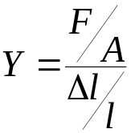
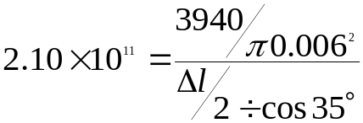

R

R

W

T
ΔL = 4.05 x 10⁻⁴ m
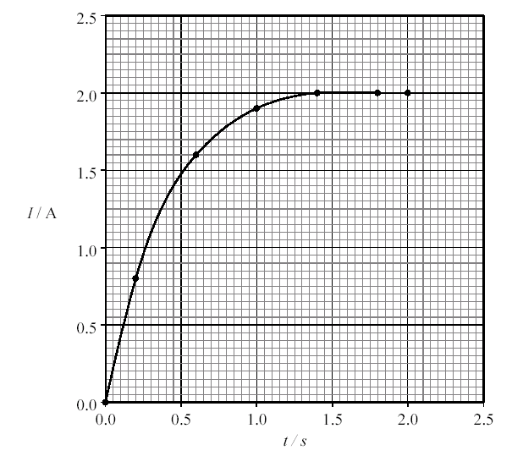
      - a) As current builds up in the coil, so does a magnetic field. As the magnetic field builds up, it induces a “back emf” that opposes the original current (Lenz’s Law). Therefore it takes some time to reach a steady state.
b)
c) 2.0 A
d) R = V/I
= 4/2
= 2.0 Ω
e) Time constant = 0.50 s
f) final value of the current = V/R,
time to reach maximum value = final value / rate of change
ie: τ = V/R ÷ V/L = L/R
g) 0.5 = L/2.0
∴L = 1.0 Ω s
Current (A)
Time (s)
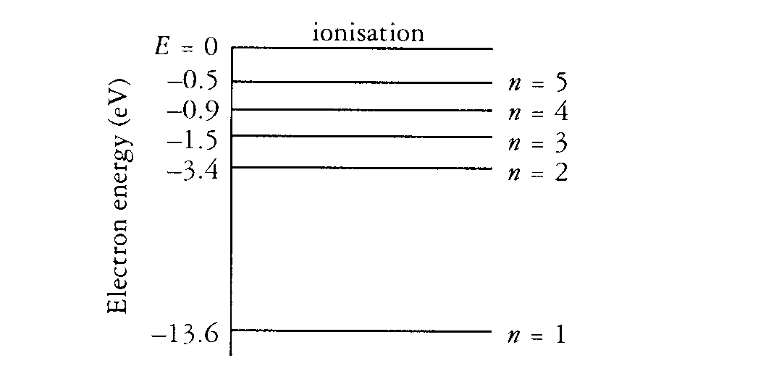
      - a) i) As series of bright lines on a dark background (emission spectrum).
ii) No, the spectral lines are a property of the gas present, unless the gas was changed to one with many more emission lines covering a wider area of the visible spectrum, white light would not be possible.
iii) Absorption spectrum
iv) A continuous spectrum with dark lines at the same position as the bright lines in part (a).
b) The heat from the flame excites the electrons in the atoms of the salt causing them to be promoted higher energy levels. When the electrons return to the ground state, they emit photons of light, some of which are in the visible region.
c) i) Fluororescence
ii) A high energy photon (uv) causes an electron to be promoted to high level, then the electron returns the ground state via a series of smaller transitions (cascades). A lot of these smaller transitions emit photons in the visible spectrum.
Current (A)
Time (s)
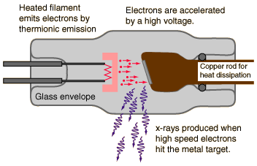
d) i)
ii) X-rays are produced when fast moving electrons rapidly decelerate upon hitting a metal target. The Kinetic energy lost is converted to heat and photon of high frequency emr (x-rays).
Higher Voltages produce more energetic x-rays (hard x-rays)

      - a) i) Ben is correct. Sound is a wave and only energy is transferred, there is no net displacement of particles.
ii)
b) i) Destructive interference.
ii) pd = ½ λ
5 – 4 = ½ λ
∴λ = 2.0 m
∴f = 346/2 = 173 Hz
Displacement
0.005 s
0.01 s
iii) Because he is standing higher, he may be standing at a point where his head is equidistant from both speakers, therefore constructive interference.
c) i) Diffraction
ii) Diffraction is maximized when λ approximates the gap width.
∴ f = V/λ
= 346 Hz.
d) i) closed pipe (only odd harmonics)
ii) fundamental approximately 220 Hz (from graph)
λ = 346/220
= 1.57 m
∴length = ¼ x 1.57
= 0.39 m

Reaction force from track
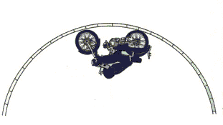
      - a) i)
ii) v²/5.0 = 9.81
v = 7.00 ms⁻¹
iii) Assume Emma’s mass = 50 kg.
R = mg + mv²/r
= 50 x 9.81 + 50 (30/3.6)²/5
= 1180 N
w
b) i)
ii) Bvq = mv²/r
B = 9.11 x 10⁻³¹ x (2.0 x 10⁶)²/(0.0512 x 2.0 x 10⁶ x 1.60 x 10⁻¹⁹)
= 22.2 x 10⁻⁴ T
PROTON
ELECTRON
X X X X X X X X X X
X X X X X X X X X X
X X X X X X X X X X
X X X X X X X X X X
X X X X X X X X X X
X X X X X X X X X X
X X X X X X X X X X
X X X X X X X X X X
X X X X X X X X X X
X X X X X X X X X X
X X X X X X X X X X

X X X X X X X X X X

Section C

a)
- Poor availability of some metal ores. Extraction can be non-economic.
- Modulus, yield strength, toughness and melting point.
- modulus: a measure of how well a material resists a stress. eg: Young’s modulus relates to tensile stress etc etc
yield strength: A stress value, beyond which materials undergo permanent deformation. eg: plastic materials have a very low yield strength etc etc
- Temps have risen from 50º C in the 50’s to temps over 1000 º. MP of nickel is
1455 º C and experiments with other materials are so far unsuccessful.
- Made of long molecule chains. The chains are strong, but only weak forces exist between the chains. To improve: 1) form polymers with stronger bonds between chains, 2) extrude to so that chains are less tangled, 3) make a composite.
- Cermets consist of very small ceramic particles separated by a thin metallic film. Toughness is usually low for ceramics, but the presence of the metallic film stops factures before they can spread. Most metals yield easily, but the presence of the ceramic limits this. Most metals have a low modulus, but the presence of the ceramic increases this and limits deformation etc.
b)
- The stove induces a current in metal cooking utensils and this current causes heat in the utensil due to its resistance. The user’s hand is not metallic and therefore no current is induced and no heat.
- Resistance of metal pan is much lower than user therefore current will not leave pan.
- Copper has a very low resistance and therefore the current in the kettle would be too great. Glass doesn’t conduct electricity!
- NO. A current will only be induced in the pan if there is changing B field. This will only happen initially for a dc current. Need an ac current to keep the B field fluctuating.
- i) P = I²R
I² = 2000/2
I = 31.6 A
ii) P = VI
I = P/V
= 2000/240
= 8.33 A
- If resistance too high, current too small. Not enough heat dissipated (P=I²R)

