PHYSICS 2004

YEAR 12
These test papers are copyright and may not be reproduced in any way.
 This paper should be withdrawn after use and stored securely in the school until Monday 25th October 2004.
Test papers may not be used for private tutoring before the above date.



Name: _______________________________________Teacher: _________________________________

TIME ALLOWED FOR THIS PAPER:
Reading time before commencing work: Ten minutes
Working time for paper: Three hours

MATERIAL REQUIRED/RECOMMENDED FOR THIS PAPER

To Be Provided By The Supervisor
This Question/Answer Booklet comprising 40 pages.
Physics: Formulae and Constants Sheet (inside front cover of this Question/Answer Booklet).

To Be Provided By The Candidate
Standard Items: Pens, pencils, eraser or correction fluid, ruler.
Special Items: MATHOMAT and/or Mathaid, compass, protractor, set square and calculators satisfying the conditions set by the Curriculum Council.

IMPORTANT NOTE TO CANDIDATES
No other items may be taken into the examination room.

It is your responsibility to ensure that you do not have any unauthorised notes or other items of a non-personal nature in the examination room. If you have any unauthorised material with you hand it to the supervisor BEFORE reading any further.

STRUCTURE OF THE PAPER

Section | No. of  Questions | No. of questions to  be attempted | No of marks out  of 200 | Proportion of  Examination total
A: Short Answers | 15 | ALL | 60 | 30%
B: Problem Solving | 7 | ALL | 100 | 50%
C: Comprehension  And Interpretation | 2 | ALL | 40 | 20%

INSTRUCTIONS TO CANDIDATES

Write your answers in the spaces provided beneath each question. The value of each question (out of 200)
is shown following each question. You should note that the space made available for an answer is not
necessarily an indication of the length of the answer.

The enclosed Physics: Formulae and Constants Sheet may be removed from the booklet and used as required.

Answers to questions involving calculations should be evaluated and given in decimal form. It is suggested
that you quote all answers to three significant figures with the exception of questions for which estimates
are required. Despite an incorrect final result, you may obtain marks for method and working, provided
these are clearly and legibly set out.

Questions containing specific instructions to show working should be answered with a complete, logical,
clear sequence of reasoning showing how the final answer was arrived at. Correct answers which do not
show working will not be awarded full marks

Questions containing the instruction "Estimate" may give insufficient numerical data for their solution.
Students should provide appropriate figures to enable an approximate solution to be obtained.

When descriptive answers are required, you should display your understanding of the context of a question.
An answer which does not display an understanding of Physics principles will not attract marks.

This page has been intentionally left blank

Section A: Short Answers

Marks allocated: 60 marks out of a total of 200 (30%)

Attempt ALL 15 questions in this section. Each question is worth 4 marks.
Answers are to be written in the space below or next to each question.

1 A bat flying in air, emits a sound with a frequency of 2.1 x 10⁴ Hz that it expects to be reflected
from an insect that is 1.0 cm long and 0.5 cm wide. Explain why it is unlikely that the sound will
be reflected from the insect.

2 Some data is necessary for this question:
- The effective cross section of the human ear drum is 1.1 x 10⁻⁵ m²

On a still night you are lying awake in bed and you can just hear the swimming pool pump
in the background.

a) What power is received by your ear?

b) What is the decibel level of the sound you hear?

3 A helicopter is travelling over the sea to assist a stranded yachtsperson. While travelling at a velocity of 40.0 m s⁻¹ horizontally, a supply package is released from a height of 500.0 m.

a) If air resistance is ignored how long does it take for the package to impact with the sea?

b) If air resistance is considered in what way will the time taken for the package to fall and the horizontal distance travelled be effected? Choose words from the following list:
unchanged, increased, decreased,

Time : ________________________

Horizontal distance ______________________

4 Explain why a satellite in ‘geostationary orbit’ about the earth can only be achieved if the
satellite is directly above the equator.

5 A special laser used in eye surgery emits a 3.0 mJ pulse in 1.0 ns at a wavelength of
1 060 nm, focused to a spot 30.0 μm in diameter on the retina.

a) In what region of the electromagnetic spectrum does this laser operate?

b) How many photons of light are produced in each pulse?

6 In making a film a stuntman is required to run and jump from one building to another and
land 4.0 m below his original position in the second building. The distance between the buildings
is 10.0 m as shown in the diagram. Treat the stuntman as a point particle and assume that air
resistance is negligible.
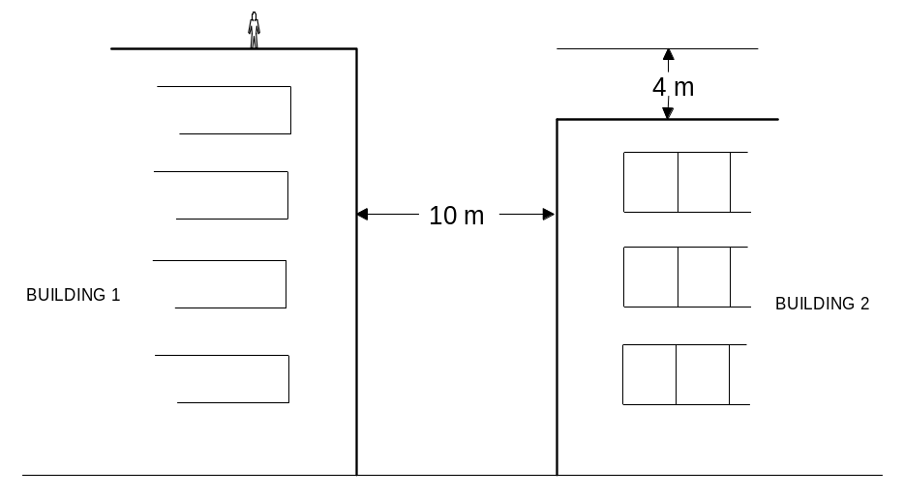

a) Calculate the minimum speed, at which the stuntman should leave building 1 in order to land safely in the second building. Show your working.

b) Consider your answer to part (a). Would it be possible for a stuntman to run at that speed? Explain your answer.

7 The line absorption spectrum of chlorophyll consists of many dark bands on a coloured background whereas the absorption spectrum of sunlight consists of discrete dark lines on a coloured background. Explain this difference.

  - An athlete is competing on an indoor track which is banked on the curves.

a) Why is the track banked on the curves?

b) Explain why the athlete experiences an ‘outwards force as they run around the curve.

9 An open double doorway in a concert hall is 3.2 m wide. A person standing outside the hall notices that lower pitched sounds from a band playing inside the hall can be heard more clearly than higher pitched sounds. Explain why this is so. A diagram of the concert hall is below.
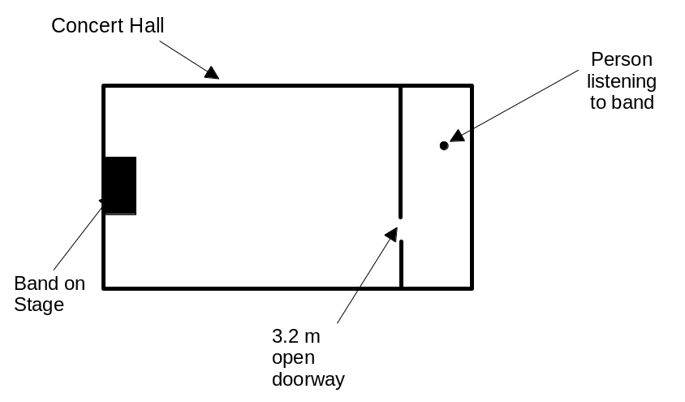

10 On a particular dynamo, the rotating coil has 500 loops, each of area 2.50 x 10^{–4} m².
The magnetic field can be assumed to be uniform and of magnitude 0.400 T. When the bicycle is ridden at a particular speed the magnet rotates at 8.00 Hz.

a) What is the magnitude of the average induced emf?

b) Complete the following sketch graph of voltage against time for two complete rotations
of the magnet. You need only show the scale on the time axis.
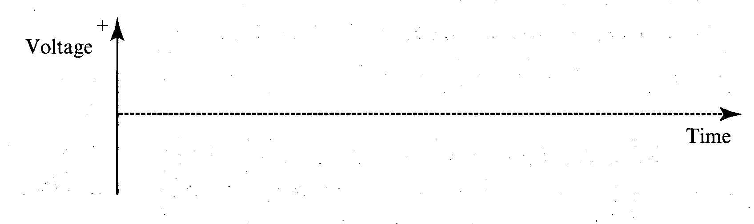

- A set of two garden lights require a 12 V input. A transformer is used to reduce the voltage from the mains from 240 V to 12 V. The two 25 W lights are wired in series with the secondary side of the transformer as shown on the diagram below.
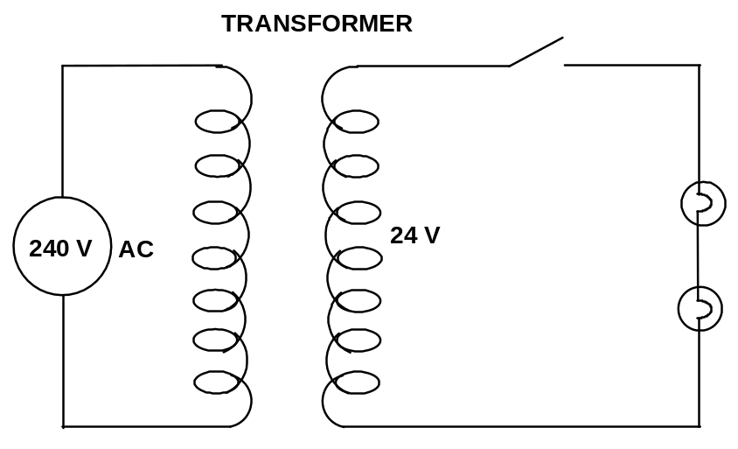

a) What is the current in the secondary side of the circuit when the switch is closed and both lights are lit?

b) Why is AC used in the primary coil rather than DC?
12 An emf can be generated in a coil of insulated wire by inserting a magnet in the coil and then
pulling the magnet quickly away from the coil. If the magnetic field near the end of the magnet
is 1.5 x 10⁻¹ T, estimate the time interval in which the magnet must be pulled away to generate
an emf of about 1.5 V in the coil?

A full scale diagram of the coil and magnet appears below.
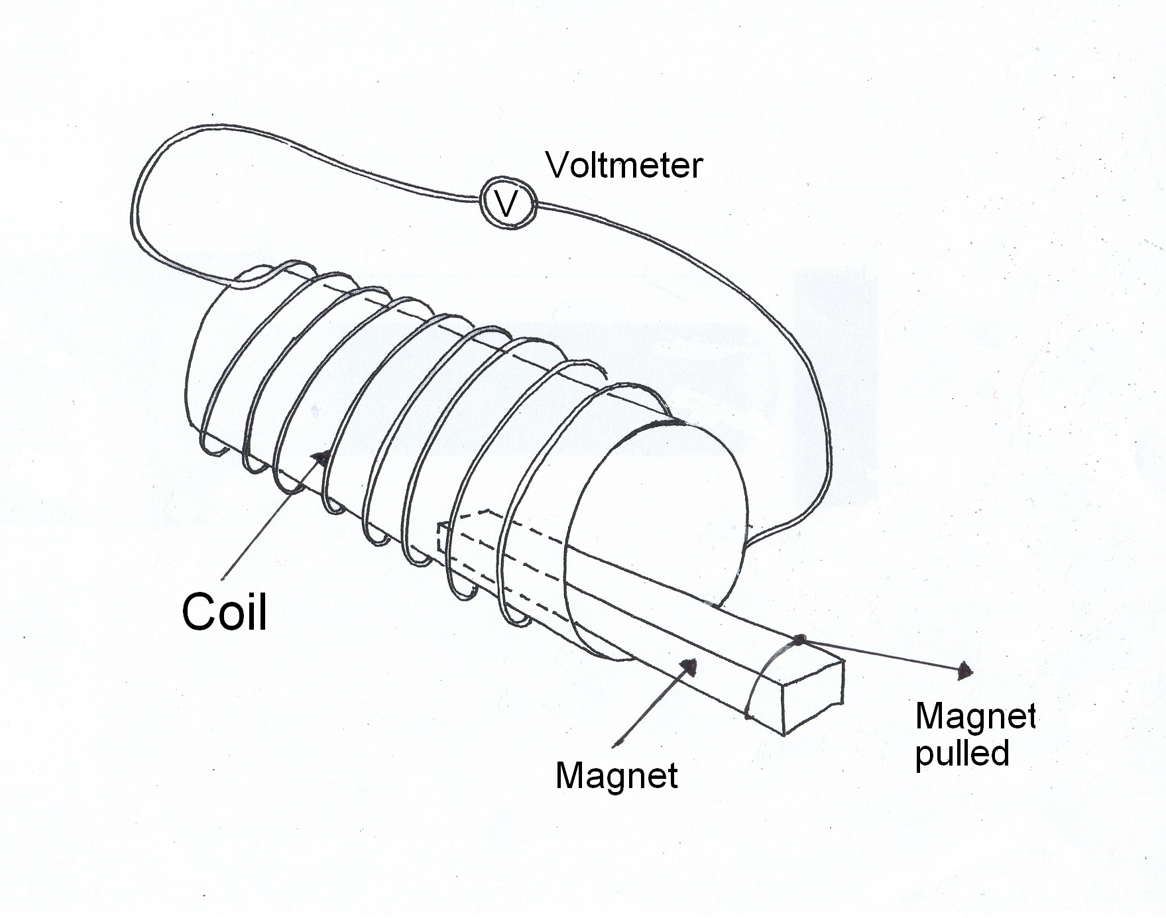

13 A researcher decides to measure the hearing of one of her students, before and after he attends a rock concert. She does this by connecting a signal generator to headphones and for each frequency finds the lowest intensity that he can just hear. The figure below shows the lowest intensities at the various frequencies before the concert (the thicker line) and after the concert
(the finer line).
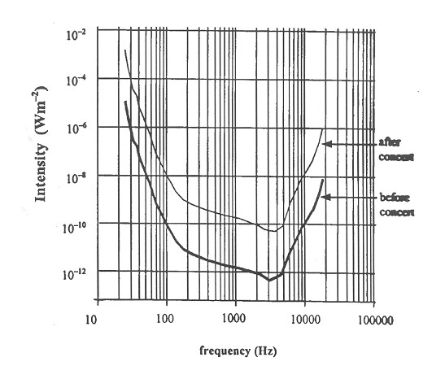

a) Before the concert, at what frequency is the student’s hearing most sensitive?

b) After the concert, what range of frequencies can the student hear if the signal generator creates sound of intensity 10^{–10} W m⁻²?

c) After the concert, what is the minimum sound level in dB that the student can hear at a frequency of 200 Hz?

d) How much louder in dB must a police siren be, operating at 1000 Hz, in order for the student to hear it after the concert than before the concert?

14 The stress strain curve for several materials is given in the diagram below. Which of these would be an appropriate material with which to manufacture steel beams? Explain why you chose your answer.

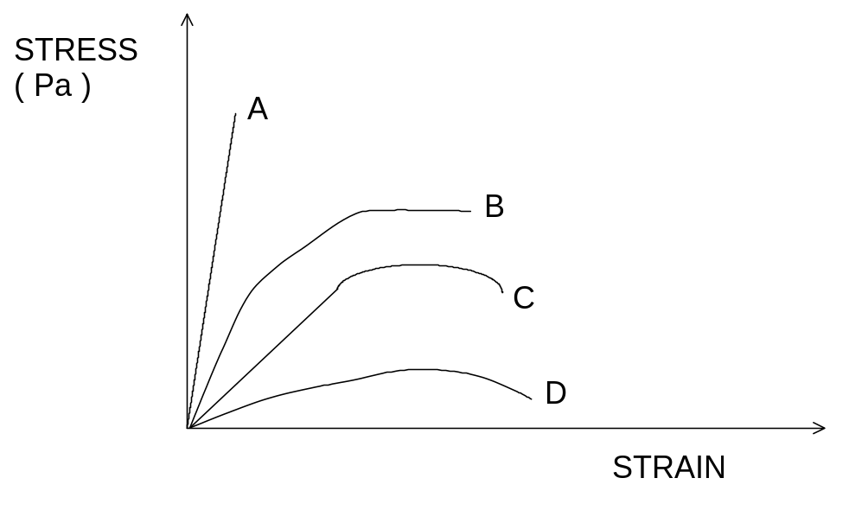

15 A radioactive source is used to fire alpha particles (He²⁺ ions) into a magnetic field.
The experimental setup is shown below.
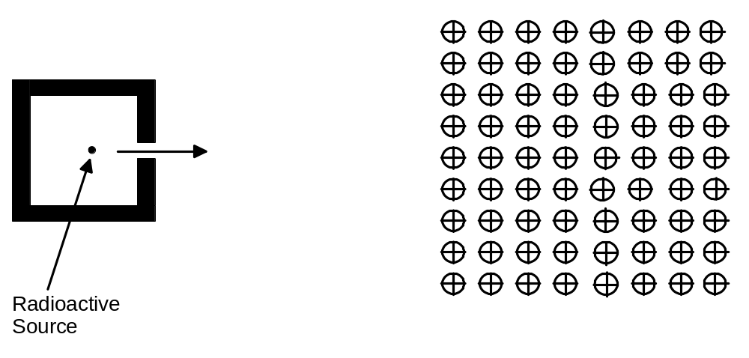

a) On the diagram carefully indicate a possible path for the alpha particles when they
enter the magnetic field. Label the path (A)

b) If an electron was fired into the magnetic field, carefully indicate a possible path for
that particle when it enters the magnetic field.
Label the path (B)

Section B: Problem Solving

Marks allotted: 100 marks out of a total of 200 (50%).

This section contains 7 questions.

You should answer: ALL of the questions.

Answer the questions in the spaces provided

- (14 marks)

A student is standing on the centreline and 10.0 m from a pair of loudspeakers. The loudspeakers are
set 3.0 m apart and are emitting a single frequency of 1150 Hz supplied by the same source at the same
time. See the diagram below.

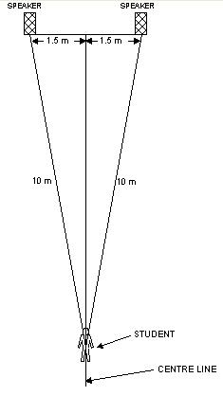

a) Describe what the student hears as she moves several metres to the right of the centre line.
(2 marks)

b) If she returned to the centreline and then walked several metres to the left of the centreline
would her experience be the same? Explain. (2 marks)

c) At a distance of about 0.5 m to the left of the centreline would the loudness of the sound be
louder or softer than when the student is on the centreline? Explain using calculations to
support your answer. (3 marks)

d) (i) On the axis below draw a sine wave that represents the wave being emitted by the
right hand speaker. Show the scale on the time axis only. (3 marks)
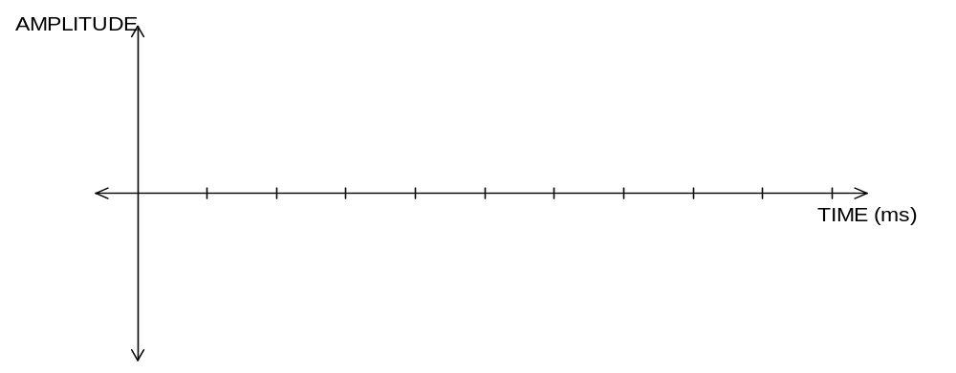

(ii) On the axis below draw a sine wave that represents the wave being emitted from the
left hand speaker. Show the scale on the time axis only. (3 marks)
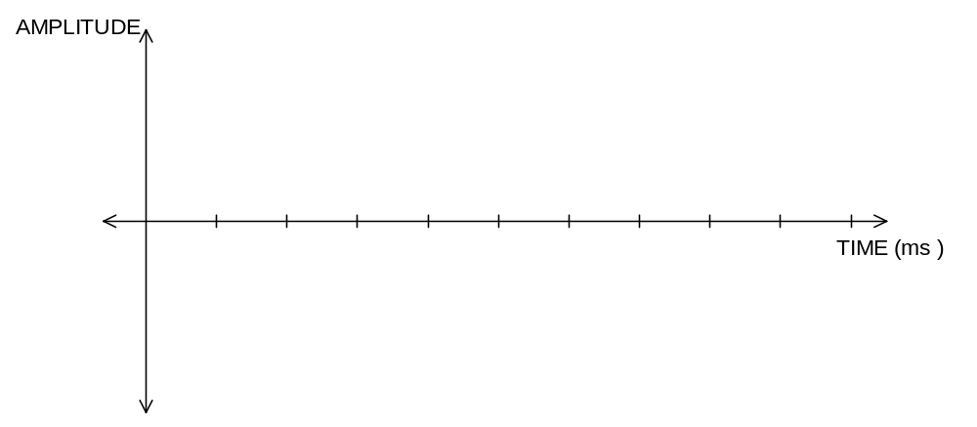

e) The phenomenon that student is experiencing in the exercise above is best described in term of
which of the following?

A beats
B interference
C reflection
D refraction
E diffraction (1 mark)

- (14 marks)
In rising to pass over a mountain peak, an aeroplane’s path is part of a vertical circle of radius 2.80 x 10³ m. The plane’s speed is constant at 200.0 km h⁻¹. The pilot has a mass of 60.0 kg. and the combined mass of the aeroplane and pilot is 2.00 x 10³ kg

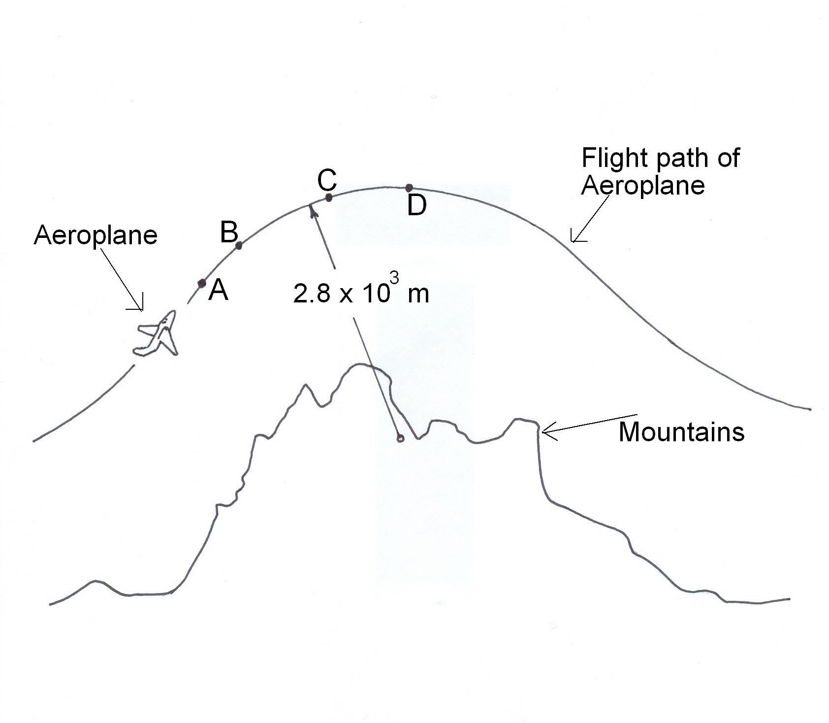
a) What acceleration does the pilot experience during this part of the flight? (3 marks)

b) What upwards force is exerted on the pilot by her seat when the plane is at its highest point? (3 marks)

c) The plane now flies at 200 km h⁻¹ along a flight path with a smaller radius.
At the highest point of the new flight path, compared with the flight path shown in the figure above, the pilot:

- feels a greater force exerted on her by her seat.
- feels a smaller force exerted on her by her seat.
- has a greater apparent weight than before.
- has less tendency to leave her seat.
- experiences no difference.
- has a greater tendency to leave her seat
Which of the above statements is true?
Note: there may be more than one correct statement (3 marks)

Ans: _________________________________

d) At what minimum speed does the aeroplane need to maintain at its highest point if it is to continue to move in an arc of 2.80 x 10³ m radius? (3 marks)

e) At which point (s) (A, B, C or D), in the aeroplane’s path, does the pilot’s mass have the least effect on the reaction force she experiences against the seat of the plane?
(2 marks)

This page has been intentionally left blank

3 (13 marks)
A sign outside a hardware shop is suspended from a beam ABC, which is uniform, is 2.10 m long
and has a mass of 20.0 kg. The beam is suspended by two identical wires attached at A and B.
The tensions in the two wires are 50.0 N and 200 N respectively. (see the diagram below).
The wires have a radius of 5.00 x 10⁻³ m and are 1.2 m long.
The graph shows the stress strain graph of the metal from which the metal wires are made.
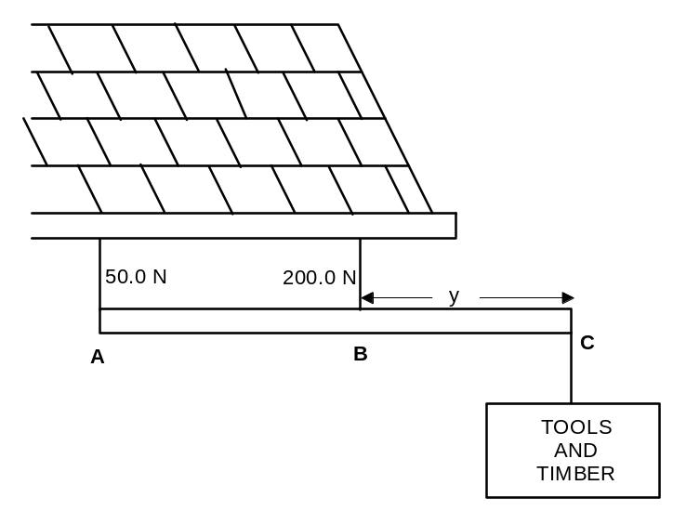

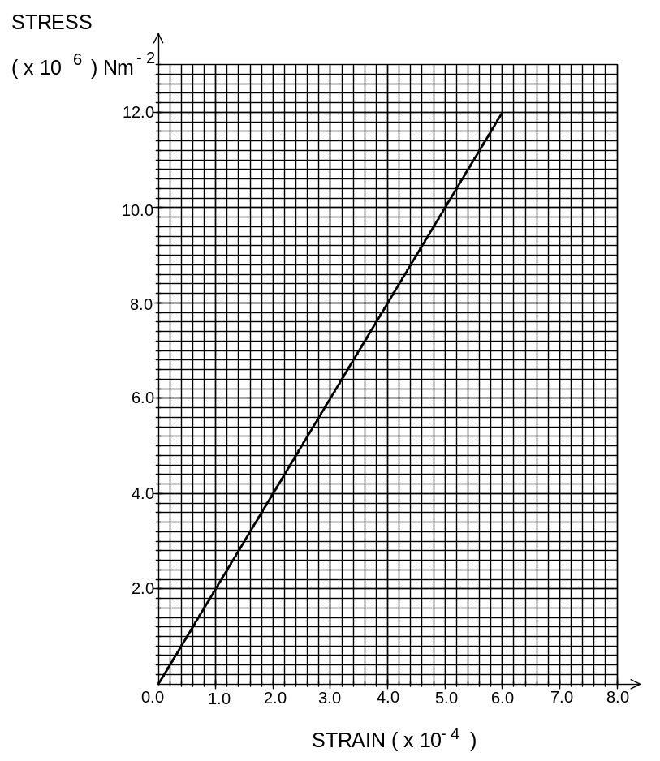

a) What is the weight of the sign ‘Tools and Timber’ (3 marks)

b) What is the distance ‘y’? (3 marks)

c) What is Young’s Modulus for the metal used to make the supporting wires? (3 marks)

d) What is the stress in wire B? (2 marks)

e) What is the strain in wire B? (2 marks)

4 (15 marks)

The diagram shows four energy levels of an atom not drawn to scale.
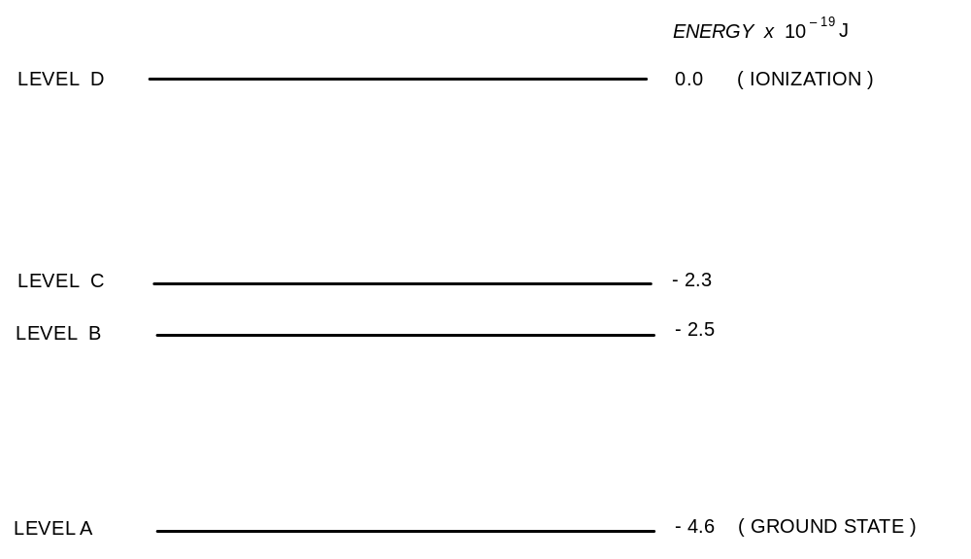

a) Explain how this atom emits a line spectrum following excitation. (2 marks)

b) Between which two levels is the longest wavelength of emitted radiation produced by a
transition? Calculate the wavelength of this emitted radiation. (3 marks)

c) Draw on the diagram two vertical arrows between levels to indicate two different
transitions that result in emitted radiation of the same frequency. (2 marks)

d) Describe the emission spectrum of this atom in terms of the number of lines and
brightness. (3 marks)

e) How much energy, in eV, would be required to ionise the atom in its ground state?
(1 mark)

f) In its ground state the atom is bombarded by a collision with an electron having
3.0 x 10⁻¹⁹J of energy.

(i) With what possible energies could the electron be scattered from the atom after
the collision? (2 marks)

(ii) Calculate all the possible frequencies of radiation that the atom may subsequently emit,
as a result of the bombardment. (2 marks)

- (17 marks)
For a new Backpackers Hostel, electric power is transmitted at 66 kV AC to a substation
transformer where it is converted to 11 kV AC for distribution to a pole transformer.
It is then delivered to the hostel at 240 V AC.
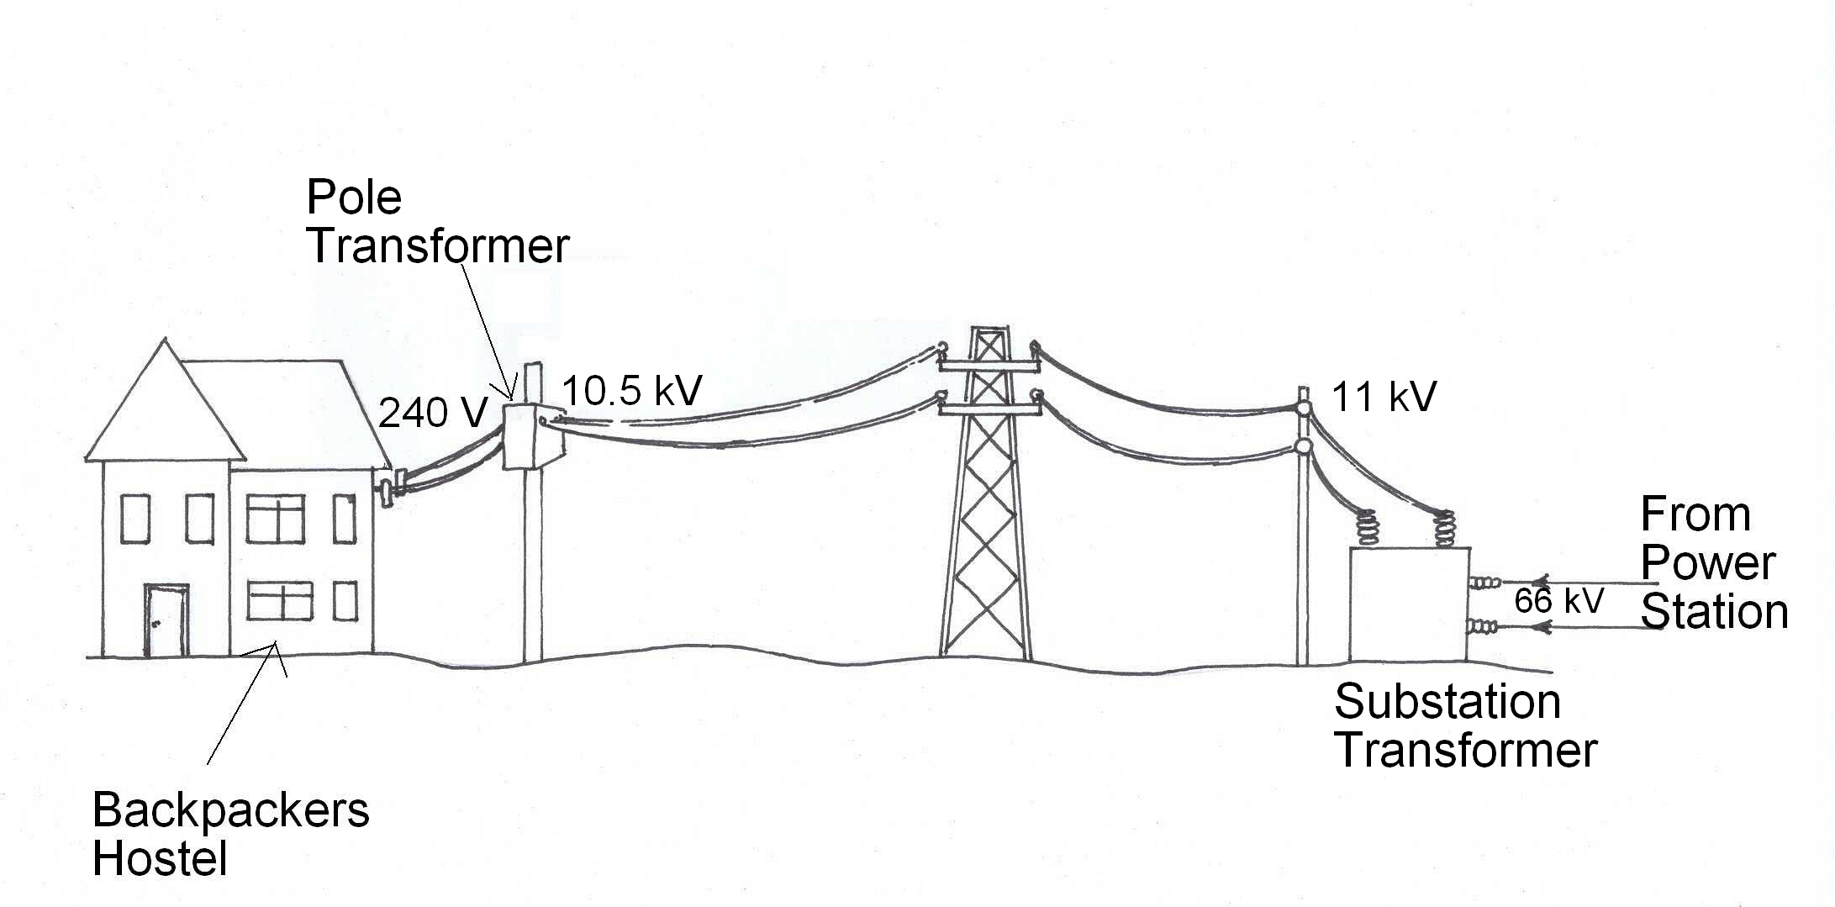

Energy is delivered at a rate of 50 kW at the secondary coil of the substation transformer, where the voltage is 11 kV AC.

a) What average current is flowing in the secondary coil of the substation transformer?
(3 marks)

b) When energy is being delivered at 50 kW at the secondary coil of the substation transformer, the voltage at the primary coil of the pole transformers is 10.5 kV.

What is the power loss in the wires joining the substation transformer and street pole
transformer? (3 marks)

c) If there are 6.3 x 10³ turns in the primary of the pole transformer, how many turns are in the secondary coil? What current flows in the secondary coil? Assume the transformer is ideal.
(3 marks)

d) Explain why the voltage is transmitted to the hostel at 11 kV AC, instead of DC.
(2 marks)

e) At some times during the day the demand for electricity at the hostel decreases.
The output voltage of the substation remains at 11 kV. Discuss whether the voltage at
the primary coil of the pole transformer will change from 10.5 kV. If it changes, describe
whether it gets bigger or smaller, and explain why this occurs. (3 marks)

f) Explain why electricity is transmitted at high voltages between power stations and the
cities where it is used. (3 marks)

6 (15 marks)
Hooke’s Law is an important relationship used by manufacturers of springs. When making springs to be used in various situations the stiffness of the spring is an important property of the spring. In simple terms Hooke’s law can be represented as

k = F/x
Where: k is the spring constant.
F is the force needed to stretch or compress a spring and is measured in newtons
x is the change in length of the spring as a result of the force applied measured in metres

The quantity of energy stored in a spring can be calculated using the expression
U = 0.5 F x
Where: U is the elastic potential energy measured in joules
F is the force measured in newtons
x is the change in length measured in metres

A group of students carry out an investigation with a spring by adding masses to the spring and measuring the corresponding change in length. The results are graphed and the resulting graph is shown below.
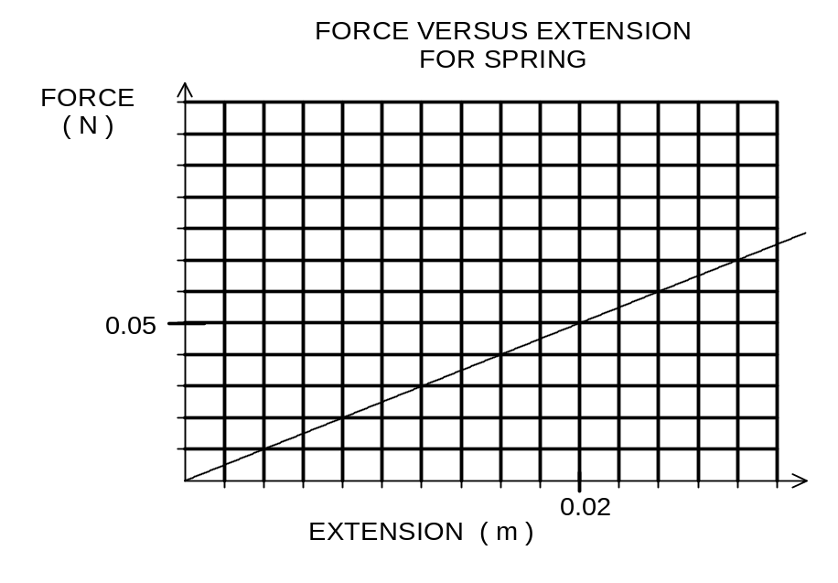

a) For the extent of the forces added to the spring, would you describe the spring as
linear or non linear? Explain (2 marks)

b) Would you expect the spring to be more suitable for use in a ball point pen or in a
trampoline? Explain (2 marks)

c) From the graph calculate the spring constant for the spring. (3 marks)

d) If the spring is extended to 23 cm how much energy is stored in the spring? (3 marks)

e) If a second spring is tested and found to have a stiffness double that of the first spring,
draw on the grid on page 26, the graph which best represents the second spring. Label it (A)
(2 marks)

f) If a third spring is tested and found to have a stiffness of 10.0 N m⁻¹, and when a
force of 0.075 N is applied the spring stretches, draw on the above grid the graph which best represents the third spring. Label it (B) (3 marks)

7 (12 marks)

The diagram below shows the flight path of a golf ball after it has been struck by a golf club.
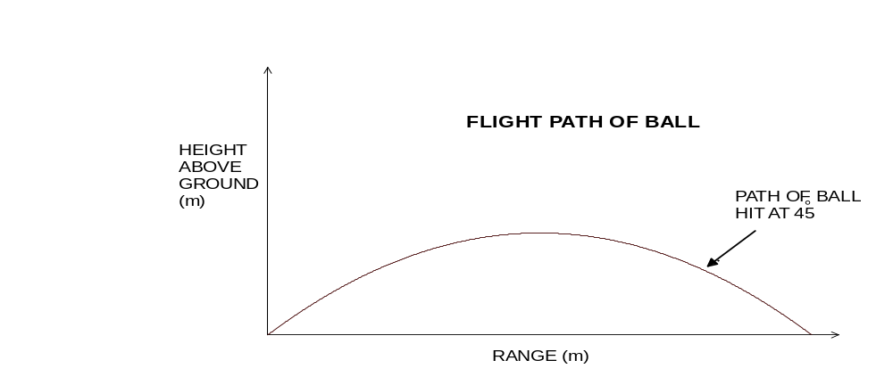

a) Explain the shape of the trajectory in terms of the forces acting on the ball. (4 marks)

b) The golfer who struck the ball was trying to hit the ball as far as he could along a level
fairway (ground). Explain why the ball left the club at an angle close to 45º to the
horizontal as shown in the diagram above. (3 marks)

c) On the diagram draw the path of the golf ball if it was hit with the same initial
speed as the ball in part (b) but at an angle of 30º to the horizontal (2 marks)

d) If the ball was struck with an initial velocity of 25 m s⁻¹ at 30º to the horizontal and was
in the air for 5.0 s, above the level ground, how far had it travelled horizontally when it
hit the ground? (3 marks)

Section C: Comprehension and Interpretation

Marks allotted: 40 marks out of 200 (20%)

Question 1 (20 marks) The Triple Jump

Para 1
At the World Athletics Championships in Gothenburg, Sweden, Jonathan Edwards shattered the world record for the triple jump with a leap of 18.15 m. A few minutes later, on his next jump, the British athlete extended the record to 18.29 m. Unknown to both Edwards and the crowd, this was also an exceptional occasion in scientific terms. Throughout the championship, a team of sports scientists had been recording the precise body movements of the athletes as they jumped - the first time this has ever been done during a world class competition. Their results show that Edwards's jumping technique is unique, that over short distances he is one of the quickest men on Earth and that, with a small change in the way he jumps, he could one day leap more than 19 m.

Para 2
The team of Swedish and Danish researchers are concerned with biomechanics - the way an athlete's body moves during an exercise. Their raw material is high speed video footage of a race, a jump or a throw. When analysed by computer, these images can be used to generate a simplified "matchstick" model of the athlete showing the movement and angle of the head, arms and legs, torso and centre of gravity.

Para 3
The triple jump is made up of three phases: a hop in which the athlete takes off and lands on the same foot, a step to land on the other foot and a final jump to land on both feet, usually in a sand pit. The athlete is allowed a long run up but the jump is measured from a pre-arranged line, where the hop begins, to the landing point. Early 19th century records show one Scottish competitor at a local game clearing 12.95 m. Ten years ago, the American athlete Willie Banks set the world record at 17.97 m. Banks once broke the 18.0 m barrier only to find that his jump didn't count as a world record because it had been assisted by a following wind greater than the 2 m s⁻¹ maximum.

Para 4
One reason for Edwards's success is his speed. Although his time over 100 m is a mediocre 10.5 seconds, few would be his equal over 20 m. When Carl Lewis set a 100 m world record in Tokyo in 1991, he ran 9.86 seconds and peaked at a speed of 11.8 m s⁻¹. In the run-up to his world record breaking jump in Gothenburg, Edwards peaked at 11.9 m s⁻¹

Para 5
The results show that the centre of gravity of most triple jumpers tends to bounce up and down during the hop and step phases, and that the average takeoff angle into the jump is 22.5 degrees. During the hop and step, the jumpers land with their foot slightly ahead of their centre of gravity. This prevents an uncontrollable forward rotation that would send the athlete head first into the sand, well short of their objective of over 17 m. But it also acts as a brake, slowing forward motion with each step. Edwards's technique is different. The path of his centre of gravity is unusually smooth and level and he takes off on the final jump at an unexpectedly low angle, a maximum of 17.5 degrees. Most surprising of all, his foot lands immediately beneath his centre of gravity. How Edwards avoids pitching into the sand is not yet clear. One theory is that he raises his knees so rapidly in midflight that this somehow compensates for any forward movement.

Para 6
The result is that Edwards is not only the fastest man in the run up but also the fastest man when he takes off for the final jump. Brian Wellman, the Bermudan silver medallist in the championship, managed 17.62 m with his best jump. His top speed during the run-up was 11.63 m s⁻¹ but after the hop and step his speed had fallen to 6.49 m s⁻¹. By contrast, Edwards's speed into the final jump was
7.27 m s⁻¹.

Para 7
In this jump phase, the athletes must convert their speed into distance. Both Wellman and Edwards actually took off from more or less the same spot but the British jumper then sailed 7.0 m, half a metre more than Wellman, because of his extra speed.
But Edwards's style is not perfect. It has been calculated that he takes off at too low an angle and by changing it by 0.1 of a degree, Edwards could clear 18.90 m. Given a legal 2 m s⁻¹ following wind he could take the record over 19.0 m.

Q1 What advantage did Edwards have over Wellman in the jump phase of the event?
(para 6) (2 marks)

Q2 Why is a following wind of greater than 2 m s⁻¹ a disadvantage when trying to break a world record for the triple jump? (para 3) (2 marks)

Q3 In theory Edward's should take off for the jump part of the event at an angle much greater than 22.5º to the horizontal to achieve maximum horizontal distance. Why can't this be achieved?
(para 5) (2 marks)

Q4 If Edwards was competing in a 100 m race and reached his maximum speed early in the race and was able to sustain his maximum speed for the rest of the race, estimate what time would he record for the race. Show how you calculated your estimate. (para 4) (2 marks)

Q5 Would the time recorded by Edwards (as calculated in Q 4) break Carl Lewis 1991 world record? Explain your answer. (para 4) (2 marks)

Q6 It seems that speed is one of the main factors which determines how far Edwards will travel during the jump part of the event. Why does a higher speed help him jump further? (para 4) (2 marks)

Q7 The triple jump is made up of three parts, a hop, a step and a jump. If the length of Edward's
hop is 4.5 m, estimate the length of the "step" in his world record feat. (para 7) (2 marks)

Q8 What advantage did Edwards have in being ‘one of the quickest men on Earth’? (para 1) (2 marks)

Q9 What is meant by the term ‘convert their speed into distance’? (para 7) (2 marks)

Q10 Using the figures quoted in the article, calculate the horizontal and vertical components of Edwards's speed into his final jump when he is taking off at a maximum of 17.5 degrees. (para 6) (2 marks)

Question 2 (20 marks)

Moving Coil Loudspeakers
Paragraph 1
Loudspeakers (commonly known simply as speakers) are incorporated into many devices, from computers to intercoms. They play a central role in home hi - fi systems, and in movie sound systems for both cinemas and homes. In hi-fi circles, because modern speaker boxes generally contain several loudspeakers, the entire box is referred to as the loudspeaker and the individual loudspeakers are referred to as 'drivers'. The most common type of loudspeaker by far is the moving coil (technically known as the 'dynamic') type.
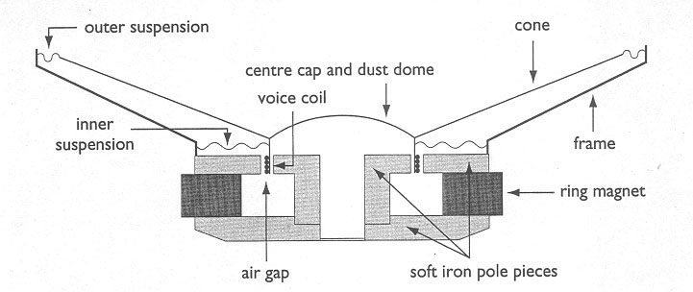

Figure 1

Paragraph 2

It is interesting to note that although the electronic components of a radio of fifty years ago are largely unrecognisable to many people today, its loudspeaker is essentially the same, although technically improved. Broadly, the principle of a moving coil loudspeaker is that a coil carrying an electric current oscillating with amplitude and frequency proportional to the sound to be produced is suspended in a uniform magnetic field. The magnetic force on the oscillating current drives the coil in and out through the field. A cone is attached to the coil, and the movement of the cone back and forth sets up compressions and rarefactions in the adjacent air, creating a sound wave.
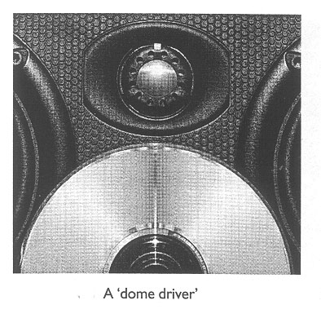

Paragraph 3
Every loudspeaker has a natural frequency of oscillation, which is the frequency at which it vibrates if the cone is manually displaced and then released. Oscillating currents near this frequency result in larger cone movements. The enclosure also affects the response of a loudspeaker, since the air is set in motion at the rear surface of the cone in addition to the front surface. This can dampen the motion of the loudspeaker.
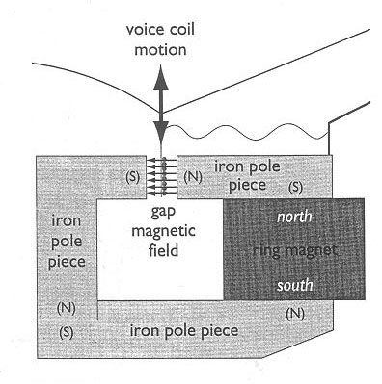

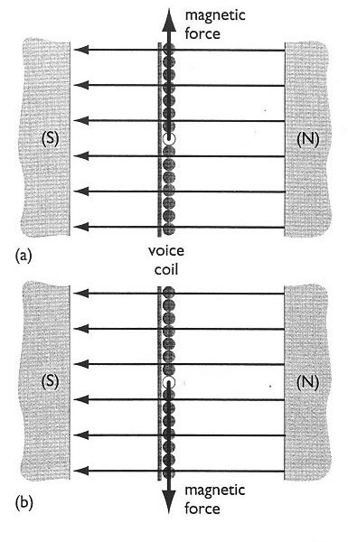

Figure 2

Paragraph 4
In practice, other components are also necessary in a workable loudspeaker. Although there are many minor differences between designs, Figure 1 shows all of the components of a typical loudspeaker used for reproducing a wide range of audible frequencies. The components fall into two groups, stationary and moving.

Figure 3

Questions
Q1 Why do modern speaker boxes that give excellent reproduction of sound, contain more than one speaker? (para 1) (2 marks)

Q2 The statement: “a coil carrying an electric current oscillating with amplitude and frequency proportional to the sound” appears in paragraph 2. Using your own words explain what this statement means. (para 2) (3 marks)

Q3 Why do oscillating currents close to the natural frequency of the speaker result in larger cone movements? (para 3) (2 marks)

Q4 How can air set in motion at the rear surface of the cone in addition to the front surface cause the motion of the cone to be dampened? (para 3) (3 marks)

Q5 In Figure 1 the pole pieces are made of soft iron. Why is soft iron used in this case?
(2 marks)

Q6a Refer to Figures 2 and 3 to answer this question. In figure 3a, when the magnetic force on the voice coil is up the page, in which direction is the current? (up the page, down the page, into the page or out of the page) (1 mark)

Q6b Explain your answer to 6a above (3 marks)

Q7 Why is it necessary for the coil to be suspended in the magnetic field? (para 2) (2 marks)

Q8 Examine Figures 1 and 2 to answer this question. List four components of the speaker that would move when it is operating (2 marks)

END OF EXAMINATION

Extra page if needed

ACKNOWLEDGEMENTS

SECTION C

Question 2: Moving Coil Loudspeakers.
Extract from Applications for Senior Secondary Physics by Dr Richard T. Parham and published by Science Teachers Association of South Australia

