

West Australian Test Papers

PHYSICS

Year 12

2004

SOLUTION BOOKLET

&

MARKING GUIDE

Markers should note that the solutions presented here are skeletal answers and should be used
as a guide only.

Alternate answers used by students may be perfectly acceptable and discretion should be used.

Section A

- The wavelength of the sound is 1.6 cm. The waves would be diffracted around the insect and not reflected. Since the wavelength and size of the insect are approximately equal.

2 a) The threshold of hearing is 10⁻¹² W m⁻²
The ear receives 10⁻¹² x 1.1 x 10⁻⁵ W
= 1.1 x 10⁻¹⁷ W

b) 0 dB This is the threshold of hearing.

3 a) s = ut + 0.5 a t²
- = 0 + 0.5 x 9.8 x t²
t = 10.1 s

b) The time will be increased.
The horizontal distance will be decreased.

- A geostationary satellite orbits the earth once every 24 hours. As the force providing the centripetal force is the gravitational attraction of the earth’s centre of mass to the satellite then the direction of the centripetal force must be towards the centre of the earth. Only at the equator is the force towards the earth’s centre and perpendicular to the orbital motion. If the orbit is to be geosynchronous then the satellite has to orbit with the earth’s rotation and therefore cannot be a polar orbit.

5 a) v = f x λ
3x 10⁸ = 1 060 x 10⁻⁹ x f
f = 2.8 x 10¹⁴ Hz
This corresponds to the infra red spectrum.

b) E = h x f
6.6 x 10⁻³⁴ x 2.8 x 10¹⁴ = 1.8 x 10 ⁻ ¹⁹ J
Number of photons = 3 x 10⁻³ / 1.8 x 10⁻¹⁹ = 1.7 x 10¹⁶ photons
(the time is irrelevant)

- a) In the vertical
s = ut + 0.5 a t²
4 = 0 + 0.5 x 9.8 t²
t = 0.9 s

In the horizontal.
s = v_{av} x t
10 = v_{av} x 0.9
v_{av} = 10 / 0.9
= 11.1 m s⁻¹

- It would be possible but a speed of 11.1 m s⁻¹ is at the upper end of human possibility. The fastest sprinters in the world can reach speeds of about 12 m s⁻¹

- The chlorophyll absorption spectrum is due to energy levels unique to chlorophyll and consist
of coloured bands on a black background. The black bands represent the energies that are
absorbed. The black lines of absorption in the suns spectrum (Fraunhofer lines) are due to
absorption of the solar spectra by elements in the sun’s and earth’s atmosphere.

8 a) The track is banked so that a component of the reaction force can provide the required
centripetal force. This allows the athlete to run faster around the curve without having
to lean excessively towards the centre of the curve which in the case of an indoor track will usually have a relatively reduced radius.

- The tendency of the athlete would be to exit the curve at a tangent if there was no
centripetal force acting towards the centre of the curve.

- The key idea here is diffraction. If the width of the gap approximates the wavelength of the
sound then diffraction is at a maximum. The lower pitch notes would have wavelengths closer
to the 3.2 width of the gap and would therefore be diffracted towards the listener more than
higher frequency notes that would have wavelengths less than the width of the gap. The higher
pitch notes would be diffracted less and may not reach the listener.

- a) E = N Δ φ / Δ t (Note: 8 Hz represents a Δ t of 0.03125 s)

E = 500 x 0.4 x 2.5 x 10^{–4} / 0.03125

E = 1.6 V

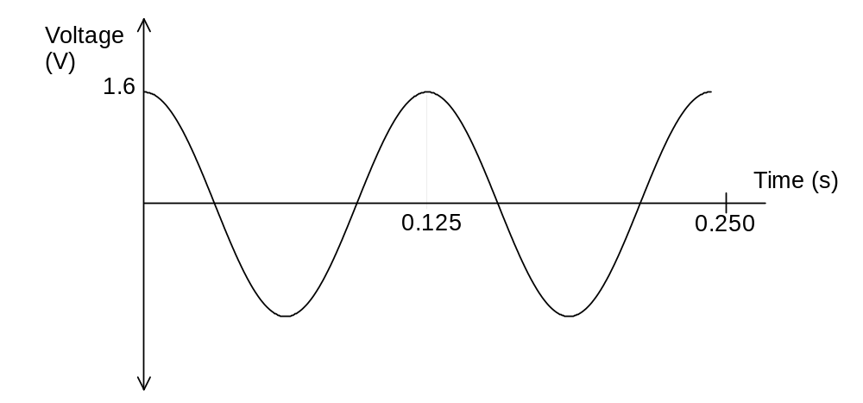

11 a) P = I x V
- = I x 24
I = 2.08 A

- Current is only induced when the magnetic field is expanding and / or collapsing through the conductor. DC would provide only a short lived current in the secondary coil. The AC expands and collapses 50 times per second and so induces a current in the secondary coil.

12 Radius of coil approx 1.25 cm
Number of coils approx 8
Area of coil = Π x r² = Π x 0.0125² = 4.9 x 10⁻⁴ m²
Φ = B x A
Φ = 1.5 x 10⁻¹ x 4.9 x 10⁻⁴

E = N ΔΦ / Δτ
1.5 = 8 x (1.5 x 10⁻¹ x 4.9 x 10⁻⁴) / Δt

Δ t = 3.92 x 10⁻⁴ s
Time interval is approximately 4 x 10⁻⁴ s

13 a) 3 000 Hz

- 100 Hz to 10 000 Hz

- 10⁻⁹ W m⁻²
dB = 10 log₁₀ 10⁻⁹ / 10⁻¹²
= 30 dB
d) 10⁻¹² before the concert 0 dB
10⁻¹⁰ after the concert 20 dB
So a siren must sound 20 dB louder after the concert than before.

- The answer is A. Steel beans are used in the construction of buildings and therefore must be able to withstand high degrees of tension and compression. Graph ‘A’ indicates that the material has a considerable elastic region where it will not deform easily when subjected to stress and strain. Its Young’s Modulus would be relatively high compared to the other materials.

- a) and b)
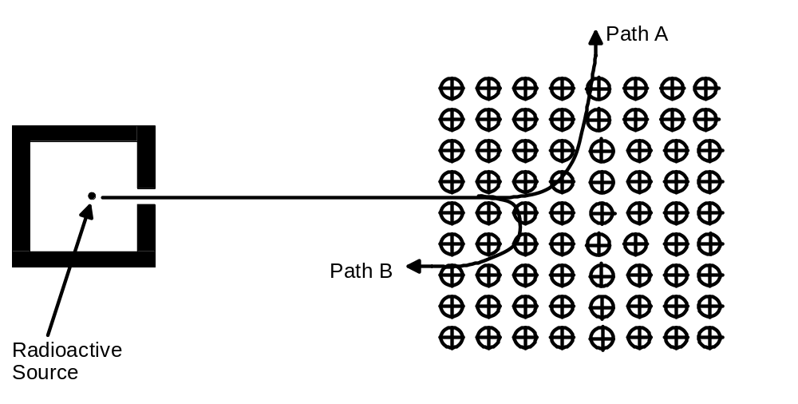

Section B

1 a) The student would hear alternative louder and softer sounds due to the constructive and destructive interference of the two sound sources.

- Yes. The student would experience the same louder and softer sounds. This is because the system is symmetrical. The same interference is occurring on both sides of the centre line.

- The wavelength of the sounds is 0.3 m

If the student moves 0.5 m to the left then using Pythagorean calculations, the distance from the student to the left hand speaker is 10.04 m and the distance to the right hand speaker is 10.19 m. This produces a path difference of 0.15 m. This path difference is about half the wavelength of the sounds therefore the position 0.5 m to the left of the centre line will be a position of destructive interference. The student will experience a softer sound.

- i)
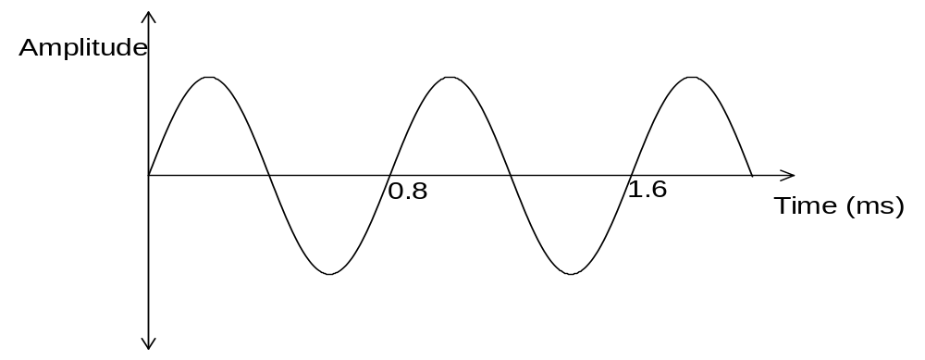

- B - interference

2 a) Velocity of the aircraft is 200000 /3600 = 55.555 m s⁻¹

a = v² / r = 55.555² / 2.8 x 10³ = 1.10 m s⁻²

b) Reaction at the top of the circle = R = mg - m v² / r
R = (60 x 9.8) - (60 x 55.555² / 2 800)
R = 588 - 66
R = 522 N

c) The answer is B. Since F_{c} is indirectly proportional to the radius.

- mg = m v² / r
  - = v² / 2.8 x 10³
v² = 9.8 x 2.8 x 10³
v = 165 m s⁻¹

- A

- a) Forces up = Forces down (let weight of sign be W)
250 - 196 + W
W = 250 – 196 = 54 N
Weight of the sign is 54 N

b) Take moments about A
Sum of anti clockwise moments = Sum of clockwise moments
[200 x (2.10 - y)] = {(20 x 9.8) x 1.05} + (54 x 2.10)
[200 x (2.10 - y)] = {(20 x 9.8) x 1.05}] + 113.4
420 – 200 y = 205.8 + 113.4
-200 y = 205.8 + 113.4 - 420
y = -100.8 / -200
y = 0.50 m

- E = stress / strain
E = 10 x 10⁶ / 5 x 10⁻⁴
E = 2 x 10¹⁰ N m⁻²

Area of wire = Π x (5.00 x 10⁻³)²
Stress in wire B = force / area
200 / Π x (5.00 x 10⁻³)²
Stress in wire B = 2.55 x 10⁶ N m⁻²

- E = stress / strain
2.00 x 10¹⁰ = 2.55 x 10⁶ / strain
strain = 2.55 x 10⁶ / 2.00 x 10¹⁰
strain = 1.28 x 10⁻⁴

- a) An electron may be excited to a discrete energy level of increased energy. It may return to a lower energy level by emitting photons with energies corresponding to the change in energy between the two energy levels. (E = h x f).
The frequency of the photon may correspond to the frequency of an
electromagnetic radiation such as a colour in the visible spectrum.

- As the frequency increases so the wavelength decreases. The longest wavelength will occur when the energy difference between levels is at its smallest.
i.e. C to B = 0.2 x 10⁻¹⁹ J

E = h x f
0.2 x 10⁻¹⁹ = 6.64 x 10⁻³⁴ x f
f = 0.2 x 10⁻¹⁹ / 6.64 x 10⁻³⁴
f = 3.01 x 10¹³ Hz

c = f x λ
3 x 10⁸ = 3.01 x 10¹³ x λ
λ = 3 x 10⁸ / 3.01 x 10¹³
The wavelength is 9.97 x 10⁻⁶ m

c)
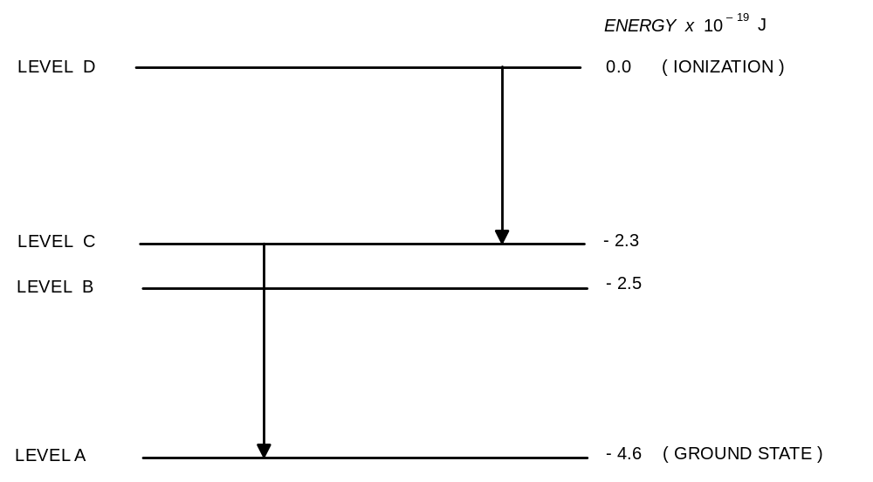

d) There are 6 possible transitions. There will be 6 lines but two of the transitions have equal energy so one line will be brighter than the other five.

e) Energy required to ionise the atom is 4.6 x 10⁻¹⁹ J

4.6 x 10⁻¹⁹ / 1.6 x 10⁻¹⁹ = 2.87 eV

f) (i) A to B (3 x 10⁻¹⁹) – (2.1 x 10⁻¹⁹) = 0.9 x 10⁻¹⁹ J

A to C (3 x 10⁻¹⁹) – (2.3 x 10⁻¹⁹) = 0.7 x 10⁻¹⁹ J

- a) 2.1 x 10⁻¹⁹ = 6.64 x 10⁻³⁴ x f
f = 3.16 x 10¹⁴ Hz

b) 2.3 x 10⁻¹⁹ = 6.64 x 10⁻³⁴ x f
f = 3.46 x 10¹⁴ Hz

5 a) P = I x V
50 000 = I x 11 000
I = 4.55 A

b) Loss = I x V
  - x (11 – 10.5) x 10³
2.28 x 10³ W

c) Ratio of voltages V₁ / V₂
= 10 500 / 240
= 43.75
The number of turns on the transformer coils are in the same ratio n_{p} / n_{s}.
6 300 / n_{s} = 43.75

n_{s} = 6300 / 43.75 = 144 turns

n_{s} / n_{p} = I_{p}/I_{s}

144 / 6 300 = 4.55 / I_{s}

Current in the secondary coil is 199 A

d) Trans formers are AC devices and will only operate (step up or step down) voltages if the current is continually being induced in the conducting wire by the flux linkage with the magnetic field. The transformer is needed to reduce the current in the transmission lines to reduce losses to heat.

e) If demand decreases then less power is required at the backpackers. Less power is drawn from the pole transformer. Therefore less current is drawn from the substation. Therefore there are less line losses. Therefore voltage at the pole is increased..

f) Electricity is transmitted at high voltages to reduce the current. Because power loss is a function of current (P = I² x R), if the current is kept lower then the losses will be reduced.

6 a) Linear. The force is directly proportional to the extension it produces.

- Reading from the graph a small force of 0.05 N will produce an extension of 0.02 m. These results would represent forces and extensions experienced in a pen rather than a trampoline where stiff springs would require larger forces to produce the same extension.

- k = 0.05 / 0.02 = 2.5 N m⁻¹

- U = Energy = 0.5 . k . x²

= 0.5 x 2.5 x 0.23²
= 6.6 x 10⁻² J

e) & f)
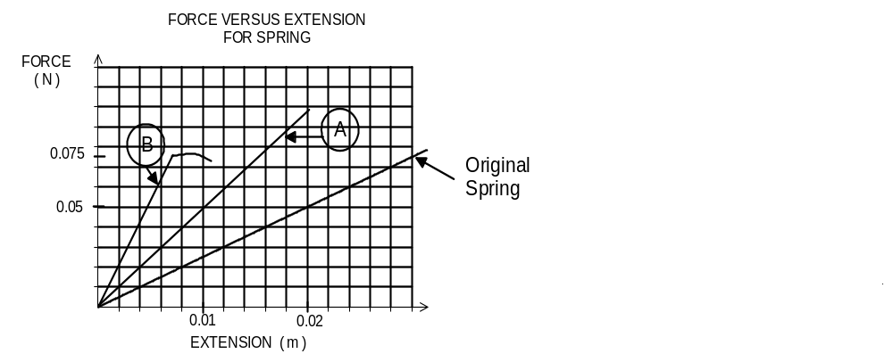

- a) There is no horizontal force on the ball after it leaves the golf stick. The only force acting on the ball is the downward vertical force of gravity producing a changing vertical velocity. The resultant of these two velocities produces a parabolic path.

- The maximum range of a ball struck from ground level and landing at ground level is achieved by giving the ball an elevation of 45º to the horizontal. At angles other than 45º the ball will land at a range less than this maximum. At 45º the horizontal and vertical components of the initial oblique velocity are equal so giving the greatest range with the parabolic trajectory.

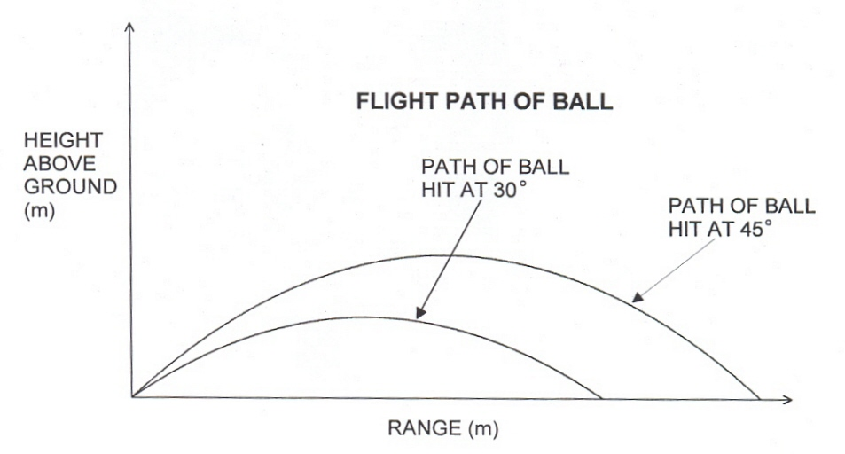

- Horizontal component of displacement if ball is hit at 30º to the horizontal

= 25 cos 30º x time
= 25 x cos 30º x 5.0
= 108 m

Section C

Question 1

- Edwards was able to achieve a very fast sprint speed, which gave him an advantage over Wellman.

- If the wind is at a speed of greater than 2 m s⁻¹ then the time for the race is disallowed. Because it is considered to be too great an advantage.

- The vertical component of the velocity is dependent on the bounce the jumper gets from the runway. For a 45º vertical take off the vertical velocity would have to equal the horizontal velocity, which is not possible.

- Say Edwards reaches maximum speed of 11.9 m s⁻¹ after 20 m in the race and travels at this speed for the next 80 m. Time for the 80 m is 6.72 s. Time for the first 20 m when travelling at an average speed of 5.95 m s⁻¹ (half the top speed from a standing start) would be 3.36 s. Adding these two times gives a time of 10.08 s for the 100m race.

- No. The time of 10.08 s is greater than Carl Lewis’ record of 9.86 s.

- High speed gives a large horizontal component of the initial velocity which is a major factor in producing a large horizontal range.

- Hop is 4.5 m, jump is 7.0 m giving a total of 11.5 m. Therefore the step must be 18.29 – 11.5 = 6.79 m.

- Edwards could accelerate to as high velocity, which is essential to achieve a long range.

- Kinetic energy at lift off is converted into horizontal displacement just as in projectile motion since the initial velocity is at 22º to the horizontal.

- Speed to commence the jump is 7.27 m s⁻¹

Horizontal component = cos 17.5º x 7.27 = 6.93 m s⁻¹
Vertical component = sin 17.5º x 7.27 = 2.19 m s⁻¹

Question 2

- Speakers are designed to best vibrate at restricted range of frequencies. Therefore more than one speaker is required to account for the total range of frequencies. Up to three speakers are housed in a speaker box to cover low, mid and high frequencies.

- The oscillating current provides the frequency (pitch) of notes that is transferred to the speaker and the amplitude of the oscillation determines how loud the reproduction of the sound will be.

- The oscillating currents close to the natural frequency of the speaker will cause resonance. This will cause the amplitude of the oscillation to be greater and so result in the cone of the speaker vibrating with greater amplitude.

- If the air is set in motion at the rear and the front of the cone there is a probability that the oscillations will be out of phase and interference will occur that will cause the motion of the cone to be restricted (dampened).

- Soft iron is can be easily magnetised but is easily demagnetised. Soft iron can be made into a temporary magnet. The soft iron core increases the magnetic effect of the coil.

6 a) Into the page

- Using the right hand rule of magnetic induction the current can be predicted to be moving into the page, as it is mutually perpendicular to the magnetic field and the force.

7 The coil needs to be able to move freely so it can set up compressions and rarefactions and set the cone vibrating.

- The parts that would move include: air, voice coil, dust cone, inner suspension, outer suspension.

