
NEWTON MOORE SENIOR HIGH SCHOOL

YEAR 11 PHYSICS EXAMINATION

SEMESTER ONE 2007

Student’s Name: ______________________________________

TIME ALLOWED:

Reading Time: 10 minutes
Working Time: 2 ½ hours

This examination consists of three sections. Answer all questions in the spaces provided below each question.

SECTION A: Short Answer.
This section contains 15 questions and is worth 60 marks.

SECTION B: Problem Solving and Extended answers
This section contains 6 questions and is worth 100 marks.

SECTION C: Comprehension and Interpretation.
This section contains 2 questions with parts and is worth 40 marks.

INSTRUCTIONS TO CANDIDATES:
- Do not use pencil except for drawings.
- Despite an incorrect final result, credit may be obtained for method and working, provided these are clearly and legibly set out.
- Ensure that your writing is legible and that correct grammar and spelling are used at all times.
- If appropriate, numerical answers should be in scientific notation with appropriate units. Answers must not be left in fractions.

NOTE: Where possible, all written answer should include naming the physics principles
involved, an explanation of the physics principle, and how it relates to the question.

SECTION | TOTAL MARK | MARK OBTAINED
A | 60
B | 100
C | 40 |  | % | Grade
TOTAL | 200

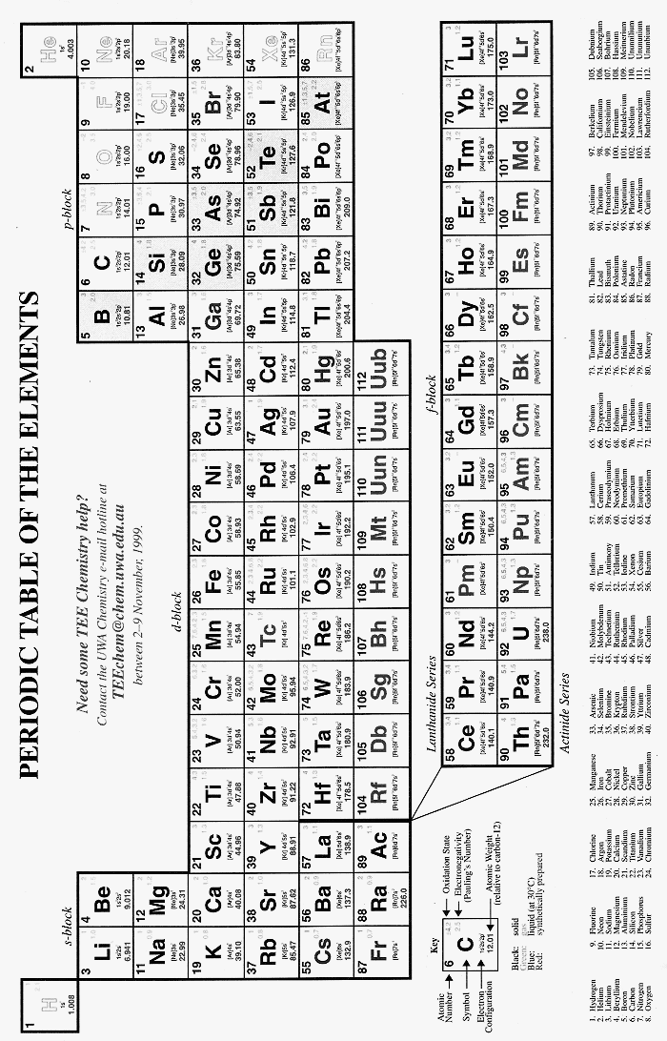
SECTION A: Short Answer

- Kathryn and Lauren had been studying for their Physics Examination and had been concentrating so hard they had let their hot milk milos get cold. Rather than make a new drink, Kathryn places their two insulated cups into the microwave to reheat them. If each cup holds 200 g of milo (specific heat 3.77 x 10³ Jkg⁻¹K⁻¹) and the microwave needs to heat both the drinks from 20⁰C to 70⁰C (they like their milo hot), how much energy did the microwave add to the drinks. (4 marks)

- Elise, our new exchange student, visited Egypt on her way to Australia and noticed many of the Arabs wearing loose fitting, light coloured clothing. As Elise has only just joined our class, explain to her, using physic principles, why people who live in hot climates often wear loose fitting, light coloured clothing to help them keep cool. (4 marks)

___________________________________________________________________________________
___________________________________________________________________________________
___________________________________________________________________________________
___________________________________________________________________________________
___________________________________________________________________________________
___________________________________________________________________________________
___________________________________________________________________________________
___________________________________________________________________________________
___________________________________________________________________________________
___________________________________________________________________________________
- Michael and Graeme were working together on a STAWA question in class. The question asked them to identify “X” in each of the following equations and to place its nuclide in the brackets shown. You also do the question as well as naming the type of radiation produced (not the actual particle) or, if no radiation produced, please name the particle produced from the reaction. (4 marks)

a. 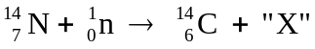 [ ] __________________________

b. 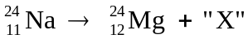 [ ] __________________________

c. 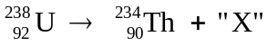 [ ] __________________________

d. 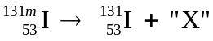 [ ] __________________________
- In an experiment to find the latent heat of fusion of a substance, Korrine and Duane measure the amount of energy needed to change the substance from a liquid to a solid. They find that the 260 g substance releases 23 kJ of energy. Calculate the latent heat of fusion for the substance. (4 marks)

- Heather is making tea for Erica and also for her sister Teresa while they are all studying hard for their year 11 and year 12 Semester One Examinations. If Heather used a 2 500 Watt kettle to heat the water from 22⁰C to 100⁰C to make the tea, how long did it take to heat the water? (4 marks)

- Chris and Rohan need to design a suitable exhaust system for an internal combustion engine. They find that the engine injects 24.6 L of gas each second at 322⁰C and 6.00 x 10² kPa pressure into the beginning of an exhaust system. As excellent physics students, they calculate the volume of exhaust gas that escapes from the end of that exhaust system each second when the temperature of the gas on exit is 45.0⁰C and its pressure is 103 kPa. What volume did they correctly calculate? (4 marks)

- A single outlet connected to both taps over a kitchen sink is supplied with cold water at 8.0⁰C and hot water at 64.0⁰C. Liam and Nicholas are measuring the flow and find out that the cold water tap is giving a flow of 6.00 litre min⁻¹. They then adjust the hot water tap to give a total flow rate of 12.0 litre min⁻¹ through the outlet. Liam then measured the temperature of the warm water. Calculate the temperature reading (assuming no loss of heat to the surroundings). (4 marks)

- In an experiment, Karra shines a ray of light from a torch through a liquid of refractive index 1.35 into another of refractive index 1.15. Kelsie, who is also carrying out the experiment, finds that the light leaves the first liquid at an angle of incidence of 40.0⁰. Complete the drawing (1 mark) then calculate the angle of deviation of the light ray (3 marks).

n = 1.15

incident
ray n = 1.35

- Tameka and Amy visit SciTech and find that one of the activities is to look at yourself in a range of different shaped mirrors. Tameka watches a child stand in front of a convex mirror that has a focal length of 0.70 m. The child is 0.8 m tall and is standing 0.9 m in front of the mirror. Using the graph section below, draw a ray diagram to show the image produced then describe the image. (4 marks)

Nature of Image: _________________ Position: ___________________________________

Magnification: ___________________ Upright or inverted: __________________________
- James has made a cool drink for Owen and himself by adding ice at -5.0⁰C to each glass. If it takes 1.169 x 10⁴ J of energy to fully melt the ice in his drink, how much ice did he add to his glass?
(4 marks)

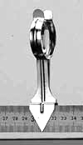
- Jamieson and Graeme are using an optical bench in an experiment to calculate the focal length of a convex lens. They find that a candle placed 15.0 cm from the convex lens forms an image on the screen 30.0 cm from the lens. The height of the flame is 1.5 cm.

  - Would the image have been real or virtual? _____________________________ (1 mark)
- Use the information to calculate the focal length of the lens and the height of the image of the flame. (3 mark)

- Tc-99m is a radioisotope that is used by medical technologist to study a number of conditions. Tc-99m has a short half life of 6.0 hours so more is sent to medical clinics than is needed. In one situation, it takes 24 hours to transport the Tc-99m from Lucas Heights, where it is made, to the clinic where it will be used immediately on receipt at the clinic. If 0.2 g is needed at the medical clinic, what is the minimal amount that can be sent from Lucas Heights? (4 marks)

- Casey had been told that the helium nucleus was very stable as it had a high binding energy per nucleon. Calculate the binding energy per nucleon of an alpha particle in MeV only. (4 marks)

- After an animal dies it no longer takes in Carbon-14, so that the ratio of C-14 (radioactive) to C-12 (not radioactive) gradually decreases. C-14 undergoes β-decay and has a half-life of about 5730 years. The decay rate of C-14 in a living animal is around 15 decays/minute per gram of carbon. Rowan and Logan, who are archaeologists, finds what they thinks is a dinosaur bone. The bone has a mass of 400g of carbon. The β-decay rate from the bone is 375 decays/minute. What is the approximate age of the bone and based on this information, do you think Rowan and Logan have a dinosaur bone (dinosaurs died out about 65 million years ago)? (4 marks)
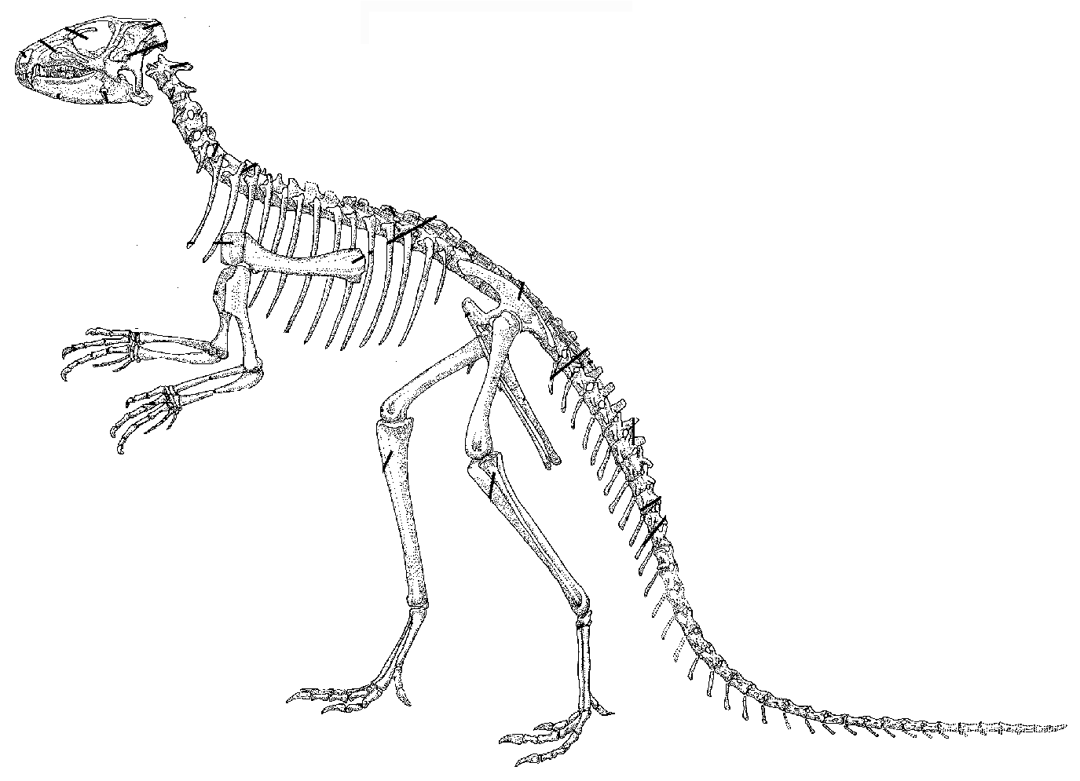

- In an experiment, Michael has collected the following data for the decay of a radioactive isotope. On the graph paper below, plot the graph Michael would have correctly plotted, draw in a line of best fit and from the graph estimate the half-live of the radioactive isotope.

Time minutes | 0 | 1 | 2 | 3 | 4 | 5 | 6 | 7 | 8 | 9 | 10
Count  Rate | 1216 | 1020 | 856 | 710 | 608 | 496 | 420 | 355 | 293 | 248 | 200

Clearly show on the graph how you obtained the half-life.

Half-life of radio-active isotope

Half-life = __________________ (4 marks)

SECTION B: Problem Solving.

- [20 marks]
Lisa is showing Kelsey how she can use a convex lens to change the size of a picture during an exhibition of alternative art styles. The lens has a focal length of 4.00 m and the 2.00 m high picture is placed 2.60 m from the lens.
- Draw the situation accurately to scale and label the object, image and focal point. (6 marks)

- Calculate where the image will form with respect to the lens, and the height of the image. (6 marks)

- What type of image is formed? ___________________________ (2 mark)

- Calculate the height of the image if she had used a concave lens. (6 marks)

- [14 marks]
While at university studying for his exams, Ryan has found that he can only read his text book when he holds it at arm’s length. If he holds the text book at a normal reading distance, the image is blurry.

- What eye defect does Ryan have? __________________________________________ (2 mark)
- What type of lens does he need to have prescribed by the optician to improve his vision? ___________________________________(2 mark)
- (i) Use the first diagram to show what the light rays of a close object are doing to produce a blurry
image. (2 marks)
(ii) Use the second diagram to show how that lens would help him form a clear image on his retina
of a close object. (3 marks)

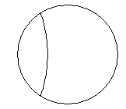

- Also at the university are Michelle and Alex. They make a very simple fixed focus camera that can focus on distance objects. The refractive index of the lens material is 1.6.

air
light from a
distance object in air

air

Michelle then waterproofs the camera and uses it to take a picture under water of a distant object. When she develops the film, she finds it is out of focus.

(i) Use the diagram below to draw in two rays to show approximately where the focal point is. (3 mark)

water
Light from a distance object in water

air

(ii) Describe one practical way that Alex could modify their camera to get the picture in focus.
______________________________________________________________________________
______________________________________________________________________________
______________________________________________________________________ (2 marks)
- [18 marks]
a. During an experiment, Reece and Dylon heat a 980g block of alloy (specific heat 301 Jkg⁻¹K⁻¹) which they place in an aluminium calorimeter of mass 855g. The calorimeter contains 250mL of water at 0.0⁰C and 60.0g of ice at -3.0⁰C. If the resulting temperature after the ice has melted and the water stirred was 6.0⁰C, what was the initial temperature of the lead alloy? Assume no loss of heat to the surroundings. (7 marks)

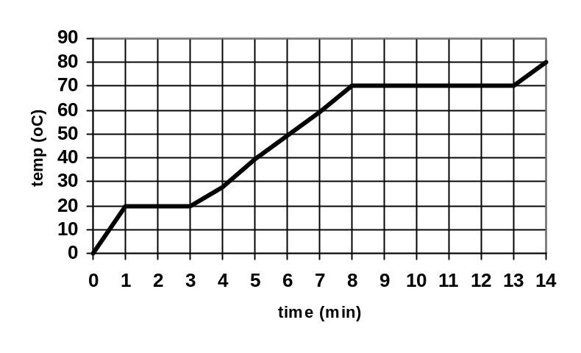
- In another experiment, Bevan and Ross used a small 200 Watt heater to continually heat 200 g of a solid in a well-insulated container. From their data they have drawn a temperature-time curve which is shown on the right. From their graph:
(i) Determine the melting point of the
solid? ____________________
(1 mark)
(ii) Explain, using the kinetic theory,
why the temperature sometimes
doesn’t change although energy is still being added. (4 marks)

_______________________________________________________________________________
________________________________________________________________________________________________________________________________________________________________________________________________________________________________________________________________________________________________________________________________________________________________________________________________________________
(iii) Calculate the latent heat of vaporization of the substance. (6 marks)

4. [18 marks]
Paul, Tarah and Talisa are working as industrial physicists. Paul accidentally swallows a radioisotope with an activity of 10.0 kBq. The material swallowed has a very long half-life. You can assume therefore that the activity will not change appreciably during Paul’s lifetime. Each decay of the isotope releases 1.60 x 10⁻¹³ J of energy into the body and that the radioisotope is not eliminated from the body.

a. Calculate the amount of energy absorbed in one year. (1 year = 365 days) (6 marks)
(NOTE: if you are unable to do this part, use the value 0.10 J to continue, this obviously is NOT the answer.)

- If Paul, in the future, has a mass of 60 kg, calculate the absorbed dose in one year. (4 marks)

Some types of absorbed radiation are potentially more damaging than others. For example, a particular absorbed dose of alpha radiation is much more damaging to the cells of the body than the same dose of beta or gamma radiation. To take this into account the absorbed dose is multiplied by an extra weighting called the Quality Factor (QF). Assume that the ingested radioisotope is an alpha emitter. (QF = 20),

- What is the dose equivalent absorbed per year? (4 mark)

- Should Paul be concerned about this yearly radiation exposure? Explain. (4 marks)
____________________________________________________________________________
____________________________________________________________________________
____________________________________________________________________________
____________________________________________________________________________
____________________________________________________________________________

5. [16 marks]
Within an atomic bomb, uranium-235 will undergo fission according to the following equation to
produce the large amount of energy necessary for destruction of the target.
a. Calculate the energy in MeV and in joules that would be released from the complete fission of one
atom of U-235 as shown in the equation above. (6 marks).

- The bomb dropped on Hiroshima, which is small compared to today’s standards, released an amount of energy equivalent to about 15 kilotons of TNT or around 5.5 x 10¹³ J from its uranium core which was about the size of a baseball. Using the data in your formula sheet, calculate the mass in kilograms of uranium within the bomb. (6 marks)

- Explain where the energy in the explosion comes from. Your answer should include the terms mass defect and binding energy. (4 mark)

________________________________________________________________________________________________________________________________________________________________________________________________________________________________________________________________________________________________________________________________________________________________________________________________________________________________________________________________________________________________________________________________________________________________________________
6. [14 marks]
A doctor wishes to diagnose a blocked blood vessel within the circulatory system of one of his patients. He injects a radioisotope into the patient's bloodstream, and follows the radioactive source through the circulatory system to locate the problem. He decides that Technecium-99^{m}, a gamma emitter with a 6.00 hour half-life, is a suitable source.

a. Complete and balance the equation below representing the gamma decay of technecium-99^{m}.
(2 marks)
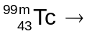

- If the original activity of a sample of technecium-99^{m} was 240 kBq, what would the activity be after 36-hours? (4 marks)

- In its use in medical imaging of human tissue, suggest one advantage and one disadvantage of the length of the half-life of technecium-99^{m}. (4 marks)

One advantage: _____________________________________________________________________
_________________________________________________________________________________________________________________________________________________________________________________________________________________________________________________________
One disadvantage: ___________________________________________________________________
____________________________________________________________________________________________________________________________________________________________________________________________________________________________________________________________________________________________________________________________________________

- Using technecium-99^{m} to create an image poses a possible risk to a patient’s health. Explain the nature of this risk. (4 marks)

________________________________________________________________________________________________________________________________________________________________________________________________________________________________________________________________________________________________________________________________________________________________________________________________________________________________________________________________________________________________________________________________________________________________________________

SECTION C: Comprehension and Interpretation.
Read the passages carefully and answer all questions at the end of the passages. Where possible, relevant formula should be included in explanation. Candidates are reminded of the need for good English and clear and concise presentation of answers.

Question One:
Lasers on my mind by Wilson da Silva

Six years ago, neurosurgeon Andrew Kaye would have given his patient 36 weeks to live. Today, after brain surgery, radiation therapy and firing lasers into the man’s head, the same patient is still visiting the Melbourne medic. Such is the promise of photodynamic therapy, a little-known branch of medical science that uses lasers and sensitised dyes, which is exciting oenologists around the world. Professor Kaye, at Melbourne University’s Department of Surgery at the Royal Melbourne Hospital, is on the leading edge of its applications on brain tumours and is one of a host of scientists working to refine it for general application against the scourge of cancer.

Central to the therapy are specially designed sensitiser dyes which are harmless when injected into patients. They drain from normal tissue in the body by the second or third day after injection but – probably due to the poor drainage system in tumours – remain soaked inside tumour tissue and even within individual cancer cells.
When irradiated with particular wavelengths of laser light, the dyes turn nasty. Chemical reactions ensue, releasing lethal elements that react with lipids on the surface of tumour cells lying in the laser’s path, rupturing them and killing the tumour. As the dyes mostly drain from normal tissue, there is little ‘collateral damage’.

Photodynamic therapy has been tested on skin, bladder, uterus, eye and bowel cancers, achieving tumour reductions of between 50 and 100 per cent. A group in Britain, led by Professor David Phillips of London’s Imperial College and University of London colleague Professor Steven Brown, has used lasers and dyes to destroy tumours in mice, rats and rabbits since animal trials began late last year. Clinical trials on humans have now begun in Britain and results are expected around mid-1993.

On a recent lecture tour of Australia and New Zealand, Professor Phillips told 21*C (a science magazine) the therapy is safer, cleaner, quicker and cheaper than using radiation and his applications in dentistry, in unblocking clogged arteries and in more rapid diagnosis of a number of ills. Professor Phillips’ dyes, developed over the past eight years, have successfully killed tumours in the pancreas of animals. “It destroyed pancreas tumours totally,” Professor Phillips said. “Some normal tissue was also killed, but some normal tissue was also regenerated.” Based on his research, Professor Phillips said the technique would probably be applied to tumours in the bladder, colon, breast, brain and surface tissue but not lung cancer.

Professor Kaye has concentrated on brain tumours and began researching the therapy in 1984, treating his first tumour two years later. The veteran of neurosurgical training in London and Cleveland now leads a team of local and international scientists pushing back the frontiers of the technique.

About 600 people die in Australia annually from cerebral glioma, the most common form of adult brain tumour. Standard treatment is to remove the visible tumour surgically and then blast the target area with radiation in the hope of killing off what is left behind. But even then, the average survival period is 36 weeks after treatment.
“It’s terrible. Although we can remove all the tumour we can see, there is still the roots of the tumour that are left, and these are growing a long way, deeply into the brain,” Professor Kaye said from his rooms at the Royal Melbourne Hospital. “It’s not possible to remove the roots of these tumours without destroying very important areas of the brain, just as it’s not possible to remove the roots of a tree without disturbing the soil.” With photodynamic therapy, the bulk of the tumour is surgically removed as normal, and while the skull is still open, lasers are fired into the region around the tumour base, activating tumour tissue soaked with sensitisers.

The therapy is still experimental and much work needs to be done on developing more potent dyes, or making dyes that are activated by higher laser wavelengths which more easily penetrate tissue. Nevertheless, some 1,000 people have been treated with photodynamic therapy around the world and Professor Kaye, who has treated more than 100 patients says it is prolonging lives: “At the moment we have a median survival of two years, but we also have patients who have survived longer than two years.”

But the therapy is not a cure. Professor Kaye’s team is in “phase two” of trials – treating people as they come forward and following up their cases. Before he can say the therapy is a complete success, more rigorous trials will be needed in which one group of patients is treated with photodynamic therapy and the other not. “Patients come to me for the treatment, and it’s very hard to tell them no. I’m trying to develop better techniques.” So if we start upon a ‘phase three’ trial, we’re stuck with using old techniques until we finish it, which may take two or three years.”
- According to paragraph one, what is photodynamic therapy? (2 marks)
___________________________________________________________________________________
___________________________________________________________________________________
___________________________________________________________________________________
___________________________________________________________________________________
___________________________________________________________________________________
___________________________________________________________________________________
___________________________________________________________________________________
- What happens to the dyes once they are injected into the body? (Paragraph 2) (4 marks)
___________________________________________________________________________________
___________________________________________________________________________________
___________________________________________________________________________________
___________________________________________________________________________________
___________________________________________________________________________________
___________________________________________________________________________________
___________________________________________________________________________________
- Fully explain what does the laser light do to the sensitiser dyes? (Paragraph 3) (4 marks)
___________________________________________________________________________________
___________________________________________________________________________________
___________________________________________________________________________________
___________________________________________________________________________________
___________________________________________________________________________________
___________________________________________________________________________________
___________________________________________________________________________________
___________________________________________________________________________________
- What do you think the terms collateral damage mean in this article (end of paragraph 2), and why is this not a major issue? (4 marks)

___________________________________________________________________________________
___________________________________________________________________________________
___________________________________________________________________________________
___________________________________________________________________________________
___________________________________________________________________________________
___________________________________________________________________________________
___________________________________________________________________________________
___________________________________________________________________________________
___________________________________________________________________________________
___________________________________________________________________________________
- Tumours can grow due to the effect of ionizing radiation on normal cells.
      - What is ionizing radiation? _________________________________________________________
________________________________________________________________________________________________________________________________________________________________________________________________________________________________________________________________________________________________________________________________________________________________________________________________________________________________________________________________________________________________________________________________________________________________________(2 marks)
      - One reaction that produces a very high ionizing radiation in human lungs is the natural decay of Radon gas, radon-222, into polonium. Write and complete the nuclear equation for this reaction showing the nuclide of the ionizing radiation that is produced. (You do not have to name the radiation.) (2 marks)

- The wavelength of laser light used has a velocity of 3.0 x 10⁸ ms⁻¹ in air. If the refractive index of human tissue is about 1.3, at what speed does the lazar light travel in human tissue? (2 marks)

Question Two:
The Coolgardie Safe
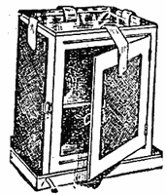
Storing perishable food was a constant problem in the days before refrigeration. The first home refrigerators arrived in 1927. Until this time food was either kept cool with ice and Coolgardie Safes, or preserved, salted or cured. The original inventor of the Coolgardie safe is unknown, however its birthplace has been attributed to the Western Australian town of Coolgardie. The cooling device began showing up in homes around the 19th century, and variations of the safe remained as a household item until the 1920s.
The Coolgardie Safe was designed to store meat and other foods, which required from protection from the heat of the Australian summer. The Coolgardie safe was made from a simple wooden frame, fitted with shelves and with the doors, sides and rear completely covered with hessian. A deep iron tray, kept filled with water, stood on top, and a larger tray stood under the safe’s short legs. Strips of flannel cloth dipped in the water and hanging against the hessian kept it wet as evaporation occurred. The safe was always kept outside in a shaded, breezy spot.
The following is the childhood memories of one Coolgardie Resident.

“In our garden grew a fine cypress tree with branches admirably arranged for climbing. This tree also sheltered the Coolgardie safe which was such a necessarily in the summer - we had no ice or refrigerators in those days. When we children were sent out to bring in milk or butter from this safe it was almost a physical impossibility to refrain from scooping a fingerful or two of luscious yellow clotted cream setting in its wide, shallow dish - but the path made by the finger would never join up again. The punishment could be a week long chore of keeping the safe’s reservoir filled with water so that the hessian sides never dried out.”

- The article talks about the “heat of the Australian summer” when they were referring to how high the temperature was. Explain the difference between heat and temperature. (4 marks)

___________________________________________________________________________________
___________________________________________________________________________________
___________________________________________________________________________________
___________________________________________________________________________________
___________________________________________________________________________________
- Name the main physics principle that helped keep the food cold in the Coolgardie safe. _________________________________________ (1 mark)
- Imagine that the housewife, after milking the cows, had made butter. If there was 600 g of butter and 1.2 L of milk, both at 35⁰C, how much energy would the Coolgardie safe have had to remove so they were both at a temperature of 5.0⁰C? (Specific heat values in data sheet.) (5 marks)

- Explain fully, using physics principles and terminology, how the Coolgardie safe worked. (6 marks)
__________________________________________________________________________________
__________________________________________________________________________________
__________________________________________________________________________________
__________________________________________________________________________________
__________________________________________________________________________________
__________________________________________________________________________________
__________________________________________________________________________________
__________________________________________________________________________________
__________________________________________________________________________________
__________________________________________________________________________________
__________________________________________________________________________________
__________________________________________________________________________________
__________________________________________________________________________________
__________________________________________________________________________________
__________________________________________________________________________________
__________________________________________________________________________________
__________________________________________________________________________________

e. Why was the safe kept in a shady, breezy spot outside the house, rather than inside the house where it
was more convenient? Fully explain. (4 marks)
__________________________________________________________________________________
__________________________________________________________________________________
__________________________________________________________________________________
__________________________________________________________________________________
__________________________________________________________________________________
__________________________________________________________________________________
__________________________________________________________________________________
__________________________________________________________________________________
__________________________________________________________________________________
__________________________________________________________________________________
__________________________________________________________________________________
__________________________________________________________________________________

End of Exam

