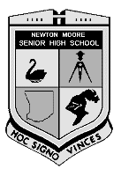
NEWTON MOORE SENIOR HIGH SCHOOL

YEAR 11 PHYSICS EXAMINATION

SEMESTER 2, 2007

Student’s Name: ______________________________________

TIME ALLOWED: Reading Time: 10 minutes
Working Time: 3 hours

This examination consists of three sections. Answer all questions in the spaces provided below each question.

SECTION A: Short Answer.
This section contains 15 questions and is worth 60 marks.

SECTION B: Problem Solving.
This section contains 8 questions and is worth 100 marks.

SECTION C: Comprehension and Interpretation.
This section contains 2 questions and is worth 40 marks.

INSTRUCTIONS TO CANDIDATES:
1. Do not use pencil except for drawings. Use a ruler to draw all straight lines.
2. Despite an incorrect final result, credit may be obtained for method and
working, provided these are clearly and legibly set out.
3. Ensure that your writing is legible and that correct grammar and spelling
are used at all times. Written answers must be in full sentences.
4. It is suggested that numerical answers should be in scientific notation and given to three significant figures with appropriate units. Answers must not be left in fractions.

SECTION | TOTAL MARK | MARK OBTAINED
A | 60
B | 100
C | 40 |  | GRADE
TOTAL | 200

SECTION A: Short Answer. Fifteen Questions, each question is worth 4 marks.
(60 marks total)

- Alex and Amy were studying for their semester examination when they decided to have a coffee break. Alex noticed that the kettle was rated at 2.50 x 10³ W and that the kettle was plugged into the 240.0 V mains. Calculate the current passing through the heating elements in the kettle.

V = 240 V P = VI (1 mark)
P = 2.50 x 10³ W 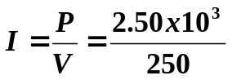 (2 marks)
I = 10 A (1 mark)

- Nic and Liam are using a convex mirror which forms an image. The mirror has a focal length of 5.00 cm and the object is 2.00 cm from the mirror. In the spaces provided accurately draw the ray diagram of the situation then fully describe the image. (Use 1 cm = 1 square.)
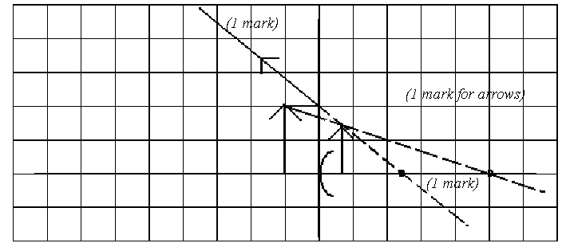

f c

Scale used: 1 cm on graph = 2 cm

NOTE: No Calculations are needed to describe the image.

Description of image:
Virtual
Behind the mirror (1 mark)
Diminished
Upright

- Tom was given four 2.00 Ω resistors. Draw a diagram below to show how he could connect the four resistors to give a total resistance of 3.00 Ω.

(4 marks)

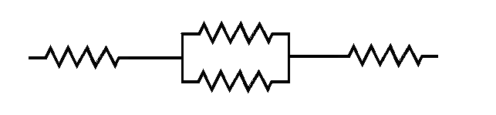

- Heather and Kelsey are listening to several of Kelsey’s latest CDs on a portable stereo system during lunch. The stereo system runs off four 1.50 V AA batteries connected in series. The total resistance of the stereo, when used to play the music, is 8.00 Ω.
  - How much current does the stereo draw from the cells?

V = 1.5 x 4 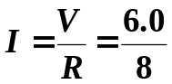
= 6.0 V (1 mark)
R = 8.00 Ω I = 0.75 A (1 mark)

  - Kelsey has the stereo running for 40.0 minutes; calculate how much charge flows through the electric circuit of the stereo during this time.

t = 40 x 60 q = It
= 2400 s = 0.75 x 2400 (1 mark)
I = 0.75 A = 1800
q = 1.80 x 10³ C (1 mark)

- Chris and Rohan were playing golf and Chris was using one of the new jumbo sized metal “woods” to hit the golf ball. Find the change in momentum of the golf ball and the force delivered to the golf ball by the metal wood from the following data:

Speed of metal ‘wood’ at impact | = 70 m s⁻¹
Mass of the club head | = 150 g
Mass of golf ball | = 50 g
Speed of ball on leaving the club head | = 140 m s⁻¹
Time for which contact was made | = 0.02 s

Change of momentum:
u = 0 ms⁻¹ Δρ = m (v – u)
v = 140 ms⁻¹ = 50 x 10⁻³ (140 – 0)
m = 50 x 10⁻³ kg Δρ = 7.0 kgms⁻¹ (2 marks)
Δρ = ?

Force on ball:
m _{(ball)} = 50 x 10⁻³ kg 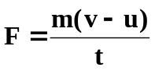
u = 0 ms⁻¹ 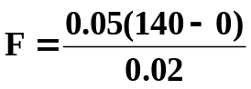
v = 140 ms⁻¹ F = 350 N (2 marks)
t = 0.02 s

OR Ft = Δρ
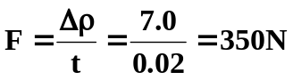

- Identify “X” in each of the following equations and place its symbol in the brackets to the right of the equation. Only where appropriate, name the type of radiation produced, leave blank otherwise.

a. 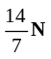 + 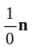 → 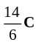 + “X” [ 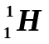 ] __________________________

b. 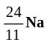 → 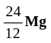 + “X” [ 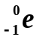 ] _____Beta_________________

c. 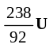 → 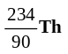 + “X” [ 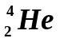 ] _____Alpha_____________
d. 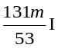 → 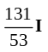 + “X” [ 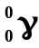 ] _____Gamma_____________
(note: m denotes in excited state) (each part 1 mark, both sections correct or zero)
- Bevan wants to cool a hot cup of Milo which is at 85.0⁰ C. 0.300 kg of the drink is in a fully insulated cup and Bevan adds a 60.0 g ice block at 0.00⁰ C to the Milo. If the specific heat of Milo is 4.10 x 10³ Jkg⁻¹K⁻¹, calculate the final temperature of the Milo when the ice has fully melted.

Heat lost = heat gained
0.3 x 4100 x (85 – T) = (0.06 x 3.34 x 10⁵) + (0.06 x 4180 x T) (2 marks)
104550 - 1230T = 20040 + 250.8T
84510 = 1480.8T
T = 57.1⁰C (2 marks)

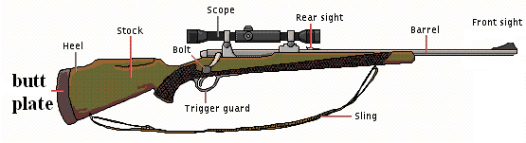
- Before firing a rifle, Ryan places the butt plate of the rifle against his shoulder for support. He fires the rifle and it jerks back into his shoulder causing a bruise. By naming and using physics principles, explain why this happens.

This is due to Newton’s Third Law. (1 mark)
For every action force there is an equal but opposite reaction. (1 mark)
When the rifle is fired, the gun applies a force on the bullet firing the bullet forwards but at the same time, the bullet applies a force on the gun pushing the gun backwards. (2 marks)

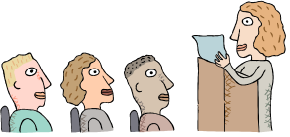
- During an oral report, Karra gives a talk on Radon-222 gas (symbol Rn) which can build up in caves and mines. Karra explains that Randon-222 is known to increase the likelihood of lung cancer in miners, especially for smokers.
a. Radon only gives off alpha particles. Write the full equation for this decay process.

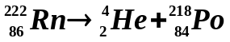 (2 marks)

b. Explain why radon gas is so dangerous if the alpha particles it emits can’t penetrate the skin.

Radon is a gas so can be breathed in. Inside the body the radon emits alpha particles which have high ionizing ability due to their size. (1 mark)
Alpha particles cause chemical reactions to occur in the body that shouldn’t occur and some of these can increase chance of cancer. (1 mark)

- Erica and Tameka are showing the class on the whiteboard how to calculate binding energy. The problem was to calculate the binding energy per nucleon of a Be-9 atom having a mass of 9.012182 u. Show how they correctly demonstrated this calculation with the energy in MeV.

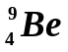 md = (mass 4 protons + mass 5 neutrons) - mass
4 protons = [(4 x 1.00728) + (5 x 1.00867)] - 9.012182
5 neutrons = 4.02912 + 5.04335 - 9.012182
nucleons = 9 = 0.060288 u (2 marks)

MeV = 0.060288 x 931.5
= 56.158 u per atom (1 mark)

binding energy per nucleon = 56.158 ÷ 9
= 6.24 MeV per nucleon (1 mark)

- Duane is a meteorologist. He is using a weather balloon to carry some equipment into the atmosphere to take readings. His expandable balloon initially contains 89.5 L of helium at 760 mm Hg pressure and 22.0⁰C. What will be the volume of the balloon when it rises to an altitude of 35.0 km where the pressure is 4.00 mm Hg and the temperature is -2.00⁰C?

V1 = 89.5L V2 = 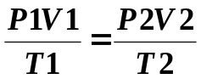
P1 = 760 mmHg P2 = 4 mmHg
T1 = 22 + 273 T2 = -2 + 273 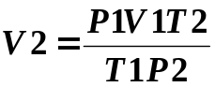
= 295K = 271K 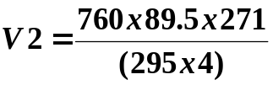 (2 marks)
(conversion 1 mark)
V₂ = 15622 L
V₂ = 1.56 x 10⁴ L (1 mark)

- Reece is on a ride at the Royal Show. This ride involves raising a platform, to which the riders are strapped, up a height of 20.0 m. The platform is then allowed to freefall until it is brought to a rapid stop near the ground. If the riders and platform have a mass of 2.60 x 10³ kg what would be the apparent weight if the platform decelerated at a rapid 22.4 ms⁻² just before it reached the ground.

m = 2.6 x 10³ kg F_{w} = ma
a = 9.8 + 22.4 = 2.6 x 10³ x 32.2 (1 mark)
= 32.2 ms⁻² (2 marks) = 83720
F_{w} = 8.37 x 10⁴ N (1 mark)

- Lauren, Tarah and Kelsie are using a heating element connected to the 240 V mains to boil 250 g of water from 20.0⁰C to 100⁰C. How much charge passed through the heating elements in this time?

Heat energy = Electrical Work
Q = W
mcΔT = qV (2 marks)

0.25 x 4180 x (100 – 20) = q x 240 (1 mark)
83600 = 240q
348 = q

q = 348 C (1 mark)

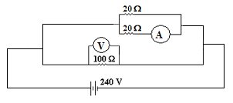
- Jamieson, Michael and Graeme have set up the following circuit. What would they find the reading on the ammeter to be?

R (parallel) = (20⁻¹ + 20⁻¹)⁻¹
= 10 Ω

R (total) = (10⁻¹ + 100⁻¹)⁻¹
= 9.091 Ω (1 mark)

I_{T} = 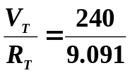 = 26.4 A
I (100 Ω section) = 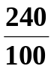 = 2.4 A (1 mark)

Current in 20 Ω parallel section = 26.4 – 2.4 = 24 A (1 mark)

This is shared equally between both resistors so reading on ammeter = 12 A

I = 12 A (1 mark)

- Heather is helping her Mum around the house by doing the weekly washing in the new washing machine. She reads in the instruction booklet that the spin cycle on a washing machine can spin as fast as 6.00 x 10² rpm (revolutions per minute). Using this information, Heather correctly calculates the speed and velocity of a sock on the edge of the tub after one and a quarter turns of the tub? Assume the tub has a diameter of 0.550 m. You must show all working for full marks.
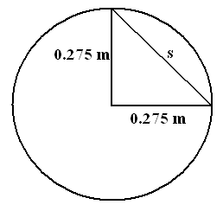

600 rev = 60 s
1¼ rev = t
t = 0.125 s
(minus 1 mark if incorrect)t

SPEED VELOCITY
Circumference = π x diameter s = 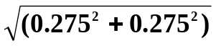
= π x 0.55 = 0.3889 m (1 mark)
= 1.7279 m t = 0.125 s
but 1¼ times around so
distance = 1.7279 x 1¼
= 2.1598 m (1 mark)

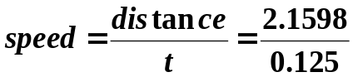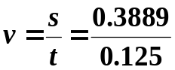

speed = 17.3 ms⁻¹ v = 3.11 ms⁻¹
(1 mark) (1 mark)

SECTION B : Problem Solving and Extended Answer. (100 marks)

1. [13 marks]
James and Dylon are using an optical instrument with a convex lens to carry out an experiment. Dylon puts an 8.0 cm high piece of newspaper 6.00 cm from the optical object which has a 0.100 m focal length convex lens.

a. Draw a labelled ray diagram to show where the image would be formed. (4 marks)
(minus 1 if no arrows)
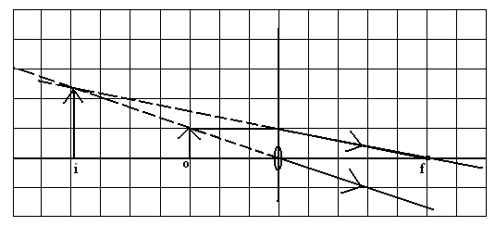

b. Calculate mathematically the position and magnification of the image.

f = 10 cm 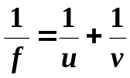 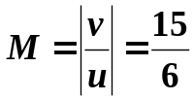
u = 6 cm 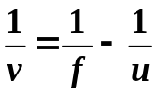 = 2.5 (1 mark)
v = (10⁻¹ - 6⁻¹)⁻¹ (1 mark) h_{i} = h_{o} x M
v = -15 cm (1 mark) = 8 x 2.5
so image is 15 cm = 20 cm (1 mark)
in front of lens (2 mark) height of image = 20 cm

c. Describe the image produced if the lens was a concave lens. No calculations needed.
Virtual upright
Diminished in front of the lens (2 marks)

d. Name the optical instrument they were most probably using.
Magnifying glass (1 mark)
2. [12 marks]

Cheetahs are the fastest animals on the planet. One cheetah, while chasing an antelope in a straight line, accelerated at 96 ms⁻² from rest to her maximum velocity in 3.00 m. She ran for 312 m at this velocity then, when she didn’t catch the antelope, decelerated for 5.0 s to stop and watch the antelope escape.
  - On the graph provided, draw a velocity-time graph of the cheetah’s journey.
(The space below has been left for your working.)

s = ut + ½ at² v² = u² + 2as t₂ = s/v
3 = 0 + (0.5 x 96 x t²) = 0 + (2 x 96 x 3) t = 312 ÷ 24
3 = 48t² = 576 t₂ = 13 s (1 mark)
t² = 0.0625 v = 24 ms⁻¹ (1 mark)
t₁ = 0.25 s (1 mark) t₃ = 5 s

t_{T} = 0.25 + 13 + 5 = 18.25 s (1 mark)

(graph = 2 marks)

Graph of the Journey of a Cheetah.
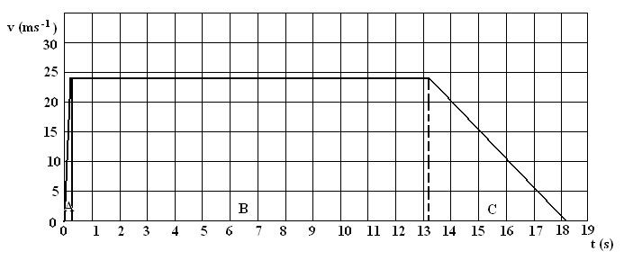

  - Calculate the displacement of the cheetah using only the graph (no marks for any other method although the values in the question can be used to confirm your calculations).

A = 0.5 x 0.25 x 24 = 3 (1 mark)

B = 24 x 13 = 312 (1 mark) s = 375 m (1 mark)

C = 0.5 x 5 x 24 = 60 (1 mark)

Total = 375 m

  - Calculate the acceleration of the cheetah in the last 5.0 s of her journey.

u = 24 ms⁻¹ 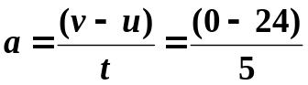(1 mark)
v = 0 ms⁻¹
t = 5 s a = -4.8 ms⁻¹ (1 mark)

3. [8 marks]

Ross is a thermodynamics student who is heating an 11.3 kg sample of a solid in an insulated container in which an electrical heating coil supplies heat at a rate of 255.0 W or 255.0 joules very second. He measured the temperature of the substance at one minute intervals. The following graph shows the changing temperature over thirteen minutes.

- What is the melting point of the solid?
60⁰C (1 mark)
- How much heat energy was absorbed while the solid was melting?
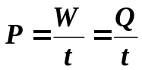 Q = 255 x 360 (1 mark)
Q = P x t Q = 91800
t = (10 – 4) x 60 Q = 9.18 x 10⁴ J (1 mark)
= 360 s (1 mark)

c. Calculate the specific heat for the substance in the solid phase.

m = 11.3 kg Q = mcΔT
ΔT = 60 – 20 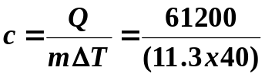 (1 mark)
= 40 (1 mark) c = 135 Jkg⁻¹K⁻¹ (1 mark)
Q = P x t
= 255 x (4 x 60)
= 61200 J (1 mark)
[17 marks]
a. Within the oval area, where could a charged particle P be placed so that it experiences no net force? You will need to draw in the field lines to justify your placement.
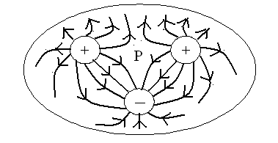

(1 mark for arrows
1 mark for P
3 marks for diagram)

b. Casey has set up an unusual experiment in electrostatics. A small sphere is suspended 1.50 cm above another sphere in a frictionless pipe. The bottom sphere has a charge of +15 nC, and both have a mass of 0.300 g. Calculate the charge on the top sphere?

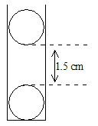
F_{g} = F_{e}
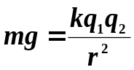 (2 mars)
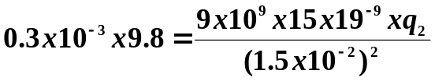 (2 mark)
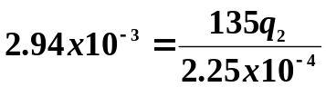
135q₂ = 2.94 x 10⁻³ x 2.25 x 10⁻⁴
= 6.615 x 10⁻⁷
q₂ = +4.9 x 10⁻⁹ C (2 marks)

(4.9 nC)

F_{g}

F_{e}

c. In another situations, Michelle has set up two freely hanging charged spheres which have a charge of +10.0 nC and -6.00 nC respectively. Michelle brings the spheres together to touch each other and then releases them. Once released the particles settle 8.00 cm apart from each other. Calculate the force they exert on each other at this time?

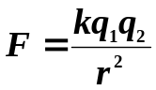+10 -6

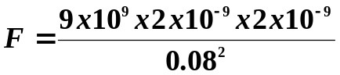
(2 marks)

+10-6 = +4

+2nC +2nC F = 5.63 x 10⁻⁶ N repulsion (2 marks)

(2 marks)

5. [14 marks]

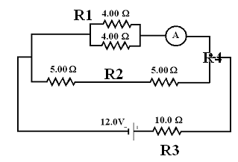
Jamieson and Michael have set up a circuit for an investigation. The circuit diagram to the right shows a battery connected to a number of resistors.

- Calculate the total circuit resistance.

R1 = (4⁻¹ + 4⁻¹)
= 2 Ω (1 mark)

R2 = 5 + 5 = 10 Ω (1 mark)

R4 = (2⁻¹ + 10⁻¹)
= 1.6667 Ω (2 mark)

R(total) = 10 + 1.6667
R_{T} = 11.7 Ω (1 mark)

- Calculate the potential difference across one of the 5.00 Ω resistors.

V_{T} = 12 V V_{10Ω} = I_{T} x R_{10Ω}
R_{T} = 11.6667 = 1.0286 x 10
= 10.286 V (2 mark)
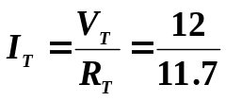 Now equal drop across both 5.0 Ω (1 mark)
I_{T} = 1.0286 A so drop across one 5.0 Ω resistor is 10.286 ÷ 2
(1 mark)
V _{5Ω} = 5.143 V (1 mark)

- If the 4.00 Ω resistors were connected in series rather than in parallel, would the reading on the ammeter increase, decrease or stay the same? Explain your answer.

DECREASE (1 mark)
Current is inversely proportional to resistance therefore increase resistance and current decreases. (1 mark)
When 4.0 Ω resistor put in series total resistance goes from 2.0 Ω to 8.0 Ω, as resistance has increased, current has decreased so metre reads less. (2 marks)

(4.0 Ω in parallel I = 0.85 A, in series I = 0.46 A – calculation not required.)

6. [13 marks]
Reece is a laboratory technician in a nuclear energy laboratory. He takes a series of sensitive Geiger counter readings every half hour at a fixed distance from a sample that contains radioactive element (X). Part of the readings he took are recorded in the table below. Note that the table is incomplete but you will need to work with the data given.
The reading when the source was removed was 180 counts min⁻¹

Time (h) | 0.5 | 1.0 | 1.5 | 2.0 | 2.5 | 3.0 | 3.5 | 4.0 | 4.5 | 5.0
Experimental count | 2477 | 2031 | 1633 | 1315 | 1084 | 916 | 760 | 635 | 548 | 470
True count | 2297 | 1853 | 1453 | 1135 | 904 | 736 | 580 | 455 | 368 | 290

- Complete the table above and using the graph paper below plot data that will enable you to determine the half life of the radioactive element (X). (4 marks)

Half life of radioactive sample

- From the graph calculate the average half life of the element (X) and indicate this on the graph.
(2 marks)

Half life is time for half of substance decayed

Using 2297 ÷ 2 = 1148.5 and the change of time for 2297 to 1148.5
is 0.5 hour to 2.0 hours or approximately 1.5 hours

half-life = 1.5 hours

- If the original mass of the sample containing radioactive element (X) is 0.205 kg, what will be the mass of radioactive element (X) after 4.50 hours? (3 marks)

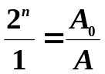
A₀ = 0.205
Half life = 1.5 hours
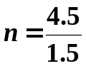 (1 mark) 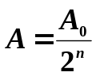
= 3
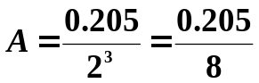 (1 mark)

A = 0.0256 kg (1 mark)

- During the experiment radioactive element (X) is decaying into element (Y) and emitting a certain type of radiation. What proportion of the original sample consists of radioactive element (X) after 3.20 hours, if at the beginning of the experiment, the original sample consisted of 50% radioactive element (X)? (3 marks)

3.2 hours = 2 half lives

50% = X

after 1 half-life = 25%

after 2 half-lives = 12.5% X = 12.5%

- Reece found that a sheet of aluminium placed between the original source and the counter noticeably reduced the count rate. What type of radiation was radioactive element (X) emitting? (1 mark)

Beta (1 mark) (count reduced but not stopped so must be beta)

7. [12 marks]
Tameka, Amy and Erica are going for a ride on a roller coaster. The roller coaster starts from rest and by the time it reaches the top of the first hill (a vertical distance of 14.0 m) it is travelling at a speed of 2.40 ms⁻¹. The 1.80 x 10³ kg coaster then plummets down a steep incline (vertical height of 12.5 m) until it climbs out of the dip by travelling up a slope that takes it to within 2.50 m of the first hill. The diagram (not to scale) illustrates this.
start
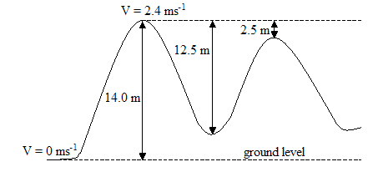

- Showing your understanding of the relationship between potential and kinetic energy, find the velocity of the coaster at the top of the second hill, you must show full working. (6 marks)

E_{T} = E_{k} + E_{p}
= (0.5mv² + (mgh)
= (0.5 x 1800 x 2.4²) + (1800 x 14 x 9.8) (2 marks)
= 5184 + 246960
= 252144 J (1 mark)

E_{T} = E_{k} + E_{p}
252144 = (0.5 x 1800 x v²) + (1800 x 9.8 x 11.5) (2 marks)
252144 = 900 v² + 202860
900 v² = 252144 - 202860
= 49 284
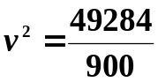
= 54.76
v = 7.40 ms⁻¹ (1 mark)

- Also at the Royal Show a gunman was demonstrating an unusual stunt. He used a 70.0 cm long rifle which was placed on the ground so that its barrel points upwards. A 300 g rubber ball was dropped downwards towards the rifle barrel by an assistant. The gunman fires the gun so that the ball, which is travelling at 4.00 ms⁻¹ downwards, is hit when it is 10 cm from the top of the barrel. The 20.0 g bullet was travelling at 460 ms⁻¹ upwards when it hits the ball and remains in the ball causing the ball to change direction and travel upwards. The assistant measured the maximum height above the ground that the ball reached after it had been hit by the bullet. What measurement did the assistant get? (Assume no loss of energy to other forms and no friction.) (6 marks)
(Hint:
- Using conservation of momentum, find the initial velocity with which the ball/bullet combination moves upwards.
- Knowing velocity of ball/bullet find ball’s maximum height after being hit by bullet.
- Find total height of ball/bullet from the ground.)

Let up be negative and down be positive.
m₁ _{bullet} = 0.02 kg
u₁ _{bullet} = -460 ms⁻¹
v₁ _{bullet} = ? but same as ball so v₁ = v₂ so now just v

m₂ _{ball} = 0.3 kg
u₂ _{ball} = +4.00 ms⁻¹
v_{2 ball} = ? but same as bullet so v₁ = v₂ so now just v

m₁u₁ + m₂u₂ = m₁v₁ + m₂v₂
or m₁u₁ + m₂u₂ = v ( m₁ + m₂)

(0.02 x -460) + (0.3 x +4) = v (0.02 + 0.3)
-9.2 + 1.2 = 0.32v
-8.0 = 0.32v
v = -8.0 ÷ 0.32
v = -25 ms⁻¹ or 25 ms⁻¹ upwards. (3 marks)

Now ball/bullet will experience gravity slowing it down until it stops

v² = u² + 2gs
- = (-25)² + (2 x 9.8 x s)
0 = 625 + 19.6s
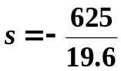
s = -31.8877 m or 31.8877 m upwards (2 marks)

but rifle is 0.7 m tall and ball was 0.1 m above rifle when hit so total height reached was

s = 31.8877 + 0.7 + 0.1
s = 32.6877 m upwards
height above ground reached = 32.7 m (1 mark)

8. [11 marks]
In 2001 a very rich American tried to fly a balloon non- stop around the world. Below is a diagram of his balloon. It was launched at Northam and moved vertically upwards with a constant velocity of 4.0 m s⁻¹. Unfortunately after only 5.0 mins an essential piece of equipment became dislodged and fell out of a gap in the basket and fell towards the ground.

a. How high was the balloon after 5.0 mins? (3 marks)
V = 4.0 ms⁻¹ as a constant velocity, can use 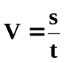
t = 5 x 60 = 300 s s = V x t
(1 mark) = 4.0 x 300 (1 mark)
s = 1 200 m

s = 1.2 x 10³ m (1 mark)

b. Neglecting air resistance, how long does it take for the essential piece of equipment to reach the
ground? (4 marks)

s = ut + ½ gt²
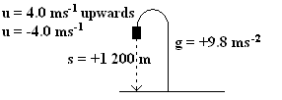
1 200 = (-4.0t) + (4.9t²) (1 mark)
4.9t² – 4.0t – 1200 = 0
t = 16.0627 s
t = 16.06 s (1 mark)
(2 mark for correct data)

c. With what speed will it impact on the ground? (3 marks)

u = -4.0 ms⁻¹ v = u + gt
g = +9.8 ms⁻² = -4 + (9.8 x 16.0627) (2 marks)
t = 16.0627 s v = 153.414 ms⁻¹

v = 153 ms⁻¹ (1 mark)

d. Describe how your answers for (b) would change if you included the effect of air resistance.
(No calculations needed). (1 marks)

The time would increase. (1 mark)

SECTION C: Comprehension and Interpretation. (40 marks)

Read the passages below then answer all questions. Candidates are reminded of the need for clear and concise presentation of answers. Diagrams (sketches), equations and/or numerical results should be included as appropriate.

QUESTION ONE:

Can Cars Make Trains Safer?

MANY deaths in rail crashes could be prevented if techniques now used to make cars safer were also applied to trains, according to investigations carried out at the Motor Industry Research Association (MIRA). After the Clapham train crash of November 1988, in which 35 people died after a commuter train travelling east ran into the back of a stationary one at about 57.6 kmh⁻¹, the British Rail subsidiary Engineering Link commissioned MIRA, which is based in Nuneaton, to study ways of cushioning rail passengers in a crash.

Last week Andy Piper, a researcher at MIRA, told a conference on railway technology at Birmingham that many of the methods used to reduce the severity of car accidents could also be applied to trains. Piper says that the major difference between car and train crashes is that rail passengers face relatively low accelerations in a crash. In MIRA tests, a crash involving a sports car produced deceleration on dummies of 50 g (this means 50 x 9.8 which equals 490 ms⁻²), lasting about 70 ms (70 milliseconds). But on a train the impact is softened as the carriages crumple, and a typical railway crash produces decelerations of about 5 g for approximately 200 ms.

In cars, seat belts and air bags are necessary if drivers and passengers are to have a reasonable degree of protection, Piper says. However, because of the relatively gentle deceleration on passengers in a train crash, quite minor changes to the design of carriages could give protection comparable to that conferred by a seat belt in a car.

One of the easiest ways to protect passengers on a train is to have all the seats facing backwards, trains reverse at the end of their journey, and in any case passengers often want to sit facing each other at a table while they have a meal or a drink. In a head-on crash, the forward-facing passengers hit the hard edge of the table abdomen-first, and as it digs in it may cause internal injuries such as a ruptured spleen.

Piper says that the solution to this problem is, in part, to redesign the leading edge of the table so that it crumples in a crash and softens the blow. The other part of the solution is to arrest the forward motion of passengers’ bodies with a “knee bolster” under the table. Knee bolsters are used extensively in cars in the US, where some states do not have compulsory seat belt laws and air bags are the main source of protection in an accident. Knee bolsters, used in conjunction with air bags, can then absorb nearly a third of the crash energy. In railway carriages, the knee bolsters would be placed quite close to the passengers’ knees so as to absorb the energy from the crash as gradually as possible.

Piper says that automotive technology can even help to protect the train driver, who is the most vulnerable person in a crash. An air bag, much larger than those used in cars, would help to restrain the driver. In conjunction with an energy absorbing front end, which would be designed to maintain a space one metre wide in a collision, this could improve drivers’ safety in quite serious crashes. Piper acknowledges though that any design used in trains not only has to soften the impact in a crash, but also be tough enough to resist the attentions of vandals. The next stage of MIRA’s research will be a full-scale test crash. This will yield data to validate its calculations and to produce designs for safety features.

Used by permission from the NEW SCIENTIST (4th June 1994) page 18, “Can cars make trains safer?”

- Assuming a test dummy is designed to have a mass of 75.0 kg (approximately the mass of an average adult), calculate the Force and the Impulse acting on the test dummy in the car crash and train crash. You will need to use values given in the article. (4 marks)

CAR | TRAIN
Force  F = ma  = 75 x 490  = 36750  F = 3.68 x 10⁴ N | Force  F = ma  = 75 x (5 x 9.8)  = 3675  F = 3.68 x 10³ N
Impulse  Impulse = Ft  = 36750 x 70 x 10⁻³  = 2572.5 Ns  Impulse = 2.57 x 10³ Ns | Impulse  Impulse = Ft  = 3675 x 200 x 10⁻³  = 735 Ns  Impulse = 735 Ns

- Fully explain, using your understanding of Newton’s Second Law of Motion, why even through the passengers in a car and a train are travelling at the same speed before a crash, the passengers in a train experience less acceleration than the passengers in a car. (5 marks)

- In a crash, the change of momentum will remain unchanged, Δρ = m(v – u).
- Change of momentum also equals Ft, so Ft = m(v – u), and 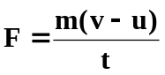.
- While mass and initial and final velocity are the same, the time over which Δρ occurs is different, car = 0.07 s and train = 0.20 s.
- As acceleration is 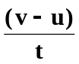,
- the greater time of the train crash will produce less acceleration on the passengers.

- Give three ways in which train (passenger) carriages can be designed to protect passengers in
collision accidents. (3 marks)

- Have seats facing backwards
- Knee bolsters under table
- Leading edge of table to crumple (1 mark for each)
Don’t accept seatbelts and air bags are these are not for passengers in trains.
- If the commuter train in the Clapham crash had an overall mass of 1.60 x 10⁵ kg and was locked together with the stationary train (mass 1.20 x 10⁵ kg) during the collision, determine the velocity in kilometres per hour (kmh⁻¹) of the combined masses after the collision. (6 marks)

Initial train travelling East and combined trains will travel East, so all velocities will be positive.

Commuter train m_{c}u_{c} + m_{s}u_{s} = m_{c}v_{c} + m_{s}v_{s}
u_{c} = 57.6 kmh⁻¹ m_{c}u_{c} + m_{s}u_{s} = (m_{c} + m_{s}) v (1 mark)
= 16 ms⁻¹ (1.60 x 10⁵ x 16) + 0 = (1.6 x 10⁵ + 1.20 x 10⁵) v
(1 mark) (2 marks)
v_{c} = v 2560000 = 280000 v
m_{c} = 1.60 x 10⁵ kg 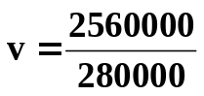
v = 9.14285

Stationary train Final velocity of both trains
u_{s} = 0 ms⁻¹ v = 9.14 ms⁻¹ East. (2 marks)
v_{s} = v
m_{s} = 1.20 x 10⁵ kg

- Piper accepts that any design used in trains will not only have to soften the impact of a crash but must be able to resist another problem. What is this problem? (2 marks)

Safety features must be tough enough to resist the attentions of vandals.

QUESTION TWO:
The following article was taken from Physics – Revealing Our World by Christina Hart.

Recollections by Mrs B. Malone …
The time came when we learned that we were to move to the big city. We younger children had never been to Melbourne, and I think we were very excited about it all….

Our Melbourne home was equipped with electricity for lighting and gas for cooking, heating, etc. – real progress. Some homes were still lit by gas mantels, gas stoves replaced the wood-fuelled ones (which had made kitchens so hot in summer) and small gas-heated water cisterns appeared on kitchen walls to service the sink. Washing was speeded up in gas-heated coppers and gas fires replaced the cheerful (but yet wasteful) wood fires in open fireplaces. Electricity was gradually appearing on the scene, but until probably well into the 1920s the normal suburban household was equipped with only one power point – usually for the electric iron. The socket had two holes only (no earth). When we first moved into our house, our mother was proudly showing us where the wonderful new electric iron was to be connected, by touching the socket with two of her fingers: only to give herself a hefty electric shock!

There were still no vacuum cleaners, etc. The first electrical kitchen aids were probably the electric iron and toaster, and a small one-bar radiator. In boarding houses double adapters boomed. Fitted into the central hanging light socket, one could connect a radiator or toaster, as long as the landlady was not about to call in! With the advent of other electrical implements, electricians must have reaped a small fortune rewiring houses and installing power points in every room.

- Up until the 1920s, most homes only had one power point. What was this usually used for?
Electric iron (2 mark)
- Early electrical homes had no earth wire. What is the purpose of an earth wire? (4 marks)

The earth wire is designed to carry away excess current from appliances in such cases as short circuits. Designed to prevent current flowing through people.

- Many appliances today such as hairdryers don’t have an earth connection. Explain how are these appliances are made safe? (4 marks)

Double insulation.
Not only are all internal conductors insulated with plastic, but appliance is also covered in plastic insulation – two layers of plastic so double insulation.

- Name one electrical safety devise in the home and explain how it works. (4 marks)

Any suitable answer but probably fuse or circuit breakers.
FUSE:
Excess current causes wire to melt so circuit breaks and no current to cause damage. Wire must be replaced with similar type of fuse wire.

OR

CIRCUIT BREAKER:
Excess current causes electromagnetic switch to turn off and so breaks the circuit. No circuit so no current to cause damage. Need to push switch back on once problem fixed.

- Modern homes have many power points and light switches. Often, one light can be controlled by two switches.

In the diagram below, is the light from the two-way switch on or off? ___OFF______ (2 mark)

globe
Neutral

Active
Switch 1 Switch 2

- Light globes are non-ohmic resistors. Explain what this means. Include diagrams to help your explanation. (4 marks)

In non-ohmic resistors, the potential difference is not proportional to the current. Often, as the potential difference is increased so does the temperature of the resistor and the resistance increases.

Ohmic resistors maintain a constant resistance over all ranges of potential difference and currents and heating doesn’t affect their resistance.

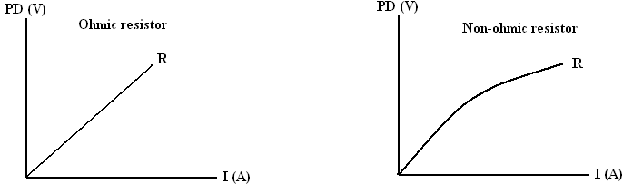
End of Exam

