Insert School Logo

Semester One

Examination 2024

Question/Answer booklet

PHYSICS
UNIT 3

Name: _______________________________________________________

Teacher: ___________________________________________________

TIME ALLOWED FOR THIS PAPER

Reading time before commencing work: Ten minutes
Working time for the paper: Three hours

MATERIALS REQUIRED/RECOMMENDED FOR THIS PAPER

To be provided by the supervisor:
- This Question/Answer Booklet; Formula and Constants sheet

To be provided by the candidate:
- Standard items: pens, pencils, eraser or correction fluid, ruler, highlighter.

- Special items: Calculators satisfying the conditions set by the SCSA for this subject.

IMPORTANT NOTE TO CANDIDATES
No other items may be taken into the examination room. It is your responsibility to ensure that you do not have any unauthorised notes or other items of a non-personal nature in the examination room. If you have any unauthorised material with you, hand it to the supervisor before reading any further.

Structure of this paper

Section | Number of questions available | Number of questions to be answered | Suggested working time  (minutes) | Marks available | Percentage of exam
Section One:  Short Response | 11 | 11 | 50 | 54 | 30
Section Two:  Problem Solving | 8 | 8 | 90 | 90 | 50
Section Three:  Comprehension | 2 | 2 | 40 | 36 | 20
 |  |  | Total | 180 | 100

Instructions to candidates

- The rules for the conduct of Western Australian external examinations are detailed in the Year 12 Information Handbook 2024. Sitting this examination implies that you agree to abide by these rules.

- Write your answers in this Question/Answer Booklet.

- When calculating numerical answers, show your working or reasoning clearly. Give final answers to three (3) significant figures and include appropriate units where applicable.

When estimating numerical answers, show your working or reasoning clearly. Give final answers to a maximum of two (2) significant figures and include appropriate units where applicable.

- You must be careful to confine your responses to the specific questions asked and follow any instructions that are specific to a particular question.

- Spare pages are included at the end of this booklet. They can be used for planning your responses and/or as additional space if required to continue an answer.
  - Planning: If you use the spare pages for planning, indicate this clearly.
  - Continuing an answer: If you need to use the space to continue an answer, indicate in the original answer space where the answer is continued, i.e. give the page number. Refer to the question(s) where you are continuing your work.

Section One: Short Response 30% (54 Marks)

This section has eleven (11) questions. Answer all questions. Write your answers in the space provided.

When calculating numerical answers, show your working and reasoning clearly. Give final answers to three (3) significant figures and include appropriate units where applicable.

When estimating numerical answers, show your working and reasoning clearly. Give final answers to a maximum of two (2) significant figures and include appropriate units where applicable.

Supplementary pages for planning/continuing your answers to questions are provided at the end of the Question/Answer booklet. If you use these pages to continue an answer, indicate at the original answer where the answer is continued, i.e. – give the page number.

Suggested working time for this section is 50 minutes.

Question 1 (4 marks)

During a cricket match a batter hits shots A and B, shown on the diagram below. Both shots achieve the same maximum height above the ground but shot B travels twice as far horizontally.

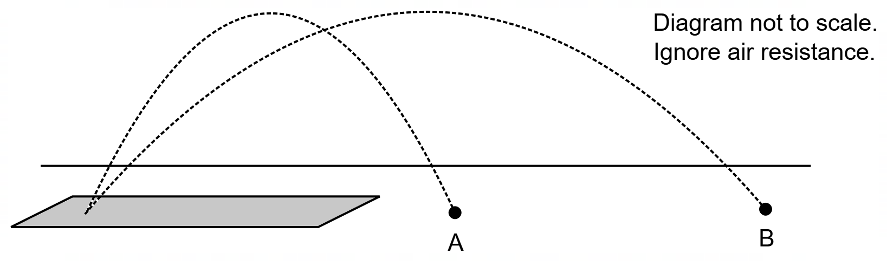

Which quantity below is DIFFERENT for shots A and B? Circle your response.

Time of Flight Initial Velocity Final Vertical Speed

Briefly explain why your chosen quantity is correct and why the others are not.

______________________________________________________________________________

______________________________________________________________________________

______________________________________________________________________________

______________________________________________________________________________

______________________________________________________________________________

______________________________________________________________________________

Question 2 (7 marks)

In a supermarket a customer notices that the milk shelf is made of smooth plastic and is angled at 15° to the horizontal. The customer notices that, despite a small amount of friction, a 2L milk bottle slides to the front of the shelf automatically.

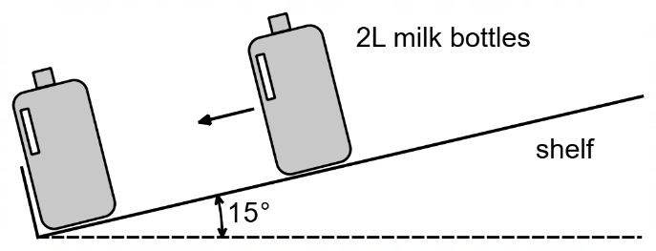

(a) In the diagram below draw a free body diagram of all the forces acting on the milk bottle as it slides down the shelf. (3 marks)

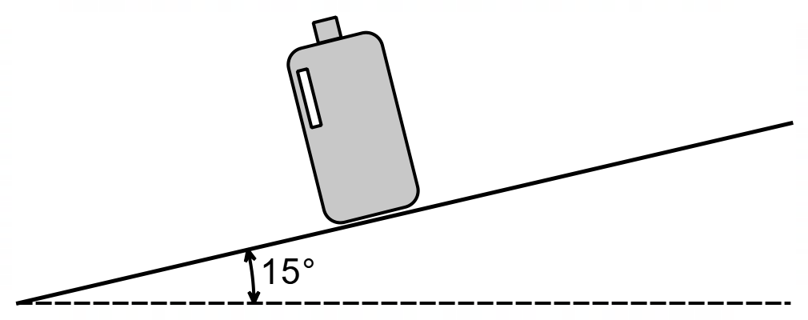

(b) As a bottle slides down the shelf, the frictional force between the shelf and the bottle is about 25% of the normal force acting on the bottle. Estimate the friction force acting on a milk bottle as it slides down the shelf, giving your answer to an appropriate number of significant figures.
(4 marks)

Answer ________________ N

Question 3 (4 marks)

A vehicle is fitted with a 1.22 m long aerial for radio communication in remote areas. The aerial is fitted to the vehicle vertically.

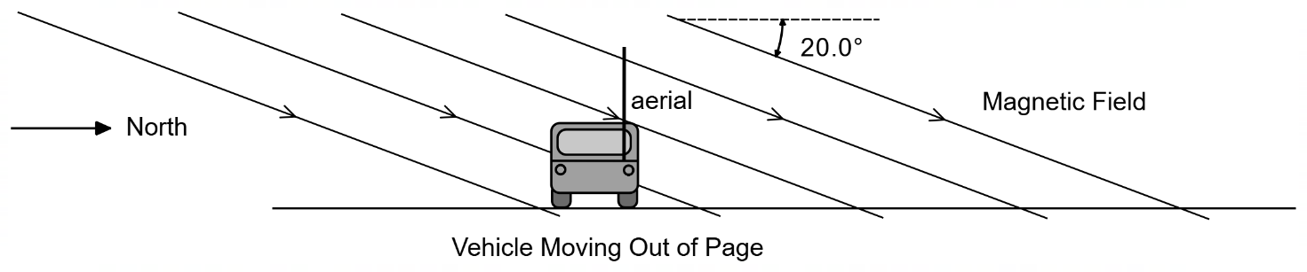

At a certain moment, the vehicle is travelling directly East at 30.0 m s^{–1} in an area where the Earth’s magnetic field strength is 5.30 × 10^{–5} T and is angled 20.0° below the horizontal.

(a) As the vehicle moves, an EMF is induced across the length of the aerial. Which end of the aerial becomes positively charged (circle your answer)? (1 mark)

TOP BOTTOM

(b) Calculate the EMF induced across the length of aerial, in millivolts (mV). (3 marks)

Answer ________________ mV

Question 4 (4 marks)

A rocket taking off from the moon is at an altitude of 370 m and travelling directly away from the moon at 72.0 km h^{–1}, when a small component accidentally detaches from the rocket.

How long does it take for the component to reach the surface of the moon?

Answer _________________ s
Question 5 (5 marks)

A composite bar hanging over the entrance to a shopping centre is used to indicate a height limit and is supported above by two chains as shown. The mass of each chain is negligible.

The composite bar consists of two uniform rods, Rod A and Rod B. Rod A can slide in and out of Rod B to adjust the overall length of the composite bar, as shown below. Rod A is 1.50 m long with a mass of 2.00 kg, and Rod B is 2.00 m long with a mass of 6.00 kg.

The overall length of the composite bar is 3.05 m as shown.

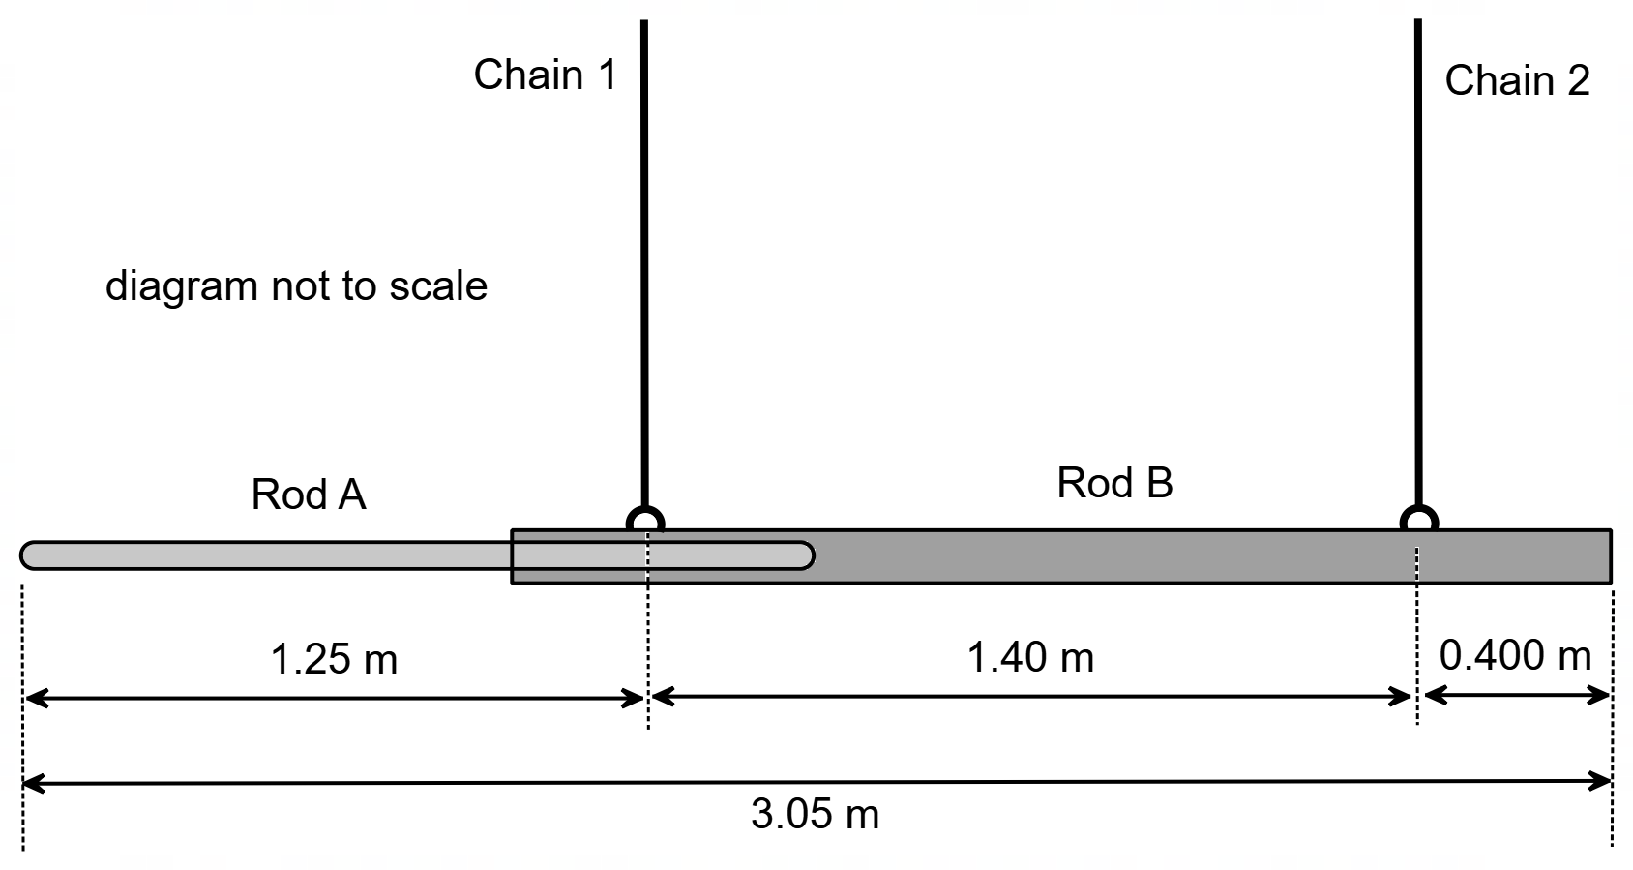

Calculate the tension in Chain 2.

Answer ___________________ N

Question 6 (6 marks)

The planet Mars as an average radius of 3,390 km and completes one rotation about its axis every 24.7 hours, taking slightly longer than one day on Earth (24.0 hours).

Consider a 75.0 kg person standing stationary on the surface of Mars, at its equator.

(a) Calculate the centripetal force required for this person to travel in a circular path, as Mars rotates on its axis. (3 marks)

Answer ___________________ N

(b) If this person was standing stationary at the equator on the surface of Earth, would the centripetal force required be greater or smaller than on Mars? Explain using relevant formula and data from your Formula & Data Booklet (no calculation is needed). (3 marks)

__________________________________________________________________________

__________________________________________________________________________

__________________________________________________________________________

__________________________________________________________________________

__________________________________________________________________________

__________________________________________________________________________

__________________________________________________________________________

__________________________________________________________________________

__________________________________________________________________________

Question 7 (5 marks)

A circular copper coil is attached by a wooden arm to a support so that it can swing like a pendulum through a magnetic field as shown. The arm with coil is released from rest in position (1) and allowed to swing through the field to position (2) and position (3).

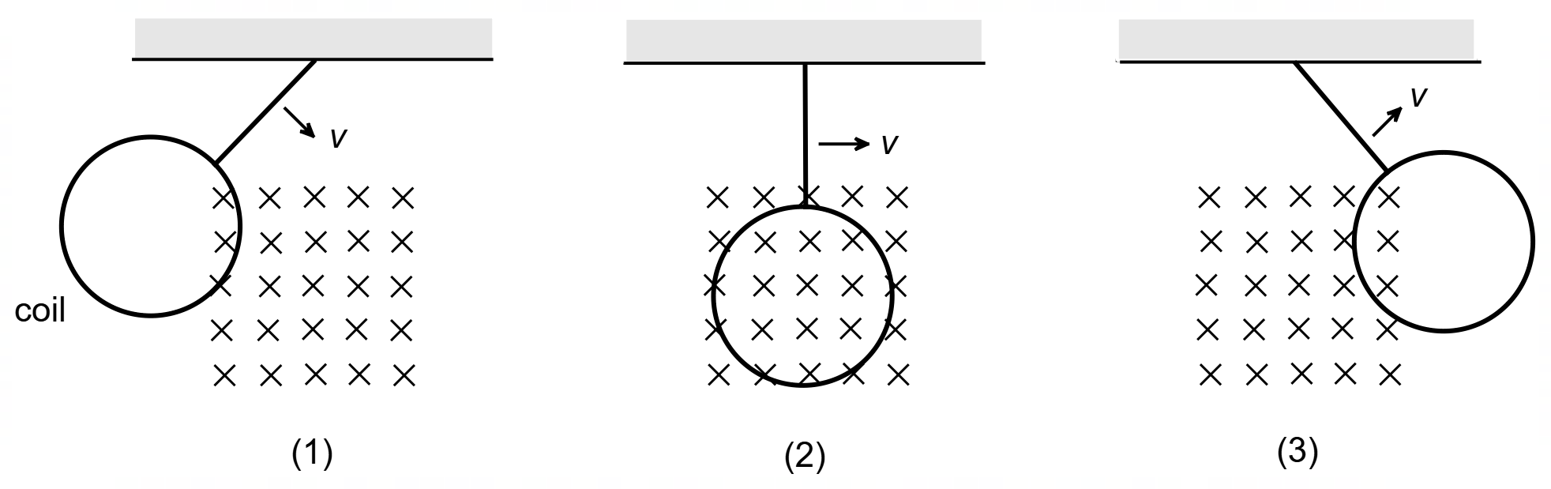

(a) Determine the direction of the current flowing in the circular copper coil as the pendulum moves through the field at Position (1) and Position (2). Indicate the direction below either as Clockwise (CW), Anticlockwise (ACW) or None. (2 marks)

Position (1) ___________________________

Position (2) ___________________________

(b) It is noticed that the pendulum comes to a stop after only a few oscillations, despite the pendulum being free to swing. Explain the sudden loss of kinetic energy with reference to relevant physics principles. (3 marks)

__________________________________________________________________________

__________________________________________________________________________

__________________________________________________________________________

__________________________________________________________________________

__________________________________________________________________________

__________________________________________________________________________

__________________________________________________________________________

__________________________________________________________________________

Question 8 (3 marks)

An AC generator produces 11.0 kW of power for a nearby mine site. The power is transmitted at 240 V along a 5.00 km transmission line, which has a total resistance of 0.150 Ω.

Calculate the voltage supplied to the mine site.

Answer ________________ V

Question 9 (4 marks)

A simple DC motor consists of 33 turns of wire, formed into a square coil of side length 6.00 cm, attached to a voltage source of 25.4 V. If the length of wire has a resistance of 3.42 Ω and the coil is placed in a uniform magnetic field of strength 1.06 T, calculate the maximum torque produced by the motor.

Answer ________________ N m

Question 10 (5 marks)

An electron is positioned 0.0245 mm from an alpha particle, as shown below. The electron experiences an attractive force of 7.67 × 10^{–19} N due to the presence of the alpha particle.

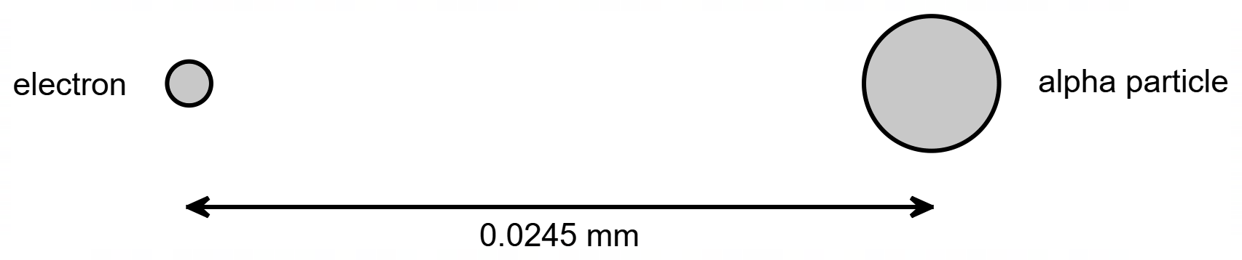

(a) Calculate the strength of the electric field experienced by the electron, due to the presence of the alpha particle. (2 marks)

Answer ________________ N C^{–1}

(b) Using the given data, show that the charge on the alpha particle is +2$e$.
(3 marks)

Question 11 (7 marks)

Racing tracks are often banked to provide assistance in maintaining horizontal circular motion.

(a) In the diagram below (right), a car is travelling on a banked curve angled $θ$ to the horizontal. In the dashed box below (left), draw a labelled vector diagram of all the forces acting on the car (ignoring friction). Include the resultant force as a dotted/dashed line. (3 marks)

Vector Diagram:

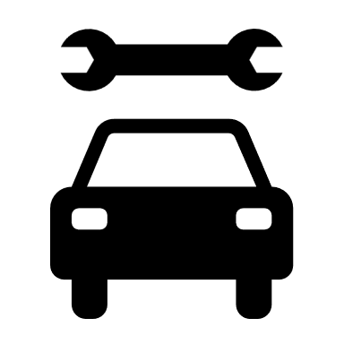

$θ$

(b) Using your vector diagram above, show that the speed of the car $v$ is given by $v=\sqrt{rg\tan{θ}}$. Then, use this formula to calculate the speed of a car travelling around this banked curve, of radius 386 m, angle at 16.0° to the horizontal, while not relying on friction. (4 marks)

Answer ________________ m s^{–1}

Section Two: Problem Solving 50% (90 marks)

This section has eight (8) questions. Answer all questions. Write your answers in the space provided.

When calculating numerical answers, show your working or reasoning clearly. Unless otherwise instructed, give final answers to three significant figures and include appropriate units where applicable.

When estimating numerical answers, show your working or reasoning clearly. Give final answers to a maximum of two significant figures and include appropriate units where applicable.

Supplementary pages for planning/continuing your answers to questions are provided at the end of this Question/Answer booklet. If you use these pages to continue an answer, indicate at the original answer where the answer is continued, i.e., give the page number.

Suggested working time for this section is 90 minutes.

Question 12 (12 marks)

Abbie and Bailey are playing a game called Tetherball, in which a 0.150 kg ball is attached to a pole via a 1.80 m long string (of negligible mass). Abbie initially hits the ball in a horizontal circular path towards Bailey, such that the string makes an angle of 62.0° with the vertical, as shown below. When the ball arrives at Bailey, he decides to hit the ball downwards in a vertical circular path as shown below. Although travelling in a vertical circle, the ball avoids hitting the pole.

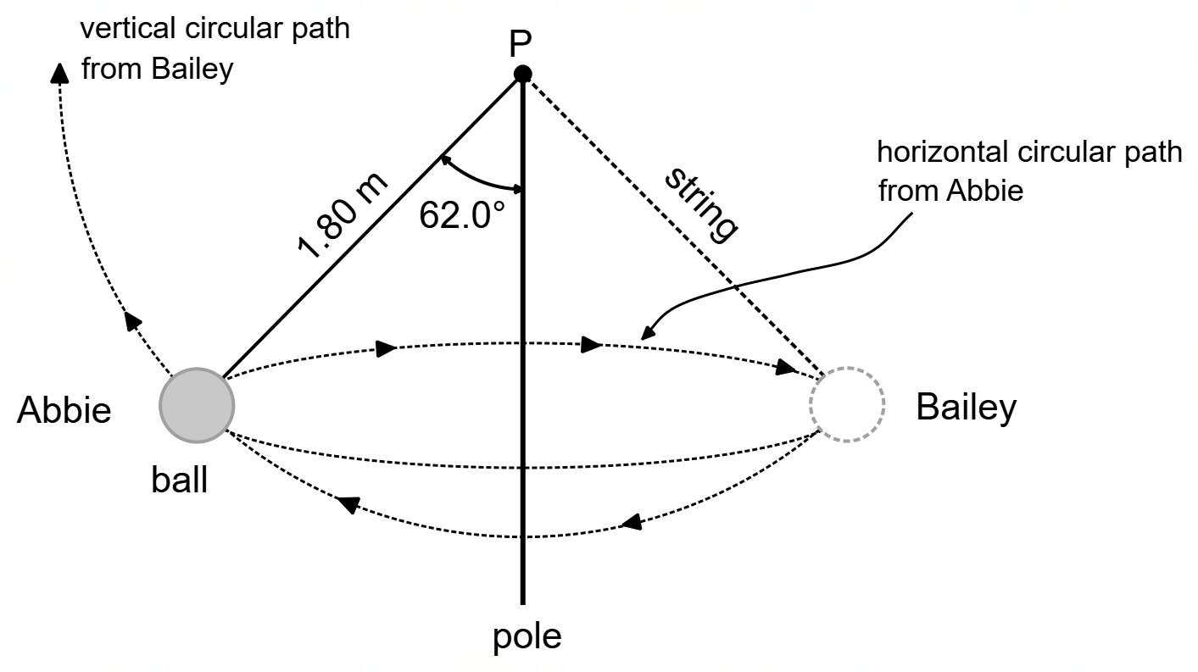

(a) Calculate the tension in the string as the ball travels horizontally to Bailey. (3 marks)

Answer ________________ N
(b) For the ball to be returned in a completely vertical circular path and complete a full circle without the string coming slack, it needs to have sufficient speed. Show that the minimum speed $v_{m}$ the ball must have at the top of the swing, for it to travel in a vertical circular path, is given by $v_{m}=\sqrt{rg}$. (3 marks)

(c) When the ball arrives at Bailey, he hits the ball so that it has 6.00 J of kinetic energy as it starts downwards on its vertical circular path. Using this information and using an energy consideration, show that the ball is travelling at sufficient velocity to ensure the string doesn’t become slack. (6 marks)

Question 13 (9 marks)

An ideal transformer is constructed with primary and secondary coils of 400 and 5600 turns respectively, where the primary coil is connected to a voltage of 240 V RMS.

(a) Calculate the peak voltage in the secondary coil of the transformer. (3 marks)

Answer ________________ V

(b) The voltage delivered to the primary coil oscillates at a frequency of 50.0 Hz and voltage generated in the secondary coil alternates at the same rate. With reference to Faraday’s Law, explain how a higher voltage is induced in the secondary coil by the primary coil.
(4 marks)

__________________________________________________________________________

__________________________________________________________________________

__________________________________________________________________________

__________________________________________________________________________

__________________________________________________________________________

__________________________________________________________________________

__________________________________________________________________________

__________________________________________________________________________

__________________________________________________________________________

(c) State and explain one (1) source of inefficiency in a non-ideal transformer. (2 marks)

Source ____________________________________________________________

Explanation ____________________________________________________________

____________________________________________________________

____________________________________________________________

Question 14 (7 marks)

A proton travelling at 1.88 × 10⁶ m s^{–1} enters a uniform magnetic field, of intensity 2.50 × 10^{–3} T, perpendicular to the field, travelling along the circular dotted path indicated.

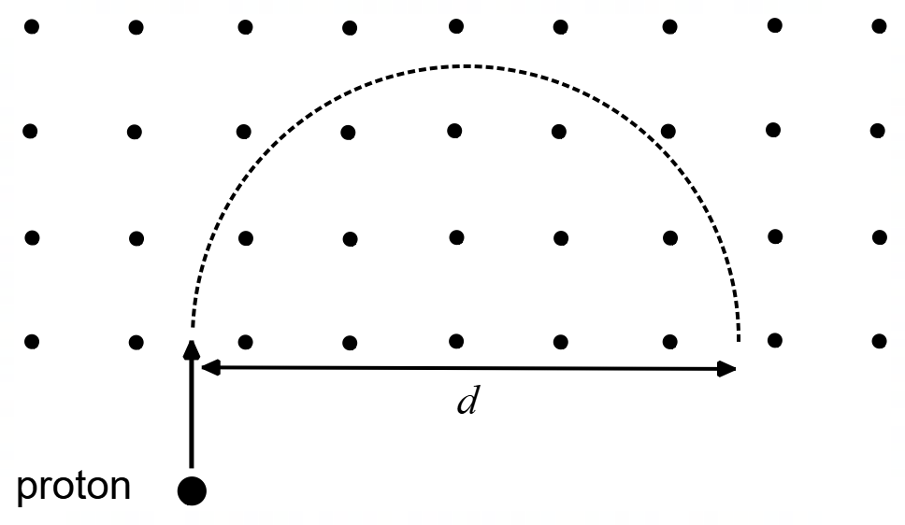

(a) Account for the shape of the path of the proton in the magnetic field. (3 marks)

__________________________________________________________________________

__________________________________________________________________________

__________________________________________________________________________

__________________________________________________________________________

__________________________________________________________________________

__________________________________________________________________________

__________________________________________________________________________

(b) Calculate the magnitude of the force on the proton in the magnetic field. (2 marks)

Answer ________________ N

(c) Calculate distance $d$. (2 marks)
(Note: if you couldn’t calculate the force in part (b) you may use a force of 8.00 × 10^{–16} N)

Answer ________________ m
Question 15 (16 marks)

The orbital radius $r$ (km) and the orbital period $T$ (days) for five moons of the planet Neptune are given in the table below.

Moon | Orbital Radius $r$ (× 10⁴ km) | Orbital Period $T$ (days)
Naiad | 4.82 | 0.294
Thalassa | 5.01 | 0.311
Despina | 5.25 | 0.335
Galatea | 6.20 | 0.429
Larissa | 7.35 | 0.556

According to Kepler’s 3rd law the relationship between the orbital radius $r$ of each moon and orbital period $T$ of each planet is given by:
$$\frac{T^{2}}{r^{3}}=\frac{4π^{2}}{GM}$$

Where: $G$ is the gravitational constant
$M$ is the mass of Neptune

The radius cubed $r^{3}$, and period squared $T^{2}$ for the five moons are given in the table below:

Moon | $r^{3}$ (× 10²³ m³) | $T^{2}$ (× 10⁸ s²)
Naiad | 1.12 | 6.47
Thalassa | 1.26 | A
Despina | 1.45 | 8.36
Galatea | B | 13.7
Larissa | 3.98 | 23.0

(a) Using data from the first table, calculate the values of the two missing entries A and B in the second table. Show your complete working below. (4 marks)

(b) On the set of axes on the next page construct a graph of $T^{2}$ (on the vertical axis) versus $r^{3}$ (on the horizontal axis). Indicate appropriate scales and axis labels and draw in a line of best fit for the data. (4 marks)

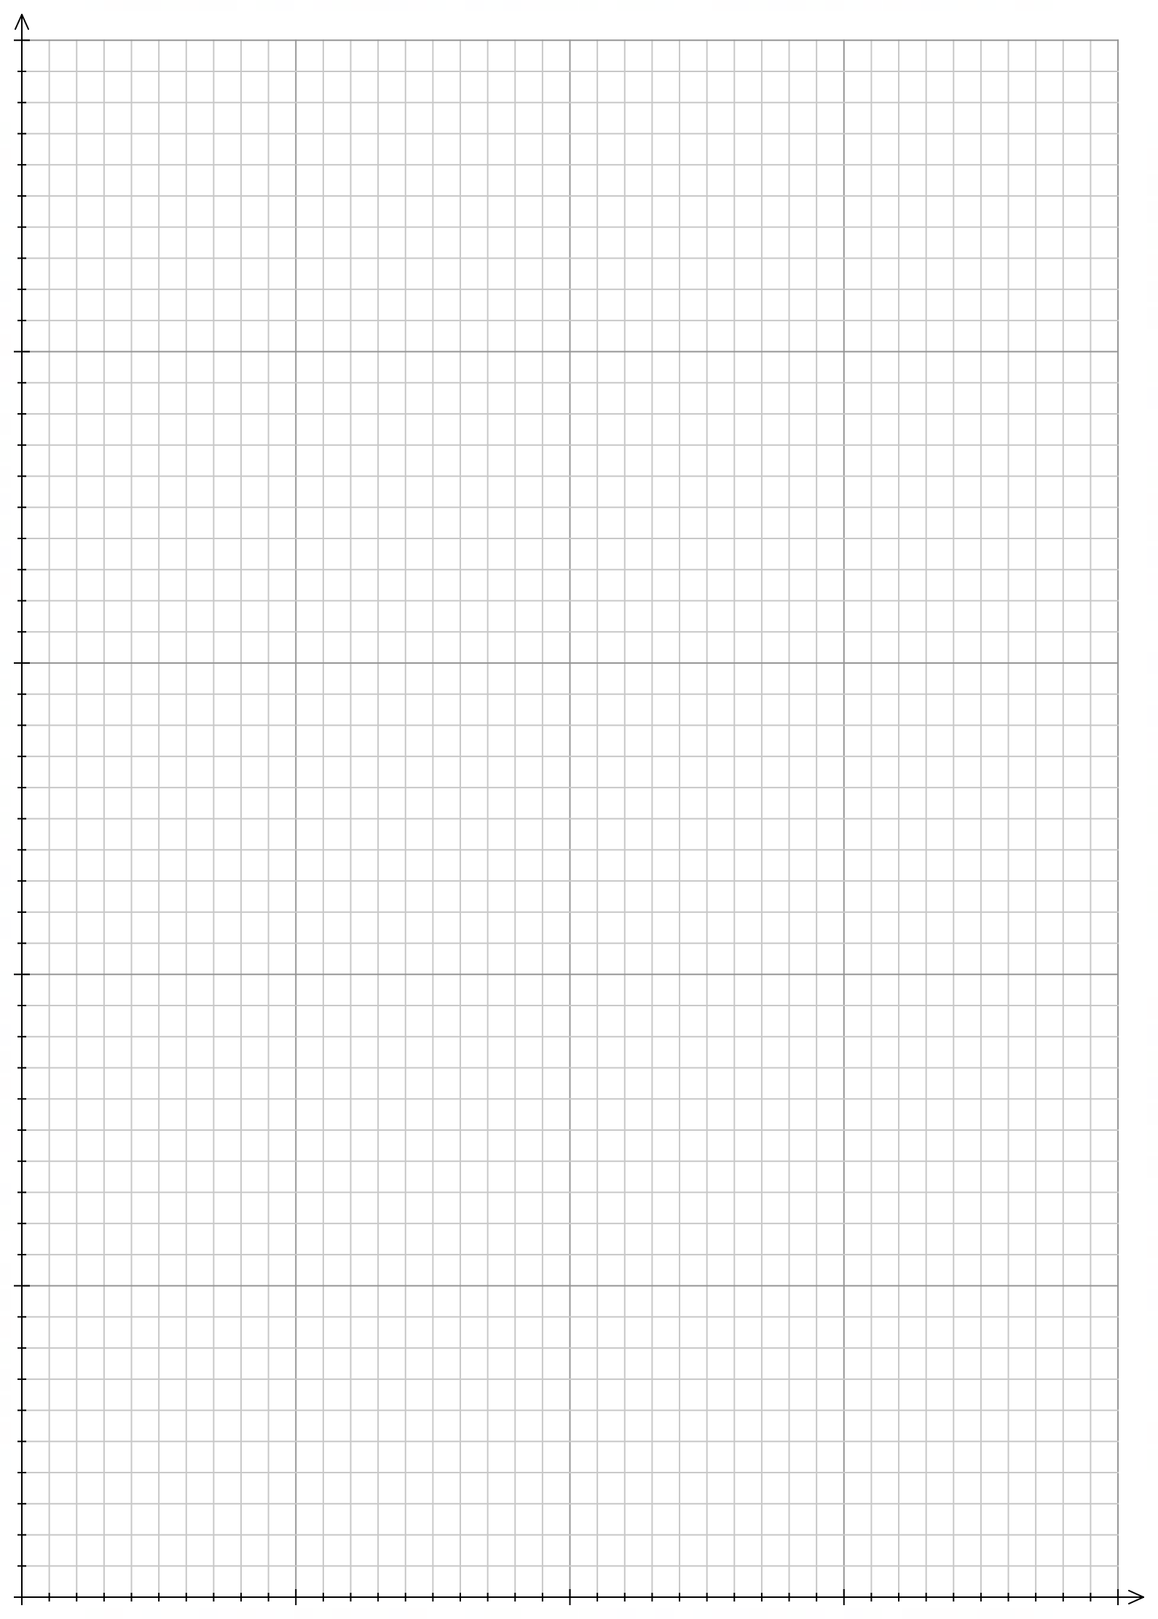

(c) Calculate the gradient of the line of best fit. Indicate on the graph the coordinates of the points used to calculate the gradient. Include units in your answer. (4 marks)

Gradient _________________ Units _________________

(d) Use your answer to part (c) to calculate the mass of Neptune, giving your answer to two significant figures. (4 marks)

Answer __________________ kg

Question 16 (8 marks)

A rugby player is attempting to a kick a goal by kicking the rugby ball off the ground at a speed of 20.0 m s^{–1} at an angle of 40.0° to the horizontal. The rugby ball is situated 34.0 m from the goal posts. To score a goal, the ball must travel between two vertical goal posts and above a horizontal crossbar 3.00 m above the ground as shown in the diagram below.

(a) By finding the height of the ball as it passes between the goal posts, determine if a goal is scored. (4 marks)

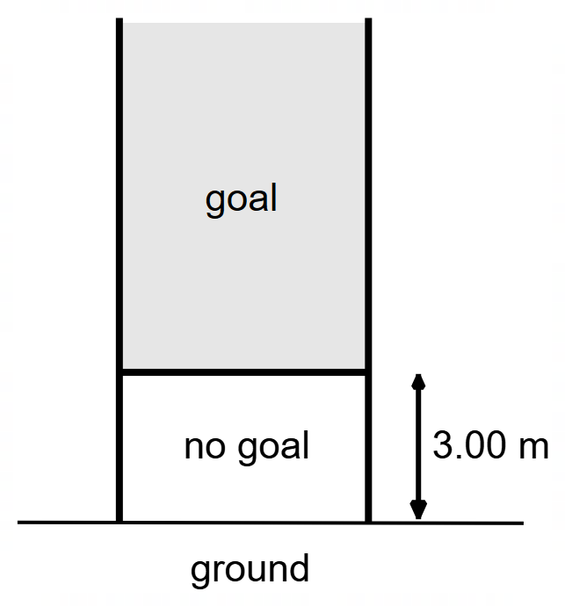

(b) Determine the speed of the rugby ball as it passes over the horizontal crossbar. (4 marks)

Answer ________________ m s^{–1}

Question 17 (15 marks)

As a castle drawbridge is being hoisted upwards, someone notices that a few wooden boards have been left on the drawbridge. The hoisting is stopped, and the drawbridge is held in the position shown, such that the drawbridge makes an angle of 53.0° with the chain and an angle of 23.0° with the horizontal. The uniform 482 kg drawbridge is 6.00 m long, and the chain of negligible mass is attached to the drawbridge 2.00 m from its end. The boards are positioned 1.00 m from the end of the drawbridge and have a combined mass of 68.0 kg.

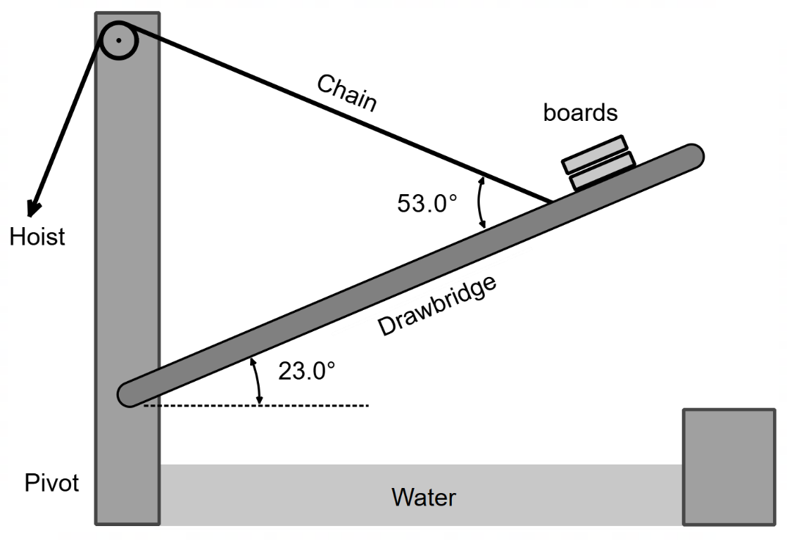

(a) Show that the tension in the chain is approximately 5000 N. (5 marks)

Answer ________________ N

(b) Determine the magnitude of the reaction force acting at the pivot on the drawbridge. (5 marks)

Answer ________________ N

(c) Due to the angle of the drawbridge, the boards start to slide down the drawbridge towards the pivot. Explain how the size of the reaction force at pivot initially changes? Circle your answer and give an explanation below. (5 marks)

DECREASE NO CHANGE INCREASE

__________________________________________________________________________

__________________________________________________________________________

__________________________________________________________________________

__________________________________________________________________________

__________________________________________________________________________

__________________________________________________________________________

__________________________________________________________________________

__________________________________________________________________________

__________________________________________________________________________

__________________________________________________________________________

__________________________________________________________________________
Question 18 (12 marks)

Two parallel high voltage transmission wires operate in an area where the Earth’s magnetic field (B_{earth}) is horizontal and has a strength of 4.20 × 10^{–5} T to the North. The two wires are 12.0 m apart and each carry a current of 710 A in a westerly direction. A person standing midway between the lines is measuring the magnetic field 8.00 m below the lines as seen in the SIDE VIEW below.

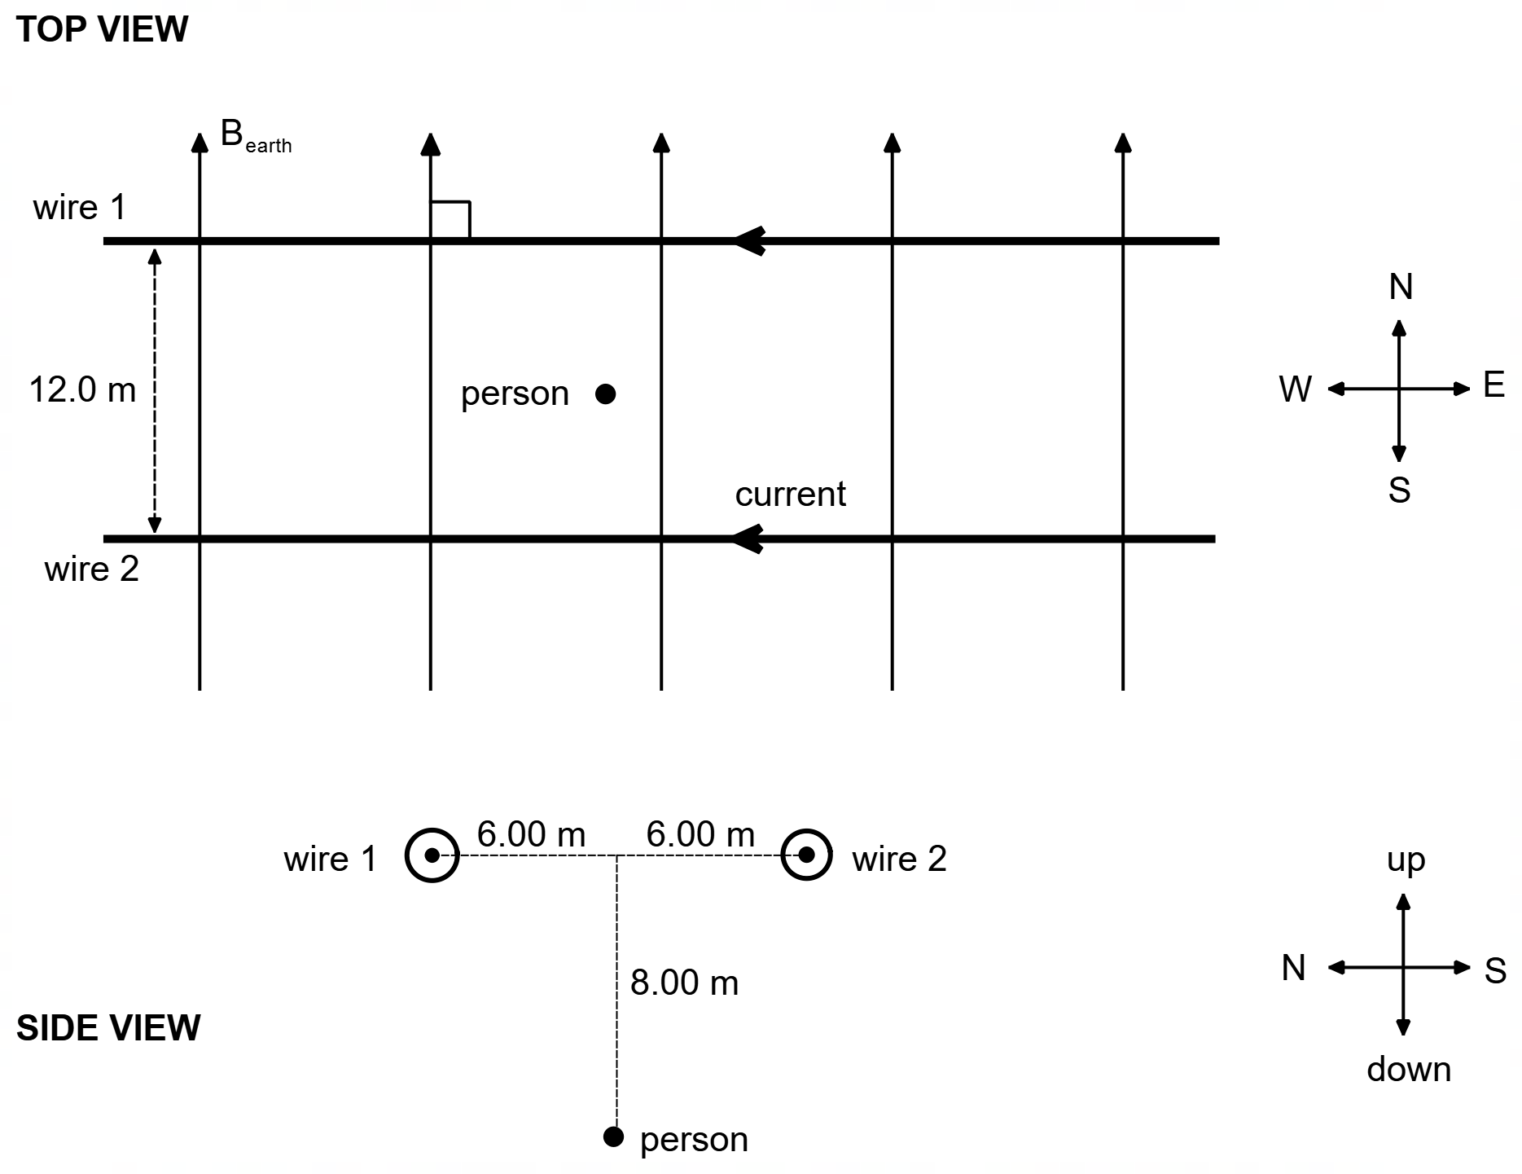

(a) On the diagram below, draw the shape of the resulting magnetic field surrounding the two wires, due to the currents travelling in the two wires. Use at least three (3) field lines to indicate the shape of the magnetic field. (3 marks)

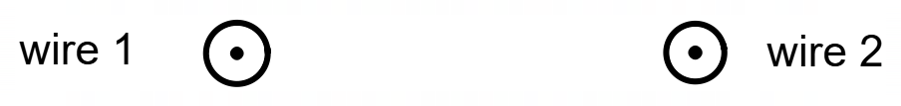
(b) On the diagram in part (a) draw the force acting on each wire. (1 mark)

(c) Calculate the magnitude of the magnetic field at the position of the person due ONLY to the current in wire 1. (3 marks)

Answer ________________ T

(d) Use your answer from part (c) to determine the magnitude and the direction of the total magnetic field measured by the person. If you were not able to calculate part (c) you may use a value of 1.5 × 10^{–5} T. (5 marks)

Answer ________________ T Direction __________________

Question 19 (11 marks)

An AC generator is made of a rectangular coil with 28 turns of wire, with lengths UV = 7.00 cm and VW = 5.00 cm. The coil sits in a permanent magnetic field of strength 0.636 T, and spins at a rate of 24.0 Hz. The diagram shows the position of the coil at the instant when the plane of the coil is parallel to the magnetic field.

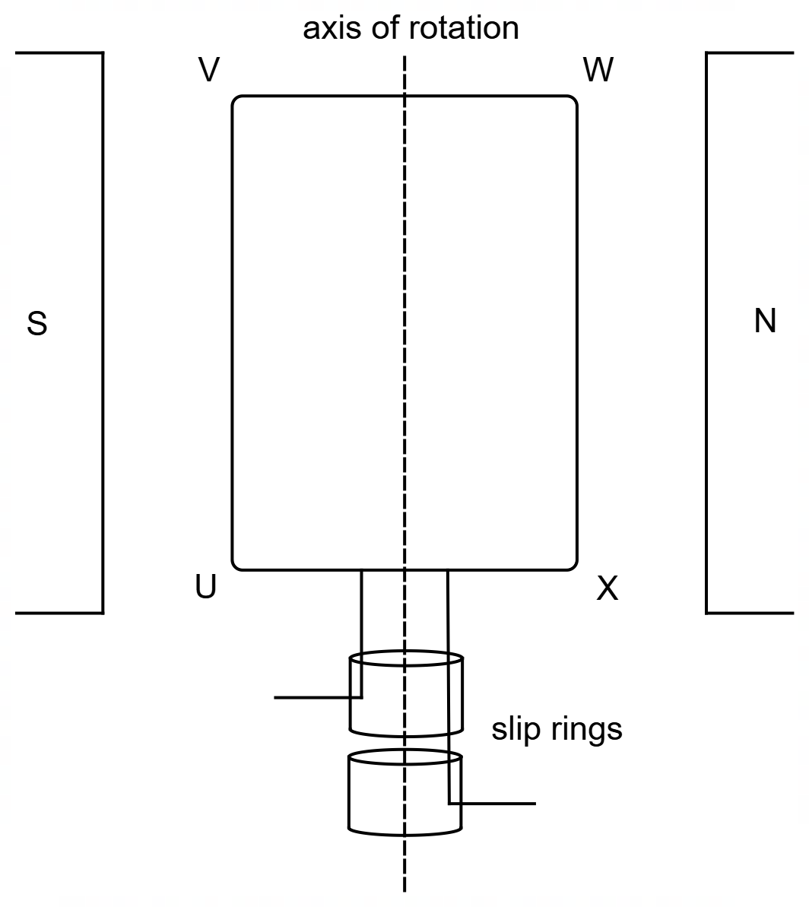

(a) At the instant shown in the diagram, side WX moves out of the page. On the diagram above indicate the direction of the induced current in the coil. (1 mark)

(b) Briefly outline the design and function of the “slip rings” in an AC generator. (2 marks)

__________________________________________________________________________

__________________________________________________________________________

__________________________________________________________________________

__________________________________________________________________________

__________________________________________________________________________

(c) Calculate the flux threading the coil when the angle between the plane of the coil and the magnetic field makes an angle of 75.0°. (3 marks)

Answer ________________ Wb

(d) Determine the maximum EMF produced by this generator. (3 marks)

Answer ________________ V

(e) Besides the magnetic field and rate of rotation, state two modifications that could be made to this generator which would increase the output EMF. (2 marks)

Modification 1 _____________________________________________________________

Modification 2 _____________________________________________________________

Section Three: Comprehension 20% (36 marks)

This section has two (2) questions. Answer both questions in the spaces provided.

When calculating numerical answers, show your working or reasoning clearly. Unless otherwise instructed, give final answers to three significant figures, and include appropriate units where applicable.

When estimating numerical answers, show your working or reasoning clearly. Give final answers to a maximum of two significant figures and include appropriate units where applicable.

Supplementary pages for planning/continuing your answers to questions are provided at the end of this Question/Answer booklet. If you use these pages to continue an answer, indicate at the original answer where the answer is continued, i.e., give the page number.

Suggested working time: 40 minutes.

Question 20 (18 marks)

Artificial Gravity in Space

There have been various attempts over the years to design spacecraft that mimic the Earth’s gravity for astronauts. All such designs are aimed at providing artificial gravity that astronauts can experience while in space. The benefit of producing artificial gravity is to reduce some of the negative effects of long periods of weightlessness, such as the weakening of bones and muscles responsible for movement.

On earth we rely on the force due to gravity to pull us down while the ground supplies an upwards reaction force. One way to imitate gravity in space is to use the centripetal force provided by a rotating space station. If an astronaut is rotated within a space station, then “up” is towards the centre of rotation and “down” is into the floor. The only force exerted on the astronaut is the floor pushing “up”. This force is the centripetal force acting on the astronaut as they rotate. The artificial gravity experienced is the centripetal acceleration.

For a set rotation rate, the artificial gravity increases with greater distance from the axis of rotation. Therefore, small-diameter structures would need to rotate at high rates to provide an artificial gravity of “1g” (where “1g” is the acceleration due to gravity experienced on the surface of the Earth). To simulate artificial gravity of “1g” at a rotation rate of 1 rpm, a very large structure would be needed. From a human perspective, rotation rates greater than 5 rpm tend to cause imbalance in the sensitive organs in our ears.
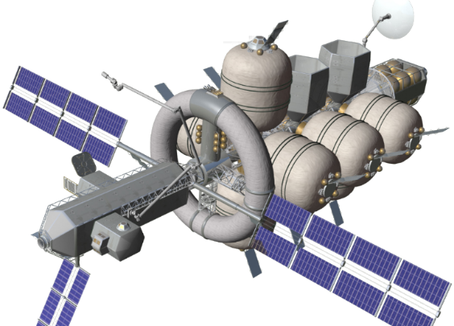
The 12.2 m diameter torus ring rotating at 10 rpm.

Figure 1 – NASA’s concept spacecraft, the Nautilus X (source: Wikipedia)
One such system is that of a rotating torus in NASA’s advanced spacecraft the Nautilus-X. Shown in Figure 1, one segment is a 12.2 m diameter torus (donut shape) that can rotate at 10 rpm, allowing astronauts to experience artificial gravity of about “1g” while in space.

Figure 2 below shows an astronaut rotating with a spacecraft. It can be shown that the amount of artificial gravity $g_{a}$ experienced by the astronaut rotating in a spacecraft is given by $g_{a}=4π^{2}rf^{2}$ where $f$ is the frequency (Hz) and $r$ is the radius (m).

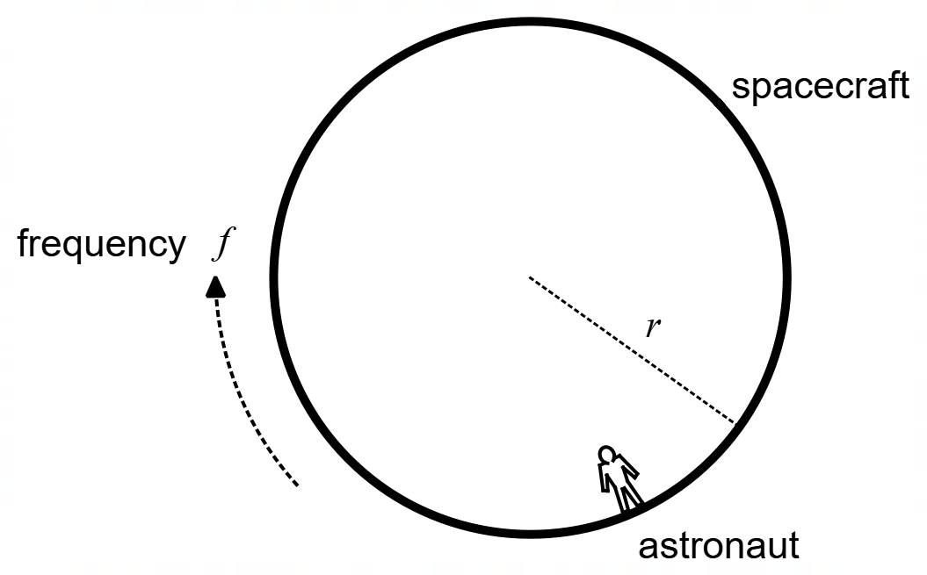

Figure 2 – astronaut rotating in spacecraft

Another idea to produce artificial gravity is that of the Tether system. This system involves placing two habitats (a habitat being a place where astronauts can live) tethered to one end of the main spacecraft structure and the engines at the other end of the structure. The entire structure is then rotated about its centre of mass. Figure 3 shows a schematic for the Mars Transfer Vehicle (MTV), having two habitats positioned 112 m apart, spinning at 4 rpm.

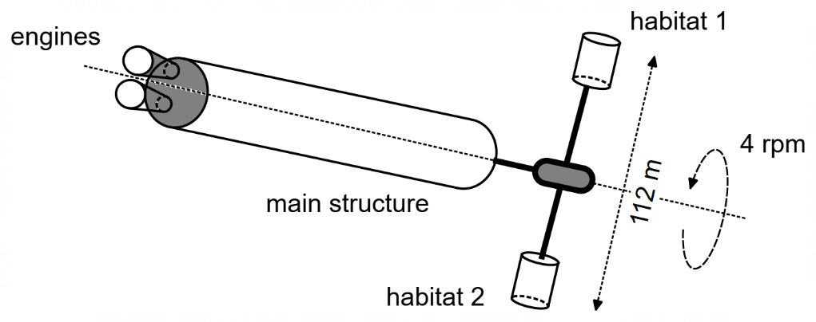

Figure 3 – schematic of the MTV

In both systems (Figure 1 and Figure 3) the rotating person is projected towards the outside of either the habitat or torus ring and the spacecraft provides a reaction force, thus simulating gravity.

(a) Derive the formula given in the text for the artificial gravity: $g_{a}=4π^{2}rf^{2}$. (2 marks)

(b) Using information from the text, determine the amount of artificial gravity experienced in the torus ring on Nautilus X. Express your answer to two significant figures, giving your answer in terms of “g”. (6 marks)

Answer _____________ “g”

(c) Given the information in the text and your answer to part (b), which of the two structures (Nautilus X or MTV) would be better for astronauts’ health and wellbeing? Briefly explain your answer. (2 marks)

__________________________________________________________________________

__________________________________________________________________________

__________________________________________________________________________

__________________________________________________________________________

(d) If the astronaut in Figure 2 (shown below) is experiencing “0.8g”, indicate on the diagram below the position(s) where the astronaut would experience “0.4g”. (1 mark)

(e) Calculate the radius of the “very large structure” referred to in paragraph 3. (3 marks)

Answer ________________ m

(f) State and explain two differences between the artificial gravity that would be experienced on the MTV (or Nautilus X) and gravity that is experienced on Earth. (4 marks)

Difference 1 ____________________________________________________________

Explanation ____________________________________________________________

____________________________________________________________

____________________________________________________________

____________________________________________________________

Difference 2 ____________________________________________________________

Explanation ____________________________________________________________

____________________________________________________________

____________________________________________________________

____________________________________________________________

Question 21 (18 marks)

Millikan’s Oil Drop Experiment

In 1909 Robert Millikan and Harvey Fletcher performed an experiment to measure the elementary electric charge on an electron. As shown in Figure 4 below, the experiment involved observing very small electrically charged oil droplets move between two parallel metal plates. These two metal plates formed a capacitor with an electric field between them.

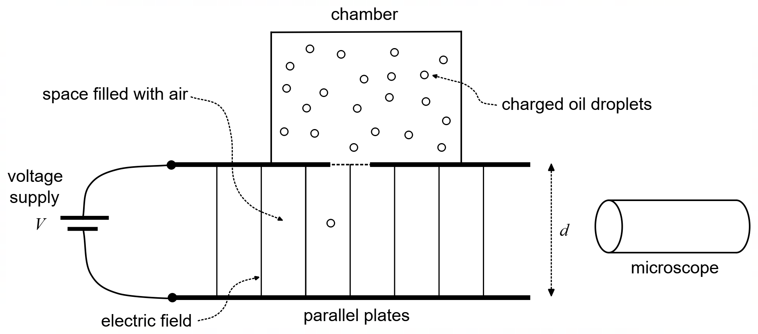

Figure 4 – schematic for Millikan’s experiment

When oil is sprayed into the chamber a fine mist of very small, charged oil droplets is created within. Due to the very small size of the oil droplets, they gradually fall under their own weight, some entering the space between the two parallel plates.

With the voltage supply turned on, an electric field is created between the parallel plates separated by distance $d$. When this happens the oil droplets rise at a constant velocity $v_{up}$. At this velocity the electric force ($F_{E}$) upwards is balanced by the downward forces of the weight of the oil droplet ($W$) and the drag force ($D_{down}$) on the droplet moving through the air.

To calculate the weight of each droplet, Millikan then turned off the voltage supply and watched the oil droplet fall, at a constant velocity $v_{down}$. At this speed the downward weight force ($W$) of the droplet is balanced by the upward drag force ($D_{up}$) on the droplet as it moves down through the air.

The forces acting on the oil droplets, when the voltage is on and off, are shown in Figure 5 below.

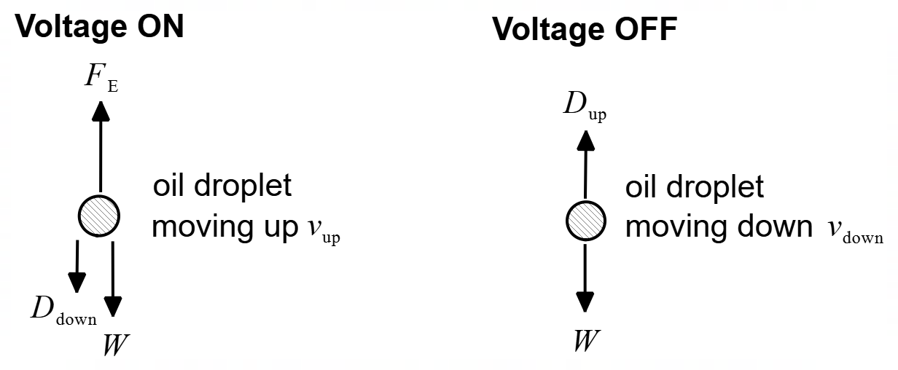

Figure 5 – forces acting on an oil droplet

From the measurements of $v_{up}$ and $v_{down}$, and from knowing that drag forces increase with velocity, Millikan could calculate the total charge on many oil droplets. Millikan assumed (correctly) that each oil droplet contained a charge equal to an integer multiple of the elementary charge on an electron. Millikan assumed that the smallest charge difference observed was the elementary charge and any larger charge difference were integer multiples of this elementary charge.

To determine a value for the elementary charge on an electron, some Physics students set up a similar apparatus where the distance between the parallel plates $d=16.0$ mm. The students then applied a high voltage supply $V$, injected some charged oil droplets, measured the upwards velocity $v_{up}$, switched off the voltage and measured the downwards velocity $v_{down}$.

The results of their experiment are recorded below in Table 1.

Table 1 – Results for Students’ Oil Drop Experiment
Droplet # | Voltage $V$ (kV) | Charge $q$ (× 10^{–18} C) | Charge Difference  (× 10^{–19} C)
1 | 1.650 | 3.678
1 | 1.650 | 3.678 | 4.65
2 | 1.545 | 4.157 | 4.65
3 | 1.483 | 4.002
3 | 1.483 | 4.002 | 1.59
4 | 1.509 | 3.843 | 1.59
4 | 1.509 | 3.843 | 6.41
5 | 1.462 | 3.202 | 6.41
6 | 1.760 | 3.359

(a) Complete the last column in Table 1 by determining the missing values. Write the values in the table. (2 marks)

(b) On Figure 4 indicate the direction of the electric field by placing arrows on the field lines in the diagram. (1 mark)

(c) In both scenarios in Figure 5, Millikan measured the velocities when the droplets were moving with constant speed. Explain the significance of this constant speed in relation to the forces acting on the droplets and how this helped Millikan with his experiment. (3 marks)

________________________________________________________________________

________________________________________________________________________

________________________________________________________________________

________________________________________________________________________

________________________________________________________________________

________________________________________________________________________

(d) Write an equation for the drag forces in terms of the other forces acting on the oil droplets when the voltage is turned on ($D_{down}$) and when the voltage is turned off ($D_{up}$). (2 marks)

Voltage turned ON $D_{down}=$

Voltage turned OFF $D_{up}=$

(e) An important factor in this experiment is the value of gravity. In Chicago, where Millikan did the original experiment, $g=9.802$ m s^{–2}. Suppose that the original experiment had been done in a location where the value of gravity was much lower than in Chicago. How would the velocities of the oil droplets ($v_{up}$ and $v_{down}$) change? Explain. (4 marks)

__________________________________________________________________________

__________________________________________________________________________

__________________________________________________________________________

__________________________________________________________________________

__________________________________________________________________________

__________________________________________________________________________

__________________________________________________________________________

__________________________________________________________________________

__________________________________________________________________________

__________________________________________________________________________

(f) Using the information given in the text and in Table 1, calculate the electric field strength acting on Droplet # 6. (2 marks)

Answer ________________ N C^{–1}

(g) Using the information in the column ‘Charge Difference’, determine an experimental value for the elementary charge of an electron. If you could not determine the values for part (a), you can still use the incomplete information in the last column. (4 marks)

Answer ________________ C

End of Questions

Additional working space

Question number(s): ……………………

Spare Graphs for Question 15 (b),

Question 15 (b)

ACKNOWLEDGEMENTS

Question 20 Image for Figure 1:
Wikipedia contributors. (2022, October 16). Nautilus-X. In Wikipedia, The Free Encyclopedia. Retrieved 14:49, August 22, 2023, from https://en.wikipedia.org/w/index.php?title=Nautilus-X&oldid=1116365157

Question 21 Information for Question 20:
Wikipedia contributors. (2023, August 10). Oil Drop Experiment. In Wikipedia, The Free Encyclopedia. Retrieved 13:30, August 26, 2023, from https://en.wikipedia.org/wiki/Oil_drop_experiment

WATP acknowledges the permission of the School Curriculum and Assessment Authority in providing instructions to students.

