 | 

Physics

Unit 3B
Assessment item bank
Short answer and extension items

Astrophysics section of Particles, waves and quanta

2009/17796[v5]

Copyright
© Curriculum Council, 2010

This document—apart from any third party copyright material contained in it—may be freely copied, or communicated on an intranet, for non-commercial purposes by educational institutions, provided that it is not changed in any way and that the Curriculum Council is acknowledged as the copyright owner.
Teachers in schools offering the Western Australian Certificate of Education (WACE) may change the document, provided that the Curriculum Council’s moral rights are not infringed.
Copying or communication for any other purpose can be done only within the terms of the Copyright Act or by permission of the Curriculum Council.
Copying or communication of any third party copyright material contained in this document can be done only within the terms of the Copyright Act or by permission of the copyright owners.

Disclaimer
Any resources such as texts, websites and so on that may be referred to in this document are provided as examples of resources that teachers can use to support their learning programs. Their inclusion does not imply that they are mandatory or that they are the only resources relevant to the course.
Short response items with marking keys

Item 1 (7 marks)

- List two characteristics of all electromagnetic waves. (2 marks)

Travel through a vacuum (1 mark)
Absolute maximum velocity of 3x 10⁸ m s⁻¹ (1 mark)

To answer the following parts of the question, refer to the electromagnetic spectrum diagram below.

 | Wavelength
λ (m) |  |  |  |  |  |  |  |  |  | 10² |  |  |  | 10 |  |  |  |  | 1 |  |  |  |  |  |  |  |  |  |  | 10⁻¹ |  |  |  | 10⁻² |  |  |  | 10⁻³ |  |  |  |  |  | 10⁻⁴ |  |  |  | 10⁻⁵ |  |  |  | 10⁻⁶ |  |  |  | 10⁻⁷ |  |  |  |  |  |  |  | 10⁻⁸ |  |  |  |  | 10⁻⁹ |  |  |  |  | 10⁻¹⁰ |  |  |  |  | 10⁻¹¹ |  |  |  |  |  | 10⁻¹²
Area of  spectrum |   microwaves  radio frequencies  infrared radiation  ultraviolet  radiation  X-rays  gamma rays
f(Hz) |  |  |  |  |  |  |  | 10⁶ |  |  |  |  | 10⁷ |  |  |  | 10⁸ |  |  |  |  |  |  |  |  |  |  |  | 10⁹ |  |  |  | 10¹⁰ |  |  |  | 10¹¹ |  |  |  |  |  | 10¹² |  |  |  | 10¹³ |  |  |  | 10¹⁴ |  |  |  | 10¹⁵ |  |  |  |  |  |  |  | 10¹⁶ |  |  |  | 10¹⁷ |  |  |  |  |  | 10¹⁸ |  |  |  |  | 10¹⁹ |  |  |  |  |  | 10²⁰
 |  | Frequency

Note: 1. Shaded areas represent regions of overlap.
2. Gamma rays and X-rays occupy a common region.

- What is the approximate frequency of a short-wave radio wave from the ‘middle’ of the short-wave spectrum? (1 mark)

10⁸ Hz (1 mark)

- Name two types of electromagnetic waves besides visible light that have allowed astronomers to learn more about celestial bodies and the universe. (2 marks)

Infrared and radio waves (2 marks)

- Describe the information that each type of wave mentioned in part (c) provides to astronomers.
(2 marks)

Infrared astronomy allows astronomers to view low temperature objects that are not able to be observed in the visible region of the EM spectrum.
Radio astronomy allows astronomers to view objects that are obscured by interstellar dust.
(2 marks)

Item 2 (5 marks)
The Hubble telescope was launched in 1990 and has orbited the Earth since at an average distance of about 570 km above the Earth’s surface.

On the Hubble website, the claim is made that ‘Hubble is one of NASA’s most successful and long-lasting science missions. It has beamed hundred of thousands of images back to Earth, shedding light on many of the great mysteries of astronomy. Its gaze has helped determine the age of the universe, the identity of quasars and the existence of dark energy.

- Provide three reasons why the Hubble telescope has been so successful compared to larger Earth-based telescopes. (3 marks)

- Able to view infra red wavelengths absorbed by water vapour and carbon dioxide in the earth’s atmosphere.
- Able to make observations of the near-ultraviolet absorbed by the earth’s atmosphere.
- Operates continuously.
- Light is not obscured by dust or clouds.
- Light is not subject to atmospheric distortion due to differences in refractive indices.
any three (3 marks)

- It has been stated that the Hubble telescope allows us to look back in time to billions of years ago. Explain this statement. (2 marks)

The Hubble telescope is able to record images of the universe's most distant objects. The light that forms these images has taken billions of years to reach the telescope.
(2 marks)

Item 3 (4 marks)
The ‘Big Bang’ theory is a model used to explain the origin of the universe. Name and describe two pieces of scientific evidence which support this theory.

- Redshift
- Abundance of light elements
- Hubble’s law
- Cosmic microwave background radiation
any two (1 mark for name, 1 mark for explanation)

Item 4 (4 marks)
The Big Bang theory predicts that the universe is expanding.
Describe two possible models that have been proposed to explain the behaviour of the expanding universe.

- Open—expand for ever
- Closed universe—stop expanding and then implode on itself (4 marks)

Item 5 (5 marks)
The Spitzer Space Telescope was launched on August 25, 2003. After more than five-and-a-half years, NASA's Spitzer Space Telescope has run out of the coolant that kept its infrared instruments chilled to -270°C. Since then Spitzer is still making observations but it has warmed to -240°C.

INCLUDEPICTURE "http://upload.wikimedia.org/wikipedia/commons/thumb/5/58/Sirtf0329_06.jpg/399px-Sirtf0329_06.jpg" \* MERGEFORMAT 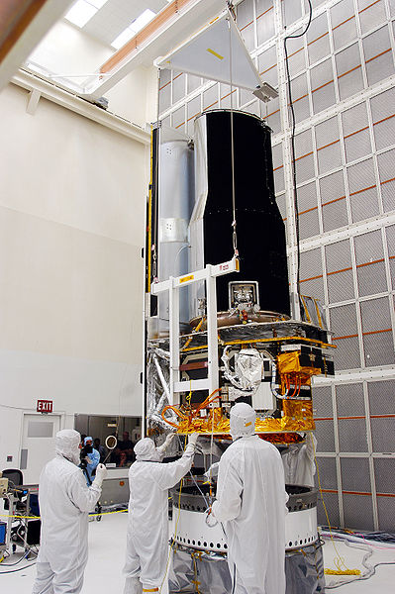
NASA. (2007). Workers at Kennedy Space Center [Photograph].
Retrieved October, 2009, from Wikimedia Commons website: http://upload.wikimedia.org/wikipedia/commons/5/58/Sirtf0329_06.jpg

- Why was it necessary to cool the instruments on the Spitzer Space telescope? (1 mark)

Spitzer telescope views in infrared and must be colder than its surroundings.
(1 mark)

- Why is a satellite useful for making infrared observations? (1 mark)

Much of the infrared spectrum from space is absorbed by the Earth’s atmosphere.
(1 mark)

- What property of infrared radiation makes it useful for making astronomical observations?
(2 marks)

Infrared can penetrate dust clouds in space. (1 mark)
As a result of the Big Bang, the Universe is expanding. For very fast moving, distant objects the visible spectrum can be Doppler shifted into the infrared. (1 mark)

- What effect would the change in temperature of the satellite have on the wavelengths that the telescope would be able to observe? (1 mark)

The telescope is now observing longer wavelength infrared radiation. (1 mark)

Item 6 (2 marks)
The Herschel Space Observatory was launched in May 2009 by the European Space Agency. It is equipped with a 3.5 meter diameter telescope that will perform photometry and spectroscopy in approximately the 55–672 micrometer range.

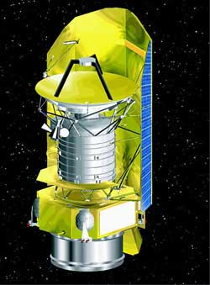
NASA. (2006). Artist's impression of the Herschel Space Observatory [Image].
Retrieved October, 2009, from Wikimedia Commons website: http://upload.wikimedia.org/wikipedia/commons/9/9a/Herschel_Space_Observatory.jpg

 |  | Wavelength
λ (m) |  |  |  |  |  |  |  |  |  | 10² |  |  |  | 10 |  |  |  |  |  | 1 |  |  |  |  |  |  |  |  |  | 10⁻¹ |  |  |  | 10⁻² |  |  |  | 10⁻³ |  |  |  |  |  | 10⁻⁴ |  |  |  | 10⁻⁵ |  |  |  | 10⁻⁶ |  |  |  | 10⁻⁷ |  |  |  |  |  |  |  | 10⁻⁸ |  |  |  |  | 10⁻⁹ |  |  |  |  | 10⁻¹⁰ |  |  |  |  | 10⁻¹¹ |  |  |  |  |  | 10⁻¹²
Area of  spectrum |  | microwaves  radio frequencies  infrared radiation  ultraviolet  radiation  X-rays  gamma rays
f(Hz) |  |  |  |  |  |  | 10⁶ |  |  |  |  |  | 10⁷ |  |  |  | 10⁸ |  |  |  |  |  |  |  |  |  |  |  | 10⁹ |  |  |  | 10¹⁰ |  |  |  | 10¹¹ |  |  |  |  |  | 10¹² |  |  |  | 10¹³ |  |  |  | 10¹⁴ |  |  |  | 10¹⁵ |  |  |  |  |  |  |  | 10¹⁶ |  |  |  | 10¹⁷ |  |  |  |  |  | 10¹⁸ |  |  |  |  | 10¹⁹ |  |  |  |  |  | 10²⁰
 | Frequency

Which part of the electromagnetic spectrum is the telescope observing?

55 micrometer = 55 x 10⁻⁶m or 5.5 x 10⁻⁵m
672 micrometer = 6.72 x 10⁻⁴m (1 mark)
From chart of electromagnetic spectrum – this is in infrared range. (1 mark)

Item 7 (4 marks)

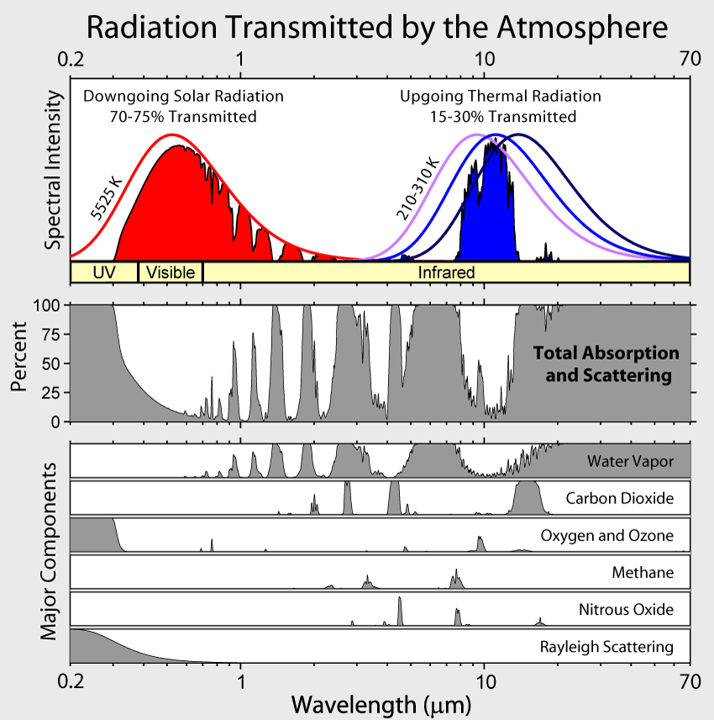

Rohde, R. A. (2007). Radiation transmitted by the atmosphere [Image].
Retrieved October, 2009, from Wikimedia Commons website: http://upload.wikimedia.org/wikipedia/commons/7/7c/Atmospheric_Transmission.png

Using information in the chart above answer the items.

- Which wavelengths of radiation from space in the visible and the infrared ranges can be observed from Earth? (2 marks)

Note – wavelength scale is not linear
Visible: 0.4 x 10⁻⁶ m to 0.8 x 10⁻⁶ m (1 mark)
IR: 1.8 x 10⁻⁶ m to 11 x 10⁻⁶ m (1 mark)

- Which compounds in the Earth’s atmosphere interfere with stellar observations in the infrared range? (2 marks)

Water (1 mark)
Carbon dioxide (1 mark)

Item 8 (2 marks)
The following photograph is of a vibration pattern produced by a moving object in a ripple tank.

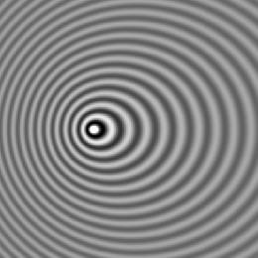
Pfalstad. (2008). Doppler effect [Image].
Retrieved October, 2009, from Wikimedia Commons website: http://upload.wikimedia.org/wikipedia/commons/d/d3/Doppler_effect.jpg

- Which direction is the vibrating source moving towards (left/right/up/down)? (1 mark)

Moving to left of picture (1 mark)

- Explain your answer. (1 mark)

Waves are closer together on the left resulting in higher frequency as predicted by the Doppler effect. (1 mark)

Item 9 (3 marks)
Radio telescopes make observations in the 21 cm radio wavelength band. These radio waves are generated by a neutral hydrogen atom. An electron in energy level 1 normally spins in the same direction as the proton. If the electron changes to spin in an opposite direction to the proton, a small amount of energy is released resulting in the 21.106 cm radio emission.

What amount of energy is released (in eV) as an electron changes the direction in which it spins on its axis?

E = hf = hc = 6.63 x 10⁻³⁴ x 3 x 10⁸
λ 0.21106 (1 mark)

= 9.42 x 10⁻²⁵J (1 mark)

In eV = 9.42 x 10⁻²⁵J = 5.89 x 10⁻⁶ eV
1.6 x 10⁻¹⁹ (1 mark)

Item 10 (2 marks)
In 1817 Joseph Fraunhofer examined the spectrum from the Sun. He observed a series of dark lines in the otherwise continuous white light spectrum.

- How are the dark lines produced? (1 mark)

The dark lines are caused by absorption of part of the white light from the Sun’s surface as it passes through gases in the Sun’s atmosphere. (1 mark)

- What information about the Sun can be gained from these dark lines? (1 mark)

The pattern of lines identifies the elements in the Sun’s atmosphere. (1 mark)

Item 11 (3 marks)
Georges Lemaître (professor of Physics at University of Leuven in 1927) proposed a theory of the nature of the Universe (now known as the ‘Big Bang’ theory), as a logical extension of Einstein’s General Theory of Relativity. ‘Big Bang’ was not Lemaître’s choice for a name—this was coined by astronomers who scoffed at the idea. Astronomers now accept Lemaître’s theory as correct. What evidence has been discovered to support this theory?

Expanding universe – further galaxies are moving away faster than closer galaxies.
This is consistent with an explosion – the particles that travel furthest move fastest.
(1 mark)

Hubble discovered distances to galaxies are proportional to their redshifts.
(1 mark)

Cosmic microwave background radiation is almost uniform in all directions.
(1 mark)

Item 12 (3 marks)
In 1990 NASA launched the Hubble Space telescope despite knowing of a major defect in its 2.4 m reflecting mirror. The telescope was launched on the very last Saturn 5 rocket capable of carrying the telescope into orbit. In 1993 a Space Shuttle mission replaced the mirror allowing Hubble to function correctly. On Earth the largest (Keck) telescopes have a 10 m diameter mirror and are 4100 m above sea level on a dormant volcano.

- Why are telescopes built so far above sea level? (1 mark)

Telescopes high in the mountains look through less of Earth’s atmosphere. (1 mark)

- Why did NASA put the Hubble telescope into space when bigger telescopes exist on Earth?
(2 marks)

Hubble telescope suffers no effects from air distorting the images. (1 mark)

Hubble also views in infrared range which is not really possible from Earth due to absorption of IR by water in Earth’s atmosphere. (1 mark)

Item 13 (2 marks)

This graph represents intensity of the energy released versus wavelength for a ‘black body’.

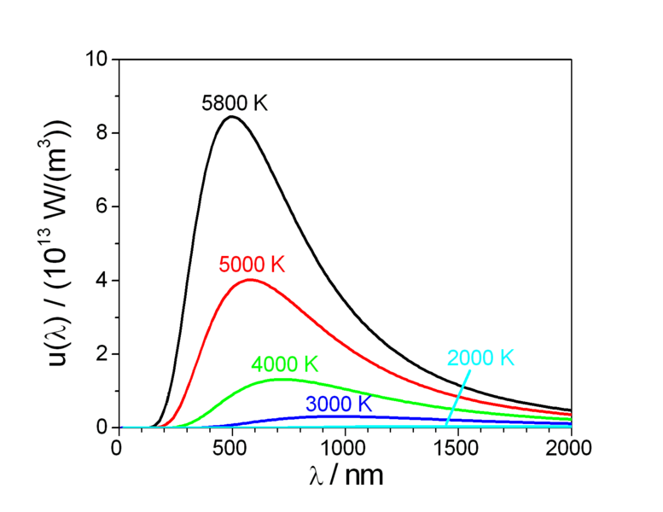
Power density x 10¹³ (W m⁻³)

http://commons.wikimedia.org/wiki/File:Planck_law_radiation.PNG

(a) Describe a trend you observe in the graph.

As temperature increases—the peak of the black body radiation curve moves to higher intensities and shorter wavelengths. (1 mark)

(b) How can this graph be used to estimate the surface temperature of a star?

The position of the energy peak gives the temperature. (1 mark)

Item 14 (4 marks)

Observing the absorption and emission spectrum from stars can provide us with information on the star, such as

surface temperature

chemical composition

rotational velocity

translational velocity.

Explain in a few lines on each of the above how the stellar spectrum gives this information.

Surface temperature – is determined from the colour of radiation (light). (1 mark)

Chemical composition – solar absorption spectral lines give elements present.
(1 mark)

Rotational velocity – side rotating toward Earth is blue shifted. Side rotating away from Earth is red shifted. Shift gives period of rotation. (1 mark)

Translational velocity – can be found from red shift. (1 mark)

Item 15 (3 marks)
In 1054 AD Chinese astronomers noticed the appearance of a bright star visible in the constellation of Taurus. It was a supernova explosion – the death of a star. The Crab Nebula is the shattered remnant of that massive star. The nebula is about 6 500 light-years away from Earth and is
5 light-years across, and has a pulsar (a rotating neutron star) at its centre.

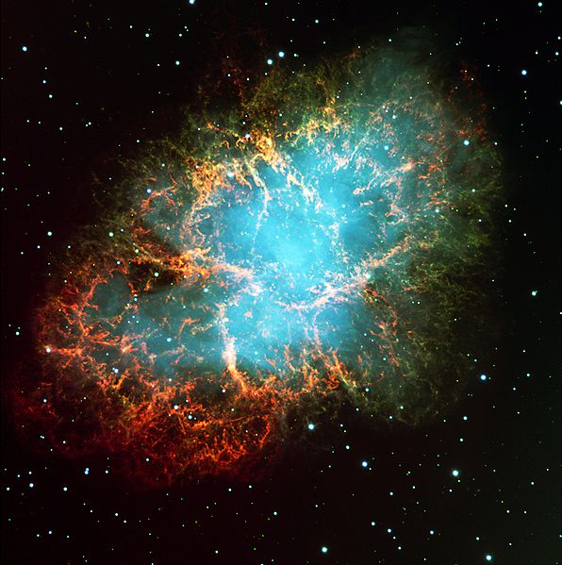

http://commons.wikimedia.org/wiki/File:M1_-_The_Crab_Nebula.jpg

- In which year (BC) did this supernova actually take place? (Show your working) (1 mark)

1054 – 6500 = - 5446

Explosion was in 5446 BC (1 mark)

- What is the distance in km across this nebula? (2 marks)

5 ly x 365.25 x 24 x 3600 x 3 x 10⁵ (1 mark)
= 4.733 x 10¹³ km (1 mark)

Item 16 (4 marks)

The surface brightness of nebulae can be used to estimate the distance of the nebula from the Earth. The recessional velocity of the nebula can be estimated by the red shift of frequencies emitted in the nebula spectrum. The following data for several nebulae was collected from telescopes on Earth in 1997.

Recessional  velocity (km s⁻¹) | Distance (D)  (megaparsecs)
540 | 4.0
650 | 9.6
910 | 10.8
800 | 12.0
915 | 14.3
1050 | 15.5
1200 | 16.1
1300 | 16.2
13500 | 15.8
1400 | 17.4

- On a suitable scale, graph the data (with velocity on the y-axis). Draw a line of best fit and determine the gradient of the line. The gradient is an estimate of Hubble’s constant. (3 marks)

v

D (1 mark for graph)

Slope = 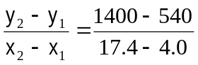 (1 mark)

= 64.2 km s⁻¹ Mpc⁻¹ (1 mark)

- The most recent determination of H₀ obtained in 2009 by using the Hubble Space Telescope yielded a value of H₀ = 74.2 ± 3.6 (km s⁻¹ Mpc⁻¹).
Why is the value based on the data from the Hubble Space Telescope likely to be more accurate?
(1 mark)

Since the Hubble telescope is above Earth’s atmosphere, it has clearer observations.
(1 mark)

Item 17 (2 marks)
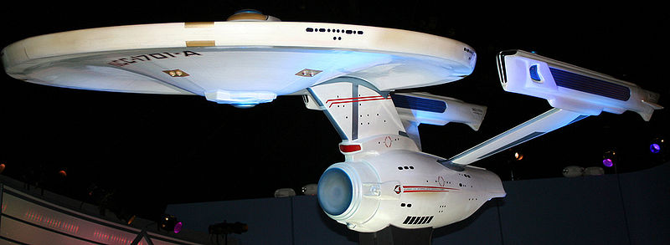
http://commons.wikimedia.org/wiki/File:Enterprise_NCC-1701-A.jpg

In the science fiction TV series Star Trek, the starship Enterprise is accelerated to a speed faster than the speed of light (‘warp speed’) for travel between star systems or galaxies. Explain why it is impossible to travel at or faster than the speed of light.

As the velocity of particles approach the speed of light, energy is required to increase the velocity further. Some of this energy is turned into mass requiring even larger amounts of energy to accelerate. (1 mark)

No particle can reach the speed of light as it will gain mass according to the Einstein equation E = mc². (1 mark)

Item 18 (2 marks)
Two identical atomic clocks of extreme accuracy are set to within the same nanosecond at Greenwich in England. One of the clocks is then flown to Perth at 800 km h⁻¹. In Perth the clock is now several nanoseconds different to its ‘twin’ still at Greenwich.

- Is the clock in Perth ahead or behind its ‘twin’? (1 mark)

Behind (1 mark)

- What is the cause of this difference in time? (1 mark)

According to Einstein’s theory of special relativity, time passage slows for a moving object.
(1 mark)

Item 19 (3 marks)
Adventure parks have developed rides that simulate a real driving adventure for their customers. Patrons sit in chairs in the dark and watch a projected computer image of a high speed chase. Every turn, dive and twist appears real as the seat appears to lurch, but in fact it is stationary. The virtual reality ride appears very realistic.

Why does it seem as if you are actually in a chase?

In the dark, you cannot see the other chairs. (1 mark)
The only frame of reference (1 mark)
is the screen which appears to be moving. (1 mark)

Item 20 (2 marks)
A freelance motoring journalist was caught speeding in an expensive imported Italian car at
231 km h⁻¹ during a test drive in a 110 km h⁻¹ zone.

- A police car coming in the opposite direction at 110 km h⁻¹ recorded his speed on its radar. What was the closing speed of the cars as they approached each other? (1 mark)

110 + 231 = 341 km h⁻¹ (1 mark)

- If the police car was following the Italian car at 110 km h⁻¹, what speed would it register on the radar? (1 mark)

231 – 110 = 121 km h⁻¹ (1 mark)

Item 21 (2 marks)
The Andromeda galaxy is receding from Earth at about 0.3c (c = speed of light).

In the search for extraterrestrial life, a radio signal is sent from Earth into space. At what speed is the radio signal received on Andromeda? Explain your answer.

Arrives travelling at 3 x 10⁸ m s⁻¹ (1 mark)
According to Einstein’s theory of special relativity the speed of light in a vacuum is constant no matter what is the frame of reference. (1 mark)

Item 22 (3 marks)
In 1983, a Korean Airlines 747 airliner that strayed into Russian airspace (due to computer navigational errors) was shot down. Since 1994, 24 satellites in orbit have allowed positions on Earth to be accurately known to within 15 metres. Orbiting at an altitude of 20 200 kilometres, about 10 satellites are visible to the ground-based receiver. Each satellite continually transmits messages which include the time the message was sent. The receiver measures the time of each message from the satellites and computes the distance to each satellite.

To work correctly, the clocks on the satellites and the clock in the receiver must be set identically. The clocks are extremely accurate, relying on vibrating quartz crystals to keep the time. Over a period of exactly 24 hours the total time difference between the clock in the orbiting satellite and the clock in the GPS receiver is 3.8 x 10⁻⁵ s.

- What could cause the difference in time? (1 mark)

The clock on board the satellite is moving. (1 mark)

- Which clock runs faster? (1 mark)

The clock on Earth runs faster. (1 mark)

- What absolute error would there be in the measurement of the distance to a GPS receiver from a satellite directly overhead after 24 hours, if the clock is not corrected? (2 marks)

Error = 0.000038 x 3 x 10⁸ (1 mark)
= 11400 m (1 mark)

Extension and Discussion items

Item E1 (2 marks)
The Space Interferometry Mission (now called SIM Lite) is due to be launched by NASA in 2015. Operating in the visible waveband, SIM has the goal to measure stars’ parallax up to 4 micro-arcsecond with absolute precision.

How many light-years away can it measure stars?

Use the formula d = 1 / p, where d = distance (in parsecs), p = parallax angle (in arcsec) and 1 parsec = 3.26156 light-years.

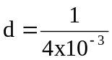 = 250 parsecs (1 mark)

250 x 3.26156 = 815.39 light years (1 mark)

Item E2 (5 marks)
Before satellites were available, stellar parallax was measured from Earth using annual parallax as the Earth orbits around the sun.

(1 parsec = 3.26156 light-years and is also the distance for which the annual parallax is 1 arcsecond. 1 Earth year = 365.25 solar days).
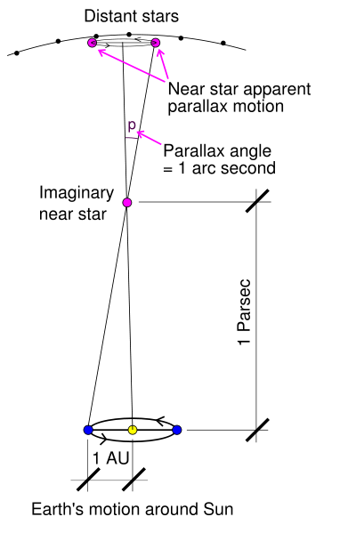
Srain. ( 2006). Stellarparallax parsec1 [Diagram]. Retrieved October, 2009, from Wikimedia Commons website: http://commons.wikimedia.org/wiki/File:Stellarparallax_parsec1.svg

- If the imaginary star in the diagram above is 1 parsec away, how distant is this star in metres?
(1 mark)

1 parsec = 3.26156 x 3 x 10⁸ x 365.25 x 24 x 3600 = 3.088 x 10¹⁶ m (1 mark)
y

- Compass headings are given in degrees, minutes and seconds. What is one second as a decimal of a degree? (2 marks)

y
There are 60 seconds in 1minute and 60 minutes in a degree.
1 second = 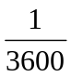 degree (1 mark)

= 2.774 x 10⁻⁴ degrees (1 mark)
y

- Calculate the radius of the Earth’s orbit around the sun in metres. (2 marks)

2.774 x 10⁻⁴

3.088 x 10¹⁶

x (1 mark)
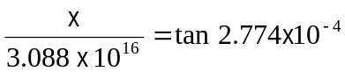 x = 1.493 x 10¹¹ m (1 mark)

Item E3 (6 marks)
In 1989, the satellite Hipparcos was launched to measure the parallax of nearby stars. It measured the parallax of over 10 000 stars much more accurately than could be done by measurements on Earth. The data for three stars is given below.

Star | Parallax (milliarcseconds)
Sirrah—the brightest star in the constellation of Andromeda | 33.60 ± 0.73 mas
Polaris—the north pole star | 7.56 ± 0.48 mas
Rigel—the brightest star in the constellation Orion | 4.22 ± 0.81 mas

- Calculate the distance to each of these stars in light years and the absolute error. Use the equation d = 1 / p, where d = distance (in parsecs), p = parallax angle (in arcsec). (5 marks)

Sirrah: 33.60 + 0.73 = 33.60 + 2.17% (1 mark)

1 = 29.76 + 2.17% pc x 3.26156 = 97 + 2.17%
33.60 + 2.17% (1 mark)
= 97 + 2.1 ly (1 mark)

Polaris: 431 + 6.35% = 431 + 27.4 light-years (1 mark)

Rigel: 773 + 148 light-years (1 mark)

- Suggest why the percentage error of each star’s distance measurement is increasing. (1 mark)

For stars further away it is harder to measure parallax angles. (1 mark)

Item E4 (2 marks)
A student uses the parallax method to determine the distance to a tree about 2 km away. His experiment log shows the following drawing of his method.

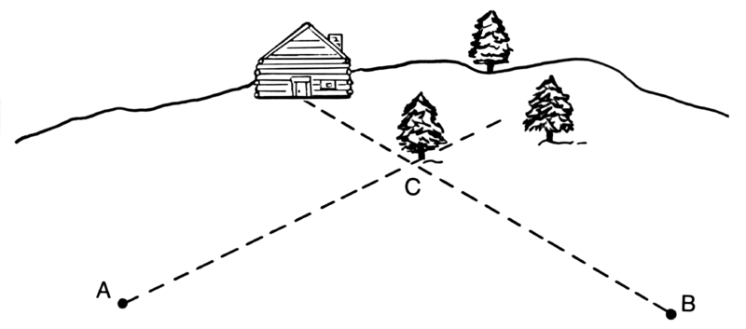
<---------- 20m --------->
Pearson Scott Foresman. (2008). Line art drawing of parallax [Diagram]. Retrieved October, 2009, from Wikimedia Commons website: http://upload.wikimedia.org/wikipedia/commons/c/cb/Parallax_%28PSF%29.png

The distance AB is accurately measured with a tape measure to be 20m.
How could this experiment be improved?

Increase the length of the base line perhaps to 200 m. (1 mark)
Increase the accuracy of the measurement of the angle. (1 mark)

Item E5 (2 marks)

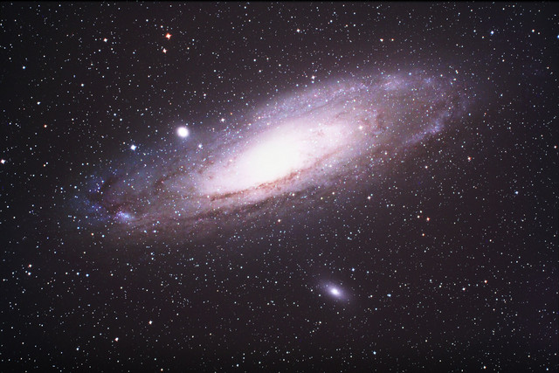
Lanoue, J. (2006). M31 Lanoue [Photograph]. Retrieved October, 2009, form Wikimedia Commons website: http://upload.wikimedia.org/wikipedia/commons/7/71/M31_Lanoue.png

The redshift of the Andromeda galaxy has been calculated as 0.301.
A radio telescope monitoring H radio emission (normally at 21.106 cm) will need to monitor a different wavelength to pick up emissions from Andromeda.

Which wavelength must be monitored?

The following equation is used for calculating red shift, Z:
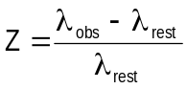

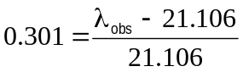
(1 mark)

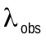= 27.459 cm (1 mark)

Item E6 (2 marks)
The end of the Universe is predicted by astronomers somewhere between 10¹⁴ and 10⁴⁰ years from now. Astronomers have two theories for the future of the Universe – the ‘open’ and ‘closed’ Universe. How do these two theories differ?

Closed universe—gravity will eventually slow the moving galaxies and then reverse their motion until they all come together again. (1 mark)
Open universe—expansion continues until all energy is used up. No energy left means no heat. (1 mark)

Item E7 (3 marks)
A Klingon battleship passes by the stationary starship Enterprise at 0.92c. To the crew on the Enterprise, the Klingon vessel appears

- Longer/ shorter/ the same as its known length of 500m. (1 mark)

Shorter (1 mark)

- Using the equation

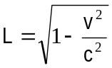

where L is the observed length and L₀ is the actual length, calculate the length of the Klingon battleship as it appears to the crew on the Enterprise. (2 marks)

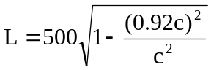
(1 mark)
= 500 x 0.3919
= 195.9 m (1 mark)

Item E8 (9 marks)
The Doppler shift in the wavelength of light emitted by galaxies can be used to measure the speed with which they are moving towards or away from the Earth.

Like the Sun, galaxies emit a wide range of wavelengths. The analysis of the absorption spectra of light from galaxies can have two spectral lines missing due to the absorption by calcium ions as light passes through the gases surrounding galaxies.

In the constellation Eridanus, which is visible in the western sky between January to April, there is a spiral galaxy NGC 1357. The wavelength of one of the calcium absorption lines in the spectrum from NGC 1357 is 399.72 nm. The same line in the calcium spectrum measured in a laboratory on Earth is 396.85 nm.

- Is the spiral galaxy NGC 1357 moving towards or away from the Earth? (1 mark)

The spiral galaxy NGC 1357 is moving away from us. (1 mark)

- Justify your answer to (a) using a brief explanation and a diagram. (4 marks)

The wavelength of the calcium line in the spectrum from NGC 1357 has increased.
This is a characteristic of a source moving away from an observer
(Earth 396.85 nm, NGC 1357 399.72 nm). (2 marks)

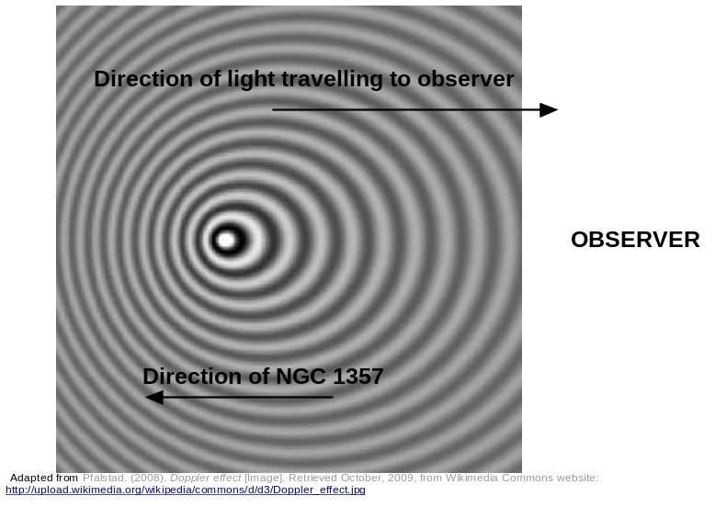

(2 marks for diagram)

- Calculate the velocity of NGC 1357 using the relationship 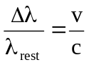 where
Δλ = λ_{shifted} - λ_{rest}
and  _{rest} is the wavelength of the fixed source,  is the speed of the moving source and c is the speed of light. (2 marks)

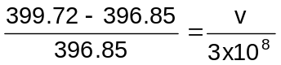

v = 2.169 x 10⁶ m s⁻¹ (2 marks)

- A star has a recessional velocity of 58.9 km s⁻¹. Calculate the ‘red shift’ that would be expected in the calcium 396.849 nm absorption line from this star.
Use the relationship where ) is the change in wavelength, _{rest} is the wavelength of the fixed source,  is the speed of the moving source and c is the speed of light.
(2 marks)

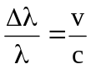
So 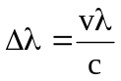

= 58.9 x 1000 x 396.85 x 10⁻⁹
3x 10⁸ (1 mark)

= 7.791 x 10⁻¹¹ m = 0.0791 nm (1 mark)

Item E9 (5 marks)
An emergency services vehicle approaches an intersection at 110 km h⁻¹ sounding the horn continuously. The horn has a frequency of 750 Hz. A pedestrian on the footpath at the intersection hears the horn of the approaching at a different frequency.

- Explain what the pedestrian would hear. (1 mark)

Since the source of sound is moving toward the observer, it would be at a higher frequency.
(1 mark)

- The observed frequency can be calculated using the formula
frequency observed = true frequency x 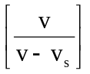
where v is the speed of sound in the medium, v_{s} is the velocity of the moving source.

As the driver approaches the intersection, in the equation is the sign allocated to the velocity of the source + or – to match what the observer hears? Explain your choice. (2 marks)

Must be negative for the denominator to be smaller, to result in a higher value for the frequency. (2 marks)

- Calculate the frequency heard by the pedestrian. (2 marks)

110 km h⁻¹ = 30.56 m s⁻¹ (1 mark)
Observed frequency = 750 x 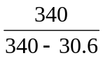 = 824 Hz (1 mark)

Item E10 (12 marks)
The visible emission spectrum of a hydrogen atom has three bright lines – red, blue-green and violet. The blue-green line is caused by the emission of a photon as it moves from energy level 4 to energy level 2. The energy of each level (in eV) can be calculated using the formula
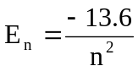

- What is the energy of the photon emitted (in eV) that causes the blue-green line? (1 mark)

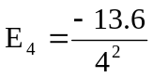 = -0.85 eV 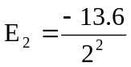= -3.4 eV

E_{4→2} = 3.4 – 0.85 = 2.55 eV (1 mark)

- What is the wavelength of this line in nanometres? (4 marks)

2.55 eV = 2.55 x 1.6 x 10 ⁻¹⁹ = 4.08 x 10⁻¹⁹ J (1 mark)

E = 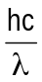 4.08 x 10⁻¹⁹ = 6.63 x 10⁻³⁴ x 3 x 10⁸
λ (1 mark)

λ = 7.8 x 10⁻⁷ m (1 mark)

= 780 nm (1 mark)

- The blue-green line of the hydrogen spectrum from a close galaxy is observed at 537.4 nm. The redshift Z can be calculated 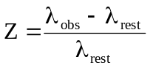
Calculate the red shift of the galaxy. (1 mark)

= 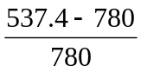 = 0.311 (1 mark)

- For close galaxies receding at a relatively low velocity, the recessional velocity of the galaxy can be calculated from 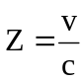 where c is the speed of light.
Use the value of the redshift from (c) to calculate the recessional velocity of the galaxy (in
km s⁻¹). (2 marks)

Z = 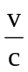 0.311 = 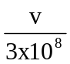 (1 mark)

v = 9.33 x 10⁷ m s⁻¹

= 9.33 x 10⁴ km s⁻¹ (1 mark)

- Using Hubble’s law calculate the distance in light-years to this relatively close galaxy using the
redshift value from part (c). (1megaparsec = 3261636.26 light-years)

Hubble’s law: v = H₀ D

v is the velocity (in km s¹), D is the distance ( megaparsecs Mpc ), H₀ is Hubble’s constant
[ H₀ = 74.2 ± 3.6 (km s⁻¹ Mpc⁻¹) ]. (4 marks)

v = H₀ D
9.33 x 10⁴ = 74.2 + 3.6 x D
D = 9.33 x 10⁴
74.2 + 4.85% (1 mark)

= 1.257 x 10³ Mpc + 4.85% (1 mark)

= 1.257 x 10⁹ pc + 4.85%

= 4.10 x 10⁹ ly + 4.85% (1 mark)

= 4.10 x 10⁹ + 2.0 x 10⁸ ly (1 mark)

Item E11 (7 marks)
Muons are formed when cosmic radiation impacts air molecules 10 km up in the Earth’s atmosphere. About 10 000 muons reach every square meter of the Earth’s surface every minute. The mean lifetime of a stationary muon is 2.2 x 10⁻⁶ seconds before it decays. Muons travel at speeds of up to 0.999c and can penetrate deep into rock. They are detectable deep underground and underwater.

Rossi and Hall in 1940 were able to ‘prove the effect of time dilation on high speed muons. They measured muon impacts on a scintillation counter at an altitude of 3000 metres (568 counts h⁻¹) and at sea level (412 counts h⁻¹).

- What distance would a muon be expected to travel in its mean lifetime (not including any special relativity effects)? (1 mark)

s = v x t
= 2.2 x 10⁻⁶ x 0.999 x 3 x 10⁸
= 660 m (1 mark)

- Using the information from (a) would you expect many muons to reach the Earth’s surface from where they were formed? (1 mark)

If the average muon only travels 660 m then few will travel from the upper atmosphere to the Earth’s surface. (1 mark)

- Using the equation below, calculate the mean lifetime of a muon in its own (moving) frame of reference.
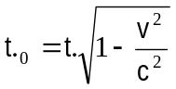 | where t₀ is the actual time and t is the apparent time. (2 marks)
___________
2.2 x 10⁻⁶ = t . √ 1 – (0.999c)²
c² (1 mark)

t = 4.92 x 10⁻⁵ seconds is mean lifetime as seen by the muon itself. (1 mark)

- How far will a muon move in its mean lifetime taking into account special relativity? (1 mark)

s = v x t
= 0.999 x 3 x 10⁸ x 4.92 x 10⁻⁵
= 14745 m (1 mark)

- Would you now expect more muons to reach the Earth’s surface? (1 mark)

Say from 3000 m where there are considerable muons – yes. (1 mark)

- How did the data collected by Hall and Rossi ‘prove’ time dilation actually exists? (1 mark)

Muons ‘live’ longer and this explains why they are recorded deep below ground.
(1 mark)

Item E12 (5 marks)
In the science fiction series Star Trek, Captain Kirk orders the starship Enterprise to travel from Earth on a rescue mission to Alpha Centauri (4.2 light-years away). Due to battle damage, the fastest speed that the Enterprise can travel at is just below the speed of light. The crew includes twins, and while one of two identical twins is on the mission to Alpha Centauri the other remains on Earth.

- The Enterprise can only manage a speed of 0.98c (c = speed of light). At this speed, how long will the starship take to travel to Alpha Centauri and return as seen from Earth? (1 mark)

At 0.98c 8.4 ÷ 0.98 = 8.572 years (1 mark)

- The time dilation equation is
c²

where t₀ is the apparent time elapsed on the starship and t is the actual time taken for the trip.
For the crew on board, what appears to be the time taken to travel to Alpha Centauri and return? (2 marks)

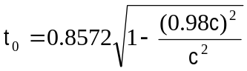
(1 mark)

= 1.706 years (1 mark)

- On the return to Earth the twins are no longer the same age, one is older. Which twin has aged more and by how much? (2 marks)

The Earth twin is older. (1 mark)
The age difference is 8.572 – 1.706 = 6.866 years. (1 mark)

Item E13 (7 marks)
The following graph shows the factor by which mass increases with increasing velocity approaching the speed of light.
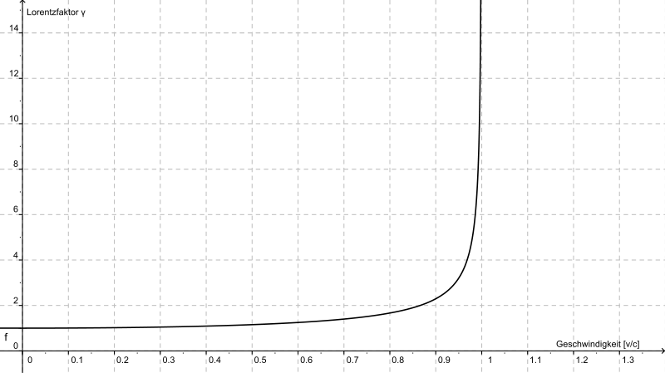
http://commons.wikimedia.org/wiki/File:Lorentzfaktor.svg

v (c)
Mass increase

A proton of mass 1.67 x 10⁻²⁷ kg is accelerated in the Large Hadron Collider until it reaches 0.95c
(c = speed of light).

- Estimate the new mass of the proton from the graph. (2 marks)

From graph mass increases roughly by 3X (1 mark)
1.67 x 10⁻²⁷ x 3 = 5.01 x 10⁻²⁷ kg (1 mark)

- What is the reason for this apparent increase in mass? (1 mark)

Some of the energy being put into the proton to accelerate it causes a mass increase,
E = mc². (1 mark)

Einstein derived the mathematical equation showing how mass changes with speed.
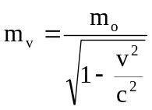 | where m₀ is the rest mass and m_{v} is the mass when moving.

- Using the equation above, calculate the mass of the proton when it is moving at 0.99c.
(2 marks)

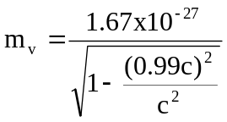 (1 mark)

= 1.67 x 10⁻²⁷
0.141 (1 mark)

= 1.18 x 10⁻²⁶ kg or about a 7X increase.

(d) Why is it impossible for the proton to travel at or faster than the speed of light? (2 marks)

The proton cannot be accelerated to the speed of light because its mass approaches infinity, and this would require an infinitely large force to accelerate the proton. (2 marks)

