Name: ​ ​ Date: ​
WACE Physics Unit 4: Special Relativity Multi-Step Problem Booklet
Question 1: Atmospheric Muon Decay [10 marks]
Muons are elementary particles created in the upper atmosphere when primary cosmic rays collide with atmospheric nuclei. A specific muon is created at an altitude of ​$10.0\text{ km}$​ above sea level and travels directly towards the surface of Earth at a constant speed of ​$v=0.995c$​.  The rest lifetime (proper lifetime) of a muon is ​$τ_{0}=2.20 μ\text{s}$​ (​$2.20×{10}^{−6}\text{ s}$​). A detector situated on Earth's surface records the arrival of these particles. Take the speed of light in a vacuum to be ​$c=3.00×{10}^{8}{\text{ m s}}^{−1}$​. |  | 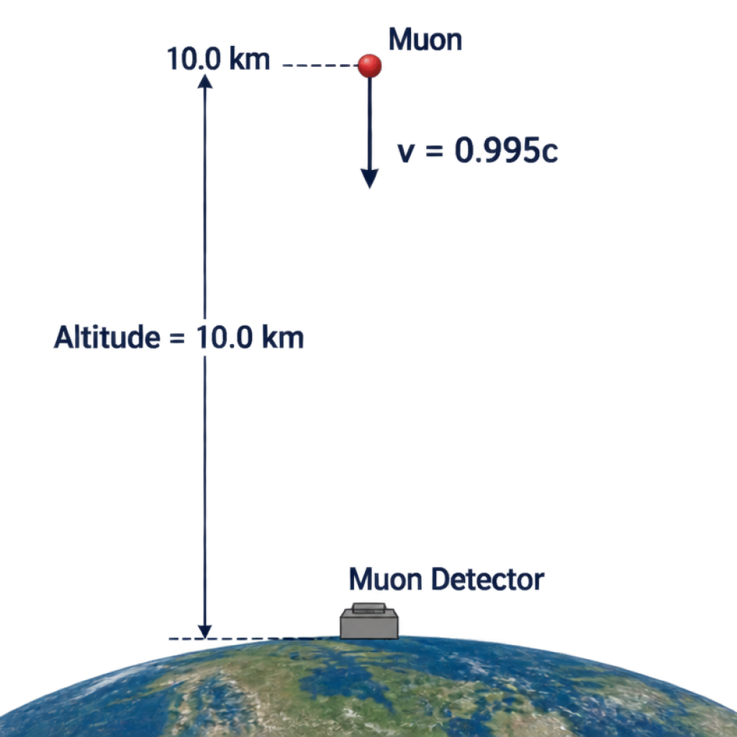

(a) Calculate the Lorentz factor, ​$γ$​, for a muon travelling at ​$0.995c$​. [2 marks]
(b) Using classical (Newtonian) physics, calculate the distance the muon would travel in one rest lifetime. Hence, explain why classical mechanics predicts that virtually zero muons should reach the ground detector. [2 marks]
(c) Calculate the lifetime of the muon from the reference frame of an Earth-based observer, and determine the mean distance the muon travels in this frame before decaying. [3 marks]
(d) In the reference frame of the muon, calculate the contracted distance from its creation point to Earth's surface. Explain how this allows the muon to reach the ground detector from its own perspective. [3 marks]
Question 2: Relativistic Interstellar Voyage [9 marks]
An uncrewed deep-space probe travels at a constant velocity of ​$v=0.850c$​ from an orbital depot near Earth to an automated research station orbiting Proxima Centauri.  The distance between Earth and Proxima Centauri is measured by mission control on Earth to be ​$L_{0}=4.24\text{ light-years}$​ (​$4.01×{10}^{16}\text{ m}$​). Both orbital stations remain at rest relative to one another. |  | 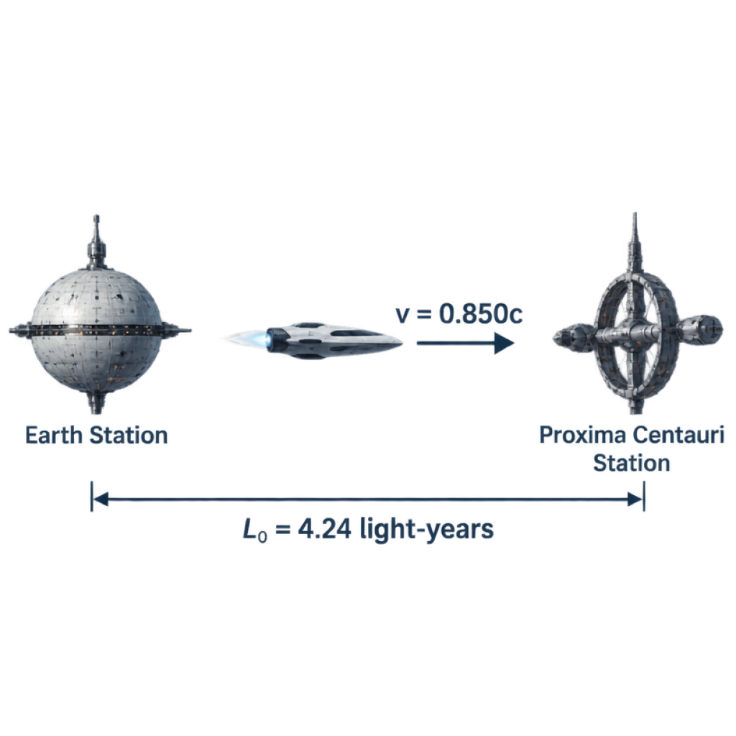

(a) Identify which observer measures the proper length of the journey and which observer measures the proper time. Justify your answer using relativistic definitions. [2 marks]
(b) Calculate the total travel time in years as recorded by observers stationed on Earth. [2 marks]
(c) Determine the Lorentz factor, ​$γ$​, for the probe, and calculate the duration of the journey in years as registered by an onboard atomic clock. [3 marks]
(d) Calculate the distance between Earth and Proxima Centauri as determined by sensors aboard the moving probe. Show that this distance is consistent with your answer to part (c). [2 marks]
Question 3: Relativistic Dynamics in a Particle Accelerator [8 marks]
In a synchrotron facility, a proton of rest mass ​$m_{0}=1.673×{10}^{−27}\text{ kg}$​ and rest energy ​$E_{0}=938\text{ MeV}$​ is accelerated through a series of radiofrequency cavities.  After acceleration, the proton reaches an energy state where its total relativistic energy is equal to exactly ​$3.20$​ times its rest energy (​$E_{\text{total}}=3.20E_{0}$​). Take ​$c=3.00×{10}^{8}{\text{ m s}}^{−1}$​ and ​$1\text{ eV}=1.602×{10}^{−19}\text{ J}$​. |  | 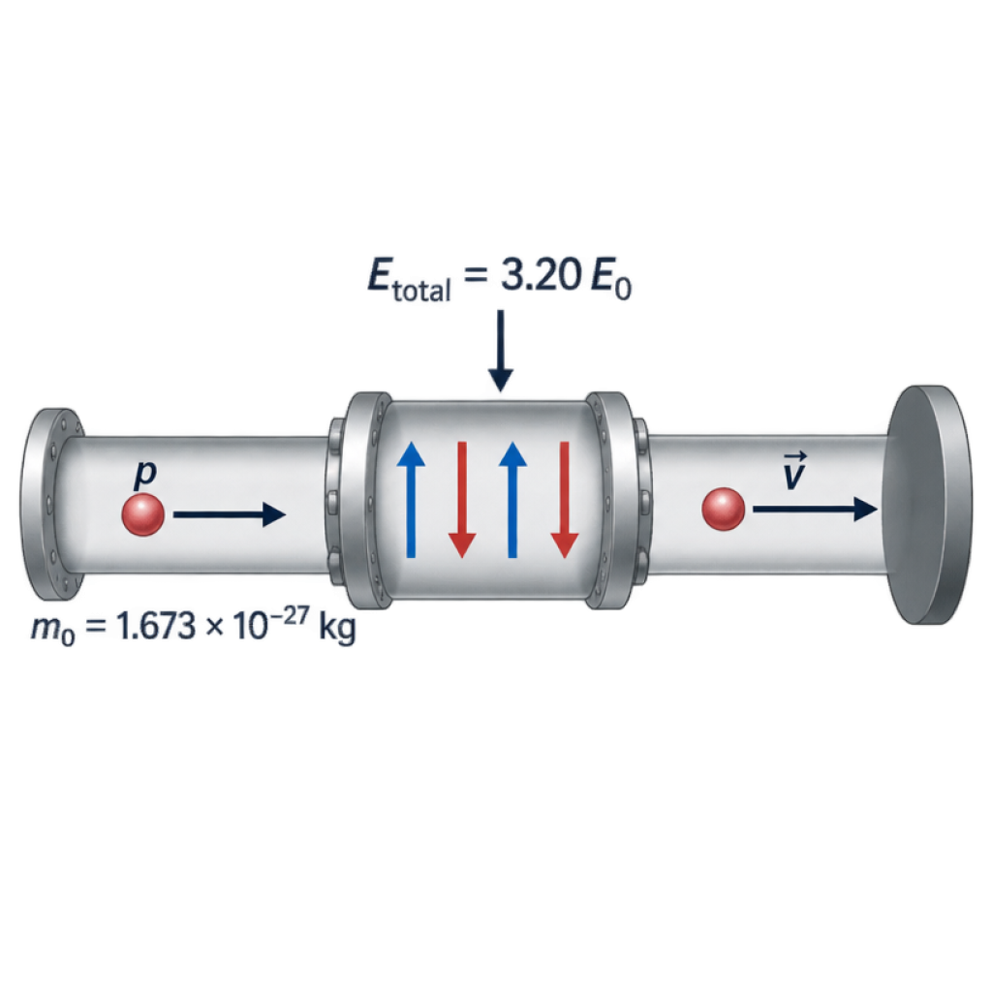

(a) State the numerical value of the Lorentz factor, ​$γ$​, and calculate the speed of the proton as a fraction of ​$c$​. [3 marks]
(b) Calculate the relativistic momentum of the proton at this speed in ​${\text{kg m s}}^{−1}$​. [3 marks]
(c) Calculate the work done on the proton during acceleration, expressing your answer in gigaelectronvolts (​$\text{GeV}$​). [2 marks]
Question 4: Moving atomic clock [6 marks]
A spacecraft moves at ​$0.600c$​ relative to Earth. An onboard atomic clock measures 12.0 minutes between two signals emitted at the same point on the spacecraft. (a) Find the Lorentz factor and the Earth-frame interval. [3 marks] (b) Find the distance travelled in the Earth frame during this interval, using ​$c=3.00×{10}^{8}$​ m s⁻¹. [3 marks]
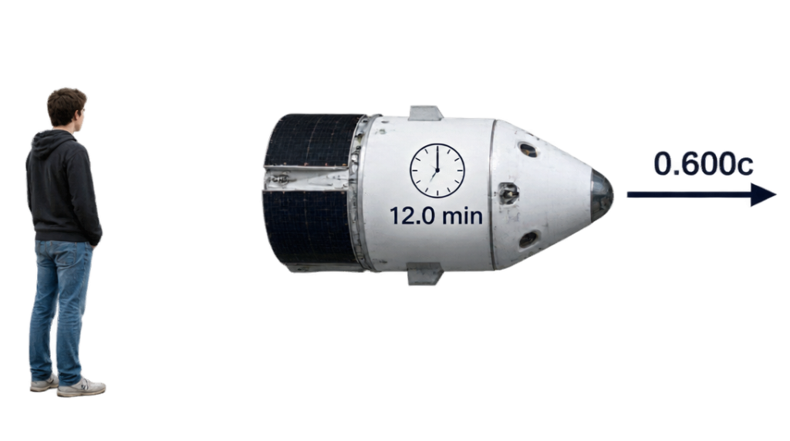
Question 5: Lifetime in a laboratory [6 marks]
A particle has a proper mean lifetime of 4.00 microseconds and moves at ​$0.800c$​ through a laboratory. Take ​$c=3.00×{10}^{8}$​ m s⁻¹. (a) Calculate its mean lifetime in the laboratory frame. [3 marks] (b) Calculate its mean travel distance in that frame. [3 marks]
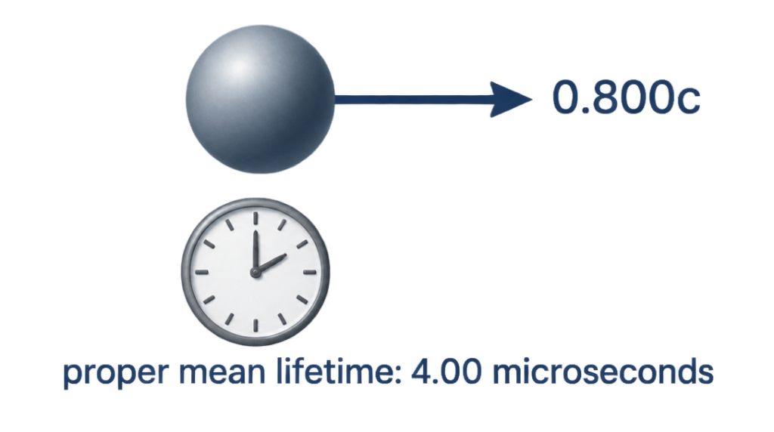
Question 6: Contracted spacecraft [6 marks]
A spacecraft has a proper length of 120 m and travels parallel to its length at ​$0.800c$​ relative to a station. Take ​$c=3.00×{10}^{8}$​ m s⁻¹. (a) Determine its length in the station frame. [3 marks] (b) Find the time between the front and rear passing a fixed station sensor. [3 marks]
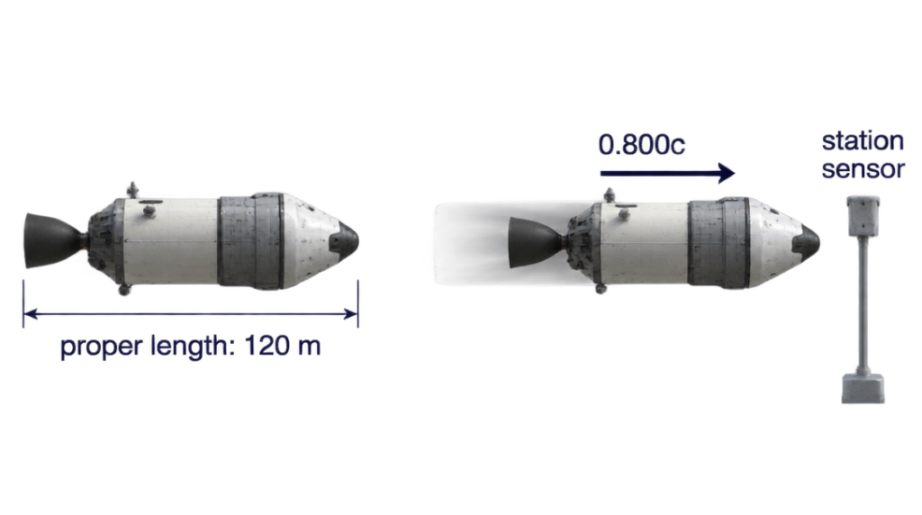
Question 7: Two observers and a clock [6 marks]
An Earth observer measures 25.0 seconds between two ticks of a clock moving at ​$0.600c$​ relative to Earth. (a) Identify the proper time and calculate it. [3 marks] (b) Calculate the distance the clock moves relative to Earth between the ticks. Use ​$c=3.00×{10}^{8}$​ m s⁻¹. [3 marks]
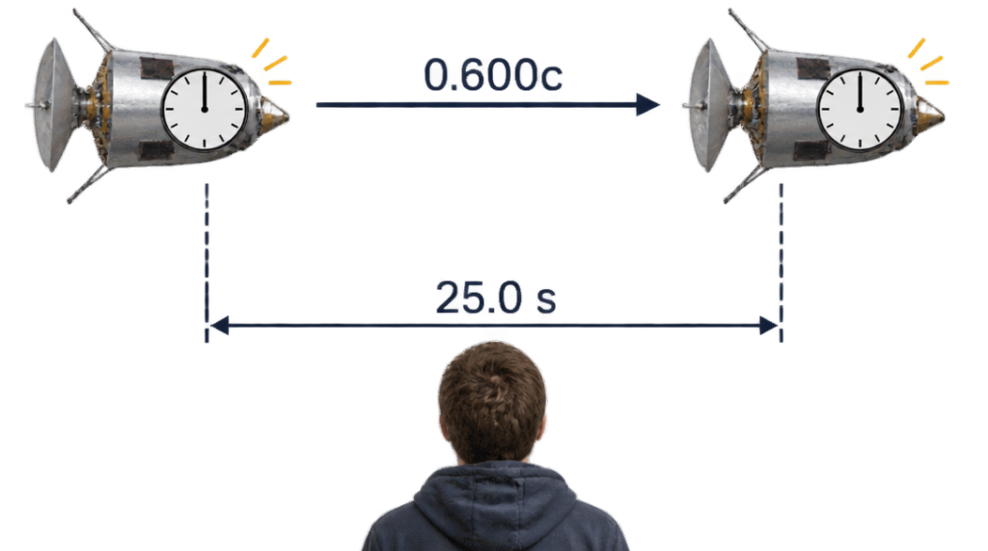
Question 8: A fast probe [6 marks]
Two stations are stationary relative to one another and separated by 6.00 light-years. A probe travels between them at ​$0.800c$​. (a) Find the travel time in the station frame. [2 marks] (b) Find the elapsed time on the probe and the station separation in the probe frame. [4 marks]
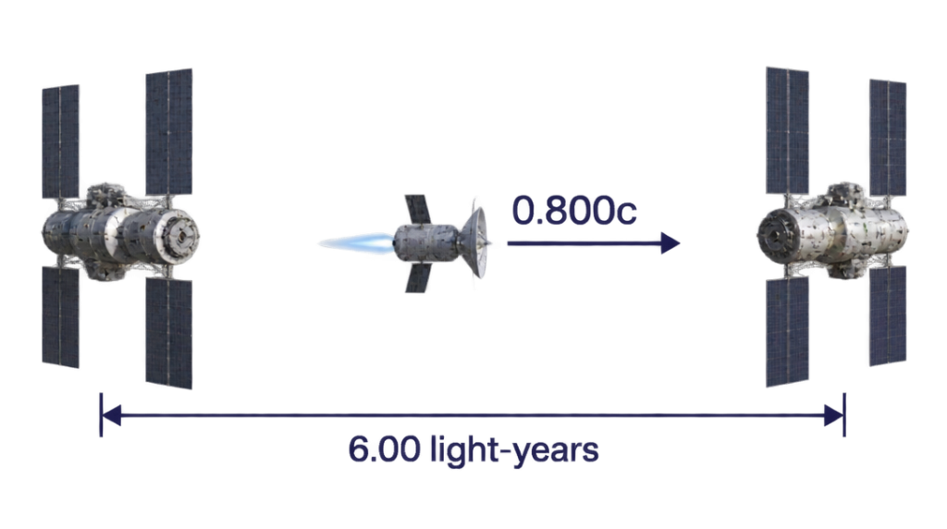
Question 9: Finding speed from clock readings [6 marks]
A moving clock records 8.00 seconds between two events at its location. An observer in a laboratory records 10.0 seconds between the same events. (a) Determine the Lorentz factor and the clock's speed relative to the laboratory. [4 marks] (b) Calculate the distance between the events in the laboratory frame, using ​$c=3.00×{10}^{8}$​ m s⁻¹. [2 marks]
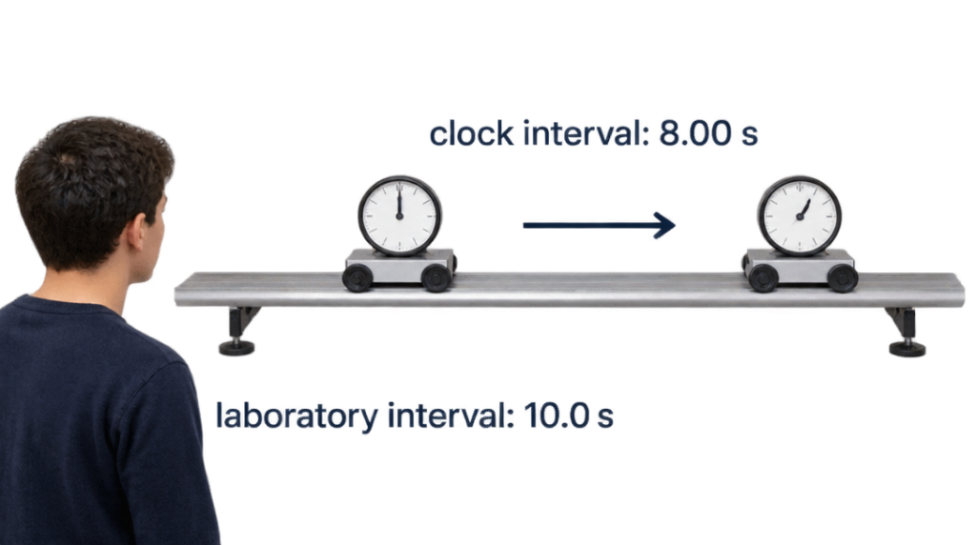
Question 10: Finding speed from length [6 marks]
A spacecraft has a proper length of 100 m. A station measures its length as 60.0 m while it moves parallel to its length. (a) Find its Lorentz factor and speed relative to the station. [4 marks] (b) Determine the time for the spacecraft to pass a stationary sensor. Use ​$c=3.00×{10}^{8}$​ m s⁻¹. [2 marks]
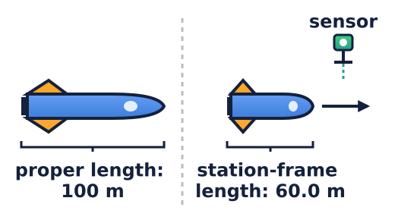
Question 11: Muon travel [6 marks]
A muon travels at ​$0.960c$​ in a laboratory. Its proper mean lifetime is 2.20 microseconds. Take ​$c=3.00×{10}^{8}$​ m s⁻¹. (a) Find its mean lifetime and mean travel distance in the laboratory frame. [4 marks] (b) Determine the laboratory distance of 2.00 km in the muon's frame. [2 marks]
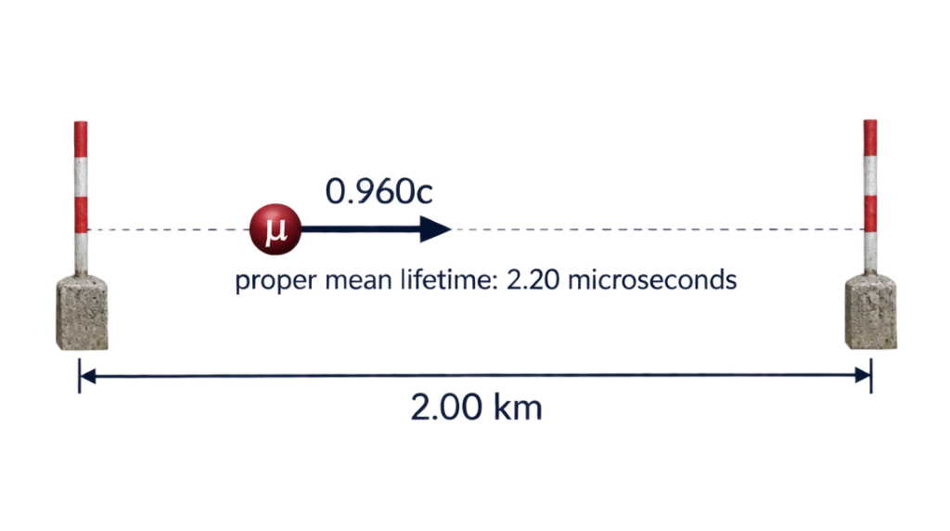
Question 12: Clock comparison [6 marks]
A clock on a spacecraft moving at ​$0.800c$​ records 9.00 hours between departure and arrival. The two stations are at rest relative to Earth. (a) Calculate the Earth-frame journey time. [3 marks] (b) Calculate the separation of the stations in light-hours in the Earth frame and in the spacecraft frame. [3 marks]
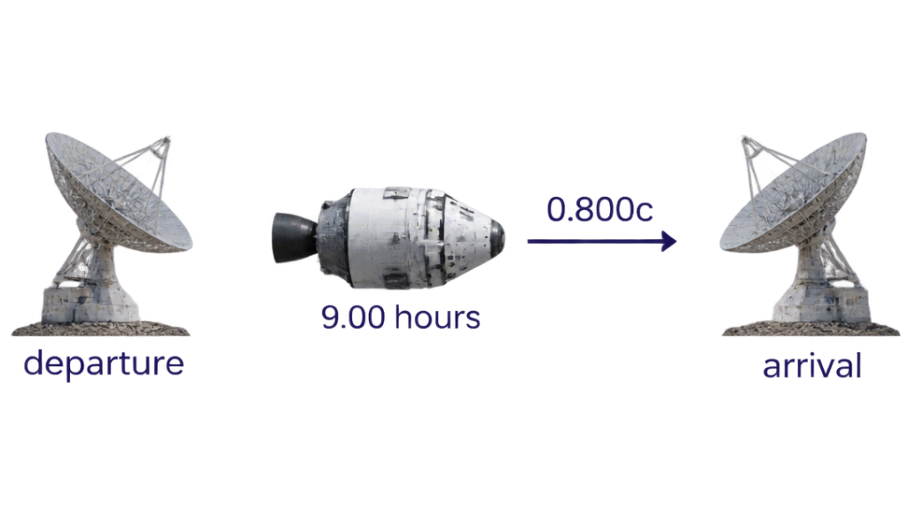
Question 13: Energy and mass [6 marks]
A reaction converts ​$2.00×{10}^{−9}$​ kg of mass into energy. Take ​$c=3.00×{10}^{8}$​ m s⁻¹. (a) Calculate the energy released. [3 marks] (b) If 25.0% of this energy is transferred to a device, determine the energy it receives. [3 marks]
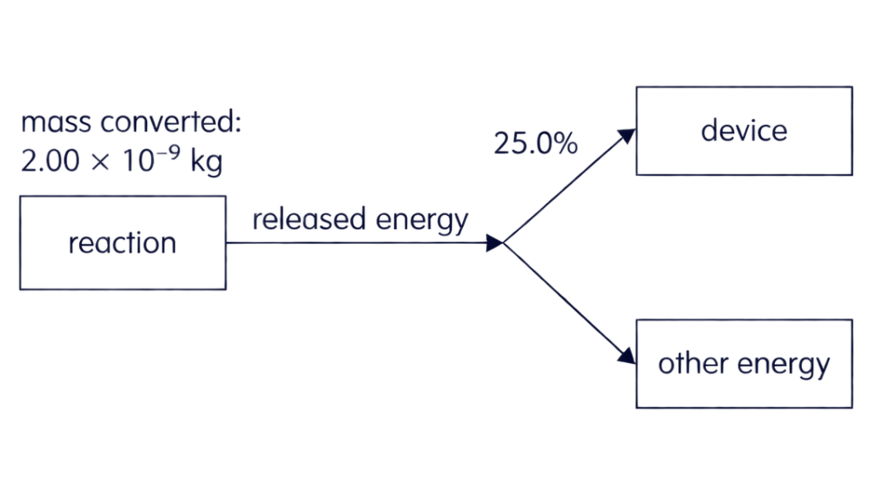
Question 14: Mass defect [6 marks]
A hypothetical reaction releases ​$7.20×{10}^{10}$​ J. Take ​$c=3.00×{10}^{8}$​ m s⁻¹. (a) Find the corresponding decrease in mass. [3 marks] (b) If 80.0% of the energy is captured over 40.0 s at a constant rate, find the useful power. [3 marks]
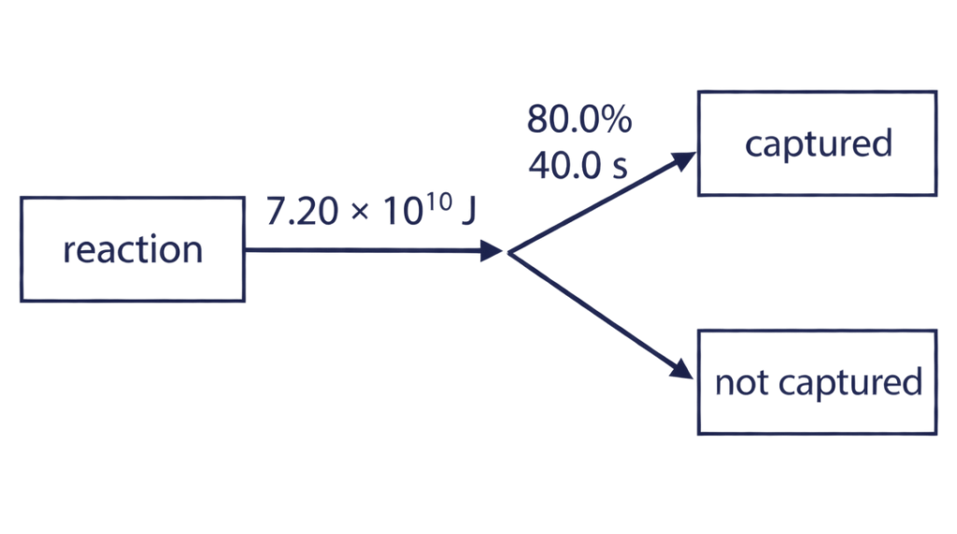
Question 15: Total and kinetic energy [6 marks]
A particle has rest energy 500 MeV and travels at ​$0.600c$​. (a) Calculate its Lorentz factor and total energy. [3 marks] (b) Calculate its kinetic energy in MeV and joules. Use ​$1$​ eV ​$=1.602×{10}^{−19}$​ J. [3 marks]
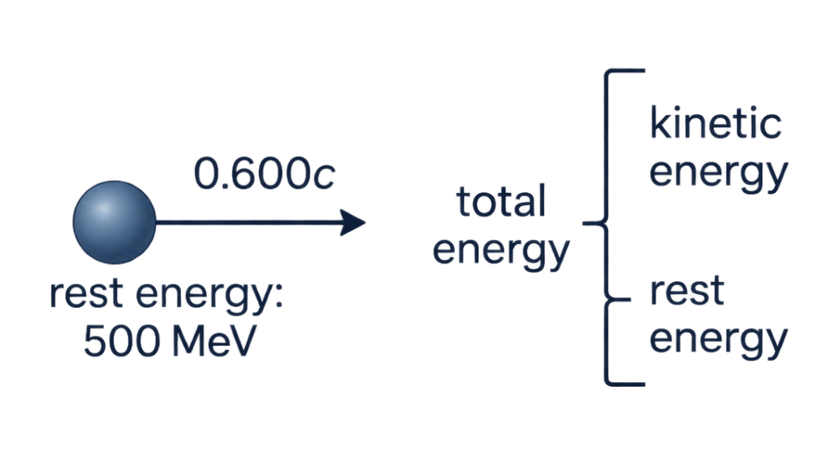
Question 16: Energy to speed [6 marks]
A particle has rest energy 200 MeV and total energy 400 MeV. (a) Determine its Lorentz factor and its speed as a fraction of ​$c$​. [4 marks] (b) Find its kinetic energy in MeV. [2 marks]
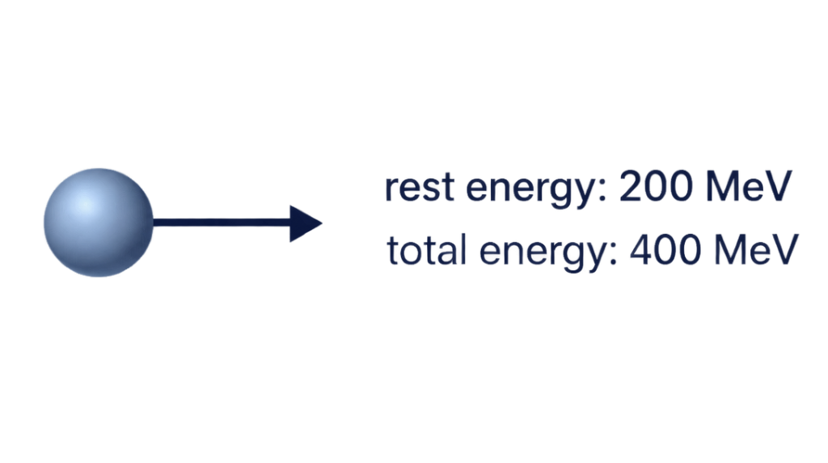
Question 17: Comparing particle energies [6 marks]
Identical particles A and B each have rest energy 100 MeV. A travels at ​$0.600c$​ and B at ​$0.800c$​. (a) Calculate the total energy of each particle. [4 marks] (b) Calculate the difference between their kinetic energies. [2 marks]
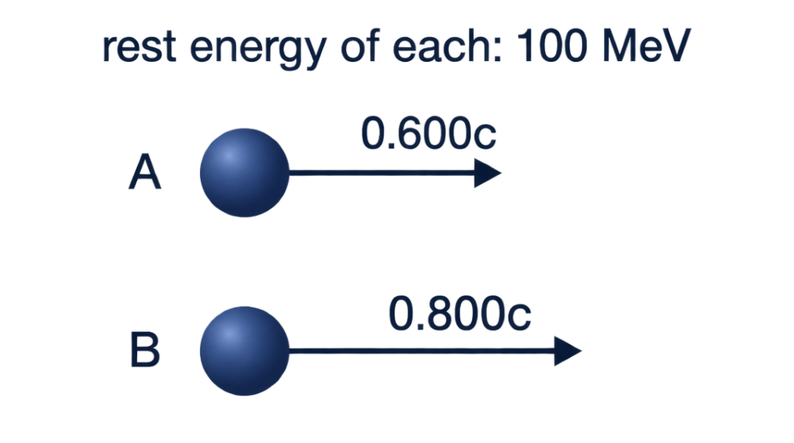
Question 18: Momentum and energy [6 marks]
A particle of rest mass ​$2.00×{10}^{−27}$​ kg travels at ​$0.600c$​. Take ​$c=3.00×{10}^{8}$​ m s⁻¹. (a) Calculate its relativistic momentum. [3 marks] (b) Calculate its kinetic energy in joules. [3 marks]
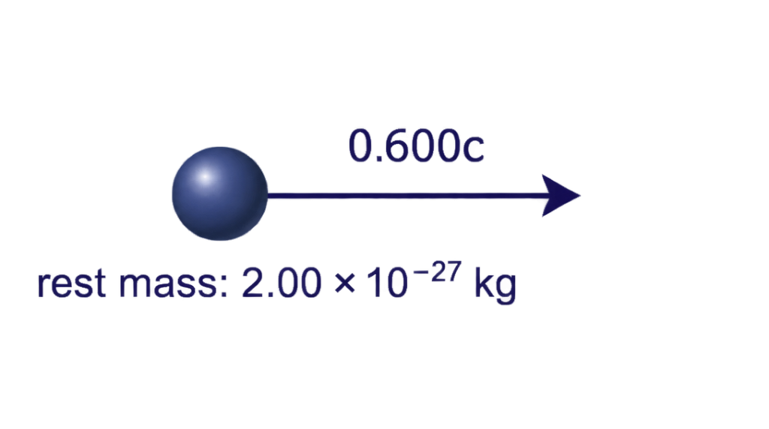
Question 19: Energy increase [6 marks]
A particle with rest energy 250 MeV is accelerated from ​$0.600c$​ to ​$0.800c$​. (a) Calculate its initial and final total energies. [4 marks] (b) Find the work done on the particle, assuming the change in kinetic energy equals the work done. [2 marks]
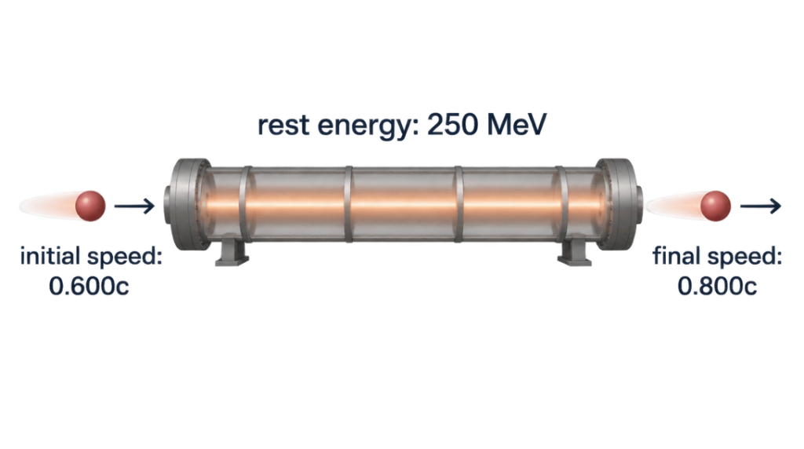
Question 20: Light-clock interpretation [6 marks]
In the rest frame of a light clock, a pulse travels vertically 3.00 m from one mirror to another at ​$c=3.00×{10}^{8}$​ m s⁻¹. The clock moves sideways at ​$0.800c$​ relative to a laboratory. (a) Find the one-way pulse travel time in the clock frame and laboratory frame. [4 marks] (b) Calculate the horizontal distance moved in the laboratory during this interval. [2 marks]
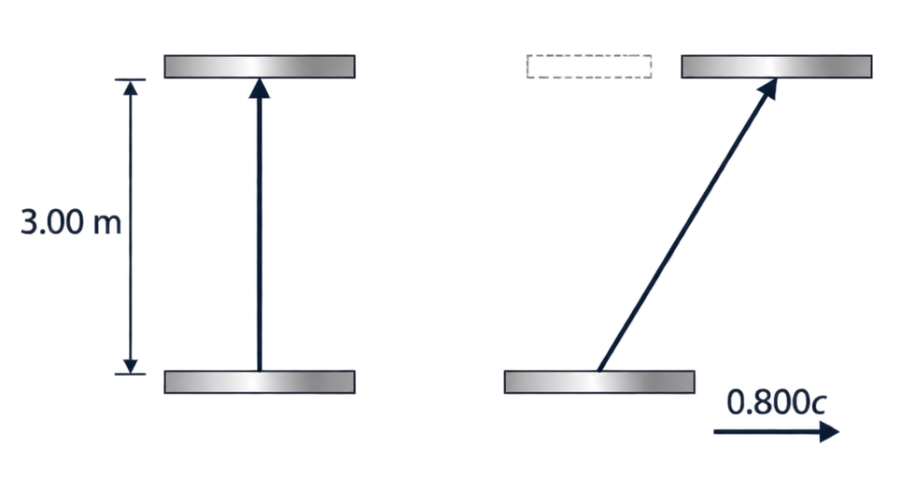
Question 21: A journey and a signal [6 marks]
A probe travels at ​$0.600c$​ from Earth to a station 3.00 light-years away, both endpoints at rest relative to Earth. On arrival it immediately sends a light signal back to Earth. (a) Find the probe's Earth-frame travel time and the return signal's travel time. [3 marks] (b) Find the time after departure when Earth receives the signal and the probe's elapsed journey time. [3 marks]
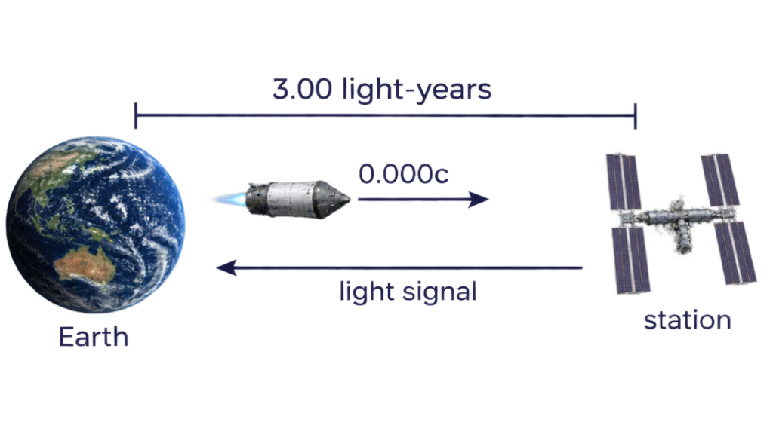
Question 22: Contracted distance and proper time [6 marks]
A vehicle travels at ​$0.600c$​ between two markers separated by 900 m in their rest frame. Take ​$c=3.00×{10}^{8}$​ m s⁻¹. (a) Calculate the travel time in the markers' frame and on the vehicle. [4 marks] (b) Calculate the separation of the markers in the vehicle frame. [2 marks]
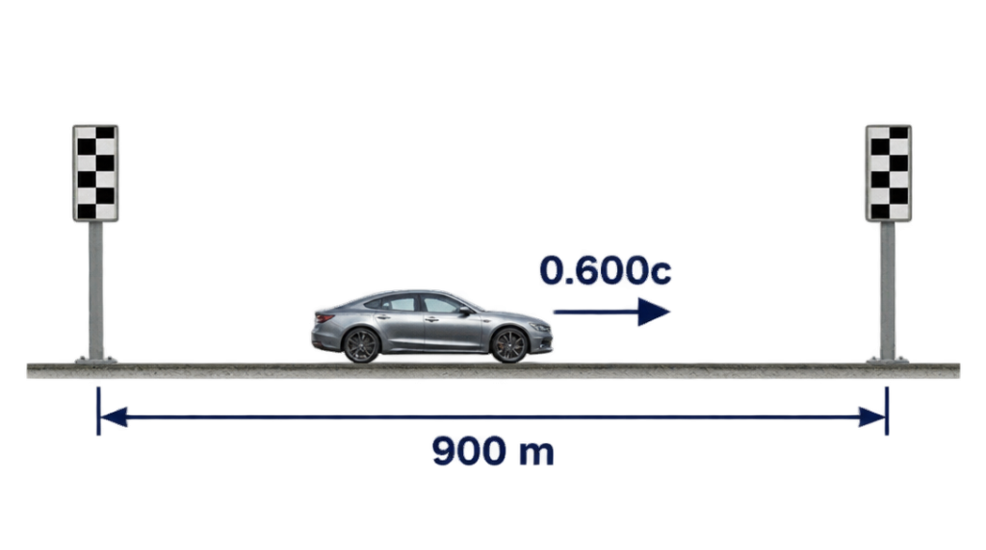
Question 23: Classical and relativistic momentum [6 marks]
A particle of rest mass ​$1.00×{10}^{−27}$​ kg travels at ​$0.800c$​. Use ​$c=3.00×{10}^{8}$​ m s⁻¹. (a) Calculate the classical momentum ​$mv$​ and the relativistic momentum. [4 marks] (b) Calculate the percentage by which the relativistic value exceeds the classical value. [2 marks]
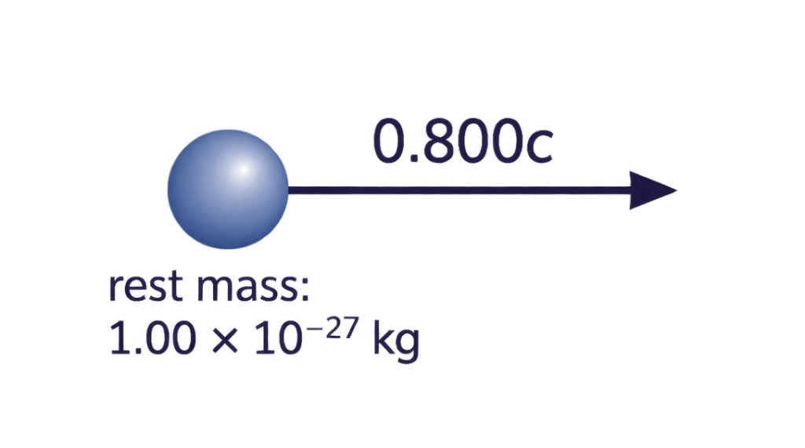
Question 24: Required speed [6 marks]
A spacecraft must cross a distance of 5.00 light-years in the station frame. Its onboard clock must record exactly 3.00 years for the journey. Assume constant speed. (a) Use the station-frame travel time and time dilation to show that ​$v/c=5/\sqrt{34}$​. [4 marks] (b) Calculate the speed as a fraction of ​$c$​ and the station-frame travel time. [2 marks]
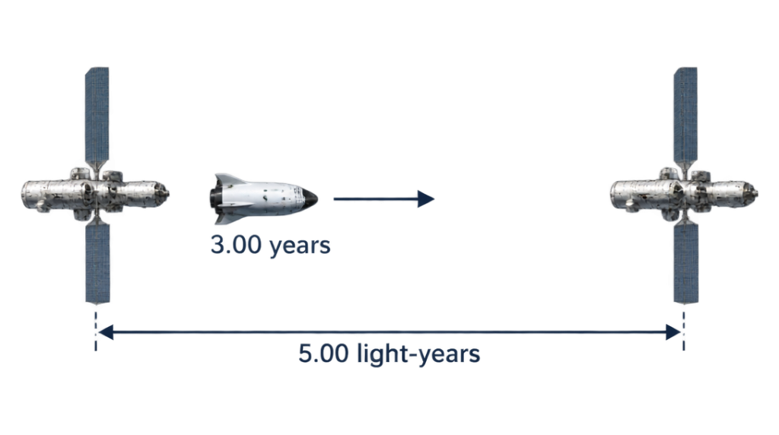
Question 25: Energy supplied to a particle [6 marks]
A particle initially at rest has a rest energy of 300 MeV. An accelerator gives it 450 MeV of kinetic energy. (a) Find its total energy and Lorentz factor. [3 marks] (b) Find its speed as a fraction of ​$c$​. [3 marks]
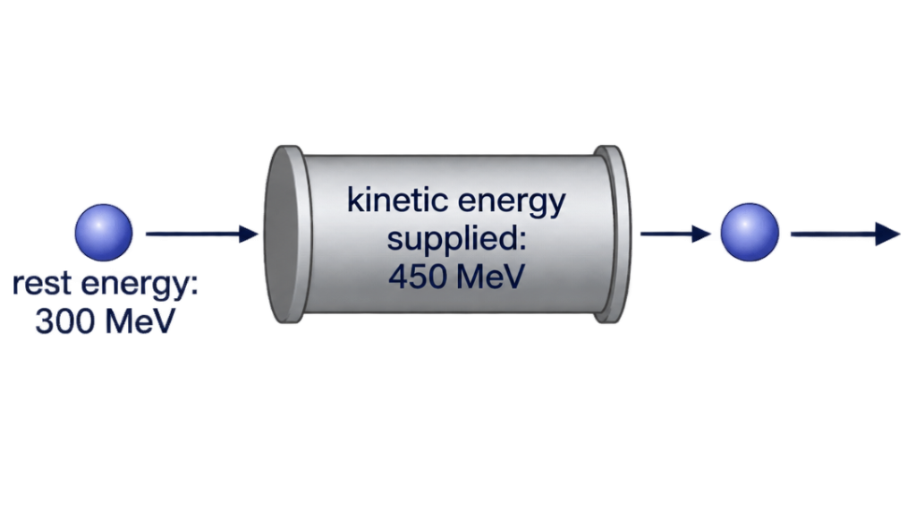

Answers
Question 1 Model Solution [10 marks total]
(a) Lorentz factor [2 marks]:
​$γ=\frac{1}{\sqrt{1−\frac{v^{2}}{c^{2}}}}=\frac{1}{\sqrt{1−(0.995)^{2}}}=\frac{1}{\sqrt{1−0.990025}}=\frac{1}{\sqrt{0.009975}}≈10.01$​ (or ​$10.0$​).
[1 mark for correct substitution into Lorentz formula; 1 mark for final value of ​$γ≈10.0$​].
(b) Classical mechanics prediction [2 marks]:
​$s=v×τ_{0}=(0.995×3.00×{10}^{8}{\text{ m s}}^{−1})×(2.20×{10}^{−6}\text{ s})=657\text{ m}=0.657\text{ km}$​.
The altitude is 15.2 mean travel distances. For exponential decay the surviving fraction is ​$e^{−15.2}≈2.5×{10}^{−7}$​, so virtually no muons reach the detector classically.
[1 mark for calculating the classical mean distance of 657 m; 1 mark for explaining why the survival fraction is negligible].
(c) Earth frame dilated lifetime and distance [3 marks]:
​$τ=γτ_{0}=10.01×(2.20×{10}^{−6}\text{ s})=2.20×{10}^{−5}\text{ s}$​ (​$22.0 μ\text{s}$​).
​$s=v×τ=(0.995×3.00×{10}^{8}{\text{ m s}}^{−1})×(2.20×{10}^{−5}\text{ s})=6.57×{10}^{3}\text{ m}=6.57\text{ km}$​ per lifetime.
Earth observers see the moving muon clock run slowly (time dilation). A substantial proportion of muons can traverse the ​$10.0\text{ km}$​ atmospheric path (​$10.0/6.57≈1.52$​ lifetimes, giving ​$≈22\%$​ transmission).
[1 mark for calculating dilated lifetime ​$22.0 μ\text{s}$​; 1 mark for calculating distance ​$6.57\text{ km}$​; 1 mark for linking time dilation to muon survival at ground level].
(d) Muon frame length contraction [3 marks]:
​$L=\frac{L_{0}}{γ}=\frac{10.0\text{ km}}{10.01}=0.999\text{ km}≈1.00\text{ km}$​ (​$999\text{ m}$​).
In the muon's frame of reference, the muon lives for its proper lifetime (​$2.20 μ\text{s}$​). However, the atmosphere moves towards the muon at ​$0.995c$​, so the distance to the surface is length-contracted from ​$10.0\text{ km}$​ to only ​$1.00\text{ km}$​. Since ​$1.00\text{ km}$​ is comparable to the distance travelled in one lifetime (​$0.657\text{ km}$​), muons readily reach the detector.
[1 mark for calculating contracted length ​$L≈1.00\text{ km}$​; 1 mark for stating muon experiences its proper lifetime; 1 mark for explaining that length contraction accounts for reaching the detector in this frame].
Question 2 Model Solution [9 marks total]
(a) Proper length and proper time identification [2 marks]:
Proper length (​$L_{0}$​): Measured by Earth observers, because the two endpoints (Earth and Proxima Centauri) are at rest relative to this frame of reference.
Proper time (​$t_{0}$​): Measured by the probe clock, because departure and arrival occur at the same spatial point within the probe's reference frame.
[1 mark for identifying and justifying proper length; 1 mark for identifying and justifying proper time].
(b) Travel time in Earth frame [2 marks]:
​$t=\frac{L_{0}}{v}=\frac{4.24\text{ ly}}{0.850\text{ c}}=4.988\text{ years}≈4.99\text{ years}$​ (​$1.57×{10}^{8}\text{ s}$​).
[1 mark for formula ​$t=L_{0}/v$​; 1 mark for correct answer with units: ​$4.99\text{ years}$​].
(c) Lorentz factor and probe time [3 marks]:
​$γ=\frac{1}{\sqrt{1−(0.850)^{2}}}=\frac{1}{\sqrt{1−0.7225}}=\frac{1}{\sqrt{0.2775}}≈1.898$​.
Since ​$t=γt_{0}$​, the proper time recorded by the probe clock is:
​$t_{0}=\frac{t}{γ}=\frac{4.988\text{ years}}{1.898}≈2.63\text{ years}$​ (​$8.29×{10}^{7}\text{ s}$​).
[1 mark for calculating ​$γ=1.90$​; 1 mark for proper time formula ​$t_{0}=t/γ$​; 1 mark for correct duration ​$2.63\text{ years}$​].
(d) Contracted distance aboard probe [2 marks]:
​$L=\frac{L_{0}}{γ}=\frac{4.24\text{ ly}}{1.898}=2.23\text{ ly}$​.
Consistency check: ​$s=v×t_{0}=0.850c×2.628\text{ years}=2.23\text{ ly}$​, which matches perfectly.
[1 mark for calculating contracted distance ​$2.23\text{ ly}$​; 1 mark for showing consistency using ​$v×t_{0}$​].
Question 3 Model Solution [8 marks total]
(a) Lorentz factor and proton speed [3 marks]:
Given ​$E_{\text{total}}=γE_{0}=3.20E_{0}$​, the Lorentz factor is ​$γ=3.20$​.
​$γ=\frac{1}{\sqrt{1−{\left(\frac{v}{c}\right)}^{2}}} ⟹ 1−{\left(\frac{v}{c}\right)}^{2}=\frac{1}{γ^{2}}=\frac{1}{{3.20}^{2}}=\frac{1}{10.24}≈0.09766$​.
​${\left(\frac{v}{c}\right)}^{2}=1−0.09766=0.90234 ⟹ \frac{v}{c}=\sqrt{0.90234}≈0.950$​.
Therefore, ​$v=0.950c=2.85×{10}^{8}{\text{ m s}}^{−1}$​.
[1 mark for stating ​$γ=3.20$​; 1 mark for algebraic rearrangement for ​$v/c$​; 1 mark for final velocity ​$v=0.950c$​ or ​$2.85×{10}^{8}{\text{ m s}}^{−1}$​].
(b) Relativistic momentum [3 marks]:
​$p=γm_{0}v=3.20×(1.673×{10}^{−27}\text{ kg})×(0.9499×3.00×{10}^{8}{\text{ m s}}^{−1})$​.
​$p=3.20×(1.673×{10}^{−27})×(2.850×{10}^{8})=1.53×{10}^{−18}{\text{ kg m s}}^{−1}$​.
[1 mark for formula ​$p=γm_{0}v$​; 1 mark for correct substitutions; 1 mark for evaluating ​$1.53×{10}^{−18}{\text{ kg m s}}^{−1}$​].
(c) Work done on the proton [2 marks]:
Work done equals the gain in kinetic energy:
​$W=E_{k}=E_{\text{total}}−E_{0}=(γ−1)E_{0}=(3.20−1)×938\text{ MeV}=2.20×938\text{ MeV}=2064\text{ MeV}≈2.06\text{ GeV}$​.
[1 mark for recognising ​$W=ΔE_{k}=(γ−1)E_{0}$​; 1 mark for calculating ​$2.06\text{ GeV}$​].
Question 4 [6 marks] (a) ​$γ=1/\sqrt{1−{0.600}^{2}}=1.25$​; ​$t=γt_{0}=1.25(12.0)=15.0$​ min. [3] (b) ​$d=vt=0.600(3.00×{10}^{8})(15.0×60)=1.62×{10}^{11}$​ m. [3]
Question 5 [6 marks] (a) ​$γ=1/\sqrt{1−{0.800}^{2}}=1.667$​; ​$t=1.667(4.00)=6.67$​ microseconds. [3] (b) ​$d=vt=0.800(3.00×{10}^{8})(6.67×{10}^{−6})=1.60×{10}^{3}$​ m. [3]
Question 6 [6 marks] (a) ​$γ=1.667$​ and ​$L=L_{0}/γ=120/1.667=72.0$​ m. [3] (b) ​$t=L/v=72.0/(0.800×3.00×{10}^{8})=3.00×{10}^{−7}$​ s. [3]
Question 7 [6 marks] (a) The clock measures proper time because both ticks occur at its location. ​$γ=1.25$​, so ​$t_{0}=25.0/1.25=20.0$​ s. [3] (b) ​$d=vt=0.600(3.00×{10}^{8})(25.0)=4.50×{10}^{9}$​ m. [3]
Question 8 [6 marks] (a) ​$t=L_{0}/v=6.00/0.800=7.50$​ years. [2] (b) ​$γ=1.667$​; ​$t_{0}=7.50/1.667=4.50$​ years and ​$L=6.00/1.667=3.60$​ light-years. [4]
Question 9 [6 marks] (a) ​$γ=t/t_{0}=10.0/8.00=1.25$​; ​$v/c=\sqrt{1−1/{1.25}^{2}}=0.600$​. [4] (b) ​$d=vt=0.600(3.00×{10}^{8})(10.0)=1.80×{10}^{9}$​ m. [2]
Question 10 [6 marks] (a) ​$γ=L_{0}/L=100/60.0=1.667$​; ​$v/c=\sqrt{1−1/{1.667}^{2}}=0.800$​. [4] (b) ​$t=L/v=60.0/(0.800×3.00×{10}^{8})=2.50×{10}^{−7}$​ s. [2]
Question 11 [6 marks] (a) ​$γ=1/\sqrt{1−{0.960}^{2}}=3.571$​; ​$t=3.571(2.20)=7.86$​ microseconds. ​$d=0.960(3.00×{10}^{8})(7.86×{10}^{−6})=2.26$​ km. [4] (b) ​$L=L_{0}/γ=2.00/3.571=0.560$​ km. [2]
Question 12 [6 marks] (a) ​$γ=1.667$​; ​$t=γt_{0}=1.667(9.00)=15.0$​ hours. [3] (b) ​$L_{0}=vt=0.800(15.0)=12.0$​ light-hours; ​$L=L_{0}/γ=7.20$​ light-hours. [3]
Question 13 [6 marks] (a) ​$E=Δmc^{2}=(2.00×{10}^{−9})(3.00×{10}^{8})^{2}=1.80×{10}^{8}$​ J. [3] (b) ​$E_{useful}=0.250(1.80×{10}^{8})=4.50×{10}^{7}$​ J. [3]
Question 14 [6 marks] (a) ​$Δm=E/c^{2}=(7.20×{10}^{10})/(3.00×{10}^{8})^{2}=8.00×{10}^{−7}$​ kg. [3] (b) ​$P=0.800E/t=0.800(7.20×{10}^{10})/40.0=1.44×{10}^{9}$​ W. [3]
Question 15 [6 marks] (a) ​$γ=1.25$​ and ​$E=γE_{0}=1.25(500)=625$​ MeV. [3] (b) ​$K=E−E_{0}=125$​ MeV ​$=125×{10}^{6}(1.602×{10}^{−19})=2.00×{10}^{−11}$​ J. [3]
Question 16 [6 marks] (a) ​$γ=E/E_{0}=400/200=2.00$​; ​$v/c=\sqrt{1−1/{2.00}^{2}}=0.866$​. [4] (b) ​$K=E−E_{0}=400−200=200$​ MeV. [2]
Question 17 [6 marks] (a) ​$γ_{A}=1.25$​, ​$E_{A}=1.25(100)=125$​ MeV; ​$γ_{B}=1.667$​, ​$E_{B}=1.667(100)=166.7$​ MeV. [4] (b) Because rest energies are identical, ​$ΔK=ΔE=166.7−125=41.7$​ MeV. [2]
Question 18 [6 marks] (a) ​$γ=1.25$​; ​$p=γmv=1.25(2.00×{10}^{−27})(0.600)(3.00×{10}^{8})=4.50×{10}^{−19}$​ kg m s⁻¹. [3] (b) ​$K=(γ−1)mc^{2}=0.250(2.00×{10}^{−27})(3.00×{10}^{8})^{2}=4.50×{10}^{−11}$​ J. [3]
Question 19 [6 marks] (a) ​$γ_{i}=1.25$​, ​$γ_{f}=1.667$​; ​$E_{i}=1.25(250)=312.5$​ MeV and ​$E_{f}=1.667(250)=416.7$​ MeV. [4] (b) ​$W=ΔK=E_{f}−E_{i}=104$​ MeV. [2]
Question 20 [6 marks] (a) ​$t_{0}=3.00/(3.00×{10}^{8})=1.00×{10}^{−8}$​ s. With ​$γ=1.667$​, ​$t=γt_{0}=1.67×{10}^{−8}$​ s. [4] (b) ​$x=vt=0.800(3.00×{10}^{8})(1.67×{10}^{−8})=4.00$​ m. [2]
Question 21 [6 marks] (a) ​$t_{probe}=3.00/0.600=5.00$​ years; ​$t_{light}=3.00/1=3.00$​ years. [3] (b) Earth receives the signal after ​$5.00+3.00=8.00$​ years; ​$t_{0}=5.00/1.25=4.00$​ years on the probe. [3]
Question 22 [6 marks] (a) ​$t=L_{0}/v=900/(0.600×3.00×{10}^{8})=5.00×{10}^{−6}$​ s; ​$t_{0}=t/1.25=4.00×{10}^{−6}$​ s. [4] (b) ​$L=L_{0}/γ=900/1.25=720$​ m. [2]
Question 23 [6 marks] (a) ​$p_{classical}=mv=(1.00×{10}^{−27})(0.800)(3.00×{10}^{8})=2.40×{10}^{−19}$​ kg m s⁻¹. With ​$γ=1.667$​, ​$p_{rel}=γmv=4.00×{10}^{−19}$​ kg m s⁻¹. [4] (b) Percentage increase ​$=(4.00−2.40)/2.40×100=66.7\%$​. [2]
Question 24 [6 marks] (a) Let ​$β=v/c$​. In years, ​$t=5/β$​ and ​$t_{0}=t\sqrt{1−β^{2}}=3$​. Squaring gives ​$9β^{2}=25(1−β^{2})$​, so ​$34β^{2}=25$​ and ​$β=5/\sqrt{34}$​. [4] (b) ​$v=0.857c$​ and ​$t=5/0.857=5.83$​ years. [2]
Question 25 [6 marks] (a) ​$E=E_{0}+K=300+450=750$​ MeV and ​$γ=E/E_{0}=750/300=2.50$​. [3] (b) ​$v/c=\sqrt{1−1/γ^{2}}=\sqrt{1−1/{2.50}^{2}}=0.917$​. [3]

