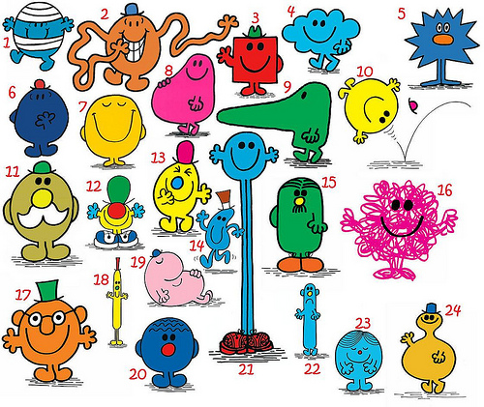
Classifying Mr Men
Each Mr Man has a unique characteristic that you could use to identify them
Mr Tickle | Mr Mischief | Mr Bump
Mr Forgetful | Mr Sneeze | Mr Happy
Mr Lazy | Mr Fussy | Mr Daydream
Mr Messy | Mr Strong | Mr Skinny
Mr Busy | Mr Clever
Create a Dichotomous Key to help others identify them

