It's all in the key

Scientists often classify objects or living things into groups by selecting features or characteristics that some of the things have and some that they don't have. The information that is used to classify these things is sometimes put into a key. These keys can then be used to decide which group an object or living thing belongs to or to find the identity of an unknown object or living thing.
The keys used below are called dichotomous keys because there are only two choices at each branch.
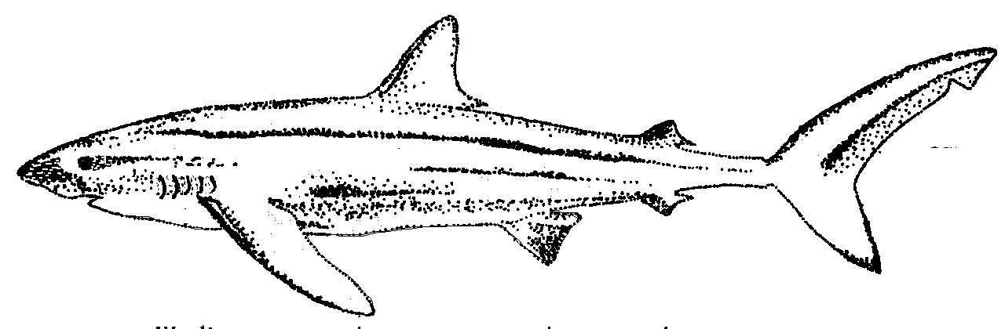
first dorsal fin
second dorsal fin
gill slits
pectoral fin
pelvic fin
anal fin
caudal fin

Part A. - Sharks!
Use the diagram of the shark and the branching dichotomous
key below to identify the sharks (A - G) drawn below:

Cat Shark
Goblin Shark
Fish with skeleton of cartilage
Body kite shaped when seen from above
Body not kite shaped
Small dorsal fin near tail tip
Pelvic fin present
True Skate
Devil Ray
Stingray
Six-gilled
Shark
Whale Shark
Six gill slits
Five gill slits
One dorsal fin
Two dorsal fins
Head not wider than body
Hammerhead Shark
Thresher Shark
Caudal fin regular length; nose long and pointed
Mackeral Shark
First dorsal fin shorter than pectoral fin
Two horn shaped parts on front of animal
Caudal fin almost as long as body
No horn shaped parts
Mouth on under side of head
Mouth at front of snout
Head wider than body
Caudal fin symmetrical
Caudal fin not symmetrical
No dorsal fin
A
B
C
Saw Shark
First dorsal fin longer than pectoral fin
No pelvic fin:
nose saw shaped

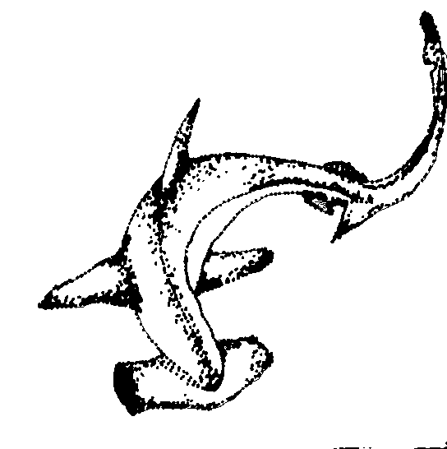

False Cat Shark

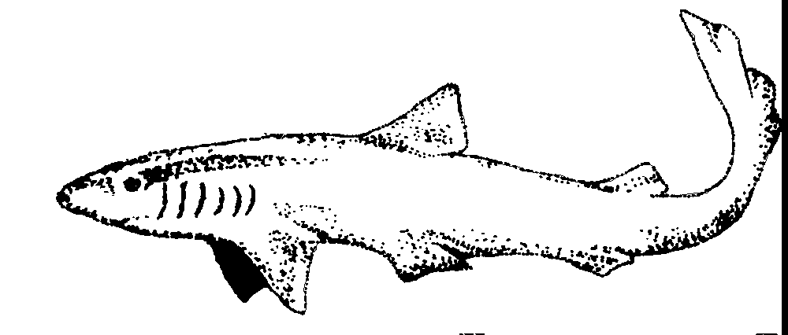

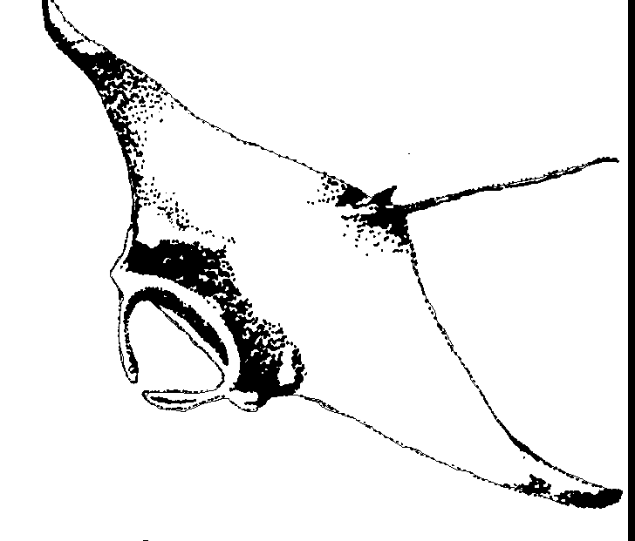

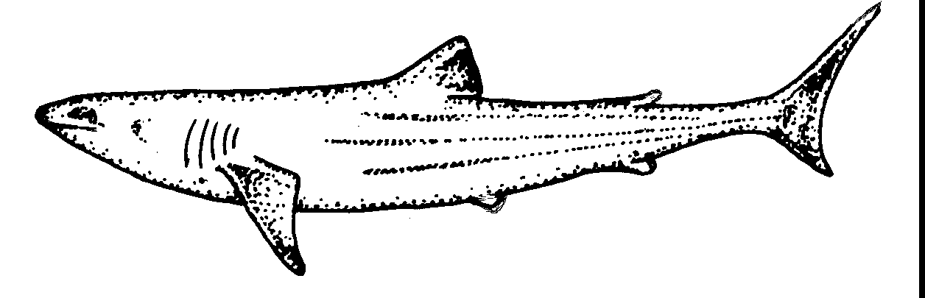
D

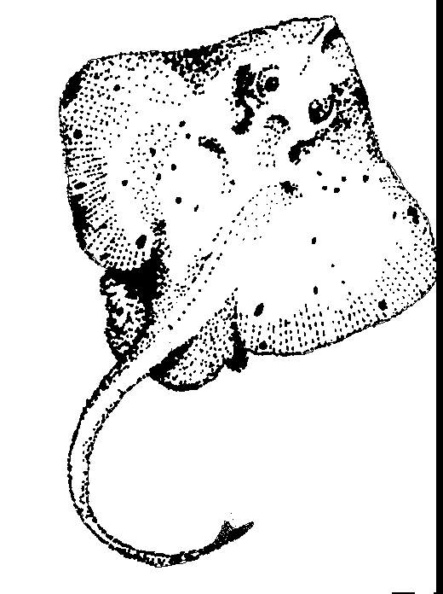
G

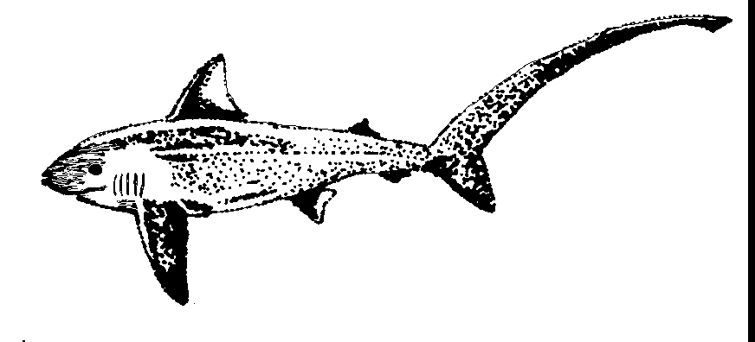
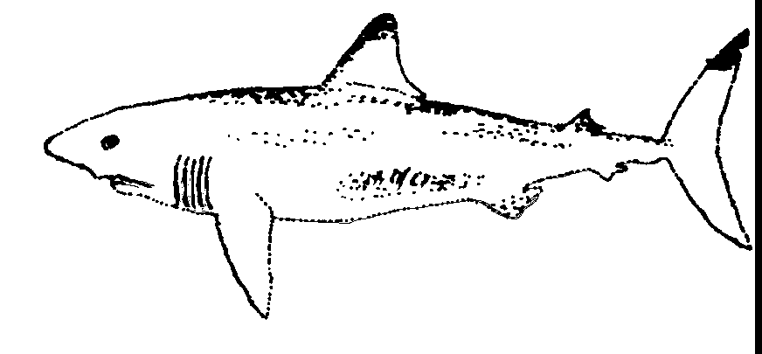
E
F

Part B. - Dinosaurs

Use the key below to name the dinosaurs shown:

Dinosaur key

1 Limbs used for flying ………………………………... Go to 2
Limbs not used for flying ……………………………. Go to 3
2 Long tail ……………………………………………….. Rhamodactyl (Ram-o-dak-tile)
Short tail ……………………………………………….. Pterodactyl (Tero-dak-tile)
3 Limbs used for swimming ……………………………. Go to 4
Limbs not used for swimming ………………………. Go to 5
4. Small head and long neck ……………………………. Plesiosaurs (Please-ee-o-saws)
Large head and short neck …………………………… Pliosaurs (Ply-o-saws)
5 All four limbs used for walking ……………………… Go to 6
Only hind limbs used for walking …………………… Go to 8
6 Long bony frill on head ……………………………… Go to 7
No frill on head ……………………………………….. Stegosaurus (Steg-o-saw-rus)
7 Large horns on head ………………………………….. Chasmosaurus (Chas-mo-saw-rus)
No horns on head …………………………………….. Protoceratops (Pro-toe-care-a-tops)
8 Bony helmets or crests on head ……………………. Saurolophus (Saw-ro-lo-fuss)
No bony projections on head ………………………. Go to 9
9 Large curved claw on foot …………………………… Deinonychus (Dine-on-eye-cus)
No large claw ………………………………………….. Tyrannosaurus (Tie-ran-no-saw-rus)

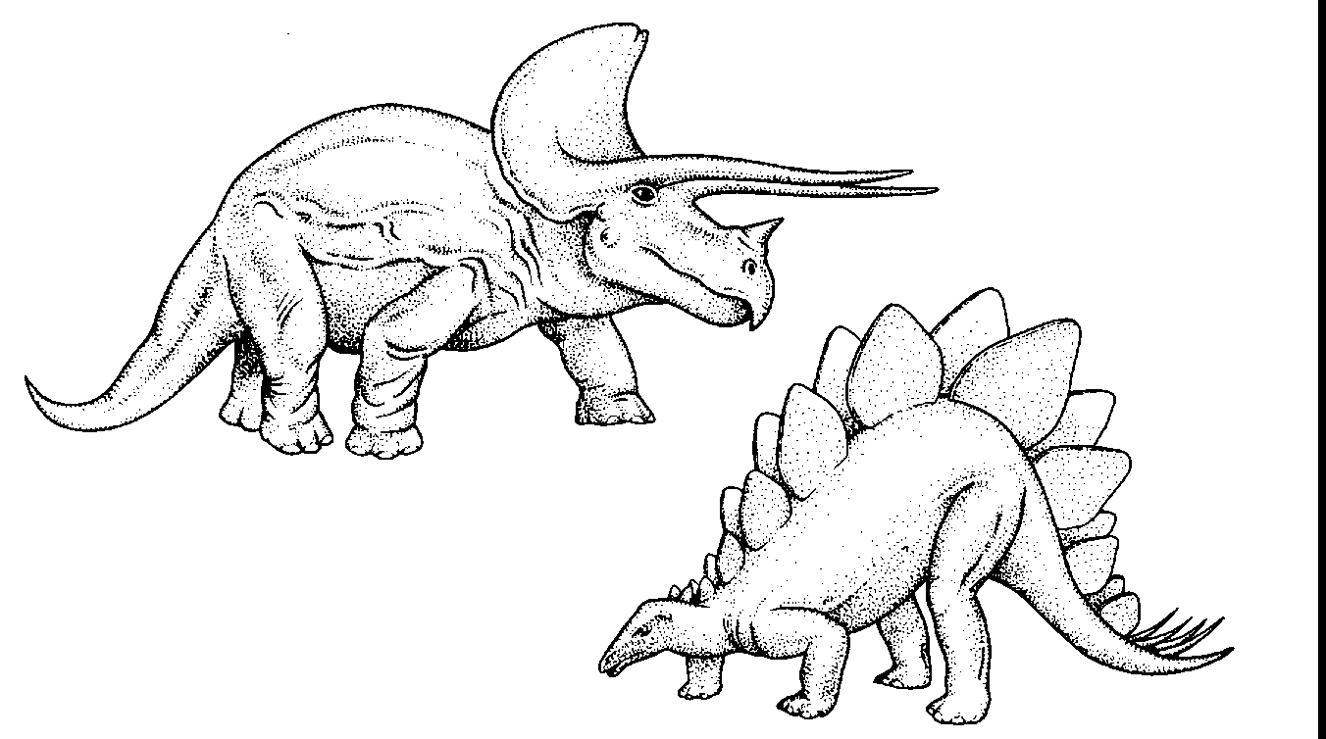
A

B

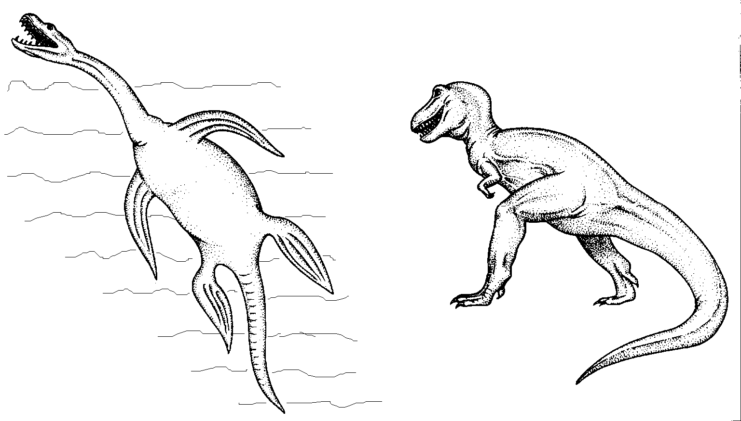

C
D

Part C. - Eight Powders

Obtain the eight powders labelled 1 - 8, from your teacher and then use the following sentence key to identify each powder.

Key to the eight powders 1 - 8
1. Is the powder white? | Yes - go to 2  No - go to 6
2. Is the powder soluble? | Yes - Glucose  No - go to 3
3. Does the powder bubble when acid is put on it? | Yes - Chalk  No - go to 4
4. Does iodine turn the powder blue-black? | Yes - Starch  No - go to 5
5. Does the powder dissolve in acid? | Yes - Calcium oxide  No - Aluminium oxide
6. Does the powder dissolve in acid to form a blue solution? | Yes - Copper oxide  No - go to 7
7. Is the powder yellow? | Yes - Sulfur  No - Charcoal

Substance 1. ...................................... Substance 2. ......................................
Substance 3. ...................................... Substance 4. ......................................
Substance 5. ...................................... Substance 6. ......................................
Substance 7. ...................................... Substance 8. ......................................

Part D. - White Powders

In this experiment you will use the key given below to identify six unknown white powders, A - F.

All white powders

Fizzes when react with acid
Does not fizz when added to acid

Fizzes when added
to water
Does not fizz when
added to water
Does not dissolve in water
Dissolves in water

Icing
sugar
Baking
powder
Turns iodine black
No colour
change with
iodine
Floats in water
Does not float
in water

Starch
Chalk
Baking
soda
Talc

Substance A ...................................... Substance B ......................................
Substance C ...................................... Substance D ......................................
Substance E ...................................... Substance F ......................................

Part E - Animals

Construct a branching dichotomous key (similar to the keys shown in Parts A and D) to identify the following animals:
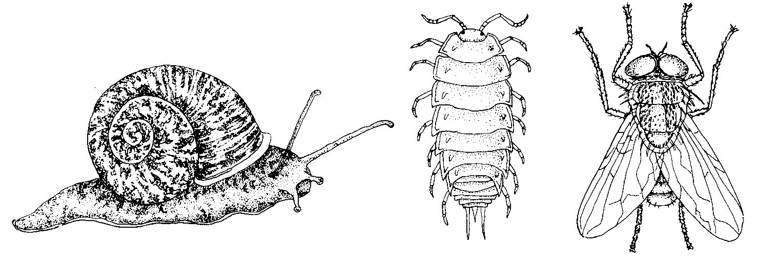

fly
snail

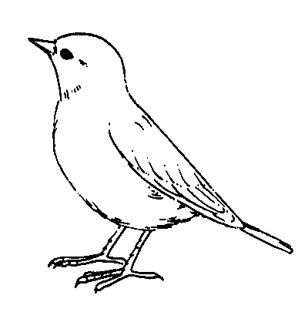
slater
bird
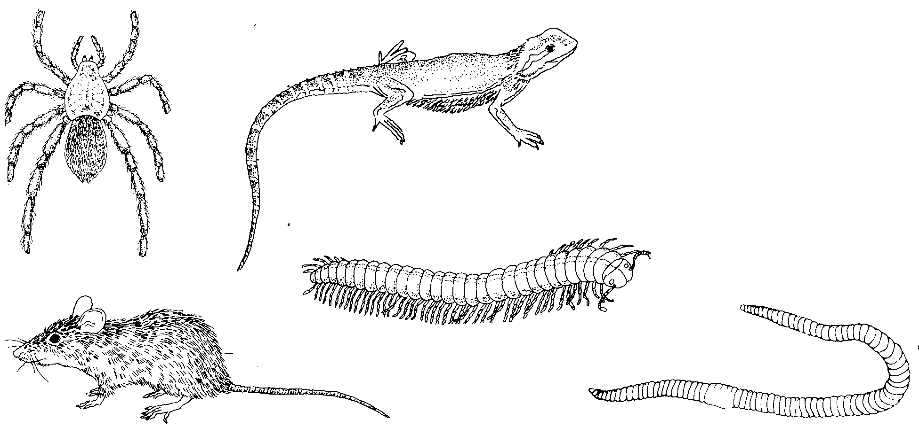

lizard
spider

earthworm
rat
millipede

