Cut out the diagrams below and arrange them in the correct order.
Complete the labels on the diagrams.

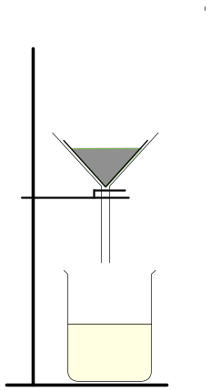 | 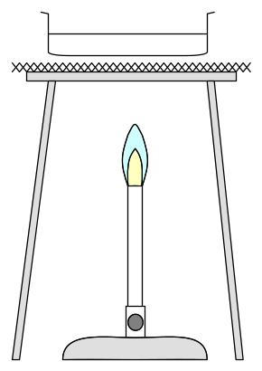
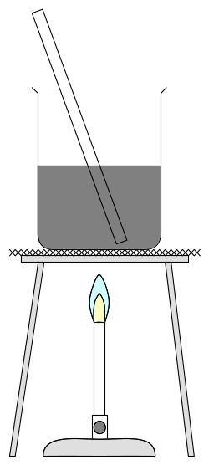 |  | 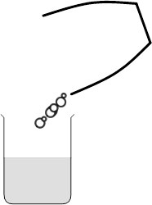

Labels:

filtrate | salt crystals | water
salt water | pestle and mortar | rock salt
Answers

Text copyright © Jackie Barns-Graham 2010
Published by Science iPS, a trading style of Andrew Hammond Ltd, Registered in England No. 07223183 www.science-ips.co.uk

