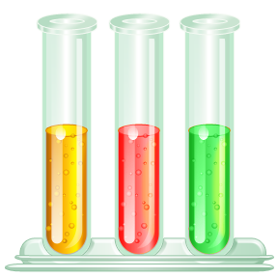
All substances should be labelled using the symbols below to show if they contain any chemicals that are hazardous.

Task 1
Use the words in the box below to label the hazard symbols.
explosives | long term health hazard | caution
flammable | oxidising | gases under pressure
toxic | corrosive | dangerous to the environment

- 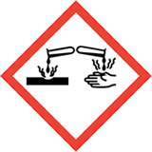 | - 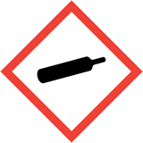 | - 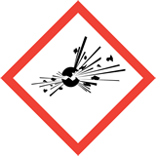
- 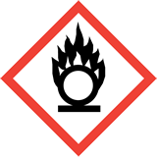 | - 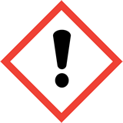 | - 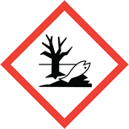
- 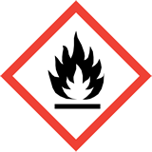 | - 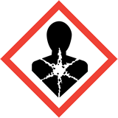 | - 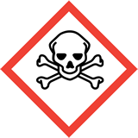
These symbols are part of the Globally Harmonised System (GHS) for labelling chemicals and were introduced into the UK recently to replace the old labelling system.
Why do you think it is important to have a global system for labelling chemicals?

Task 2
Below are statements associated with the potential hazards of some chemicals.
Consider which hazard symbols you would put in the labelling of these products. Write the numbers of the symbols from the chart above next to each statement.

1 | Kills fish in rivers
2 | Can burn a hole in wooden surfaces
3 | Causes an explosion in confined places
4 | Keep away from a naked flame
5 | Makes your eyes sting
6 | Do not swallow
7 | Can cause a mild rash
8 | Weed killer
9 | Use gloves when applying cleaner
10 | May intensify a fire
11 | Reacts violently with water
12 | Camping gas – store in a fireproof cupboard

Task 3

Do you think symbols alone would provide sufficient information on the label of a hazardous substance?

In the space below design a label for an everyday substance of your choice, e.g. hairspray, oven cleaner, furniture polish or bleach.

Think about what other information would be needed as part of the hazard labelling and present it clearly.

Compare your ideas with the label of the product you have chosen.

Answers

Task 1
1. Corrosive | 2. Gases under pressure | 3. Explosives
4. Oxidising | 5. Caution | 6. Dangerous to the environment
7. Flammable | 8. Long term health hazard | 9. Toxic

Why do you think it is important to have a global system for labelling chemicals?

Symbols can be understood everywhere / avoids confusion by having only one labelling system.

Task 2

1 | Kills fish in rivers | 6, 9
2 | Can burn a hole in wooden surfaces | 1
3 | Causes an explosion in confined places | 3
4 | Keep away from a naked flame | 7
5 | Makes your eyes sting | 5
6 | Do not swallow | 9
7 | Can cause a mild rash | 5
8 | Weed killer | 9, 1
9 | Use gloves when applying cleaner | 1
10 | May intensify a fire | 4
11 | Reacts violently with water | 3, 7
12 | Camping gas – store in a fireproof cupboard | 2, 7

Task 3

Open ended answers.

