Cut out the statements and sort them into the correct positions in the Venn diagram.

They fill their container completely. | Mercury, water and milk at room temperature. | When cooled, particles vibrate less and take up less room.
They contract  when cooled. | Particles are very far apart. | Particles are  randomly arranged.
Particles are close  together. | Particles can move around each other. | Particles move very fast  in all directions.
Particles vibrate and are arranged in a regular pattern. | They can flow. | They expand  when heated.
Strong forces called ‘bonds’ hold particles close together. | Particles can diffuse. | Cannot be  compressed.

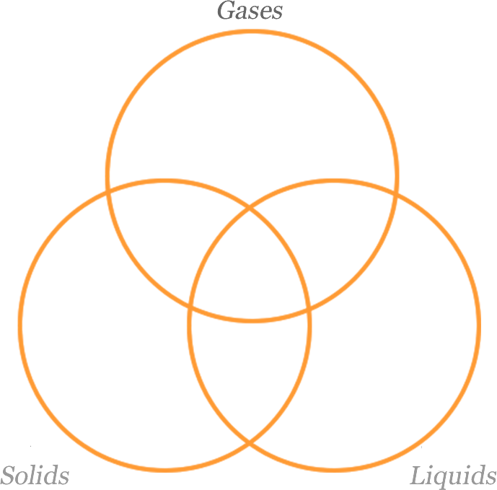
Gases

Answers

Solids | When cooled, particles vibrate less and take up less room. | Strong forces called ‘bonds’ hold particles close together. | Particles vibrate and are arranged in a regular pattern.
Liquids | Mercury, water and milk at room temperature. | Particles can move around each other.
Gases | They fill their container completely. | Particles are very far apart. | Particles move very fast in all directions.
Solids and liquids | Particles are close together. | Cannot be compressed.
Liquids and gases | They can flow. | Particles can diffuse. | Particles are randomly arranged.
Gases and solids
Solids, liquids and gases | They expand when heated. | They contract when cooled.

