Imagine a clear plastic bag, or a balloon or a bubble, filled with water. Inside you push a squash ball, a few dried beans and some cling film, all scrunched up. You have made a model of a typical animal cell. Add a few dried peas, a smaller balloon, squeeze the whole lot into a cardboard box and you have a typical plant cell!

However, most animal and plant cells do not look like typical cells because they have special jobs to do. Think of the Olympics and the competitors for each sport: a cyclist looks different from a weightlifter; a basketball player would not make a very good gymnast!

Different cells have different jobs. In plants, palisade cells, found in the upper part of leaves, are green. The green colour is due to chlorophyll, a chemical essential for photosynthesis. The job of a leaf cell is to produce glucose from carbon dioxide and water using energy from the sun. A root hair cell is long and thin. This gives it a large surface area. Its job is to absorb water and minerals from the soil. Stomata are formed from two curved cells, rather like your lips. They can move to create an opening between them. This enables air to move in and out of the leaf.

Animals too have a wide variety of cells. Sperm cells resemble tadpoles: both have long, lashing tails to help them swim. Sperm cells have plenty of mitochondria. Mitochondria provide energy for the long swim to the egg cell. The role of a sperm cell is to fertilise an egg. Under a microscope, nerve cells look like trees in winter. At one end, surrounding the nucleus, are lots of ‘branches’. There is a long, thin ‘trunk’ ending in a cluster of ‘roots’.
The function of a nerve cell is to receive and pass on messages, in the form of electrical signals, to different parts of the body. Red blood cells are shaped like ‘donut’ peaches. They do not have a nucleus because they are designed to carry as much oxygen as possible. They are packed with a special, oxygen-carrying molecule called haemoglobin.

- Use a blue pen to highlight all the words which identify a type of cell. | 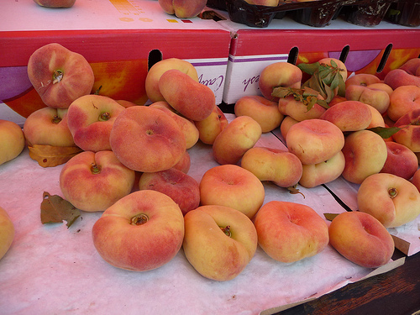  ‘Donut’ peaches  © Bev Sykes 2012 http://www.flickr.com/photos/basykes/7513209784/
- Now, using a green pen, highlight all the phrases which identify the structure of each cell (i.e. what it is made of).
- Next, use a red pen to highlight all the phrases which describe a cell’s function (i.e. what it does).
- Finally, write a sentence about each cell (blue word) which explains the link between the structure (green phrase) of the cell and its function (red phrase), using the word ‘because’ as the link word.
E.g. Sperm cells have long, lashing tails because they need to swim to the egg to fertilise it.

Suggested answers

Imagine a clear plastic bag, or a balloon or a bubble, filled with water. Inside you push a squash ball, a few dried beans and some cling film, all scrunched up. You have made a model of a typical animal cell. Add a few dried peas, a smaller balloon, squeeze the whole lot into a cardboard box and you have a typical plant cell!

However, most animal and plant cells do not look like typical cells because they have special jobs to do. Think of the Olympics and the competitors for each sport: a cyclist looks different from a weightlifter; a basketball player would not make a very good gymnast!

Different cells have different jobs. In plants, palisade cells, found in the upper part of leaves, are green. The green colour is due to chlorophyll, a chemical essential for photosynthesis. The job of a leaf cell is to produce glucose from carbon dioxide and water using energy from the sun. A root hair cell is long and thin. This gives it a large surface area. Its job is to absorb water and minerals from the soil. Stomata are formed from two curved guard cells, rather like your lips. They can move to create an opening between them. This enables air to move in and out of the leaf.

Animals too have a wide variety of cells. Sperm cells resemble tadpoles: both have long, lashing tails to help them swim. Sperm cells have plenty of mitochondria. Mitochondria provide energy for the long swim to the egg cell. The role of a sperm cell is to fertilise an egg. Under a microscope, nerve cells look like trees in winter. At one end, surrounding the nucleus, are lots of ‘branches’. There is a long, thin ‘trunk’ ending in a cluster of ‘roots’. The function of a nerve cell is to receive and pass on messages, in the form of electrical signals, to different parts of the body. Red blood cells are shaped like ‘donut’ peaches. They do not have a nucleus because they are designed to carry as much oxygen as possible. They are packed with a special, oxygen-carrying molecule called haemoglobin.

- Palisade cells contain chlorophyll because it is essential for photosynthesis.

- Palisade cells are green because they contain chlorophyll which helps the cell produce glucose from carbon dioxide and water during photosynthesis.

- Root hair cells are long and thin which gives the cell a large surface area, because these cells have to absorb water and minerals.

- Guard cells are two curved cells which can move to create an opening and this allows air to move in and out of the leaf.

- Sperm cells have long, lashing tails because they need to swim to the egg to fertilise it.

- Sperm cells have lots of mitochondria because they need energy to swim.

- Nerve cells have lots of branches because they need to send messages to different parts of the body.

- Red blood cells do not have a nucleus because they need to carry as much oxygen as possible.

- Red blood cells are packed with haemoglobin because their job is to carry oxygen around the body.

