Task

Match each cell with its name, role and special adaptation.

Diagram | Type of cell | Role | Adaptation
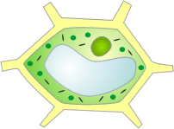

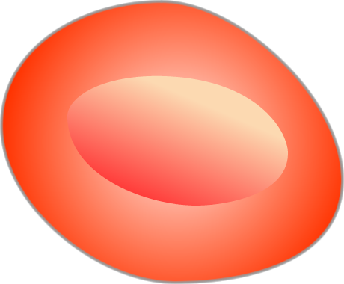
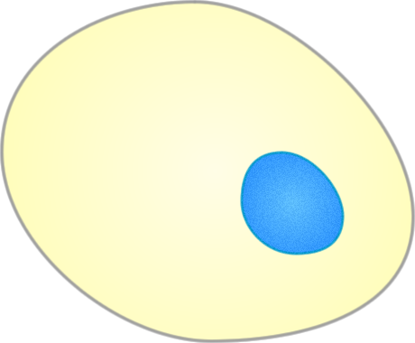

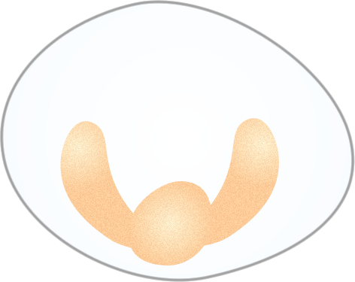

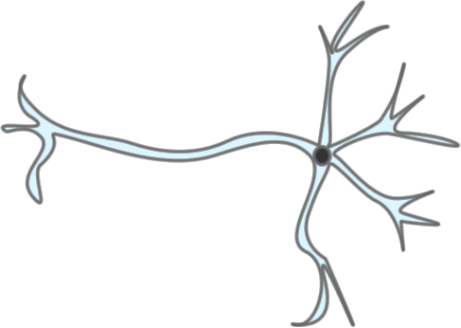

photosynthesis | sending messages | tail for swimming | protection
egg | reproduction | xylem | white blood
carrying oxygen | very long and branched | nerve | mobile
contains haemoglobin | nutrient rich cytoplasm | support | lots of chloroplasts
red blood | long and thin | absorbing water | reproduction
hollow tubes | palisade | sperm | root hair

Answers

Diagram | Type of cell | Role | Adaptation
 | palisade | photosynthesis | lots of chloroplasts
 | sperm | reproduction | tail for swimming
 | red blood | carrying oxygen | contains haemoglobin
 | egg | reproduction | nutrient rich cytoplasm
 | xylem | support | hollow tubes
 | white blood | protection | mobile
 | root hair | absorbing water | long and thin
 | nerve | sending messages | very long and branched

