This activity outlines the flow of energy through a woodland ecosystem. It involves Maths and Design.

Every year 6.3 x 10⁶ KJ/m² of energy from the sun reaches a woodland ecosystem.

A small amount of this energy is absorbed by plants during photosynthesis.
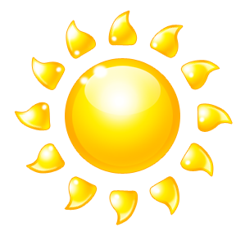
Over the year, 2000 KJ/m² of the energy absorbed by the plants is lost into their surroundings. However, 8000 KJ/m² is used by the plants for growth.

- What type of plants do you think these are? Can you name any? Make a list.

2. What is the total amount of energy absorbed by the plants each year?

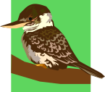
Over the twelve month period herbivorous birds consume 300 KJ/m² from the plants. They do this by eating leaves, fruits and seeds.

Of this 300 KJ/m², only 3 KJ/m² is used by the birds to grow. The remaining 297 KJ/m² is lost into their surroundings.

3. How is this energy lost to their surroundings? (Think of yourselves on a cold winter’s day.)

4. How efficient are birds at converting the energy they consume into new growth?


Herbivorous mammals consume 500 KJ/m².
They use 5 KJ/m² for growth and lose 495 KJ/m² to their surroundings.

Herbivorous invertebrates consume 1200 KJ/m².
They use 190 KJ/m² for growth and lose 1010 KJ/m².

5. Which type of herbivore is most efficient at converting the energy it consumes into growth? Why do you think this is?

6. What percentage of the plant’s annual growth is consumed by herbivorous animals?


Thrushes are birds which prey on invertebrates. Each thrush’s territory extends beyond the area of woodland in this example.

7. Why do you think each thrush needs such a large territory?

8. The information about energy flow through a woodland ecosystem is difficult to visualise when presented in this way.

Can you design a more effective method of presenting the information in this example?
What extra information or data (not given in this activity) might help enhance and extend your work?

Answers

- What type of plants do you think these are? Can you name any?

Any trees, e.g. oak, beech, ash etc.; smaller shrubs and plants of the
woodland floor, e.g. bluebell, bramble, grasses etc.

- What is the total amount of energy absorbed by the plants each year?

2000 + 8000 = 10 000 KJ/m²

- How is this energy lost into their surroundings?

Heat, excretion, movement, through reproduction.

- How efficient are birds at converting the energy they consume into new growth?

3/300 x 100 = 1%

- Which type of herbivore is most efficient at converting the energy it consumes into growth?

Mammals: 5/500 x 100 = 1%
Invertebrates: 190/1200 x 100 = 15.8%

Why do you think this is?

Invertebrates are more efficient because they do not use energy to maintain their body temperature.

- What percentage of the plant’s annual growth is consumed by herbivorous animals?

300+500+1200 = 2000
2000/10 000 x 100 = 20%

- Why do you think each thrush needs such a large territory?

The area of woodland in this example does not support enough invertebrates for a thrush to meet its own energy requirements.

- Can you design a more effective method of presenting the information in this example?

A food chain or flow chart with arrows, which includes the energy data.

What extra information or data (not given in this activity) might help enhance and extend your work?

Secondary consumers
The area of woodland
Energy lost through death and decomposition

