Science is about looking at the world around you and trying to understand why things are as they are. Scientists have been asking questions and looking for answers for centuries. They still are!

On this sheet you are asked to follow through what is called ‘the scientific method’ when trying to answer a question:

Hypothesis

You will have some ideas that might answer this question and explain what is happening. Write one idea below. This idea together with a possible explanation is your hypothesis. Hypotheses should be testable.

How will you test if your idea is correct?

Write down, briefly, what you could do to see if your idea is right.

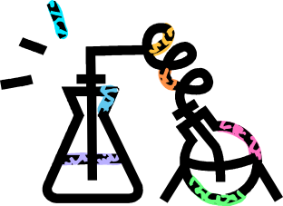

Prediction

What do you predict will be the outcome of your experiment? This is your prediction. Predictions do not need to have an explanation.

Testing

Scientists carry out an experiment to prove or disprove their ideas.
Think about how you would carry out the experiment.
Discuss what your method will be? Is it a fair test?

Fair testing

To be sure that the test is fair you should only change one thing this is known as the independent variable.
The thing that you measure is called the dependent variable.

What is the independent variable in your experiment?

Which other variables will you control (keep the same)?

What is the dependent variable in your experiment?

Write a numbered list of instructions to describe this method. Include a diagram of any apparatus you need to use.

Conclusion

When you have performed your experiment you will have to decide whether or not your hypothesis is right. Did your experiment work out as you predicted? This is your conclusion.

You may need to go back to the drawing board and test out some new ideas. When you find an idea that’s correct you have discovered something new for yourself. This is how scientists add knowledge for everyone to benefit from.

Evaluation

How could improve your experiment if you were to do it again?

Lastly, think of another question you would like to investigate and write about it here.

Teaching notes

The resource is designed to be used as a scaffold to help guide students through the scientific process. It can be used to plan an investigation for any appropriate question.

The questions could be teacher or student generated and relevant to the topic they are studying e.g. is sugar more difficult to dissolve than salt?, do sugar lumps dissolve quicker than granulated sugar?, etc.

Students in a class could investigate different questions and present their findings to the rest of the class.

