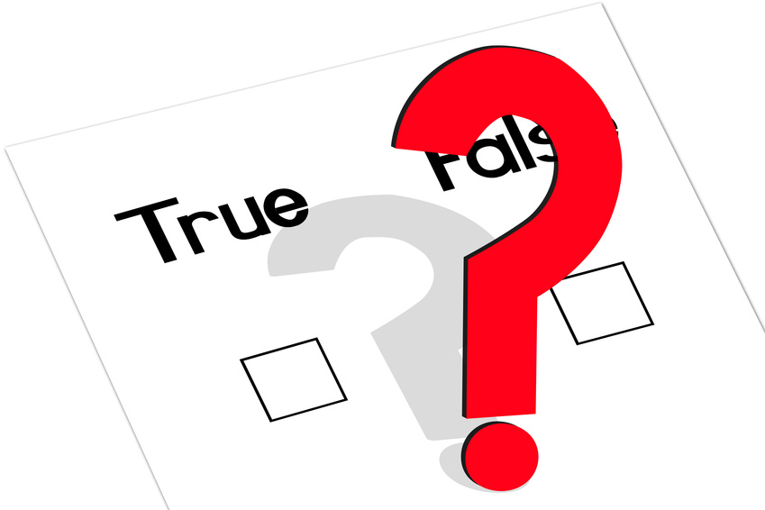
Task

Complete the last column using T/F to indicate whether the statement is true or false.
Use the space below each false statement to rewrite it.

Statement | T/F?
- A molecule is a small group of atoms joined together.
- Compounds are different types of atoms joined together.
- Neutrons have a negative charge.
- Compounds do not usually behave like the elements they contain.
- In symbols representing elements, the second letter is always a capital letter.
- In pure substances the atoms are all the same type.
- The periodic table is a list of all known compounds.

- Iron, potassium and calcium are metal elements.
- Electrons are found in the nucleus of an atom.
- Atoms are made of protons, neutrons and electrons.
- Most of the mass in an atom is in its electrons.
- The centre of an atom is called the neutron.
- Sodium chloride is a common element.
- Protons are so small that chemists say they have no mass.
- An atom is the smallest part of an element that can exist and still behave like the element.

Answers

Statement | T/F?
- A molecule is a small group of atoms joined together. | T
- Compounds are different types of atoms joined together. | T
- Neutrons have a negative charge.  Neutrons have no charge. | F
- Compounds do not usually behave like the elements they contain. | T
- In symbols representing elements, the second letter is always a capital letter.  In symbols representing elements, the second letter is always a small letter. | F
- In pure substances the atoms are all the same type.  In pure substances the particles, which can be atoms or molecules, are all the same type. | F
- The periodic table is a list of all known compounds.  The periodic table is a list of all known elements. | F
- Iron, potassium and calcium are metal elements. | T
- Electrons are found in the nucleus of an atom.  Electrons are found in the shells of an atom. / Electrons orbit the nucleus of an atom. | F
- Atoms are made of protons, neutrons and electrons. | T
- Most of the mass in an atom is in its electrons.  Most of the mass in an atom is in its nucleus, which is made up of protons and neutrons. | F
- The centre of an atom is called the neutron.  The centre of an atom is called the nucleus. | F
- Sodium chloride is a common element.  Sodium chloride is a common compound. | F
- Protons are so small that chemists say they have no mass.  Protons are small and chemists say they have a relative mass of 1. | F
- An atom is the smallest part of an element that can exist and still behave like the element. | T

