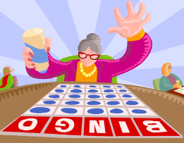
Teaching notes

A bingo activity with a slightly different slant on the traditional game.

Students write down six numbers between one and fifteen.

Ask the students questions from below. Choose a student to answer each question. When a student gets the answer correct they choose a number and all the students with that number cross it off their list.

The first student to cross out all their numbers is the winner.
These questions can be used as they are, as a general overview of the topic covered so far, or you can differentiate them to suit the ability of your class.

How does light travel? | At high speeds, in straight lines.
Which is faster, thunder or lightning? | Lightning.
What is the speed of light? | 300 000 km/s
What are formed because light cannot travel through opaque objects? | Shadows.
What do we call materials that allow all light to pass through them? | Transparent.
What is the simplest type of camera? | Pinhole camera.
What is the name of the part of the eye that allows light to pass through? | Pupil.
Give one similarity between the way cameras and eyes work. | They both need light; in both the image forms upside down; both have a lens.
What is the name given to a flat mirror? | Plane.
What is the relationship between the angle of incidence and the angle of reflection? | They are equal.
If you move an object further away from a mirror, what happens to its reflection? | The image moves further away.
The change of direction of light when it enters a different substance is called what? | Refraction.
Name the two types of lens. | Concave and convex.
Name the colours of the spectrum. | Red, orange, yellow, green, blue, indigo and violet.
Why is a rainbow curved? | Because the raindrops that create it are curved.
What colour light would a green filter allow to pass through it? | Green.
What piece of equipment can be used to refract separate white light into the spectrum? | Prism.

