Cut out the statements and put them in the correct order.
- How we hear
The impulse travels along the auditory nerve to the brain.
The pinna directs the waves into the ear canal.
This in turn makes the small bones vibrate.
The hairs on the cochlea turn the wave into an electrical impulse.
Sound waves travel through the air.
The small bones make the cochlea vibrate.
The waves make the ear drum vibrate.

The cornea bends (refracts) the light rays as they enter the eye.
The optic nerve carries the electrical impulse from the eye to the brain.
The iris controls the size of the pupil and the amount of light let in.
Light rays travel through the air.
The light rays are bent (refracted) by the lens.
The light rays pass through the pupil.
The image is focused on the retina, which contains light receptor cells.
- How we see
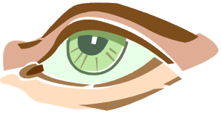
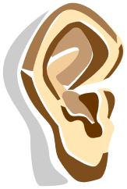
Answers

- How we hear
Sound waves travel through the air.
The pinna directs the waves into the ear canal.
The waves make the ear drum vibrate.
This in turn makes the small bones vibrate.
The small bones make the cochlea vibrate.
The hairs on the cochlea turn the wave into an electrical impulse.
The impulse travels along the auditory nerve to the brain.

- How we see

Light rays travel through the air.
The cornea bends (refracts) the light rays as they enter the eye.
The iris controls the size of the pupil and the amount of light let in.
The light rays pass through the pupil.
The light rays are bent (refracted) by the lens.
The image is focused on the retina, which contains light receptor cells.
The optic nerve carries the electrical impulse from the eye to the brain.

Answers

- How we hear
Sound waves travel through the air.
The pinna directs the waves into the ear canal.
The waves make the ear drum vibrate.
This in turn makes the small bones vibrate.
The small bones make the cochlea vibrate.
The hairs on the cochlea turn the wave into an electrical impulse.
The impulse travels along the auditory nerve to the brain.

- How we see

Light rays travel through the air.
The cornea bends (refracts) the light rays as they enter the eye.
The iris controls the size of the pupil and the amount of light let in.
The light rays pass through the pupil.
The light rays are bent (refracted) by the lens.
The image is focused on the retina, which contains light receptor cells.
The optic nerve carries the electrical impulse from the eye to the brain.

