Introduction

Want a blank diagram that you can adapt? Add your own labels (or ask the students to do it).

1 | Model gut – Visking tubing
2 | Diffusion of gases
3 | Root hair
4 | Osmosis
5 | Palisade cells
6 | Leaf cross section
7 | Blood vessel close to gut
8 | Gas exchange alveolus
9 | Bowman’s capsule
10 | Gas exchange alveolus
11 | Capillary network around a villus

1.

2.

3.  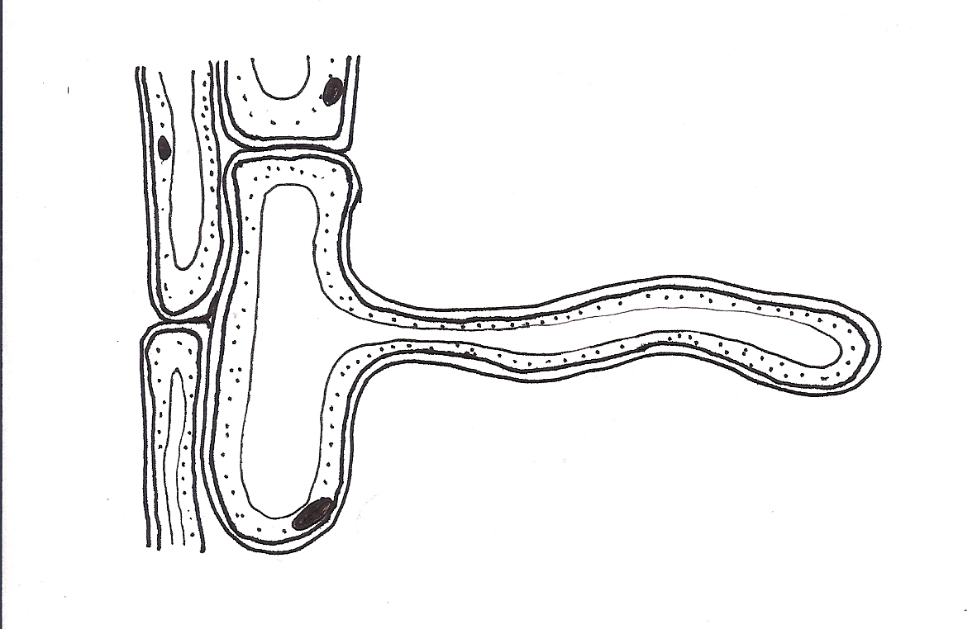 | 4.  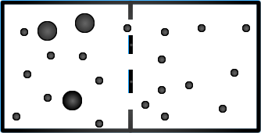
5.  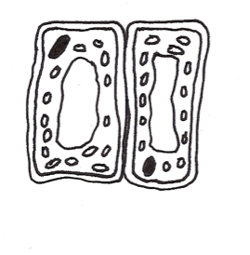 | 6.  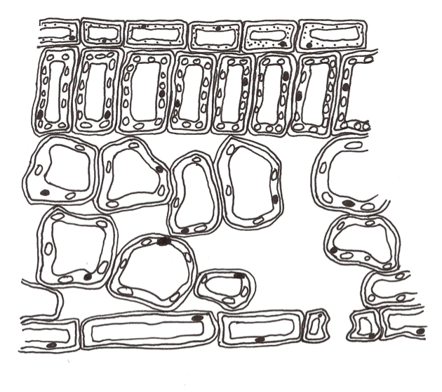
7.  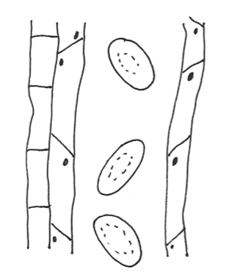 | 8.  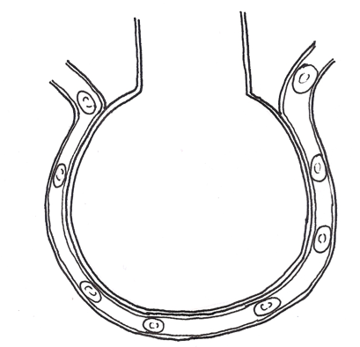

9.  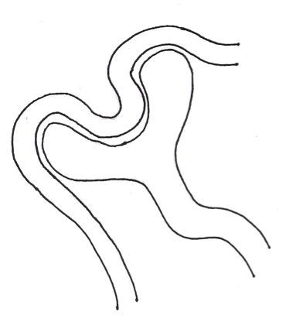 | 10.  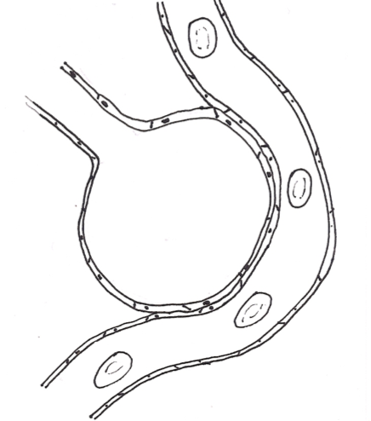
11.


