Mr Jones has set his class some biology homework. He decides to hand the work to you for marking. For each answer, read the question and decide who has got the answer correct and award marks appropriately.

Question 1

Draw a diagram of an animal cell. Label the nucleus.

Student A | Student B
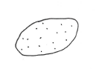 | 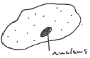
/3 | /3

a) Who got it correct?

b) Clearly explain anything that is wrong. State which student made each error.

Question 2

Draw a diagram of a plant cell. Label 3 parts that are just found in plant cells.

Student A | Student B
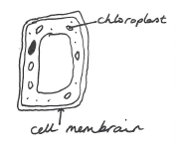 | 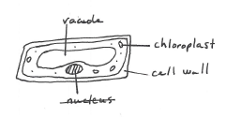
/3 | /3

a) Who got it correct?

b) Clearly explain anything that is wrong. State which student made each error.

Question 3

Draw a diagram of a red blood cell.

Student A | Student B
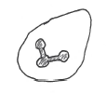 | 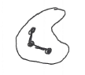
/1 | /1

a) Who got it correct?

b) Clearly explain anything that is wrong. State which student made each error.

Question 4

Draw and label a sperm cell.

Student A | Student B
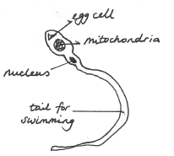 | 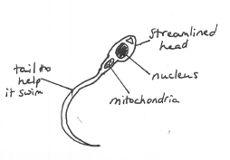
/4 | /4

a) Who got it correct?

b) Clearly explain anything that is wrong. State which student made each error.

Question 5

Draw and label two guard cells.

Student A | Student B
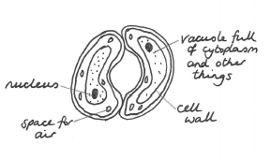 | 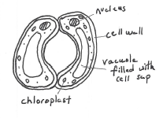
/4 | /4

a) Who got it correct?

b) Clearly explain anything that is wrong. State which student made each error.

Question 6

Draw and label a root hair.

Student A | Student B
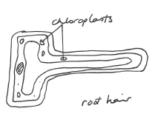 | 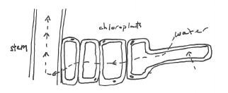
/3 | /3

a) Who got it correct?

b) Clearly explain anything that is wrong. State which student made each error.

Question 7

Label the diagram of a cross section of a leaf.

Student A | Student B
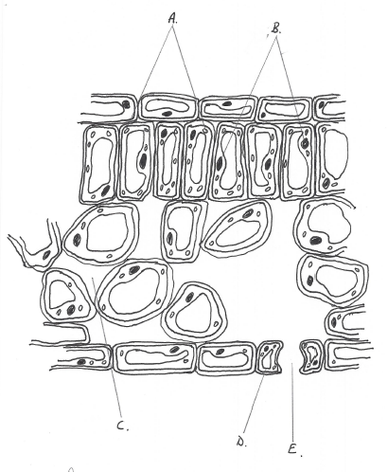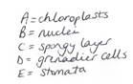 | 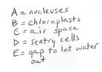
/5 | /5

a) Who got it correct?

b) Clearly explain anything that is wrong. State which student made each error.

Who got the highest mark?

Student A got ………….

Student B got …………..

Answers

Question 1

Student A - missed nucleus (2)
Student B - correct (3)

Question 2

Student A - labelled the cell wall as a membrane (incorrectly spelt), missed vacuole label (1)
Student B - correct (3)

Question 3

Both incorrect - they have drawn white blood cells (0)

Question 4

Student A - has nucleus and mitochondria wrong way round.
missed labelled the head. He could have mention ‘streamlined’, or ‘ head
contains enzyme to help get into egg’ for example (1)
Student B - correct (4)

Question 5

Student A - all labels incorrect. Has placed cytoplasm and nucleus within the vacuole. (0)
Student B - all labels correct but hasn’t labelled the stomatal pore(3 or 4)

Question 6

Student A - has drawn the correct structure, but shouldn’t have labelled chloroplasts (1)
Student B - has drawn a cross section through a root and hasn’t labelled the root hair cell (0)

Question 7

Student A - nearly correct but refers to ‘grenadier’ instead of ‘guard cell’.
Also confused about the ‘air space’ and ‘spongy layer’. Not incorrect but as there
was no mention of other layers could be marked incorrectly (3)

Student B - nuclei and chloroplasts muddled up
- not aware of plural for nucleus
- sentry cell instead of guard cell
- is aware that the stoma is a gap but not sure what for (3)

Total marks

Student A - 8 marks approximately
Student B - 16 marks approximately

