Teaching notes

This could be a starter, plenary or revision exercise.

A statement about a type of blood vessel is read out.

Students decide whether the statement refers to arteries, veins or capillaries.

They could work in pairs and write their answer on a mini whiteboard.

For a more active start to the lesson, they could physically move to different parts of the room. Rather than the class moving en masse, you could select a small portion of the class at a time to answer e.g. boy/girls only, people wearing glasses etc.

On www.teachitscience.co.uk there is an interactive Magnet activity which will randomly generate a statement and when double-clicked will reveal the correct answer.

Statements about capillaries
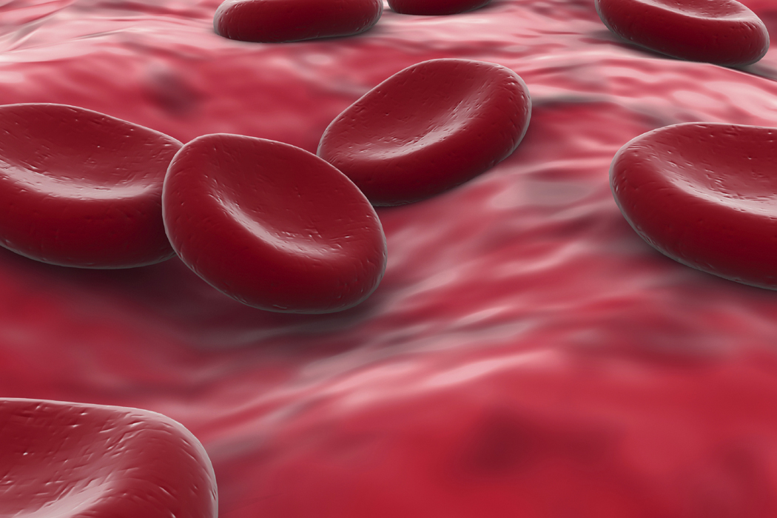
- The vessel wall is one cell thick.

- They have a very small lumen.

- Glucose diffuses into tissues from these vessels.

- Oxygen diffuses from these vessels into surrounding tissues.

- They absorb amino acids and glucose (products of digestion).

- Waste products pass into the blood through vessel walls.

- They form a dense network around alveoli.

- White blood cells can squeeze out of these vessels.

- They form the glomerulus.

- They lie beneath the epithelium of villi.

- These vessels are very numerous in the placenta.

Statements about arteries

- Almost all of these vessels carry oxygenated blood.

- Blood is at high pressure in these vessels.

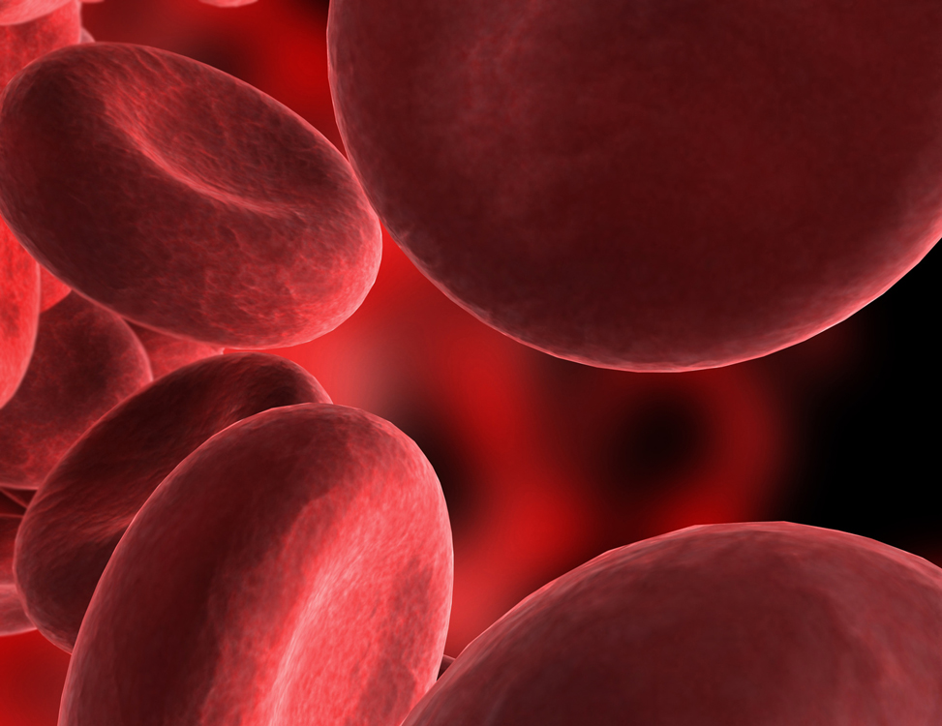
- They have relatively thick walls.

- Their walls are elastic.

- Their walls are more muscular than other blood vessels.

- They carry blood away from heart.

- They have a pulse.

- They supply oxygen to heart muscle.

- In these vessels, red blood cells are rich in oxyhaemoglobin.

- These vessels carry bright red blood.

- The carotid is …

- The aorta is …

Statements about veins

- They carry deoxygenated blood.

- Blood travels through these vessels at low pressure.

- They have a large lumen.

- They will collapse if empty of blood.

- These vessels have relatively thin walls.

- They have valves to prevent back flow of blood.

- They are known as ‘varicose’ if valves have deteriorated.

- Blood plasma in these vessels contains more carbon dioxide.

- Body movements keep blood flowing through these vessels

- They have connections with lymph vessels.

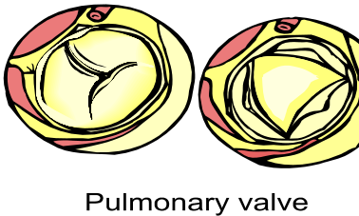
- Three types are known as superficial, deep and systemic.

- The jugular is …

- The vena cava is …

