Teaching notes

This resource is a series of questions which become more demanding – ranging from asking students to state/name something to asking them to explain a more difficult concept.

It could be used in a variety of ways.

- The cards could be cut up and placed around the room (more than one set could be distributed) The students move round and find cards then record their answers on paper. They could be asked to find two of each type of question, e.g. state, define and explain. The cards could be photocopied onto different coloured card depending on the demand of the question. The task could be differentiated by asking different groups to find different numbered/coloured cards.

- The cards could be used as a quick starter where a student picks a card and reads out the question. Students discuss the answer in pairs and one pair is picked to suggest an answer. If the answer is correct, they choose the next card.

- The cards could be used as a team quiz where teams choose to attempt an easy/medium/difficult question. If they get it right, then they are awarded 1 point for easy, 2 points for medium and 3 points for difficult questions.

1  Draw and label  an animal cell. | 2  Name the organ in which eggs are stored until they mature. | 3  What is a baby called when it first starts to grow in the uterus? | 4  What are the male and female sex cells called?
5  Name these  specialised cells:  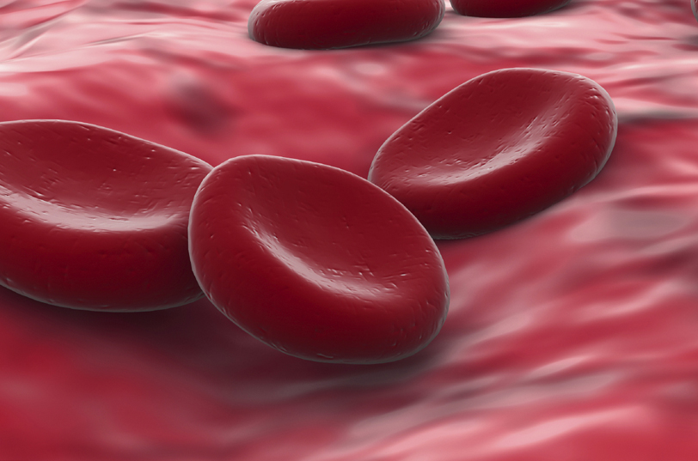 | 6  Name the two types of reproduction. | 7  How long does the menstrual cycle last for? | 8  Which structures are found in the nucleus of your cells?
9  Describe the process of artificial selection. | 10  Describe the structure of a sperm cell. | 11  What is environmental variation? Name an example. | 12  Describe the differences between an animal cell and a plant cell.

13  What is meant  by inherited variation? | 14  Describe what is meant by genetic engineering. | 15  Describe what happens to the lining of the uterus during the menstrual cycle. | 16  Describe the role of the placenta and umbilical cord in the development of a baby in the uterus.
17  Explain why the offspring of the same two parents show variation. | 18  Explain how the structure of a sperm cell relates to its function. | 19  Explain why blood group is an example of discontinuous variation. | 20  Explain how the baby is protected in the uterus.
21  Explain why frogs produce thousands of offspring at once. | 22  Explain why genetic modification is seen by some as unethical. | 23  Explain why  some twins are identical. | 24  Explain why height is an example of continuous variation.

Suggested answers

- Animal cell labelled: cytoplasm, nucleus, cell membrane.
- Ovary.
- Embryo.
- Sperm and eggs.
- Red blood cells.
- Sexual and asexual.
- 28 days.
- Chromosomes.
- Organisms are chosen for their desirable characteristics and are bred together. Offspring exhibiting the characteristic are then selected to breed from.
- Long tail, lots of mitochondria, head with genetic material.
- Variation caused by environmental factors, e.g. diet, climate, soil type, flower colour, hair style.
- Plant cells have a cell wall, chloroplasts and a vacuole; animal cells do not.
- Inherited variation is due to offspring receiving genetic information (genes) from their parents, e.g. eye colour, blood group.
- The genetic code is altered in the lab.
- The lining of the uterus builds up, then breaks down and is lost in menstruation.
- Oxygen and nutrients move from the mother’s blood to foetal blood in the placenta. Waste moves from foetal blood to the mother’s. The umbilical cord joins the placenta to the foetus.
- Sex cells contain half the chromosomes from each parent.
- Tail for swimming, mitochondria to supply energy for movement, head to penetrate egg cell, genetic information to combine with egg cell haploid set.
- There are only a few types of blood group. Discontinuous variation shows discrete variation.
- The amniotic fluid cushions the baby against knocks. The baby develops inside the mother’s uterus. Waste products are removed via the placenta.
- Frogs do not raise their offspring. Lots do not survive so are produced in large numbers.
- Unknown long term effects.
- They share the same genetic information.
- Height shows an infinite amount of variation within the range of height. It is affected by lots of factors, e.g. genetic and environmental.

