20 – Finish!  Burning sugar. | 19  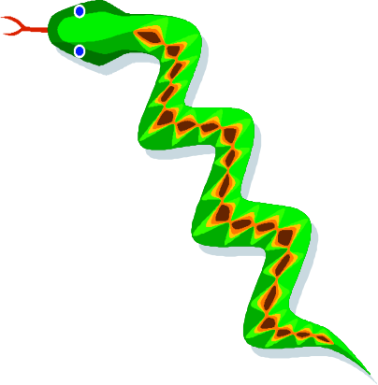  What type of change is fermentation? | 18  Melting candle wax. | 17  What type of change is sublimation? | 16  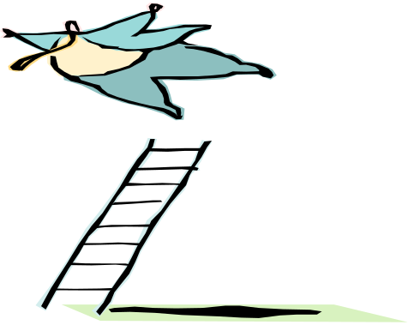  Melting sugar.
11  A puddle ‘disappearing’ on a warm day. | 12  Burning magnesium to produce magnesium oxide. | 13  A type of a change that is easily reversed. | 14  What type  of change is combustion? | 15  Juice turning into ice lollies.
10  Mixing salt  with water. | 9  What type of change is condensation? | 8  What type of change is rusting? | 7  Making popcorn. | 6  What type of change is dissolving?
1  A type of change that forms no new substances. | 2  A type of change that is not easily reversed. | 3  Baking cupcakes. | 4  Solid changing to a liquid. | 5  Freezing liquid nitrogen.

Rules of the game
Players must state whether the square they land on refers to a physical or a chemical change. Miss a turn for a wrong answer.
If a player lands on a ladder they can move up if they get the type of change correct. Miss a turn if the answer is incorrect.
When a player lands on a snake they can remain on that square if they get the type of change correct. If the answer is incorrect, they must go down the snake.
Counters
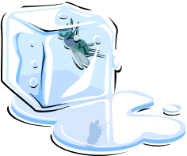 | 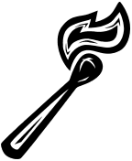 | 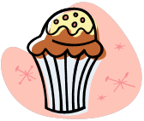 | 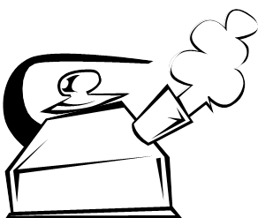

Answers

Burning sugar.  chemical | What type of change is fermentation?  chemical | Melting candle wax.  physical | What type of change is sublimation?  physical | Melting sugar.  physical
A puddle ‘disappearing’ on a warm day.  physical | Burning magnesium to produce magnesium oxide.  chemical | A type of a change that is easily reversed.  physical | What type of change is combustion?  chemical | Juice turning into ice lollies.  physical
Mixing salt with water.  physical | What type of change is condensation?  physical | What type of change is rusting?  chemical | Making popcorn.  chemical | What type of change is dissolving?  physical
A type of change that forms no new substances.  physical | A type of change that is irreversible.  chemical | Baking cupcakes.  chemical | Solid changing to a liquid.  physical | Freezing liquid nitrogen.  physical

