Look at a copy of the carbon cycle and answer the questions below.  - State the number of processes that remove carbon dioxide from the air.  - List the processes that add carbon dioxide to the air. | 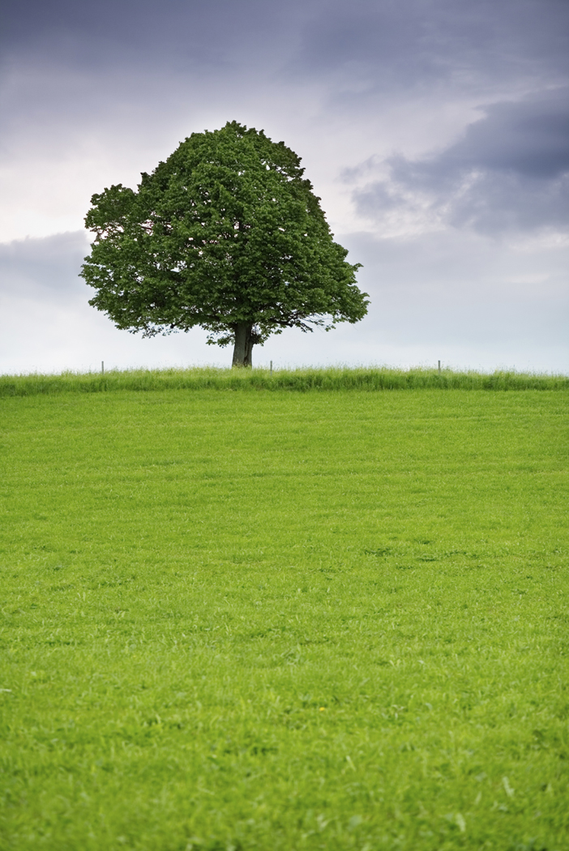

- Describe how the carbon compounds in plants end up in animals such as foxes.

- Describe how a carbon atom in coal could end up in a penguin.

- Define combustion.

- Decomposer organisms feed on waste, breaking down carbon compounds to build up their bodies and to use for respiration. What would happen if they all become extinct?

- Explain why deforestation is a problem for the carbon cycle.

- Describe how carbon is recycled in no more than 100 words.

- Explain how human activity other than deforestation may disrupt the natural carbon cycle.

- Suggest how human disruption to the carbon cycle can be minimised.
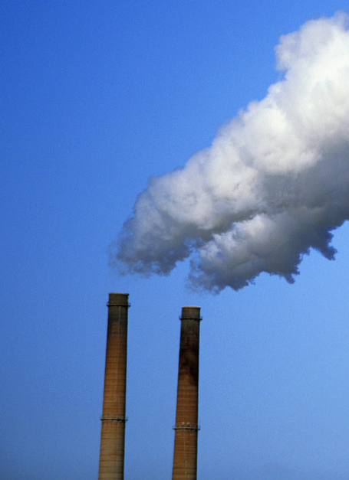

Teaching notes
These questions were designed to be used with the Teachit Science resource ‘Carbon cycle jigsaw’. However, they could be used with other diagrams of the carbon cycle.
The following are suggested answers.
- One (photosynthesis).

- Respiration by animals.
- Respiration by plants.
- Respiration by decomposers.
- Combustion (of fossil fuels).
This is an ideal opportunity to correct misconceptions about respiration.
- Feeding.
Students should be encouraged to recognise that as the question gives the name of a carnivore, that two stages of a food chain are involved. This gives opportunity to emphasise that carbon passes along food chains.
- Combustion of coal releases carbon as CO_{2.}
Phytoplankton remove carbon dioxide from the atmosphere by photosynthesis.
Carbon is passed along the food chain as fish eat the plants.
Penguins feed on the fish, taking in the carbon compounds containing the original carbon atom.
The basic expectation is the inclusion of the process names of combustion, photosynthesis and feeding.
- Combustion is a chemical reaction when something burns. Atoms combine with oxygen to make products such as carbon dioxide.
- Less carbon dioxide would be added to the atmosphere because there would be no decomposers to respire.
There would be less carbon dioxide for plants to take in for photosynthesis.
Food chains would be disrupted.
There would be a build-up of dead bodies and waste.
The point of the question is to establish that each part of the carbon cycle is crucial. Disrupting one part of it disrupts the whole thing.

- Deforestation will reduce the amount of photosynthesis causing atmospheric CO₂ levels to rise.
Students may then link this to disrupting other parts of the carbon cycle and/or to global warming.

- Plants use CO₂ in the atmosphere for photosynthesis to make glucose. The carbon is then transferred to animals during feeding.
The carbon atom ends up in waste material or a dead organism.
Decomposers, e.g. fungi, start decay.
All living organism,s including these decomposers, respire.
Respiration returns carbon atoms back to the atmosphere as CO₂.
Carbon atoms are in fossil fuels (from dead organisms).
During combustion of fossil fuels, carbon is returned to the atmosphere as carbon dioxide.
- Farming
Farming could increase CO₂ (through the following processes: respiration of animals; increase in decomposer respiration; a reduced area for forests, due to the need for farmland, and so less photosynthesis).
Transport
The carbon in fossil fuels is given off in combustion, hence adding to CO₂ in the atmosphere.
Combustion of fossils fuels
This adds CO₂ to the atmosphere.
Building
Building reduces the area of natural habitats and hence reduces photosynthesis.
- Planting trees to increase photosynthesis, which would remove CO₂ from the atmosphere.
Reduce combustion of fossil fuels by e.g. car sharing, use of public transport, walking, using fuel efficient cars, improving insulation.
Farming more plants and fewer animals would increase photosynthesis and reduce respiration and waste.

