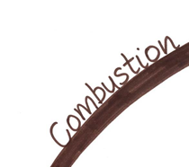 | 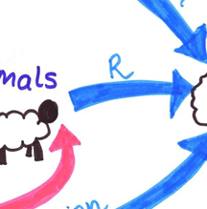 | 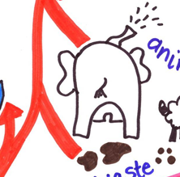
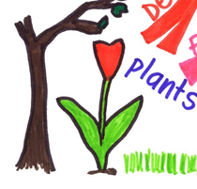 |  | 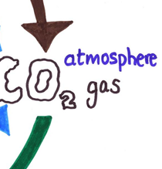
 | 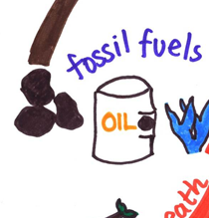 | 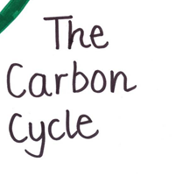
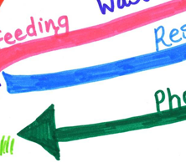 | 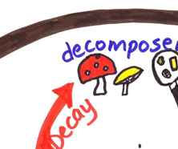 | 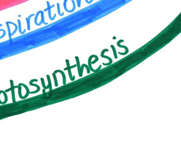

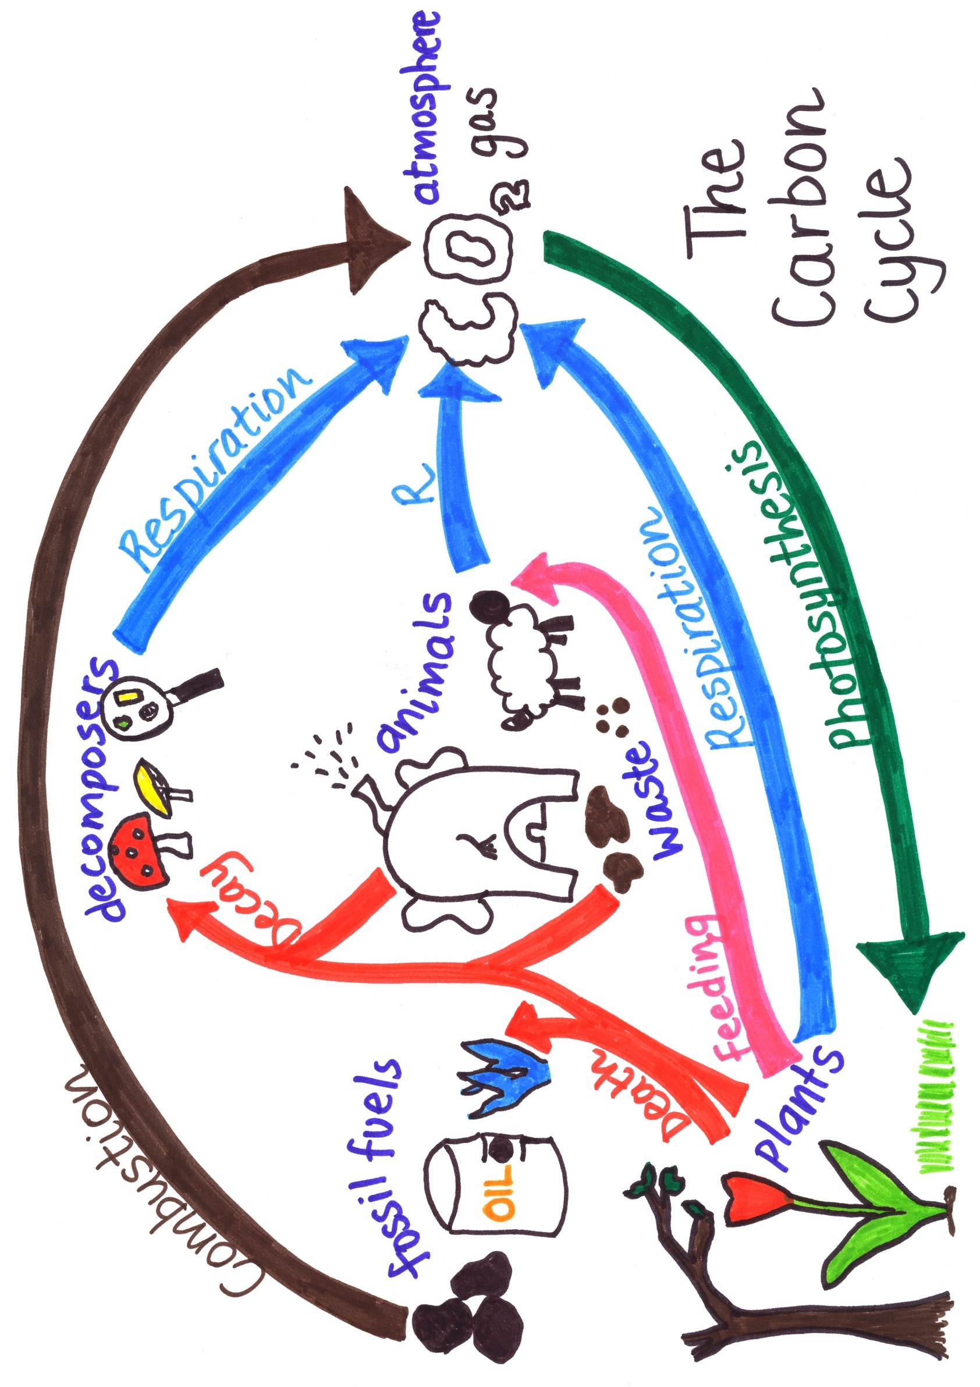

Teaching notes
This jigsaw helps students engage with the carbon cycle. Students often struggle to link processes together in science and the carbon cycle can be difficult in this regard, particularly for lower ability students.
As an initial task, students are asked (either individually or in pairs) to cut out and put together the pieces of the carbon cycle. This gives them some familiarity with the key parts and processes involved.
Students can then use the jigsaw they have created to do individual research on the carbon cycle. There is a worksheet that follows on from the jigsaw activity (resource 19849, ‘Carbon cycle questions’).
The diagram can either be printed on paper each time it is used, for each student/pair to stick into their books, or it can be printed on card for multiple uses.
Page 2 shows the completed image, which could be used for class discussion.
A jigsaw for the nitrogen cycle is also available (resource 19846, ‘Nitrogen cycle jigsaw’), along with a set of questions (resource 19847, ‘Nitrogen cycle questions’) and a consolidation activity focused on improving exam answers and based on peer-assessment strategies (resource 19848, ‘Nutrient cycles peer assessment’).
There are also two fully interactive resources, one for each of the nutrient cycles, available from the Teachit Science Biology whizzy things page:
http://www.teachitscience.co.uk/whizzybiology.

