Introduction

A simple game designed to increase students’ confidence in the symbols of circuitry. Most students have played ‘pairs’ at some time or other, so the rules are generally known to all.

Instructions

Divide the class into groups of between two and four players. Photocopy one set of the sheets (as well as a sheet of answers) for each group. It is best to photocopy them onto card or stiff paper that is thick enough so the typing cannot be seen through it!

Cut the sheets into individual cards. Remove any pairings not relevant to your group.

The aim of the game is to make pairs. A pair consists of symbol or graph with its appropriate name. The answer sheet is given to each group to help them check the pairings are correct.

Rules of the game

The cards are shuffled and spread out randomly face down on the bench.

The first player turns over two cards. If they are a pair, the player removes them and has another go. If they are not a pair they are turned face down again. When the first player has finished their go, play moves to the next player.

The winner is the one with the most pairs at the end.

Variations

One player can be nominated in each group whose sole responsibility is to check the answers.

Groups of students can be formed according to their ability and different groupings of cards given to them. The less able may find that sheets one and two are enough to start with.

Also, with a bit of manipulation the names can be photocopied onto one colour of card and the symbol or graph onto another. Therefore, when a student picks up a pair of cards they are picking up two different colours. The game is faster this way.
cell | battery | switch  (open)
closed switch | filament lamp | resistor

variable resistor | fuse | voltmeter
 |  | V
ammeter | diode | thermistor
A

LDR | DC | series circuit
 | direct  current | A
parallel  circuit | LED | AC
A |  | alternating  current

thermistor resistance/  temperature graph | diode  current/ voltage graph | filament lamp current/voltage  graph
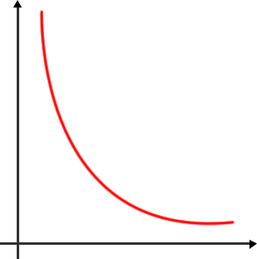  temperature  resistance | 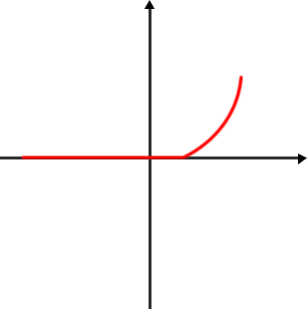  voltage  current  Current flowing in the reverse direction | 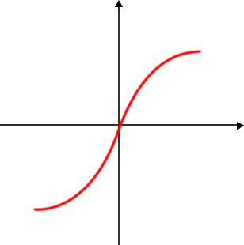  Current flowing in the reverse direction  voltage
ohms | volts | current
Ω | V | I

Answers

cell | battery | switch  (open) | closed  switch
filament  lamp | resistor | variable resistor | fuse
voltmeter | ammeter | diode | thermistor
V | A
LDR | DC | series circuit | parallel circuit
 | direct current | A | A  A
LED | AC | thermistor  resistance/  temperature graph | diode  current/  voltage graph
 | alternating current | resistance  temperature | current  voltage  Current flowing in the reverse direction
filament bulb current/voltage  graph | ohms | volts | current
current  Current flowing in the reverse direction  voltage | Ω | V | I

