Task
The table is muddled.
Cut out the boxes in the second and third columns. Arrange the boxes to complete the table.
- Type of fertilisation | External fertilisation | Internal fertilisation
- Organism | 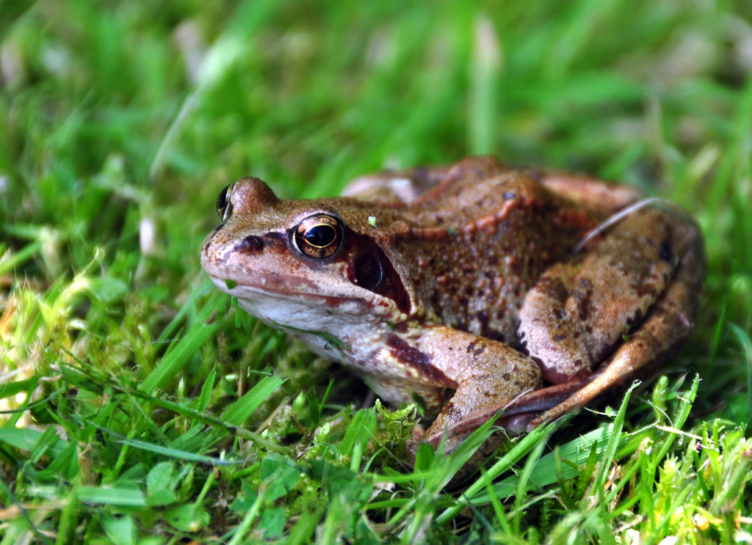  frog | 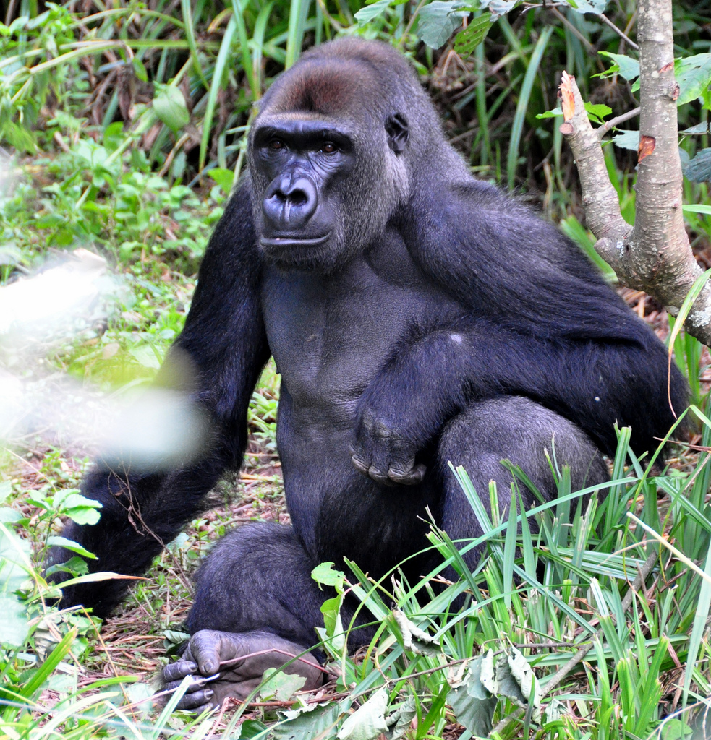  gorilla
- Number of gametes produced | Only one offspring is likely to be produced. | The number of young produced is about 5 000.
- Chance of fertilisation | Fertilisation takes place outside the parents’ bodies. | Fertilisation takes place inside the female’s body.
- Place of fertilisation | Eggs have a high chance of being fertilised. | Many of the eggs produced will not be fertilised.
- Site where offspring develop | Most offspring are likely to survive. | Many of the offspring will not survive.
- Time taken for offspring to develop | The offspring develop as eggs in ponds, lakes and streams. | The offspring develop in the female’s uterus.
- Number of young produced | Offspring will not spend any time with their parents. | Offspring will be cared for by parent for 2.5 years.
- Chance of survival | The offspring take about 8.5 months to develop. | The offspring take about 20 days to develop.
- Time spent with parents | Large numbers of gametes are produced. | Far fewer gametes are produced.


Answers
- Type of fertilisation | External fertilisation | Internal fertilisation
- Organism | frog | gorilla
- Number of gametes produced | Large numbers of gametes are produced. | Far fewer gametes are produced.
- Chance of fertilisation | Many of the eggs produced will not be fertilised. | Eggs have a high chance of being fertilised.
- Place of fertilisation | Fertilisation takes place outside the parents’ bodies. | Fertilisation takes place inside the female’s body.
- Site where offspring develop | The offspring develop in ponds, lakes and streams. | The offspring develop in the female’s uterus.
- Time taken for offspring to develop | The offspring take about 20 days to develop. | The offspring take about 8.5 months to develop.
- Number of young produced | The number of young produced is about 5 000. | Only one offspring is likely to be produced.
- Chance of survival | Many of the offspring will not survive. | Most offspring are likely to survive.
- Time spent with parents | Offspring will not spend any time with their parents. | Offspring will be cared for by parent for 2.5 years.

Both photos © 2009 xlibber
Frog: http://www.flickr.com/photos/xlibber/3643984338/sizes/l/
Gorilla: http://www.flickr.com/photos/xlibber/3830692663/sizes/l/

