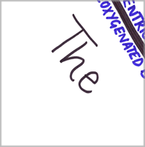 | 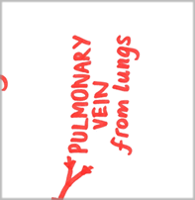 | 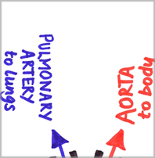
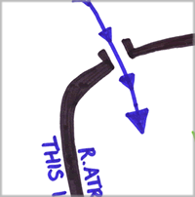 | 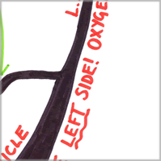 | 
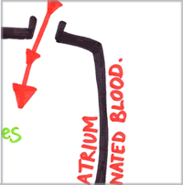 | 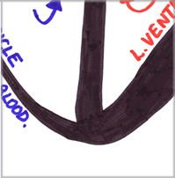 | 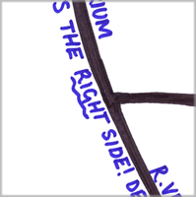
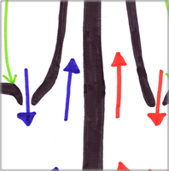 | 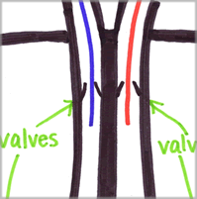 | 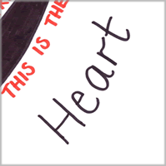

Teaching notes
This jigsaw was designed to help engage students in learning the structure and function of the heart. Whilst students are usually very interested a heart dissection, they often struggle with naming the structures and remembering the direction of blood flow.
As an initial task, students are asked (either individually or in pairs) to cut out and put together the pieces of the heart. This gives them some familiarity with the key parts and names involved.
Students can then use the jigsaw they have created to do individual ‘research’ on the heart.
A jigsaw of the circulatory system (resource 20000, ‘The circulatory system – jigsaw’) is also available, along with a set of questions for both (resource 20001, ‘The circulatory system questions’ and resource 19998, ‘The heart – questions’) and a consolidation activity focussed on improving exam answers and based on peer-assessment strategies (resource 20002, ‘Circulatory system peer assessment’).



