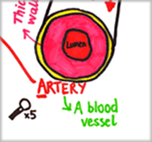 |  | 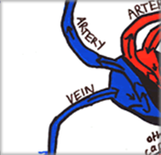
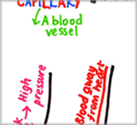 | 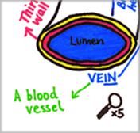 | 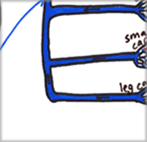
 | 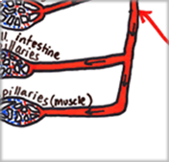 | 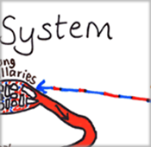
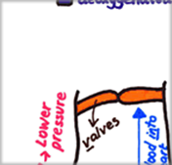 | 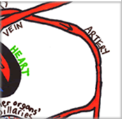 | 


The circulatory system diagram – teacher guidance
The diagram has been designed to help engage students in studying the circulatory system.
The diagram can either be printed on paper each time it is used for each pupil/pair to be stuck into books or it can be printed on card for multiple uses.
A set of associated questions is available to enable students to become familiar with the structure and function of the parts of the circulatory system whilst focusing on the knowledge and understanding needed for KS4 exams. A consolidation activity is also available (based on the circulatory system as a whole and the structure and function of the heart). The consolidation activity is focussed on improving exam answers and based on peer-assessment strategies.



