Viruses

Viruses are even smaller than bacteria and are the cause of many diseases. They are different from bacteria because they can only reproduce inside a living cell. The common cold, chicken pox, measles, AIDS and glandular fever are all caused by viruses. Antibiotics do not affect or harm viruses. Viruses can be used to transfer genes into target cells.

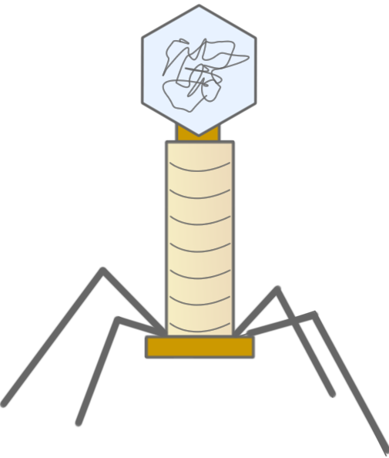

Bacteria

Bacteria are so small we need a microscope to see them. They are single celled organisms found in the soil, water and air around us. Harmful bacteria can cause diseases such as scarlet fever, food poisoning and whooping cough. Bacteria can reproduce and grow outside a living organism, and they can reproduce very quickly: a small group invading the body does not take very long to multiply into millions. They can be treated with antibiotics. Bacteria have many uses, including the production of insulin and sewage treatment.

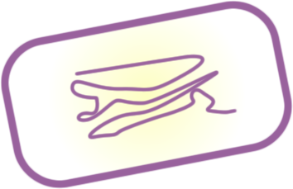

Fungi

These are simple organisms that feed off dead and rotting material. Organisms that belong to this kingdom are moulds, yeasts and mushrooms. They used to belong to the plant kingdom. Some fungi can cause rashes and often affect nails, hair and mucous membranes. Ringworm, athlete’s foot and thrush are all examples of fungal diseases. Fungi have many uses, e.g. yeasts are used in brewing and baking; Penicillin is produced from the mold Penicillium.

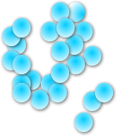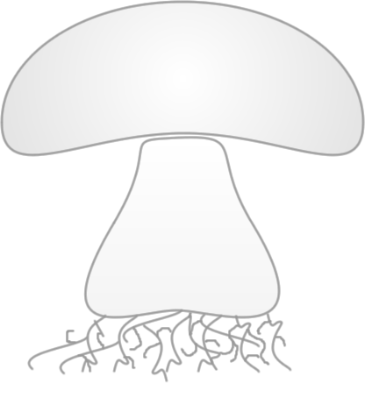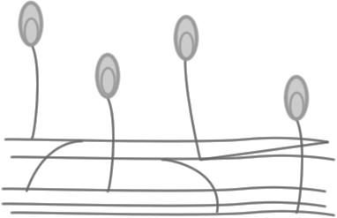

Task 1
Cut up the page of pictures and group them into viruses, bacteria or fungi.

Task 2
Using the information sheet, fill in the table and answer the questions.

 | Viruses | Bacteria | Fungi
Do you need a microscope to see them?
Do they contain a proper nucleus?
Can they reproduce outside a living cell?
Name a use.
Can they be destroyed with antibiotics?
Name two diseases caused by them.

- Viruses cannot reproduce outside of a living cell. Should they be classed as living organisms? Explain your answer.

- Bacteria belong to the Prokaryotic Kingdom. Prokaryotic means ‘before nucleus’. Look at the diagram of a bacterium. Why is it classed as a prokaryote and not as a plant or animal cell?

- Members of the Fungi Kingdom used to be part of the Plant Kingdom. Yeast cells have the following structures a nucleus, mitochondria, a cell wall, cytoplasm and a cell membrane.

- Draw and label a yeast cell. Explain why it was put into the Plant Kingdom.

b) Suggest a reason why fungi were taken out of the Plant Kingdom.

