Task 1

Cut out the statements about Euglena and sort them according to whether each characteristic is exhibited by the following groups:

- plants
- animals
- both plants and animals
- neither plants nor animals.

If you need extra information you can use the prompt cards.

Task 2

Write down how you would classify Euglena. Explain why you have classified Euglena as you have.

Statement cards

Euglena does not have a cell wall. | Euglena contains chloroplasts.
Euglena has a nucleus. | Euglena is a single celled organism.
Euglena can absorb food from its surroundings. | Euglena can change its shape.
Euglena exhibit phototaxis. | Euglena have flagella.
Euglena has a pellicle. | Euglena can reproduce by binary fission.
Euglena contains cytoplasm. | Euglena make  their own food by photosynthesis.
Euglena has a vacuole. | Euglena has a red eyespot.

Prompt cards

Euglena can change their shape as can some animal cells e.g. white blood cells that engulf bacteria. | A vacuole controls the amount of liquid in a cell.
The nucleus contains DNA and controls the cell. | Chloroplasts enable a cell to photosynthesize.
Flagella are long whip like extensions that enable cells to move. They occur in some single celled organisms as well as the gametes of algae, fungi, mosses and animals. | A pellicle is made up of protein strips that spiral around the cell giving it flexibility.
Binary fission is cell division by mitosis, a type of asexual reproduction. | Phototaxis is movement of an organism towards light.
The eyespot is thought to filter light of certain wavelengths. | Euglena confused early scientists who used a two kingdom classification system.
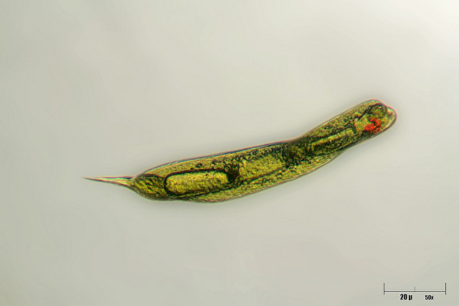  © Giuseppe Vago 2010 http://www.flickr.com/photos/giuseppevago/4904864656/ | 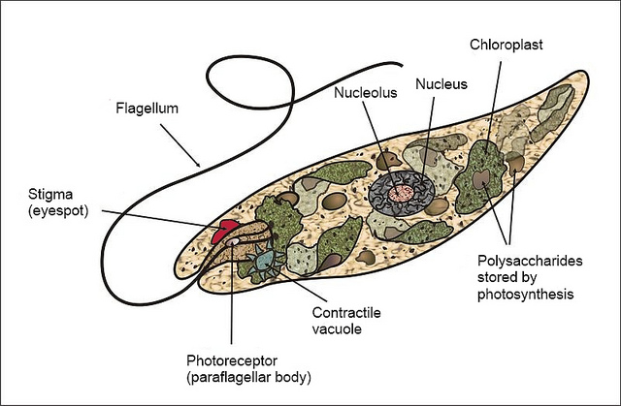  © fickleandfreckled 2012 http://www.flickr.com/photos/fickleandfreckled/6793271762/

Teaching notes

The statement cards and the prompt cards could be put onto different coloured card and cut up before the lesson. The task could then be easily differentiated by removing some of the cards.

Before the main task students could be shown a short video of Euglena and asked to make observations of its characteristics. The following link was available at time of publishing.

http://www.youtube.com/watch?v=4TwAaPO9q-4

Task 1

Suggested answers

Plant | Animal | Plant and animal | Neither
Euglena make their own food by photosynthesis. | Euglena does not have a cell wall. | Euglena has a nucleus. | Euglena has a pellicle.
Euglena has a vacuole. | Euglena can absorb food from its surroundings. | Euglena contains cytoplasm. | Euglena can reproduce by binary fission.
Euglena contains chloroplasts. | Euglena exhibit phototaxis. |  | Euglena is a single celled organism.
 | Euglena has a red eyespot. |  | Euglena have flagella.
 | Euglena can change its shape.

Task 2

Many students will classify Euglena as a plant. The other features may make them unsure about how to classify Euglena or just be considered inconvenient and therefore ignored! This activity offers an excellent opportunity to discuss the difficulties of an artificial classification system and how it has been adapted over time as new discoveries are made.

