Substance | Distance (m) | Time (s) | Speed of sound (m/s)
iron | 1000 | 0.17
sea water | 1000 | 0.65
wood | 1000 | 0.26
water | 1000 | 0.67
glass | 1000 | 0.18
air at 0ºC | 1000 | 2.92
Task 1
- Calculate the speed of sound as it travels through different substances.

- Rank the substances according to the speed that sound travels through them.
fastest slowest

- Underline the solids in red, liquids in blue and gases in green.
- Does sound travel fastest through solids, liquids or gases?

- Why does sound travel faster through liquids than gases?

- Sound travels through cork at a speed of 500 m/s. Cork is a solid. Why does sound travel very slowly through cork compared to iron?

- Sound travels at a speed of 342 m/s in air at a temperature of 20 ºC. Explain why sound travels faster through warm air than cold air.

Task 2

The car breaks down in the middle of the bridge and the driver sounds the horn. Use the information given to answer the questions.

Substance | Speed of sound through substance (m/s)
air | 340
steel | 5000
lake water | 1500

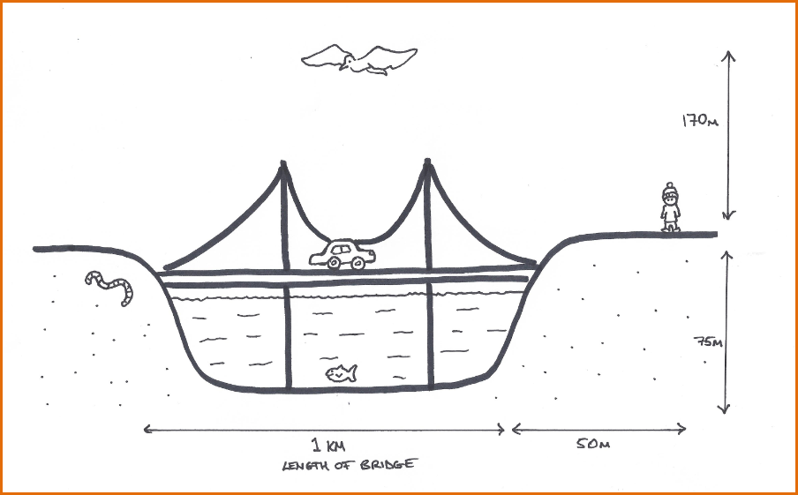

- Use arrows to show the direction that the sound of the car horn travels in.
- Does the sound of the car horn travel fastest through the bridge, the water or the air?

- In what order does the sound reach the bird, fish and worm?

- Using the information given calculate how long the sound takes to get to the bird, fish and worm.

- The birdwatcher is further away from the car than the bird.
- Describe what the birdwatcher could do to hear the sound of the car horn before the bird.

- Explain why this means the birdwatcher can hear the sound before the bird

- Use the information given to prove your answer.

Keywords

speed distance time density kinetic energy particles

Answers

Task1

Substance | Distance (m) | Time (s) | Speed of sound (m/s)
iron | 1000 | 0.17 | 5882
sea water | 1000 | 0.65 | 1538
wood | 1000 | 0.26 | 3846
water | 1000 | 0.67 | 1492
glass | 1000 | 0.18 | 5556
air at 0 ºC | 1000 | 2.92 | 331

and

fastest slowest

iron glass wood sea water water air at 0 °C

- Solids.

- Particles closer together in liquids so sound energy is passed on more quickly.

- Cork has lots of air spaces whereas iron particles more densely packed.

- Particles in warm air have more kinetic energy so are moving faster therefore sound energy passed on more quickly.

Answers: Task 2

- arrows from car in all directions

- the bridge

- first the fish, then the worm, finally the bird

- fish: 75 m ÷ 1500 m/s = 0.05 s. worm: 500 m ÷ 5 000 m/s = 0.1 s. bird: 170 m ÷ 340 m/s = 0.5 s.

- a) The birdwatcher could put their ear to the ground.
b) Sound travels faster through solids than gases.

Time taken for birdwatcher to hear the sound with an ear to the ground: 550 m ÷ 5000 m/s = 0.11 s.
This is 0.39 s (0.5 s – 0.11 s) faster than the bird would hear it.

