Task 1

Look at the diagram and complete the labels to describe what is happening at stages 1 to 5.

human egg cell

patient’s cell

2.
1.

3.

4.

5.

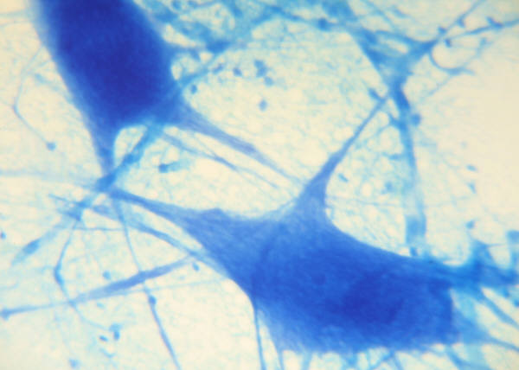
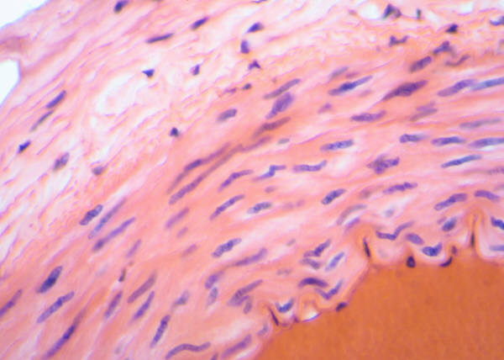
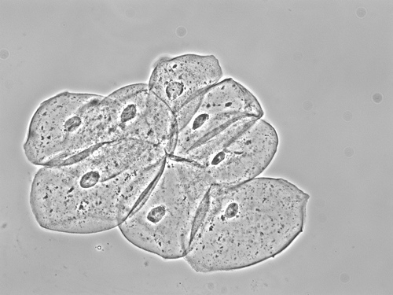

Suggested answers

human egg cell

patient’s cell

2.
A cell is taken from the patient and its nucleus removed.
1.
The egg is enucleated. The nucleus is removed from a donated egg cell and discarded.

3.
The nucleus from the patient’s cell is inserted into the enucleated egg cell.

4.
The cell divides to form an embryo.
5.
Stem cells are separated and can potentially develop into different tissues.

Teaching notes

This resource is a good starting point from which to explore how to approach extended answer exam questions.

The following link is a BBC learning zone clip that is a good introduction to the advantages and disadvantages of stem cell research: http://www.bbc.co.uk/learningzone/clips/stem-cell-research/6013.html.

Students could discuss the following questions in pairs or as a class.

- What do you think this type of cloning could be used for?

- Why will these cells, and the tissues and organs they form, not be rejected when put into the patient’s body?

- Evaluate the issues involved in the use of embryonic stem cells in medical research and treatments. Do you think stem cells from embryos should be used for medical research?

Ask students to break their answer down into two sections:

- List all the advantages and disadvantages of embryonic stem cell research they can think of. Ask them to compare some of the advantages with the disadvantages. They should try to use link words such as ‘but’, ‘whereas’, and ‘however’.

- Draw your own conclusion about the use of stem cells. You will need to justify your conclusion.

Overall, I think ......... because………

Further information

All links were available at the time of publishing.
http://www.bbc.co.uk/programmes/p0188d3s (from 00:26 – 05:30 minutes)
http://www.wellcome.ac.uk/About-us/Policy/Spotlight-issues/Human-Fertilisation-and-Embryology-Act/Stem-cell-basics/
http://www.bbc.co.uk/news/health-22540374
http://www.bbc.co.uk/news/health-11518539

Image credits

Cheek Cells
© Monshire Museum of Science 2010 http://www.flickr.com/photos/33808539@N07/4520951050/

