Teaching notes

This learning grid has been adapted from an idea from the book Outstanding Teaching: Engaging Learners (Crown House Publishing) by Andy Griffith and Mark Burns (2012).

This resource is designed for revision of OCR GCSE Gateway Science Biology module B2, ‘Understanding our environment’, but can easily be adapted for other specifications.

Equipment needed by each group

- 2 dice
- learning grid
- set of keyword cards, placed face down
- pencils and paper
- play dough

Instructions

Students can play in pairs or groups of four.
Students roll a dice twice to get a grid reference.

They take it in turns to link the image to a keyword or explain the keyword.

The activity can be differentiated by asking students to:

A. Give three key points related to the square.
B. Make links between their square and another.
C. Talk for a minute on the keyword/image.

Alternatively on their first go they could give A answers, on their second go they do B etc.
Or the teacher could allow 5 minutes when everyone gives A answers. Then using the Teachit timer they could get everyone to swap to B and then change to C a few minutes later.

When students land on one of the following squares they take a keyword from the pile.

 | Students act out a keyword for the others to guess.
 | Students make up a question for the others to answer which involves the keyword in the question or answer.
Quick draw | Students take a keyword from the pile and then draw it for the others to guess.
Model it | Students take a keyword from the pile and use play dough to model it for the others to guess.

Keyword cards

lichen | sulphur dioxide | variation
biodiversity | habitat | mimicry
species | arthropod | Linnaeus
producers | secondary consumers | pyramid of biomass
carbon dioxide | decomposers | root nodules
acid rain | behavioural adaptation | Wallace
extinction | seed banks | sustainability
counter-current heat exchange | population | phylum
hybrids | evolution | natural classification
artificial classification | evolutionary tree | denitrifying bacteria

 | 1 | 2 | 3 | 4 | 5 | 6
1 | energy transfer |  | classification | N2 | food web | carbon sinks
2 |  | trophic levels | mutualism | indicator species | Model it | conservation
3 | 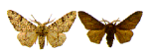 | Darwin and Lamarck | Quick draw |  | competition | hybrids
4 |  | MRSA | generalists | legumes |  | 
5 | niche | ozone layer | 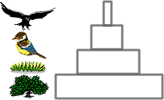 |    | predator/prey relationship | 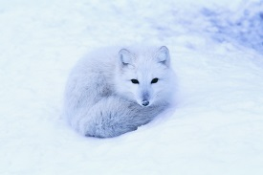  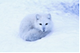
6 |  | photosynthesis and respiration |  | extremophile |  | natural selection

