Teaching notes

This game is designed to be used with lower ability students (Yr7). The board and cards can be copied and laminated for reuse. If laminated, the cards could be fastened down with Velcro or Blu Tack. If using a paper version you may want to provide glue so that they can stick the squares down.
The board needs to be completed before the students can play the game.
Ask the students to place the cards in the correct positions on the board. Each pair will need a dice and two counters to represent the eggs. If they throw an odd number they move forward one space, if they throw an even number they can move forward two spaces.

Complete board

Your egg has  been fertilised!  Go forward 3 spaces |  | The fertilised egg divides to form a bundle of cells. |  | 5. Your egg has not been fertilised!  GO back to the start
 | 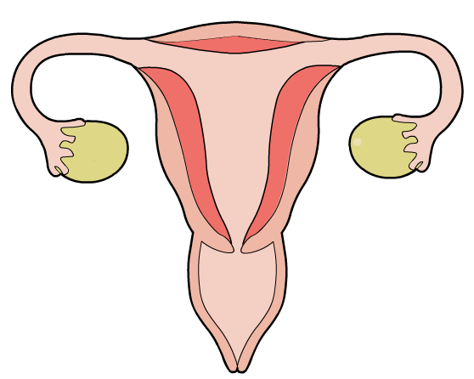
The egg starts to travel along the oviduct. |  |  |  | The fertilised egg finds somewhere to bury itself in the lining.
START  An egg is released. |  |  |  | 7. Your fertilised egg has not been able to implant itself into the lining.  Go back to the start
The baby is born.  FINISH! |  | A baby takes 9 months to grow.  Wait to throw a 6 to move to the finish! |  | Your fertilised egg has grown into an embryo!
Task

Cut out the missing squares for the board game.
Put each square into the correct space on the board.
Play the board game.

How to play
Put your counters on the start.
Take it in turns to throw the dice.
If you throw an odd number move forward one space.
If you throw an even number move forward two spaces.
First player to reach the finish is the winner.

An egg is  released. | A baby takes 9 months to grow.  Wait to throw a 6 to move to the finish! | The egg starts to travel along the oviduct. | The baby is born.
The fertilised egg finds somewhere to bury itself in the lining. | The fertilised egg divides to form a bundle of cells. | Your fertilised egg has grown into an embryo! | Your egg has been fertilised!  Go forward 3 spaces

5. Your egg has not been fertilised!
GO back to the start
7. Your fertilised egg has not been able to implant itself into the lining.
Go back to the start
START

FINISH!

