same colour hair  name: | same clothes  name: | same size feet  name:
similar hair style  name: | same colour eyes  name: | similar nose  name:
same height  name: | same size hands  name: | Find someone who has another characteristic in common with you.  characteristic:  name:

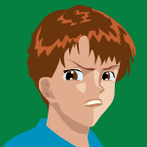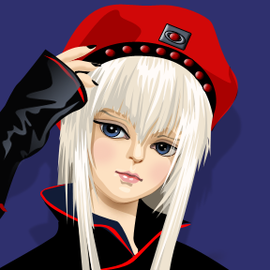

Teaching notes

This is intended as a quick starter activity (5 minutes) to stimulate a discussion about variation and what factors it is caused by, i.e. inherited and environmental factors. It should be used sensitively and with students who will be supportive of each other.

Once the activity is completed ask the students:

- If they managed to fill in all of the boxes, it’s quite likely that they have not been able to. Can they explain why?

- If anyone found someone who had all of the same characteristics as themselves. This might happen if there are identical twins in the group!

- Ask for their ideas as to why everyone is different.

- Ask what they notice about the characteristics to introduce the idea of features being inherited and dependent on the environment.

- The students could group the characteristics depending on whether they are inherited or affected by the environment.

