Task

You are going to build a road connecting two towns, Eastry and Firtree. Think about the environmental impact the road will have.

 | A | B | C | D
1 | 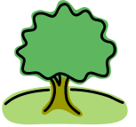 | 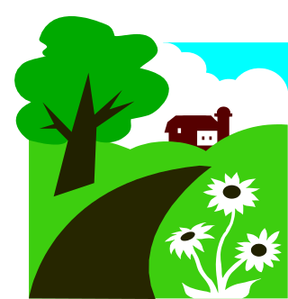 |  | Eastry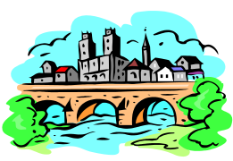
2 | 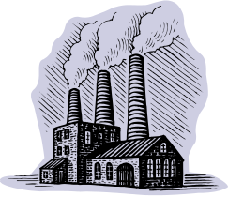 | 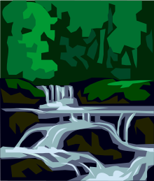
3 |  |  | 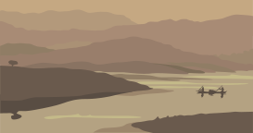 | 
4 |  | Firtree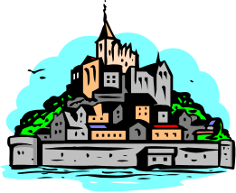

You can use as many squares as you want. Endangered animals are underlined. If you use these places you will lose more points.

A1 | forest | bats , owls, squirrels | C1 | forest | bats, owls, squirrels
A2 | factory | rats | C2 | forest | bats, owls, squirrels
A3 | forest | bats, owls, squirrels | C3 | reed beds | bittern
A4 | fields | field mice, foxes | C4 | endangered forest | adders
B1 | fields | field mice, foxes | D1 | Eastry
B2 | protected stream | fresh water mussels | D2 | fields | field mice, foxes
B3 | village | blackbirds, mice | D3 | village | blackbirds, mice
B4 | Firtree |  | D4 | forest | bats, owls, squirrels

My Route

Now you have built your road, work out how many points you have. Start with100 points. Use the table to add or deduct points depending which squares your road will pass through.

A1 | forest | -40 | C1 | forest | -40
A2 | factory | +40 | C2 | forest | -40
A3 | forest | -40 | C3 | reed beds | -60
A4 | fields | -20 | C4 | endangered forest | -60
B1 | fields | -20 | D1 | Eastry
B2 | protected stream | -60 | D2 | fields | -20
B3 | village | +20 | D3 | village | +20
B4 | Firtree |  | D4 | forest | -40

My total score is ________

Answer the following questions.

- How could you have got more points?

- What would be the impact of building a road between the two towns for the human population?

- Which animals would be affected if you had built the road through the endangered forest?

- What impact would a road have on the forest?

- Which endangered animals would be affected if you built the road over the protected stream?

- How do you think a new road would affect the reed beds?

- Do your answers to 2), 4) and 6) describe positive or negative impacts? Write + (for positive) or – (for negative) by your answers to 2), 4) and 6).

 | A | B | C | D
1 |  |  |  | Eastry
2
3
4 |  | Firtree

Teaching notes

This resource is intended to introduce lower ability students to the environmental impact of building a road through various natural areas. Give out the second sheet after the students have decided on their route. The large grid could be photocopied and laminated so that students can draw their route (use washable pens, so it can be reused).

Suggested answers

- Answer depends on the students score
- The road would allow people to travel more easily between the towns. May increase tourism, industry and jobs, transport of goods.
- Adders
- Traffic would cause noise, pollution, vibration, lights at night etc.
Road may cut off animals routes and affect their territory etc.
Loss of habitat which will affect species diversity, reduce available food and habitats, disrupt the food web etc.
- Fresh water mussels
- Traffic would cause noise, pollution, vibration, lights at night etc.
Loss of habitat, which could affect the bitterns and their source of food.

Extension activity

Ask students to compare their routes. They could discuss the positive and negative impacts that the road could have and conclude if the road should be built and which is the best route.

For further information about the endangered species mentioned, try the following links:

Bittern
http://www.norfolkwildlifetrust.org.uk/Wildlife-in-Norfolk/Species/Birds/Bittern.aspx

Chalk streams habitat and fresh water mussels.
http://www.wildlifetrusts.org/wildlife/habitats/chalk-streams

Bats
http://www.bats.org.uk/pages/about_bats.html

Adders
http://www.bbc.co.uk/nature/life/Vipera_berus
http://www.forestry.gov.uk/forestry/Adder

