Teaching notes

This task can be used when covering cells, tissues and organs with GCSE students or high achieving KS3 groups.
It is based on the article from The Week magazine called ‘Living ear grown in lab’. Further information and web links can be found at http://www.nhs.uk/news/2013/08August/Pages/Artificial-ear-grown-in-lab.aspx.
All links were available at the time of publishing.

Starter
As an interesting stimulus show the class the famous image of a human ear grown on a mouse's back (http://news.bbc.co.uk/1/hi/health/1949073.stm). You may also like to show them a video (http://www.youtube.com/watch?v=LHHe_q3DNas).
Ask the students to discuss in pairs why they think scientists have done this and feedback their ideas.
Explain that some people have lost ears through injury or because they were born without them (you might like to show a suitable image at this point) and this kind of research is helping to work out ways of building human tissue in the lab to help such people. It is called tissue engineering. The image shown at the start shocked the world when it was released in 1997. Since then, tissue engineering is making progress and the same team have recently announced improvements to the human ears they are engineering.

Main
Students complete Task 1. If you have access to microscopes and slides with cartilage then students could use them to take a look at some cartilage and draw what they observe.
Go through the answers with the students:

Answers
1.
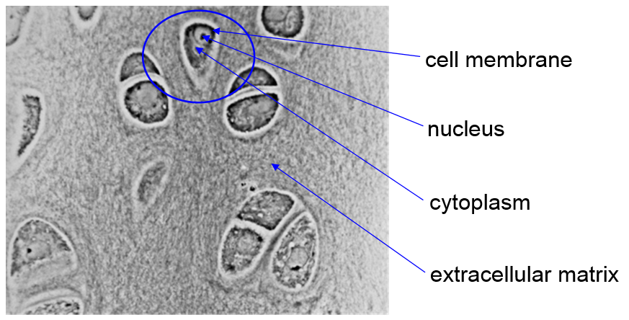
2. Cartilage is a tissue because it is made up of one type of cell (chondroblasts). The ear is an organ because it is made up of several different tissues all working together to perform a function.
3a. Cartilage in the outer ear contains mostly elastin in its extracellular matrix so it is flexible.
3b. The cartilage that makes up the rings around the trachea contain mostly collagen so it is strong enough to hold open the trachea so air can pass through.
4. Titanium was used because it is lightweight so the ear would be light enough to wear and also it is non-reactive. This is important so it does not react with the cells.
5a. The rat's immune system would have attacked the foreign cartilage cells and rejected the ear if it had a functioning immune system.
5b. If the ears are to be used in humans then the patient's immune system would have to be suppressed or the ear would be rejected. With a weak immune system the patient would be at risk from infections.
5c. To avoid this problem the replacement ear would have to be made using the patient's own cartilage cells.

Then ask students to work in small groups to complete Task 2. They should cut out the cards and use the information to answer the question: 'How close are we to building replacement outer ears?'

Ask students from each group to read out their statement. Discuss with the class what steps the researchers need to take next.

Plenary
Discuss with the students the need for scientists to develop techniques to build other replacement body parts such as whole organs. Talk about why this is more complicated and why. For example, organs are made up of many tissues working together, they require a blood supply and connection to the nervous system.
Ask the students to consider the question: 'How close are we to building replacement organs?' Ask them to stand in a line to form a continuum to show where they think we are in this endeavour.

Homework idea
Ask the students to do some research into other teams that are working in the field of tissue engineering and summarise their work in their own words. For example, another recent news story reported that a team have grown a miniature human brain (see http://www.bbc.co.uk/news/health-23863544)

Task 1 – image of cartilage under the microscope

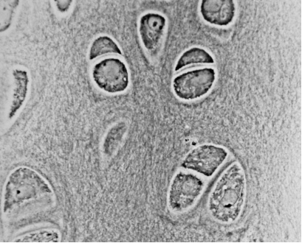
© Robert M. Hunt, 2010
http://en.wikipedia.org/wiki/File:Hypertrophic_Zone_of_Epiphyseal_Plate.jpg

Task 1 – image of cartilage under the microscope

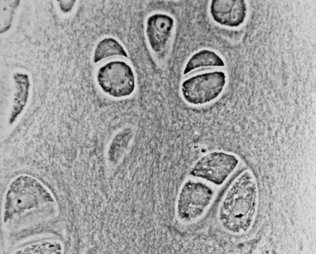
© Robert M. Hunt, 2010
http://en.wikipedia.org/wiki/File:Hypertrophic_Zone_of_Epiphyseal_Plate.jpg
Read the article from The Week magazine called ‘Living ear grown in lab’.

Task 1
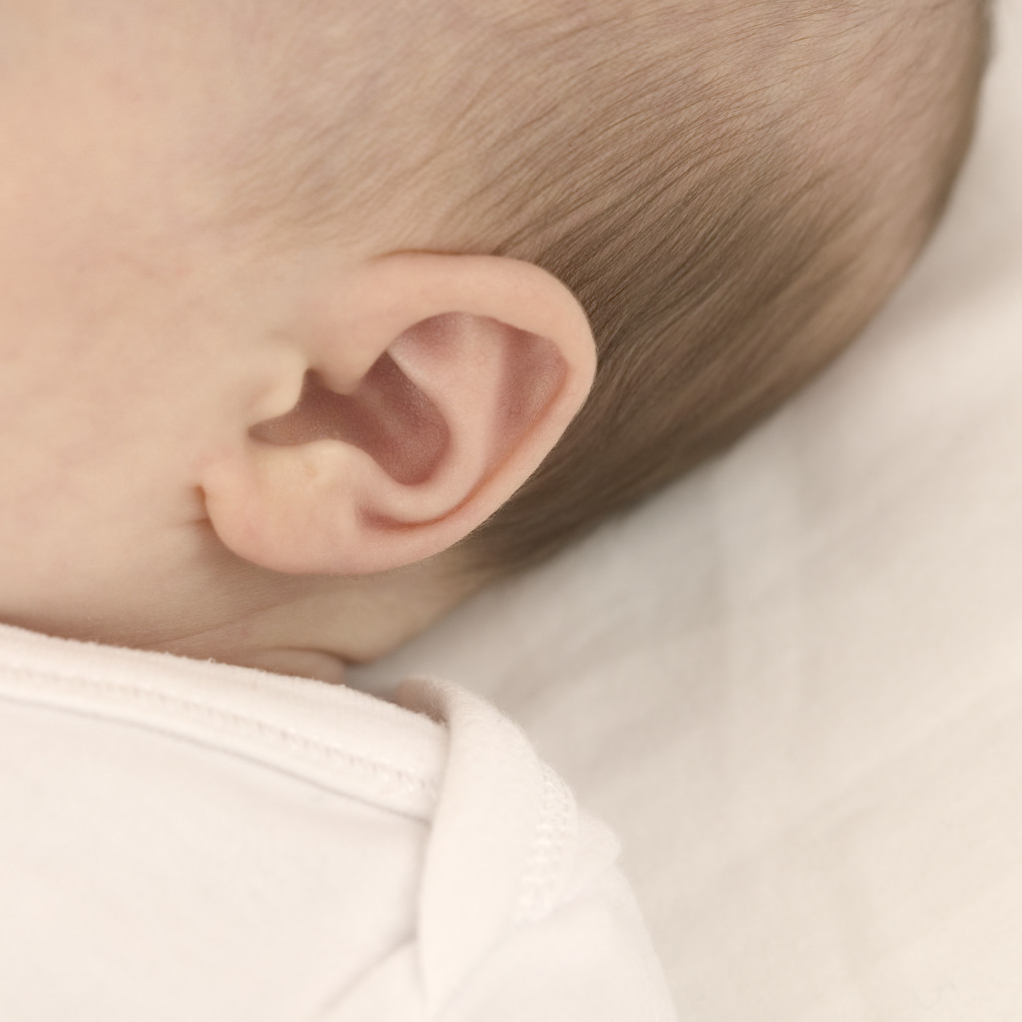
The outer ear (pinna) is made of a tissue called cartilage.

Cartilage is made up of specialised cells called chondroblasts which produce a number of different fibres. These fibres form a network surrounding the cells called an extracellular matrix.

Look at the image you have been given of cartilage under a microscope.

Sketch the area in the box in the space below.

1. Draw a circle around one chondroblast and label the organelles you can see.
Also label the extracellular matrix.

2. Explain why cartilage is classed as a tissue and the ear (including the inner ear) is an organ.

3. The extracellular matrix contains a mixture of different fibres which will contain collagen (which is very strong) and elastin (which is very stretchy). The properties of the cartilage depend on the proportions of these fibres.
For each type of cartilage, predict which fibre is most abundant in its extracellular matrix and explain your answer:

a) The outer ear

b) The rings around the windpipe (trachea)

4. The cartilage used to create the ear was grown using chondroblasts from cows and sheep which grew on a titanium wire scaffold shaped like a human ear. Why did the team choose titanium for the scaffold?

5. The ear was implanted into a rat whose immune system had been suppressed.

a) Why did the rat need to have a suppressed immune system?

b) What problem does this present if the ears are to be used on humans?

c) Suggest how to overcome this problem

Task 2

Work in a small group and cut out the cards.

You will be using them to answer the question:
'How close are we to building replacement outer ears?'

First, place the cards into three piles:
- statements that show that we are close,
- statements which show that we are not ready,
- statements that do not show either.

Now, discuss in your groups the answer to the question.
Write a short statement answering the question with your reasons.

The wire-supported ear implants looked like human ears. | The ear was grown using cartilage cells from cows and sheep. | The team did not surgically transplant the ear into a human. | The ear successfully maintained its shape and flexibility.
The researchers didn’t attempt to grow the parts of a human ear used in hearing. | The scientists found that when they tried to make implants without the wire supports they distorted more easily. | The implanted tissue showed that it had a similar appearance to normal cartilage when studied under the microscope. | The rats used have defective immune systems and do not reject implanted tissue.
 | The ear was successfully transplanted into a rat. | The team believes trials on humans could begin within five years.

