Teaching notes

This could be used as a review worksheet or as part of a teacher guided lesson through plant pollination and fertilisation.
As an extension or homework task you may ask the students to complete a storyboard activity showing the process of pollination/fertilisation or both.

Answers

Task 1

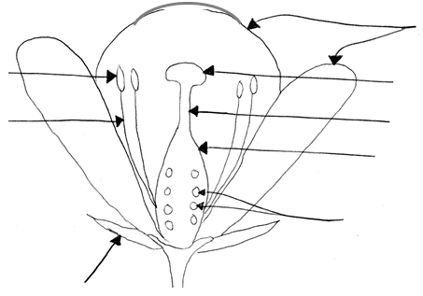
anther
filament
ovule
style
stigma
petals
sepal
ovary

Name of reproductive part | Function
filament | Holds the anther up
ovule | The egg cell. This will become the seed when it has been fertilised.
sepals | Small leaves under the flower, which protected the flower bud.
anther | Produces the male reproductive cells, pollen.
ovary | Contain the female reproductive cells or ovules.
style | The structure between the ovary and the stigma.
petals | Attract insects to the flower.
stigma | The place where pollen lands for pollination to occur.

Task 2

Adaptation | Pollen carried by …
Adaptation | the wind | insects
very low mass | ✓
higher mass |  | ✓
sticky, spikey surface |  | ✓
smooth surface | ✓
rich in protein |  | ✓
may have air sacs | ✓
produced in very large quantities | ✓
produced in smaller quantities |  | ✓

Self pollination: Pollen is carried from the anther of a plant to the stigma of the same plant.
Cross pollination: Pollen is carried from the anther of a plant to the stigma of another plant.

Task 3

Pollen is deposited onto the stigma, this is called pollination.
A pollen tube starts to grow down the style.
The pollen tube continues to grow down towards the ovary.
When the pollen tube reaches the ovary, the nucleus of the male sex cell travels down the tube.
The pollen nucleus fuses with the ovule nuclei and fertilisation is complete.
The fertilised ovule divides and develops into an embryo.
The embryo develops into a seed. The ovary swells and ripens into a fruit.

The reproductive organs of a plant are the flowers. They contain male and female parts.

Task 1

- Use the names of the plant reproductive parts in the box below to label the diagram of the flower.

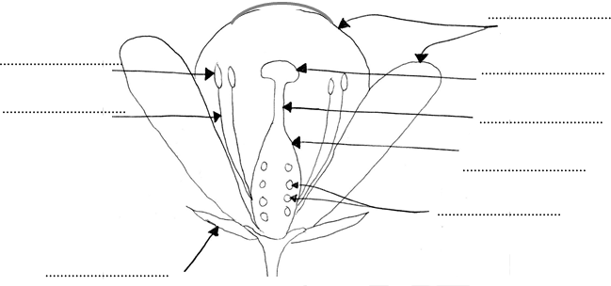

stigma |  | ovule |  | sepal |  | anther
 | ovary |  | petals |  | filament |  | style

- Circle the 3 female reproductive parts in pink and circle the 2 male reproductive parts in blue.

- Match the parts of the flower to their function to complete the table below:

Name of reproductive part | Function
 | Holds the anther up.
 | The egg cell. This will become the seed when it has been fertilised.
 | Small leaves under the flower, which protected the flower bud.
 | Produces the male reproductive cells, pollen.
 | Contains the female reproductive cells.
 | A structure between the ovary and the stigma.
 | Attract insects to the flower.
 | The place where pollen lands for pollination to occur.
Pollination is when pollen is transferred from the anther of a flower to the stigma. Some flowers are wind pollinated whilst others are adapted to be pollinated by insects. The structure of pollen produced by wind pollinated plants is different to that made by insect pollinated plants.

Task 2

- Look at the statements below. Tick the boxes to show which features are most likely to be found in pollen carried by the wind or insects.

Adaptation | Pollen carried by …
Adaptation | the wind | insects
very low mass
heavier mass
sticky, spikey surface
smooth surface
rich in protein
may have air sacs
produced in very large quantities
produced in smaller quantities

- Use the information from the table to draw and label two pollen grains to show their different adaptations.

a pollen grain carried by the wind | a pollen grain carried by an insect

- Explain what is meant by self pollination and cross pollination.

Fertilisation

After the pollen has been deposited on the stigma of a flower, the fertilisation process begins. The statements below describe fertilisation but are mixed up.

Task 3

Cut out the statements below. Put them in the correct order to show fertilisation and the development of a fruit.

The pollen tube continues to grow down towards the ovary.
When the pollen tube reaches the ovary, the nucleus of the male sex cell travels down the tube.
The male nucleus fuses with the female nucleus in the ovule and fertilisation is complete.
The fertilised ovule divides and develops into an embryo.
Pollen is deposited onto the stigma, this is called pollination.
The embryo develops into a seed. The ovary swells and ripens into a fruit.
A pollen tube starts to grow down the style.



